Forest game

The following exercise is about individual decisions and natural resources. This exercise is intended to recreate a situation in which a group must make decisions about the use of a forest.

You will play several rounds equivalent, for example, to years or wood harvest seasons.
Let’s pretend this group has an area of forest with 100 initial resource units. Each round you have to make a decision about how many resource units you want to harvest. You can harvest a maximum of 5 units and minimum of 0 units of the resource.

[Visual explanation; we have a number of magnets on the board which represent the forest units. The instructor shows what happens if a number of units are harvested]
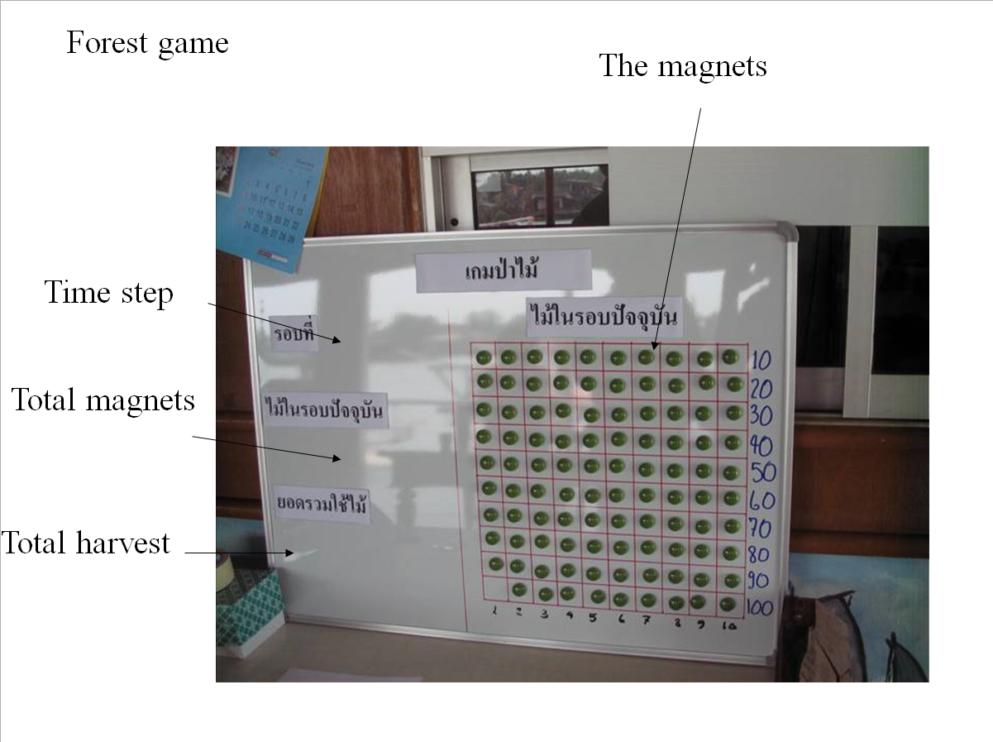

Between the rounds the resource is regrowing. For each ten units of the existing resource, one new unit is added for the next round. [visual explanation; the monitor shows with the magnets that for each row of 10 magnets one new magnet is added to the forest, use rows of 10 magnets on the board]. The forest can not grow to more than 100 units.

Each participant makes a harvest decision.

When the size of the resource is less than 25 units, the maximum harvest is less than 5 units.

In the MAXIMUM HARVEST LEVEL TABLE, that is green, which will be distributed now [MONITOR distributes the MAXIMUM HARVEST LEVEL TABLE at the same time he shows a poster on the wall of the same table]. I will announce the maximum quantity of units you can harvest according to the size of the resource at the beginning of the round and post it on the wall.

In order to make decisions in each round you must write down your decision on your YELLOW DECISION SHEET, a number between 0 and the MAXIMUM HARVEST LEVEL depending on the current resource level. [MONITOR shows the yellow decision sheet at the same time that shows a poster on the wall with the same card]. Please check your player number on the yellow decision sheet. This will be your player number from now on.

Observe that the sheet has a row with the round number. Next there is a row marked with “my harvest decision”, in this space you will write down the harvest level you decided in this round.

It is very important to know that you must make your decisions privately. Therefore, you need to write down the numbers on the decision sheet in private and you can not show them to the rest of the group members. The MONITOR will collect the YELLOW DECISION SHEETS from all of you and she or he will sum the total of units the group decided to harvest. When the monitor announces the group harvest total I will write on the board the new resource level. You will then get the decision sheets back for the next round.

Let us explain this with an example (Use visual explanation).

Suppose the current size of the resource is 68. Each of you decided to harvest 3 units, and thus a total of 15 units. The resource size reduces to 53 (68-15) and then 10% of 53, which is 5 units, is added, which leads to 58 units. Thus 15 units are harvested, and the size of the resource, after regrowth, is reduced with 10 units. And each participant earned 3 points during this round.

For each 10 units of resource 1 unit is added. If there are no 10 units of resource we do not increase the resource, it means if there are less than 10 units we do not add 1 unit more. If the resource is less than 5 units, no units can be harvested any more. Now let’s continue with the next round. Now the current size of the resource is 58 units. It means that the maximum harvest allowed remains 10 units according to the MAXIMUM HARVEST LEVEL TABLE.

Again, each player decides how many units to harvest and again we calculate the resource decreasing and its increase in a 10% for new level of the resource.

Now we are going to explain the PLAYER CALCULATION SHEET, the white sheet the
MONITOR has handed in to you.

[Before we start the monitor will announce one additional rule for this group.]

To start the first round of the game we will organize the seats and desks in a circle where each of you face outwards. The monitor will collect in each round your YELLOW DECISION SHEET. Finally, to get ready to play the game, please let us know if you have difficulties reading or writing numbers and one of the monitors will seat next to you to assist you with these. Also keep in mind that from now on no conversation or statements should be made by you during the game unless you are allowed to.

We will have first a few rounds of practice that will NOT count for the real earnings, just for practicing of the game.

[up to three practice rounds are performed and questions are addressed during the practice]

The initial size of the resource is 100 units

[After the practice rounds announce that the initial size of the resource is again 100 units and that the decisions are now real and affect the earnings]

