Protocol for Game

Groundwater Field Experiment Protocol

[FACILITATOR: Make sure everyone is sitting and not distracted by other matters. Read aloud, from the script, and always alert to any questions; be alert for facial expressions of the participants to detect lack of understanding of the activity.
The group can consist of 5 to 10 people. We use N for the number of participants and will show how to adjust the numbers for the group with size N.

Instructions to read to the students

We do an experiment today which is similar to experiments done with farmers in India. This is a voluntary experience for you to learning about groundwater problems. In case there is something you do not understand during the instructions, we invite you to raise your hand and we will be glad to respond to any question. We ask you to turn off your mobile phones to avoid any distractions during the activity.

The types of crops that you choose to plant affect how much groundwater is used and how much money you make. We all know that cash crops like sugar cane require more water to grow than subsistence crops like groundnut, but sugar cane also can fetch more income than groundnut.

So, if everyone grows sugar cane, then the groundwater levels are likely to fall more than if everyone grows groundnut.

We are going to play an activity that looks at how people make these decisions of what crops to plant. This is not a test; it is just an opportunity for you to make decisions just like you do all the time. But in this situation, you will be playing through several years of planting crops in a short period of time. This activity is very simple, and it doesn’t include all the things that farmers usually deal with in the fields. We are focusing on how you decide between planting one or two different kinds of crops. They are not actual crops that you use; they are pretend crops. One requires a little amount of water to grow and it gives you a small amount of money. We will call that Crop A. The other crop requires more water to grow but gives you more money. We will call that Crop B.

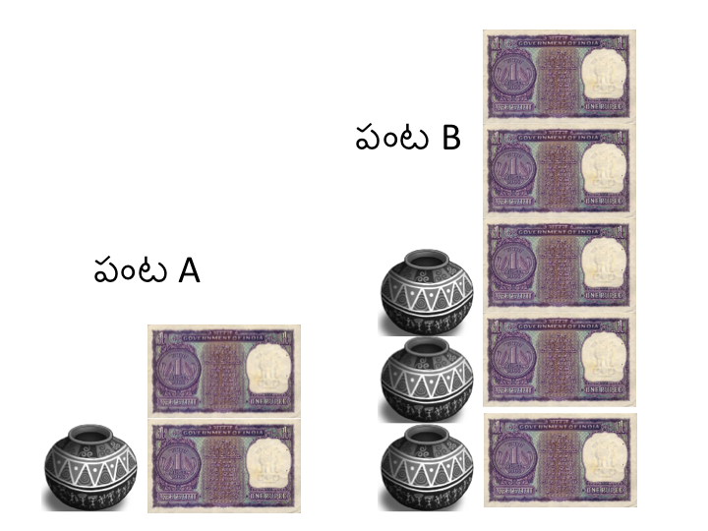
Figure 1. Crop A/B Comparison

During this activity, you are asked not to speak unless we ask you to do so..

This activity is intended to recreate the situation in which people must make decisions about using water to grow crops. You have been organized into a group of N individuals. You will play a number of years, which have one pretend growing season, when all your water comes from groundwater. Though each of you may have different amounts of land, for this activity you should pretend that you all have the same amount of land, say 1 hectare.

At the beginning of the activity, there are (20 + 6 * N) (50 for 5 players; 56 for 6 players, 62 for 7 players, 68 for 8 players, 74 for 9 players and 80 for 10 players) units of groundwater available for your group to grow crops. The amount of groundwater available is shown on the board as blue water in a bore well. As water is used, we will move the blue column down to show you how much groundwater is remaining. Every year, you will have to make a decision, which of the two crops to plant: Crop A or Crop B. Crop A costs one unit of water and gives two units of income. Crop B costs three units of water and gives five units of income. At the beginning of each year, the groundwater supply recharges by (N + 2 ) units of water. We will show this recharge happen by moving the blue column up by N+2 units of water in the bore well. The community also needs to use water for domestic use, which are estimated to be 2 units of water each year.
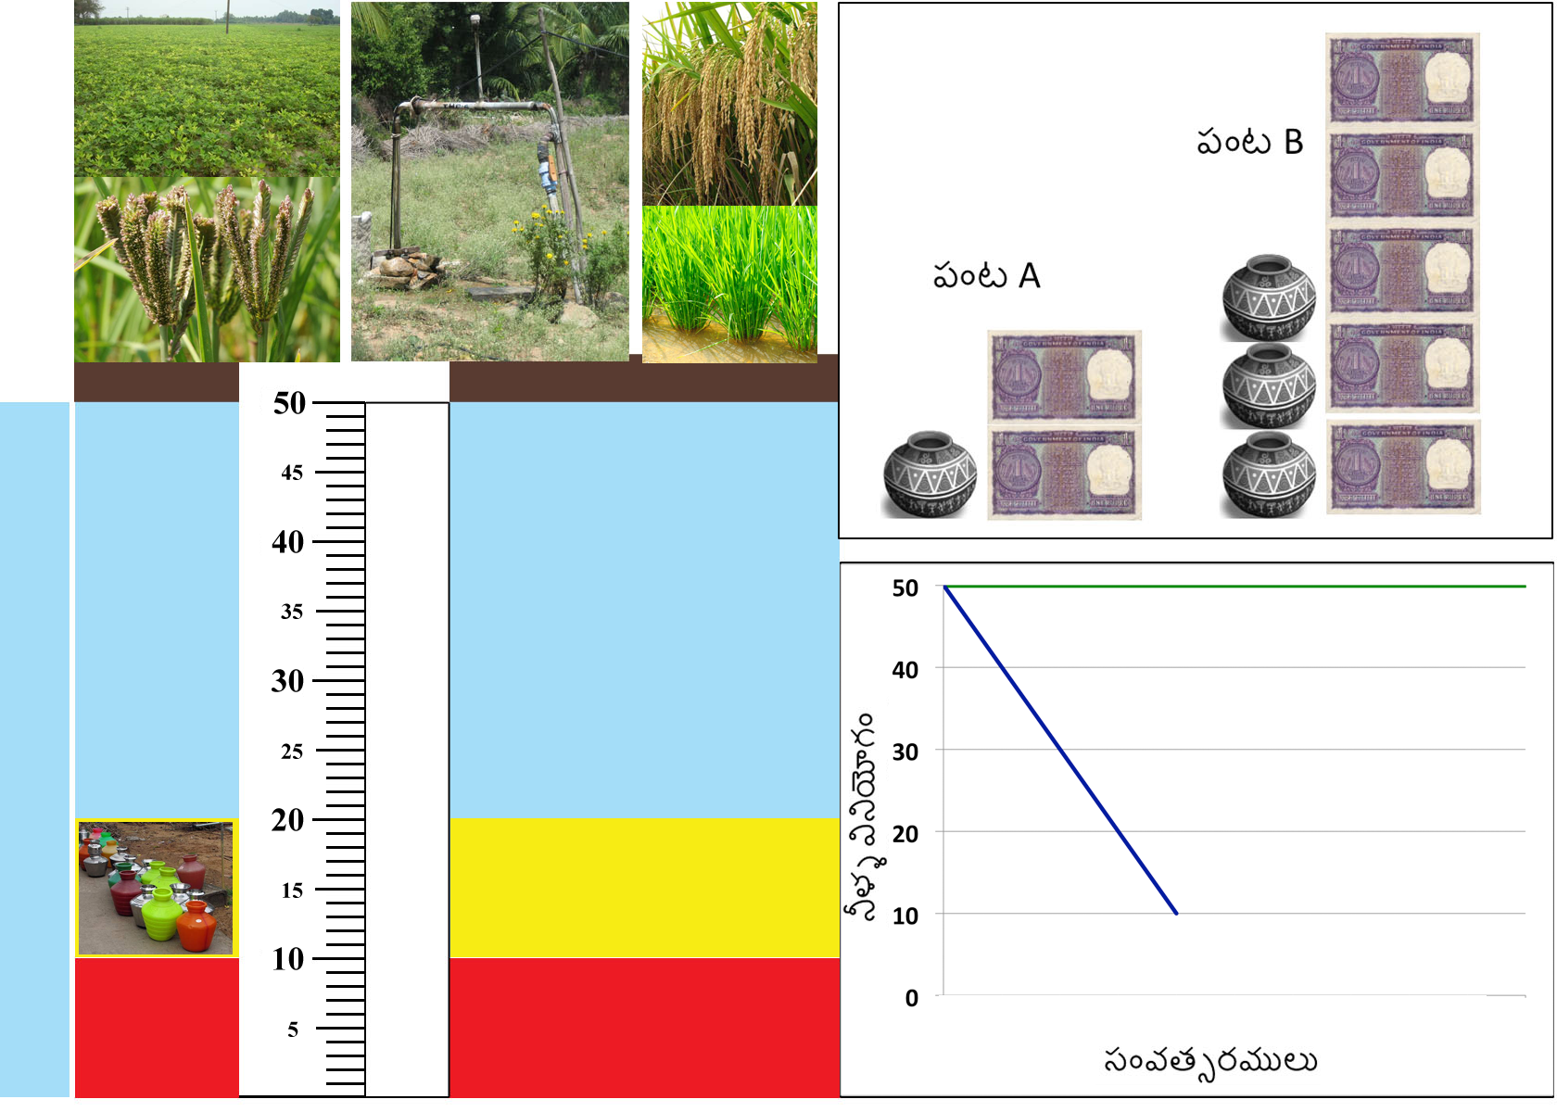

Figure 2. Water Level Indicator

So looking at our picture of a bore well, if a group of 5 people are playing in this game, and everyone plants crop A, 5 units of water will be used, leaving 40 units of water. If we subtract the 2 units of water for domestic use we will have 48 units of water. At the beginning of the next round, the groundwater will recharge with 7 units of water, so there will once again there will be 50 units of water available for the group.

If everyone plants crop B, 17 units of water will be used (15 + 2), leaving 33 units of water. At the beginning of the next round, the groundwater will recharge with 7 units of water, so there will be 40 units of water available.

If some people choose Crop A and others choose Crop B, then the amount of water that will be used will between these two possibilities.

Everyone needs water for domestic use but if the groundwater level drops to 20 units or less, the quality of the groundwater is low and cannot be used as drinking water. If that happens, everyone will have to pay 1 unit of income to buy bottles of water to satisfy demand for drinking water.

We will play the activity for a number of years. If the groundwater level drops below 10 units of water, which is marked here with this red line, for simplicity’s sake, the activity is ended due to insufficient water for the group.

When the activity is ended, we will begin a discussion period, where you can talk about the activity, and share any thoughts or observations you may have about your experience. After the discussion session, we will play the activity again, starting with a fresh groundwater supply of 20 + N*6 units.

I will now describe how we will play the activity in detail. We are handing each of you a piece of paper, your Decision Form. Each year, you will choose which crop to plant by circling one of the two options in the “My Crop” column. Circle “A” if you want to plant crop A, or circle “B” if you want to plant crop B. We will come around to record which crop you want to plant, and we will write how much income you receive for your crops in your Income column. Hold the Decision Form in your hand so only we can see which crop you have chosen to plant.

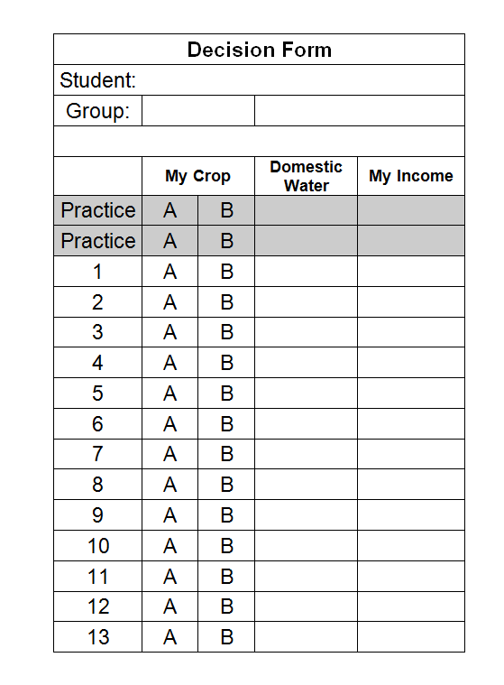
Figure 3. Participant Decision Form (also shown in large-format to participants for instruction)

We will calculate how much water the group has used, and we will move the blue column down [on the board] to show you how much groundwater remains. This is the end of the year.

It would also helpful to show the progress in a graph so the participants see the change of the groundwater over the years.

At the beginning of the next year, we will move the blue column up by (N+2) units of water to show you the groundwater recharge and announce how much groundwater is available to your group.

So for example, if everyone were to plant Crop A every round, the groundwater supply will fully recharge every time. Each participant would earn a total of 20 units of income from their crops in 10 years, or 30 units in 15 years.

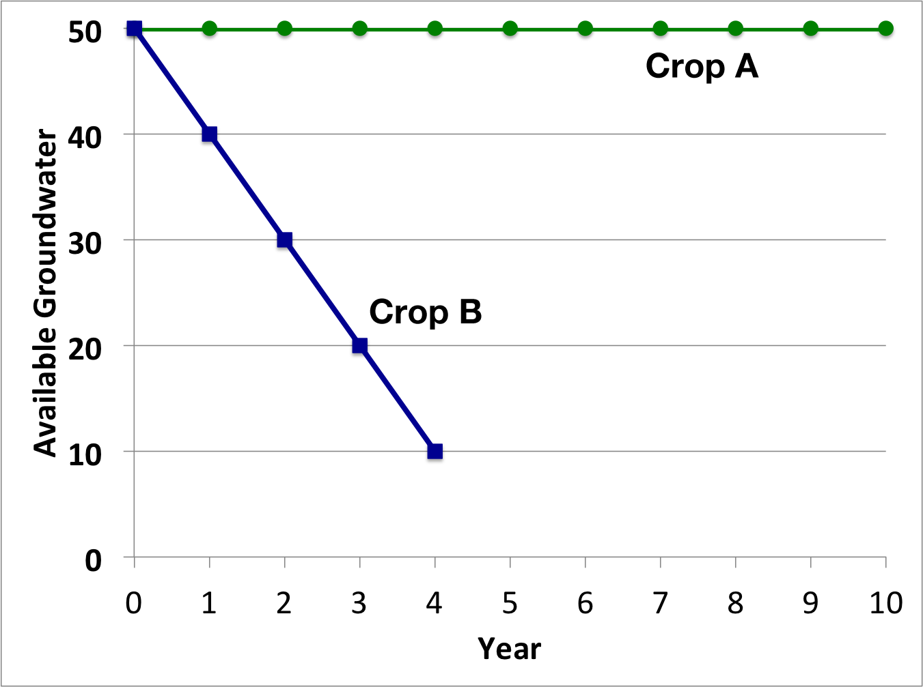
Figure 4. Comparison of Everyone Playing A vs Everyone Playing B (AAAAA vs BBBBB)

If everyone plants Crop B every round, the groundwater supply would last for 4 rounds. Each participant would earn 20 units of income from their crops.

Keep in mind that your decisions are private, and everyone can decide for themselves which crop they wish to plant each round. This means when you show us your Decision Form, only we see the crops you circled on your form.

Do you have any questions about this? [FACILITATOR: pause to resolve questions.]

Keep in mind that from now on you are not allowed to talk to each other until we tell you it is ok for you to do so.

First, we will play two practice years that will not count toward the results of the groundwater levels. These practice rounds are just an opportunity for you familiarize yourself with the activity.

After we have completed the practice years, you will have another opportunity to ask any questions you may have. After that, we will begin the actual activity.

Practice Year:

[FACILITATOR: If this is the second practice round, add N+2 units of water to the groundwater diagram.]

This is the beginning of a new practice year. [ N+2 units of groundwater have recharged.] There are ___ units of groundwater available. Please make your decision on which crop you will plant for this round, Crop A or Crop B. Please carefully show your Decision Form to the monitor when they come to you.

[MONITOR: Write down each participant’s crop decision on the Monitor Form. Calculate the amount of water used, and the remaining water. Show these numbers to the Facilitator.]

For the practice years only, we are going to tell you how many people chose to plant crop A and crop B, so you can tell us how many units of water was used, and how many units of income each person received.

____ people chose to plant Crop A, and ____ people chose to plant Crop B.

How many units of water have been used?

How many units of water is used by the community for domestic use?

How much water is left?

How many units of income do the people who planted Crop A receive?

How many units of income do the people who planted Crop B receive?

[FACILITATOR:
Fill in lines in the following table
Round | Water  Level | # Crop A | # Crop B | Irrigation Use | Domestic Use | Recharge | New Water Level | < 20 Domestic Water
If this is not the last practice round, return to the beginning of the practice round instructions above. Otherwise, continue to the Beginning of the actual activity rounds below.]

[That was the last practice year. Do you have any questions?]

[Look for any questions]

[We will now reset the groundwater level to 20+N*6 units of water and begin the real exercise.]

ACTIVITY 1: YEARS WITHOUT COMMUNICATION

[FACILITATOR: If this is round 2 or later, add N+2 units of water to the groundwater diagram.]

This is the beginning of a new practice year. [ N+2 units of groundwater have recharged.] There are ___ units of groundwater available. Please make your decision on which crop you will plant for this round, Crop A or Crop B. Please carefully show your Decision Form to the monitor when they come to you.

[MONITOR: Walk around to each participant and write down their crop decision on the Monitor Recording Form. Calculate how much water has been used by the group’s crops. Announce how much water was used by the group [and write down the choice for each participant using numbers of participants (not names)].]

[FACILITATOR: subtract the water usage from the water level poster.]

[FACILITATOR:
If the remaining amount of groundwater is 20 or less, announce that there is a shortage of domestic water and it will cost each participant 1 unit of money to get domestic water.

If the remaining amount of groundwater is less than 10 units, announce the end of the activity. Otherwise, move to the next round.]

IF CONTINUE TO NEXT YEAR:

This year has now ended.

IF END ACTIVITY:

[There is no longer sufficient groundwater available for the group.]

If water table is above 10 units, go to 11 rounds. Then announce:This was the last year and the activity is now ended. We are now going to gather your Decision Forms and we are going to discuss your experience in the exercise.

[MONITOR: Gather the participants’ Decision Forms. Store the forms in the correct envelope.]

[FACILITATOR: Use the Discussion Guidelines to ask questions and encourage talking between the participants.]

[RECORDER: Use the Discussion Topics Instrument to check off the topics that are brought up by the participants. Also write down any issues or interesting points that are brought up by the group.]

ACTIVITY 2: YEARS WITH COMMUNICATION

[FACILITATOR: If this is round 2 or later, add N+2 units of water to the groundwater diagram.]

This is the beginning of a new practice year. [N+2 units of groundwater have recharged.] There are ___ units of groundwater available.

This time, you can talk with your neighbors before each round.

After we have collected the information which crop you choose, we will announce which crop each player has chosen. This is like walking by the fields of community members and seeing the crops they are planting.

FACILITATOR: After a few minutes (or when the discussion is stopped, announce that the game continues.

Please make your decision on which crop you will plant for this round, Crop A or Crop B. Please carefully show your Decision Form to the monitor when they come to you.

[MONITOR: Walk around to each participant and write down their crop decision on the Monitor Recording Form. Calculate how much water has been used by the group’s crops. Announce how much water was used by the group. [and write down the choice for each participant using numbers of participants (not names)].]]

[FACILITATOR: subtract the water usage from the water level poster.]

[FACILITATOR:
If the remaining amount of groundwater is 20 or less, announce that there is a shortage of domestic water and it will cost each participant 1 unit of money to get domestic water.

If the remaining amount of groundwater is less than 10 units, announce the end of the activity. Otherwise, move to the next round.]

IF CONTINUE TO NEXT YEAR:

This year has now ended.

END ACTIVITY:

[There is no longer sufficient groundwater available for the group.]

If water table is above 10 units, go to 10 rounds. Then announce This was the last year and the activity is now ended. We will gather your decision forms and hand you a short survey to be filled out. We will go over the survey with you. Thank you for providing this very valuable information.

VARIATION: ADDING RAINFALL VARIABILITY

If we want to include rainfall variability, we can do this but one will need a die. Each round, the recharge level will be determined by a throw of a die. We distinguish a dry year, a normal year, and a wet year.
Dry year: 2 units of water recharge
Normal year: N + 2 units of water recharge
Wet year: 2 * N + 2 units of water recharge
In the table below you see some examples of distributions of rainfall that you can assume. In these examples we assumed that the average rainfall remains the same over the 10 rounds. Of course you could change the distribution to mimic a decline of rainfall.
Die | Uniform | Small Risk | Big Risk
1 | Dry | Dry | Dry
2 | Dry | Normal | Dry
3 | Normal | Normal | Dry
4 | Normal | Normal | Wet
5 | Wet | Normal | Wet
6 | Wet | Wet | Wet

Text highlighted in gray are instructions for facilitator.

