INSTRUCTIONS FOR THE FISHERY GAME

The following exercise is intended to recreate a situation in which a group must make decisions about the use of a fishery resource. You have been selected to participate in a group of five persons among those who have been registered to participate. You will play several rounds equivalent, for example, to years or fishing seasons.

The resource is spread in two locations A and B. Each round you have to make a choice which location to harvest, and whether to put in 0, 1 or 2 levels of effort. The resulting harvest from the effort put in harvesting depends on the condition of the resource. The state of the resource depends on the condition in the previous round and the amount of effort invested in the previous round.

Depending on the condition of the resource the amount of fish is defined by the PAYOFF TABLES for conditions LOW and HIGH. To be able to play you will receive the blue
PAYOFF TABLE equal to the one shown in the poster. [MONITOR: show PAYOFF TABLE in poster and distribute PAYOFF TABLE to participants]. This table contains all the information that you need to calculate the amount of resource units available depending on the current resource level and the quantity of units harvested by the 5 participants of the group. Each participant makes a harvest decision. Each harvest unit is equivalent to $?. For example, if you harvest 40 units during 20 rounds you will receive $?.

When you chose to put your effort in a location with a high payoff situation, you can harvest 0, 7 or 8 depended whether you put in 0, 1 or 2 units of effort. The resource condition can change in each fishing place. The condition depends on the decisions of others. The HIGH condition can move to a LOW condition when FIVE or more units of effort are invested in a location. A LOW condition can move to a HIGH condition when not more than ONE unit of effort are allocated in the same fishing place for two successive rounds.

For example a HIGH PAYOFF TABLE will be a LOW PAYOFF TABLE in the next round when 6 units of effort are applied in one location. A LOW PAYOFF TABLE will move into a HIGH PAYOFF TABLE when no effort is invested in the location for two rounds.

At the beginning of each round, the monitor will announce the condition of the resource at each of the two fishing locations. To play in each round you must write your decisions, a character A or B , and a number 0, 1 or 2 on the YELLOW DECISION SHEET like the one I am about to show you. [… MONITOR: show yellow decision sheets and show in the poster…]

It is very important that we keep in mind that the decisions are absolutely individual, that is, that the numbers we write in the game card are private and that we do not show them to the rest of members of the group. The monitor will collect the 5 sheets from all participants, and will define the harvest for each individual and the condition of the resource in the next round.

When the monitor announces the harvest in each location and the conditions of the resource at each location, we will write these conditions on the boards so that you know which payoff table to use.

Remember that the points you earn depend on your own decisions and will become money at the end of the exercise.

Let us explain this with an example.
[here we run a round with an example]
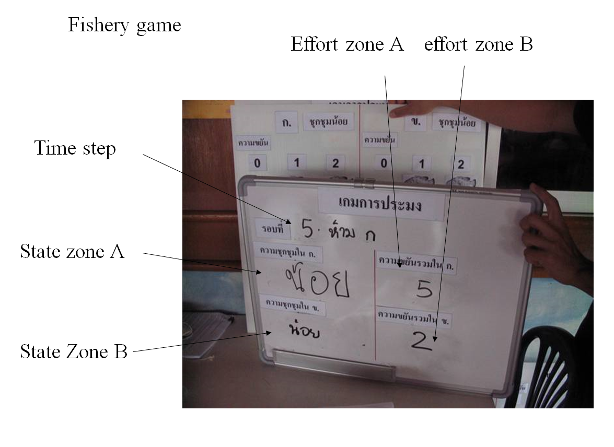
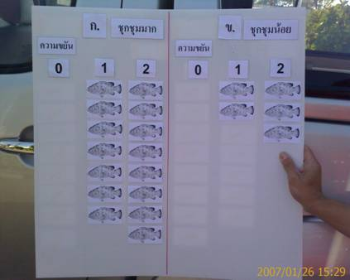

Are there any questions about this? [MONITOR: pause to resolve questions.]

Before we start, and once all players have understood the game completely, the monitor will announce one additional rule for this group. To start the first round of the game we will organize the seats and desks in a circle where each of you face outwards. The monitor will collect in each round your yellow GAME CARDS. Finally, to get ready to play the game, please let us know if you have difficulties reading or writing numbers and one of the monitors will seat next to you to assist you with these. Also keep in mind that from now on no conversation or statements should be made by you during the game unless you are allowed to.

We will have first a few rounds of practice that will NOT count for the real earnings, just for practicing of the game.

In the first round you use the HIGH PAYOFF TABLE in each location.

payoff table
Fishing place | Fishing effort
 | 0 | 1 | 2
Low | 0 | 2 | 3
High | 0 | 7 | 8

Suppose total fishing effort in a location is more than 4 in a high payoff table, then the payoff table drops to a low payoff table. In case of a low payoff table, if two subsequent rounds of less then 2 units of investment, the system flips back to the high payoff table.

