**INSTRUCTIONS FOR THE IRRIGATION GAME**

We would like to thank you for accept this invitation. We will spend about two hours explaining the activity, and playing the game. Let’s start.

The following exercise is a different and entertaining way to actively participate in a project about individual decisions and natural resources. Besides participating in this exercise and having the chance of earn money, you will participate in a workshop in the coming days in order to jointly discuss the exercise as well other topics about natural resources. The funds to cover these expenses have been donated by a scientific body.

In this exercise it is intended to recreate a situation in which a group or family must make decisions about the use of water to irrigate its plots. You have been selected to participate in five persons group among persons who have been subscribed to participate. You will play several rounds equivalent, for example, to years or irrigation seasons.

Each round consists of two decisions. First, each of you decide how much to contribute to a public fund in order to maintain irrigation canals. The sum of the contributions will affect the amount of water units available for the five players. The next decision is for each player to take some part of the water units available. Each unit you collect during the game is equivalent to $200 pesos. For example if you get 100 units during 20 rounds of the game you will receive $20.000 pesos.

We now discuss the first decision in detail. Each round you have 10 units to spend. You can spend some of it in the public fund, or you can keep the rest. You can think of this as the amount of labor you invest in the maintenance of the irrigation system. The level of thiseffort is between 0 and 10. On the green TABLE OFAVAILABLE WATER QUANTITY and the poster we show how much water will be available for the group of five players depending on the total contributions.

[the MONITOR shows TABLE OF AVAILABLE WATER QUANTITY in the poster and distribute the table to participants].

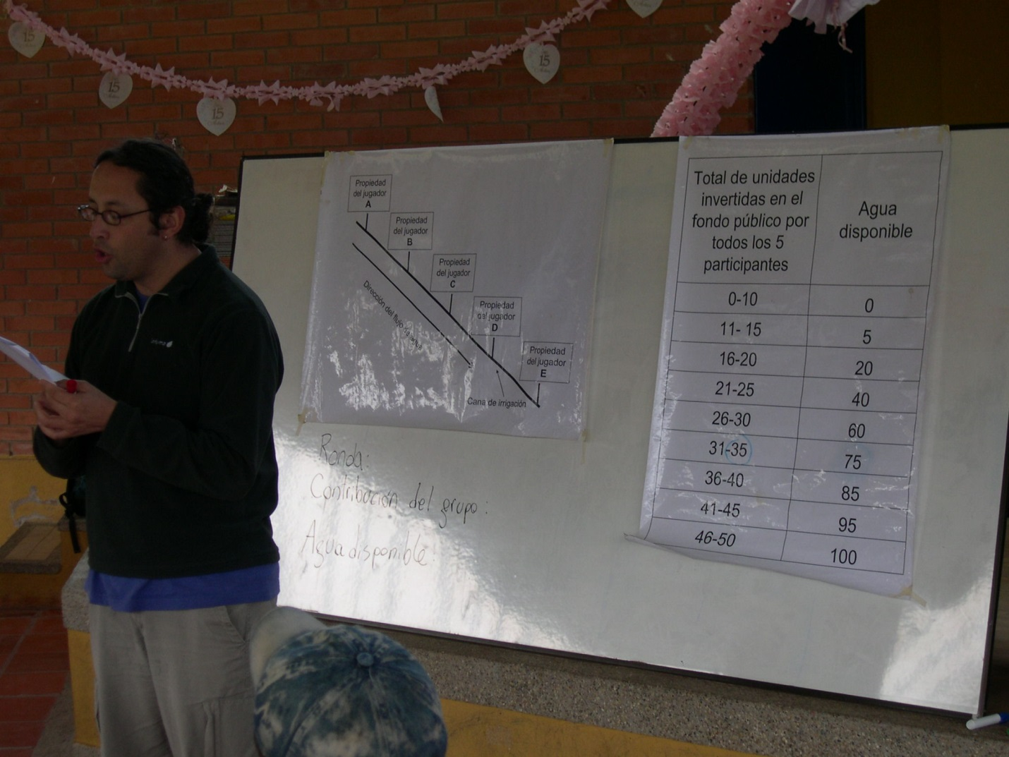

This table contains the information that you need to calculate the resulting size of the public fund available depending on your contribution and those of the other 4 players. The decision of the contribution is written down on the yellow DECISION SHEET like I will show you right now and provided to the monitor [the Monitor shows the yellow decision sheet on the board].

The monitor calculates the level of the public good and posts this amount on the board. The Monitor will collect the yellow DECISION SHEETS of 5 participants and he will sum the total units that the group decided to contribute to the public fund. We will write on the board the new current size of the public fund.

[explanation: we may use coins or magnets to explain the allocation of the 10 tokens]

For example, everybody invest 2 units in the maintenance of the irrigation system, and keep the 8 other units for themselves. In that case no water is available to be distributed among the players. As a result everybody ends up with 8 units at the end of that round.

Another example is that everybody invests 10 units in the maintenance of the irrigation system, which leads to 100 units of water to be allocated among the 5 players.

Remember decisions are made private and everybody can decide on how much they want to invest in maintenance.

After the first decision is made, the monitor collects the yellow sheets, and decides the total amount of water available. This amount will be written on the board. Next, all the players get back their yellow decision sheets.

The next decision is to take **a quantity of water for irrigation**. Everybody has the same size of land for irrigation. The money you earn is directly dependent on the water you take from the public pool. Each one of you will receive, FOR ALL THE ROUNDS, randomly a card marked with the following characters: A, B, C, D and E. The player who obtains character A will be the first to decide how much water she/he takes to irrigate her/his plot. It means that characters on the cards define the order in which the properties of each player are situated through an irrigation canal [the monitor shows a draw in the board that represents the situation].

The player who has the card with the letter A decides how much water to take and writes down his/her decision on the YELLOW DECISION SHEET. [Monitor shows the allocation decision spot on the yellow decision card on the poster on the wall]. The Monitor will subtract the collected water from the available water and write the remaining amount of water on a WHITE piece of paper to show this to player B, who has the second option to make a decision. This process continues until player E has made a decision.

[example: given is an amount of water, represented as an amount of coins/magnets. The instructor shows what happens if first player A takes from the pool, then B, etc.]

Then the next round starts with first turning in the contribution to the public good.

It is very important to remember always that the decisions are absolutely individual, it means, the numbers you write down on the game sheets are private and you must not show them to the others members of the group.

Are there any questions about this? [MONITOR: pause to resolve questions.]

Remember that the points you earn depend on your own decisions and will become money at the end of the exercise.

[Before we start, the monitor will announce one additional rule for this group.] To start the first round of the game we will organize the seats and desks in a circle where each of you face outwards. The monitor will collect in each round your YELLOW DECISION SHEETS. Finally, to get ready to play the game, please let us know if you have difficulties reading or writing numbers and one of the monitors will seat next to you to assist you with these. Also keep in mind that from now on no conversation or statements should be made by you during the game unless you are allowed to.

We will have first a few rounds of practice that will NOT count for the real earnings, just for practicing of the game.

Now we will distribute the cards with the letters from A to E which we draw randomly from a bag.

*Relation between investment in public good and availability of water.*

The first row is the total level of investment by all the subjects, and the second row is the amount of water available, before the first subject can take from it.

|  |  |
| --- | --- |
| investment | Total water available |
| 0-10 | 0 |
| 11-15 | 5 |
| 16-20 | 20 |
| 21-25 | 40 |
| 26-30 | 60 |
| 31-35 | 75 |
| 36-40 | 85 |
| 41-45 | 95 |
| 46-50 | 100 |

Below we see the public good as function of investment.

