Common Pool Resources

I. The Problem

A. Introduction

The resources of common use do not have clearly defined spatio-temporal limits and are an important part of income generation or sustenance of rural communities. The main characteristic of these resources is that the extracted units are no longer available to other potential users, but the act of excluding them from accessing the resource has a high cost. The need to recognize the rules and the organizational forms of the communities, as well as the influence of the internal or external norms in the decision of how to manage the natural resources, is the intended use of this game - to analyze the rationality of resource users

B. Purpose of the Game
The game aims to analyze the individual and collective incentives of people who use and manage common use natural resources, especially in communities that depend on them economically. It also seeks to recognize the effect that different internal and external rules for regulating the use of natural resources has on peoples’ decisions.

C. Economic Model of Analysis

The economic model of this experiment is similar to the one presented at the beginning of the manual and is inspired by previous experimental works (Cárdenas et al., 2000) and particularly by the model developed in Cárdenas (2004). In this commonly used resource model, a number N of players have access to a natural resource. Each player i can extract an amount X_{i} from the resource. That amount X_{i} increases their income, but the total withdrawal ΣX_{i} reduces the income of that player and the others. This problem is derived from the physical configuration of the resource, and the rules of access and ownership of it will generate a possible externality, perhaps better known from the famous article by Garret Hardin (1968) "The tragedy of common goods. " The reason for this apparent contradiction is that player i receives benefits for the resources extracted by him/her, but also receives costs or suffers negative consequences for the total extraction that he/she and others have made, since this total extraction affects the renewability of the resource.

The problem optimization for the player i will be to maximize family welfare, but this welfare depends on his/her decisions and the decisions of the other members of the community; that is, player i is trying to optimize his/her decision, this is Max Y_{i} (x_{i}, Σx_{i}), where Y_{i} is the welfare of i, which depends on his/her level of extraction and the aggregate of the community. However, the gains of i increase with the individual extraction X_{i} but are reduced with the total extraction Σx_{i}. These two conditions are what generate the cooperation dilemma. In other words, private income increases with the extraction of resources, but decreases with total extraction. The dilemma is that in order to balance individual and collective interest it is necessary to find the institutional mechanisms (rules of the game) that guide individual behavior toward socially desirable levels of extraction.

The profit function that was used to generate the table of points of the experiment in this chapter is as follows:

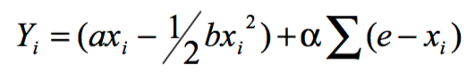
Where we assign the values ​​e = 8, a = 0, b = 5, and α = 20, with the purpose of creating a situation in which the individual interest and the collective interest enter into conflict, that is, the so-called "tragedy" of the commons." Note that this model is similar to the public goods game in the second version, in which players extract trees from the forest. However, this model has a nonlinear payment function to reflect greater similarity with ecosystems and natural resources whose benefits vary with the amount of effort and pressure exerted on them.

In the experimental design used here we restrict the decisions to a minimum of one extraction unit and a maximum of 8 units. The main reason is to facilitate the problem for the participants in the experiment and to simplify the range of numerical possibilities, without sacrificing much of the continuous character of the decisions from less to greater extraction of a natural resource.

D. Model Predictions: Nash Equilibrium, Social Optimum, Other Hypotheses
With these parameters, we have two solutions to the problem. The solution that maximizes individual gains (or Nash equilibrium in terms of game theory), where X_{i} = 8 units, and the solution that maximizes group gains when X_{i} = 1 unit. Note, however, that for any level of extraction by the group, each player obtains greater gains choosing the maximum possible extraction of 8 units. These two solutions are easily verifiable in the points table that will be described below.

II. Game or Experimental Set-Up

A. Experimental Design (base line versus treatments)
As stated above, the intention of this game is to analyze the economic rationality of the people who use and manage a common pool resource. In order to do this, the game has two parts: the first, which is called baseline, is the same for all groups of participants. In this part we try to obtain data to which the decisions of the second part can be compared. The objective of the second part is to collect data on the decisions of the players taking into account rules such as communication and external regulation (for example, a high fine versus a low fine for non-compliance with a regulation), in order to compare them with the decisions they made during the first part.

B. Sample Size (Suggested Minimum)

The minimum sample size for this game is that it is sufficient so that there can be five groups – on group for each of the rules.

C. Session Design (N player, T rounds)
For a session, it is necessary to have a group of five participants (you can play at the same time with two or three groups, depending on the space and the number of people who make up the field team), who will receive a number from 1 to 5, which will be their player number during all rounds of the exercise. The total number of rounds of each exercise will be 20: 10 will be played during the first part of the game and 10 in the second part, when the rule is introduced with which the group must play.

D. Type of Participants

In this game, people who live near a resource for community use and who benefit from different forms of its use and conservation must participate. For example, some may extract food or wood from it, while others benefit from its conservation because of the biodiversity found there or because of the ecotourism services it offers.

E. Estimating Incentives and Payment to Participants

On average, each of the players can earn 16,000 pesos ($ 7.20), meaning that for each session (5 players for 20 rounds) approximately 80,000 pesos ($ 36) are paid.

In accordance with the conditions of the study and the place where the game is played, the values ​​of the table can be taken as points that can convert into money- taking into account the economic characteristics of the place- or into prizes that, like money, will be delivered at the end of the exercise.

Throughout the exercise, the decisions of the players are individual and private; This characteristic is part of the confidentiality of the study. People who cannot read or have difficulties with writing will receive the support of a team assistant, who will be responsible for this task; It is important to note that everyone in the community can participate, and that it is not a requirement that they are able to read or write.

III. Tools, Logistics

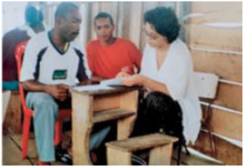
A. Type of Place

For this game it is necessary to have a large room, which allows the implements that are used to explain the game to be placed on the wall, and where each of the players can be placed with their backs to the rest of the group members so that they can make their decisions individually and privately.

B. Field Team (Roles/Functions)

For the realization of this game it is necessary the presence of a moderator and a monitor; If more than one group plays in a session, one assistant must be available for each additional group.

The role of the moderator is:
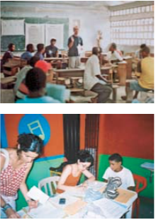
The moderator is the person in charge of welcoming the participants, explaining the intention of the game and reading the instructions (explanation of the formatted cards given to the players), giving an example of how the exercise will be carried out and answering the questions of players.

After clarifying the game to the players, the first 10 rounds of the game will begin, informing the group the number of the round that is being played and the total number of units drawn by all the members of the group. Only the moderator knows the decision of each of the players, and no other person can have this information.

After finishing the first 10 rounds, the second stage begins, in which the moderator explains to the group the new rule and the effects it will have on the winnings of each player, according to the decisions made.

In addition to reading the instructions to the group, the moderator is in charge of guiding the players during the exercise and answering their questions; for this it is necessary that he/she maintain his/her neutrality and refrain from influencing the players through answers or attitudes directed at the decisions that the players make.

A frequent question in this exercise is: "Can we always choose the same number?" The moderator must respond that each person can choose the number of extraction they want in each round, and insist on the privacy and autonomy enjoyed by the players when choosing the number with which they will participate.

The role of the monitor is:

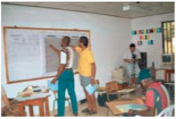
The monitor is the person in charge of recording the data of each of the players during each round; they will record the data on a monitoring sheet (this sheet is shown later in the protocol). They are also the in charge of supporting the moderator during the whole exercise, especially when delivering the materials to the participants. Like the moderator, the monitor must maintain their neutrality during the exercise, and avoid influencing the decisions of the players.

IV. Materials Needed to Carry Out the Game Session

A. For explaining the Instructions

Once the participants have understood the intentions of the study and have organized themselves into groups, they should know and understand the dynamics of the exercise. For this reason, it is important to have enlarged samples of the formats/recording cards that will be delivered to the players; In these extended samples, the moderator can write the examples, so that the players become familiar with the format of the cards and the explanation is more useful.

B. For each one of the players

In the first part of the game:

Game Cards: Each player will receive 13 cards printed on yellow paper, with a number from 1 to 5, which will identify him/her throughout the game year. This number has no relevance because the cards are delivered randomly to the participants of the group. Apart from the space in which the player number is indicated, the cards have two other spaces, one for marking the round number and another for writing the level of extraction during that round (from 1 to 8). 13 cards are given because 3 will be used for the first rounds of practice or as examples (these examples do not add up in the winnings).

Game Cards
Player Number
Round Number
My level of extraction (from 1-8)

Accounting Cards: As reported in the instructions, each player will receive a green printed sheet, which should be marked only with the player number (remember that decisions are anonymous), the place where the experiment is performed, and the time. On this sheet, the player must write his/her decision during each round (the one written on the game card and delivered to the monitor), the total extraction by the group (which is announced by the moderator), and write down the total points they get in that round.

Date: __/__/__ Time:_____ Place: __________ Player Number:________
 | A | B | C | D
Round | My Extraction (1-8, my decision) | Total Extraction of the group (Moderator announces) | Extraction level of the rest (column A – B) | My Earnings (use the blue point table)
Practice
Practice
Practice
1
2
3
4
5
6
7
8
9
10
Total

Point Table

The point table permits each player to see how much they earn according to their decisions and the decisions of the rest of the players in their group. This is the table of points:

My level of Resource Extraction
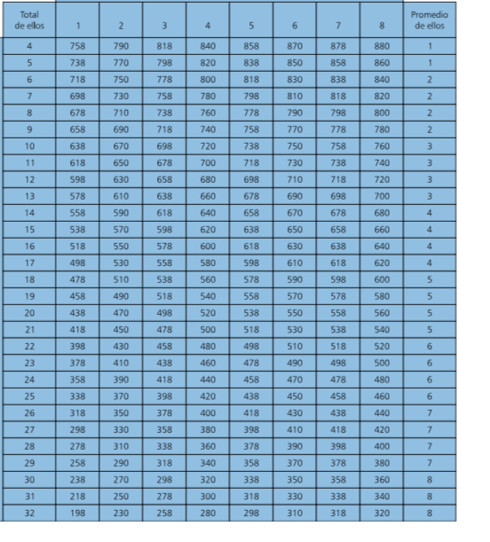
Average
Total
The Level of others’ Extraction

- For those in charge of running the game

For the moderator

Introduction: Thank you for being here and accepting our invitation. The following exercise is a different and entertaining way to participate actively in a study about people's economic decisions. Depending on the decisions you make today, you can earn a certain amount of money or prizes; that is why it is important that you pay close attention to these instructions. You may wonder why money is used in these exercises. Money is used because the exercise requires people to make economic decisions, that is, decisions that have consequences for their pocket, as they do in reality. At no time is it expected that the money constitutes a payment for participating in the study or is the only reason for you to participate.

Explanation of the Game: This exercise tries to recreate (imagine, simulate) a situation in which a group of people must make decisions about how to take advantage of natural resources, for example a forest, a water source, a mangrove, a fishing zone or any other that the community uses.

In this community,_________________, an example would be the case of taking advantage of the _______________ resource, located in the __________ zone.
You have been chosen to participate in a group of five people. The game in which you will participate is different from those played by other groups (there are different rules for each game), so the comments you have heard from other people are not necessarily valid for this game. You will play for several rounds equivalent to, for example, months or seasons of fishing or harvest, work tasks, et cetera. At the end of the exercise, you will earn a certain amount of points that will be converted into money or prizes.

- Deliver the materials to each participant

Now we are going to give you all the sheets/cards you need in order to play:

The yellow game cards: Each one of these cards has the player number that corresponds to each person, spaces to mark the number of the round, and your decision.

The green accounting cards: On this card, you will write down your player number (the one in the yellow cards), the date, the time and the place.

And the most important, the blue point sheet, where you will find the points you can earn according to the decisions that you and the other people in your group make.

Remember that the points you earn will be converted into money or prizes that will be delivered at the end of the year.

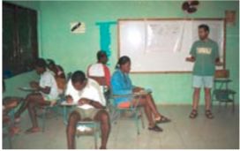
- First Practice
Each of the players will take one of the yellow color decision cards, mark the letter P (practice) in the space called the round number, and for this first practice everyone will decide to extract units from the resource.

As in this practice round, the level of extraction was 2, each of the players must write this number in column A of their green sheet of accounts.

At this moment, the moderator collects the yellow cards of each one of the players and adds up the total level of extraction of the group.

The total level of extraction for this round of practice will be 10 (2 + 2 + 2 + 2 + 2 = 10), which will be announced by the monitor and recorded by each player in column B of his/her green account sheet.

Next, each player must subtract their extraction level from the total extraction level announced by the monitor. For this round of practice, each player must subtract his/her extraction level (2) from the group total (10), and he/she must record the result (8) in column C of his/her green account sheet.

At this time, the player must observe in the blue dotted chart how much his/her winnings are for this round (710 points) and write this figure in column D of his/her green bill sheet.

- Second Practice

Each of the players will take one of the yellow decision cards, it will be marked with the letter P (practice) in the space called the round number, and for this second practice everyone will decide to extract 6 units from the resource.

Since in this practice round the extraction level was 6, each player will enter this number in column A of his green account sheet. At this moment, the moderator collects the yellow cards of each player and adds the total level of extraction of the group.

The total level of extraction for this round of practice will be 30 (6 + 6 + 6 + 6 + 6 = 30), which will be announced by the monitor and recorded by each player in column B of his/her green bill sheet.

Next, each player must subtract their extraction level from the total extraction level announced by the monitor. For this practice round, each player must subtract his/her extraction level (6) from the group total (30), and h/she will record the result (24) in column C of his/her green account sheet.

At this time, the player must observe in the blue dotted chart how much his/her winnings are for this round (470 points), and he/she will enter that number in column D of his/her green bill sheet.

All the examples of the practice rounds are done on the large samples of the cards, the accounts sheets and the points table.

As the first two rounds of practice were public, the moderator should mark the levels of extraction that he/she is giving as an example on the large sample cards. Like this:

Practice Round 1

Game Cards
Player Number | 1,2,3,4, or 5
Round Number | P
My level of extraction (from 1-8) | 2

Practice Round 2

Game Cards
Player Number | 1,2,3,4, or 5
Round Number | P
My level of extraction (from 1-8) | 6

And the large display of the accounting card, like this:

Date: __/__/__ Time:_____ Place: __________ Player Number:________
 | A | B | C | D
Round | My Extraction (1-8, my decision) | Total Extraction of the group (Moderator announces) | Extraction level of the rest (column A – B) | My Earnings (use the blue point table)
Practice
Practice
Practice
1
2
3
4
5
6
7
8
9
10
Total

- Third Practice

For the third practice, it is necessary that the players are already located in their groups and with their backs to their teammates. In this practice it is no longer the moderator who indicates the level of extraction, but each player decides what his/her level of extraction will be.

Each of the players will take one of the yellow decision cards, mark the letter P (practice) in the space called the round number and decide, privately, what their extraction level is.

Suppose that in this third round of practice player 1 decided to extract 3 units of the resource, player 2 decided to extract 7 units of the resource, player 3 decided to extract 5 units of the resource, player 4 decided to extract 4 units of the resource and player 5 decided to extract one unit of the resource.

In this practice round and during the rest of the exercise, each player must record his/her decision in column A of his/her green account sheet.

At this moment, the moderator collects the yellow cards of each one of the players and adds the total level of extraction of the group.
The total level of extraction for this round of practice will be 20 (3 + 7 + 5 + 4 + 1 = 20), which will be announced by the monitor and recorded by each player in column B of his/her green account sheet.

For this example we will do the accounts of player number 5. He/she must subtract his/her level of extraction from the total level of extraction announced by the monitor. In this round, the total level of the group was 20 and the extraction level of player 5 was 1. Player 5 must subtract his/her extraction level (1), and record the result (19) in column C of the green bill sheet.

At that time, player 5 should see in the blue points table how much his/her winnings are for this round (458 points) and write it down in column D of the green score sheet.

According to the previous example, in the practice round the yellow decision card of player number 5 was as follows:

Game Cards
Player Number | 5
Round Number | P
My level of extraction (from 1-8) | 1

And his/her accounting sheet was as follows:

Date: __/__/__ Time:_____ Place: __________ Player Number:________
 | A | B | C | D
Round | My Extraction (1-8, my decision) | Total Extraction of the group (Moderator announces) | Extraction level of the rest (column A – B) | My Earnings (use the blue point table)
Practice | 2 | 10 | 8 | 710
Practice | 6 | 30 | 24 | 470
Practice | 1 | 20 | 19 | 458
1
2
3
4
5
6
7
8
9
10
Total

At this time, the moderator will give space for the questions that are generated within the groups and will proceed to read the informed consent. It is important to remind the group that the points won in the rounds that have just been played are not added up for the final payment since they are practices.

V. Informed Consent
It is necessary that you, as participants, review and sign the acceptance or informed consent form. In this sheet, we assure you that we will manage all the information collected in the exercises in a confidential manner; In addition, we point out that participating in these exercises does not present any risk. You signature signifies that you are aware of and have accepted the project and the exercises that will be carried out [read the informed consent form to the whole group, aloud]. If you agree to participate, please fill in your acceptance form, and do not forget to write your player number on it.

For the Monitor

Sheet for registering the decisions of the players

File for the monitor (one per group)

Date:___/___/___ Time: ______am/pm Place:_______________

Monitor: _________________ Treatment:___________

 | Individual Decisions
 |  | Players |  |  |  |  | Group Total
Round | Rules | 1 | 2 | 3 | 4 | 5
Practice
Practice
Practice
1 | X
2 | X
3 | X
4 | X
5 | X
6 | X
7 | X
8 | X
9 | X
10 | X
Phase 2 | Rules | Write the decision of the Player |  |  |  |  | Group Total
 |  | 1 | 2 | 3 | 4 | 5
11
12
13
14
15
16
17
18
19
20
Total

In the monitor’s file, the monitor registers the decisions of each player in each round, and en the last box is written the group total that is announced by the monitor.

VI. The Rules
All the necessary steps have been explained to carry out the first 10 rounds of the game. Now, we are going to concentrate on the second part of the game, in which there are some changes in the dynamics of the exercise because a new rule is introduced, which may be different for each of the groups.

The rules of the second part that can be implemented are:
- Communication
- High External Regulation
- Low External Regulation

Rule 1: Communication
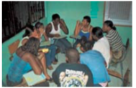
After finishing the first 10 rounds of the exercise, each player must calculate his/her winnings, and then the monitors collect the green score sheets of all the players, to calculate the group's profits.

Before starting this new stage of game, the moderator tells the members of the group that they can talk about what they want for five minutes: about the game, the winnings, about the ways of playing, how the game resembles reality, and so on. This conversation is only between the members of the group, it should not be directed by the moderator. The only thing that is not allowed during this time of conversation is that players make promises to one another about transfers of points during the exercise or after it.
Each player must be given 10 yellow cards to write their decision and a new accounting sheet similar to the one given in the first part of the game, but without the first three practice rounds on it (it is part of the photocopying material).

There are two options for the instructions the moderator gives the group: one in which he/she tells them that by playing 1, the results for the group are better; and the other in which they give them no indication of the profits.

In the same way, there are two options for when to communicate: one is that they meet once at the beginning of the 10 rounds, and the other is that they meet before making the decision of each round.

The Instructions that the Moderator should read are:

In addition to the rules described in the instructions that we have just explained, there is an additional rule for the participants of this group:

Please, make a circle or sit around the table.

Before making your next decision, you can have an open discussion, which will last a maximum of five minutes, with your group. You can talk about whatever you want about the game and the rules, but no player can make a promise or threat related to payments or transfers of points during or after the end of the exercise. It is simply an open discussion. The rest of the rules of the game are maintained. We will tell you when the time is over. Afterwards, you and your colleagues should suspend the discussion and each will make his or her individual decision for the next rounds. These decisions will remain private and confidential as in the other rounds, and may not be known by the rest of your group or by other people.

After the five minutes have elapsed, the moderator warns that the time has ended; all the players must return to their place so that their decisions remain private, and the game dynamics continue as in the first part. The monitor’s accounting sheet, in which the decisions of the players are recorded, is the same as that presented in the first part of the game.

Rule 2: High External Regulation

For this rule, the exercise dynamic continues in the same way as in the first part of the game, but the moderator imposes an external penalty to one of the members of the group that has been selected at random.

The Instructions that the Moderator should read are:

In addition to the rules described in the instructions that we have just explained, there is an additional rule for the participants of this group:
This new rule serves to obtain the maximum points possible for the group. We are going to try to guarantee that each player chooses an extraction level of one. If a player chooses more than one unit, we will apply a penalty fee of 175 points for each additional extracted unit.

However, since it is difficult to inspect the results of all of the group members, we will select at random one of the group members. Only those that are randomly selected must show – to the monitor – the decision that they made and then the monitor will apply the fine if it is required.

As the rules indicates, the level of the penalty corresponds with the level of extraction of each participant; the player is chosen and charge 175 points for each additional extracted unit. The table of penalty fees is the following:

Table of Penalty Fees

Decision | 1 | 2 | 3 | 4 | 5 | 6 | 7 | 8
Fee | 0 | -175 | -350 | -525 | -700 | -875 | -1,050 | -1,255

Each participant will be given a copy of this table of fines, and the explanation will be made with the help of extended samples. Along with the fines tables, each participant will be given 10 decision cards and a new green account sheet.
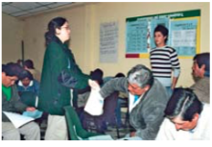
To select the person to be inspected, it is recommended to place five ballots marked with the number of each player (1, 2, 3, 4 and 5) in a dark bag. In each round, after the players have made their decision, they have delivered the decision card to the monitor, the monitor has announced the total of the group and have done the accounts, the moderator will invite a person of the group to extract a single ballot; then, the player with that number will be inspected. This should be repeated during the 10 rounds of the second part, so that in each round a player is chosen at random. Note that it is possible for the same player to be inspected in more than one round.

Example 1
Suppose that all the participants of the group chose to extract 6 units (it is marked in column A of the new account sheet). Then, the total extraction of the group is 30 (it is marked in column B of the new account sheet).

As in the first part of the game, we subtract the extraction level of each of the total extracted by the group. This results in 24 units (it is marked in column C of the new account sheet). Since the level of extraction was 6 and the total extracted by the other members of the group was 24, the gains for this round totaled 470 points (it is marked in column D of the new account sheet).

Until now, nothing has changed from the first part of the game. Suppose that for this example the player inspected was number 3. Observing the penalty points table, you must deduct 875 points because it was outside the norm of one, and that fine is noted in column E of your new green account sheet. Then, your earnings are counted in that round by subtracting the fine noted in column E of the gains in column D (470 - 875 = - 405 points), and this is what should be marked in column F.

Accounting Card

Date: __/__/__ Time:_____ Place: __________ Player Number:________

 | A | B | C | D | E | F
Round | My Extraction (1-8, my decision) | Total Extraction of the group (Moderator announces) | Extraction level of the rest (column A – B) | My Earnings (Before the regulation) | My Penalty in this Round | My Final Earnings in this Round (Column D – E)
1 | 6 | 30 | 24 | 470 | -875 | -405
2
3
4

Important:

In this example, the final earnings for this round result in negative earnings, this is possible in the game. It is necessary to clarify to the group that the penalty will only be applied to the inspected person.

Example 2

Suppose that one of the members of the group decides to extract 5 units while the rest of the group only extract one unit. The total extraction level of the group is 9 (they mark this in column B of the new account sheet).
For this example, we will make the accounts of the player who decided to extract 5 units. Since the level of extraction was 5 and the total extracted by the other members of the group was 4, the gains for this round totaled 856 points (it is marked in column D of the new account sheet).

Until now, nothing has changed regarding the first part of the game. Suppose that, for this example, the player who chose to extract 5 units will be inspected. According to the points table, you must deduct 700 points because it was out of the norm, and that fine is noted in column E of your new green account sheet.

Then, their earnings are counted in that round, for which the fine written in column E of the profits of column D is subtracted (856 - 700 = 156 points), and this figure is marked in column F.

Accounting Card

Date: __/__/__ Time:_____ Place: __________ Player Number:________

 | A | B | C | D | E | F
Round | My Extraction (1-8, my decision) | Total Extraction of the group (Moderator announces) | Extraction level of the rest (column A – B) | My Earnings (Before the regulation) | My Penalty in this Round | My Final Earnings in this Round (Column D – E)
1 | 5 | 9 | 4 | 856 | -700 | 156
2
3
4

Rule 3: Low External Regulation

For this rule, the exercise dynamic continues in the same way as in the first part of the game, but the moderator imposes an external penalty to one of the members of the group.

The Instructions that the Moderator should read are:

In addition to the rules described in the instructions that we have just explained, there is an additional rule for the participants of this group:
This new rule serves to obtain as many points as possible for the group. We will try to guarantee that each player chooses a level of extraction of one. If a player chooses more than one unit, a fine of 50 points will be applied for each extra unit drawn. However, as it is very difficult to inspect all the members of the group, we will randomly select only one person. Only those who are selected will show (only to the monitor) what decision they took, and they will apply the fine if this is the case.

As the rule indicates, the level of fine is in accordance with the level of extraction of each participant; the chosen player will have 50 points deducted for each additional unit extracted. The table of fines is as follows:

Table of Penalty Fees

Decision | 1 | 2 | 3 | 4 | 5 | 6 | 7 | 8
Fee | 0 | -50 | -100 | -150 | -200 | -250 | -300 | -350

Each participant must be given a copy of this table of fines, and in the enlarged examples the explanation is made. Along with the fines table, each participant will receive 10 decision cards and a new green account sheet.

To select the person to be inspected, it is recommended to place five ballots marked with the number of each player (1, 2, 3, 4 and 5) in a dark bag. In each round, after the players have made their decision, they have handed the decision card to the monitor, the latter has announced the group's total and they have made their accounts, the moderator will invite a person from the group to draw a single ballot. Then, the player with that number will be inspected. This must be repeated during the 10 rounds of this second part.

For this fine, a new account sheet is used, different from the one used in the first part of the exercise. In this case, the following examples should be presented for the whole group, using the extended examples (it is necessary to show these examples to the group so that all identify the fines and become familiar with their new account sheet):

Example 1
Suppose that all the members of the group chose to extract 5 units (it is marked in column A of the new account sheet); the total extraction of the group is 25 (it is marked in column B of the new account sheet).

As in the first part of the game, we subtract the extraction level of each one of the total extracted by the group; that results in 20 units (it is marked in column C of the new account sheet). Since the level of extraction was 5 and the total extracted by the other members of the group was 20, the gains for this round totaled 538 points (it is marked in column D of the new account sheet).

Until this moment nothing has changed regarding the first part of the game. Suppose that for this example the player inspected was the number 4. According to the points table, 200 points must be deducted because it was outside the norm; that fine is entered in column E of your new green account sheet.

Then, the player calculates the earnings for this round based on the penalty fee noted in Column E and the earnings prior to the fee in Column D (538 - 2 = 338 points), and this will be marked in column F. The rest of the players should mark 0 in column E (even if they extracted more than one unit, if they were not inspected they will not have a fee), and put the same as the earnings listed in column D into column F.

Accounting Card

Date: __/__/__ Time:_____ Place: __________ Player Number:________

 | A | B | C | D | E | F
Round | My Extraction (1-8, my decision) | Total Extraction of the group (Moderator announces) | Extraction level of the rest (column A – B) | My Earnings (Before the regulation) | My Penalty in this Round | My Final Earnings in this Round (Column D – E)
1 | 5 | 25 | 20 | 538 | -200 | 338
2
3
4

Example 2
Let's suppose that one of the members of the group decides to extract 7 units and the other 2 units. The total extraction of the group is 15 (it is marked in column B of the new account sheet).

For this example, we will make the accounts of the player who decided to extract 7 units. As the extraction level was 7 and the total extracted by the other members of the group was 8, the gains for this round add up to 798 points (it is marked in column D of the new account sheet).

Until now, nothing has changed regarding the first part of the game. Suppose that for this example the player who chose to extract 7 units will be inspected. Observing the points table, you must deduct 300 points because it was outside the norm (of 1). That fine is noted in column E of your new green account sheet.

Then, the player calculates the earnings for this round based on the penalty fee noted in Column E and the earnings prior to the fee in Column D (798 - 300 = 498 points), and this will be marked in column F.

Accounting Card

Date: __/__/__ Time:_____ Place: __________ Player Number:________

 | A | B | C | D | E | F
Round | My Extraction (1-8, my decision) | Total Extraction of the group (Moderator announces) | Extraction level of the rest (column A – B) | My Earnings (Before the regulation) | My Penalty in this Round | My Final Earnings in this Round (Column D – E)
1 | 7 | 15 | 8 | 798 | -300 | 489
2
3
4

Experimental Sequence (Steps)
- Introduce the field team
- Introduce the participants
- Explain the instructions
- Explain the experiment
- Give examples
- Explain the informed consent process
- Play the first part of the game (10 rounds)
- Play the second part of the game (10 rounds)
- Pay the participants
- Close the Session

VII. Capturing the Data Digitally

We will use the data from the examples given in the first part of the exercise and the data of the examples of the rule of high external regulation in the second part, together with other data to demonstrate this.

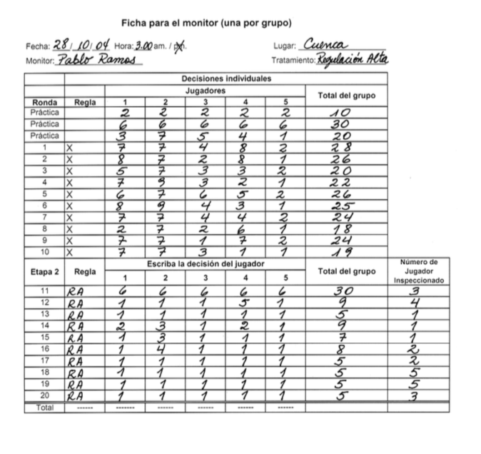

Example of how to translate the hand recorded data above into a digital format:

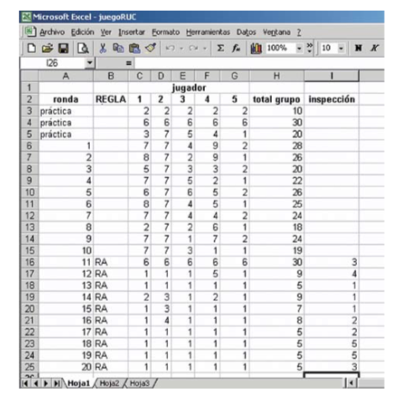

Analyzing the Data

For the baseline analysis (ie, the first 10 rounds, which are the same for all groups), the data from the first three rounds of practice are not used.

Average decision
Distribution
Frequency of each level of extraction

For each rule an analysis is made of decision averages, distribution and frequency, and the result is compared with the baseline data.

VIII. Presenting the Results

The data to be presented to the players are:
- The average decision per round in each part of the game, the differences between the baseline and each one of the rules
- The average payments to the players under each one of the rules

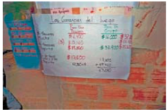

IX References
Cárdenas, J.C. (2004) Norms from Outside and from Inside: An Experimental Analysis on the Governance of Local Ecosystems. Forest Policy and Economics, 6: 229-241.
Cárdenas, J.C., J.K. Stranlund and C.E. Willis (2000) Local Environmental Control and Institutional Crowding-out. World Development 28(10): 1719-1733.
Hardin, G. (1968) The Tragedy of the Commons.. Science 162: 1245-1248.

X. Material to Photocopy

Game Card
Player Number | 1
Round Number
My level of extraction (from 1-8)
Game Card
Player Number | 2
Round Number
My level of extraction (from 1-8)
Game Card
Player Number | 3
Round Number
My level of extraction (from 1-8)
Game Card
Player Number | 4
Round Number
My level of extraction (from 1-8)
Game Card
Player Number | 5
Round Number
My level of extraction (from 1-8)

Date: __/__/__ Time:_____ Place: __________ Player Number:________
 | A | B | C | D
Round | My Extraction (1-8, my decision) | Total Extraction of the group (Moderator announces) | Extraction level of the rest (column A – B) | My Earnings (use the blue point table)
Practice
Practice
Practice
1
2
3
4
5
6
7
8
9
10
Total

Date: __/__/__ Time:_____ Place: __________ Player Number:________

 | A | B | C | D | E | F
Round | My Extraction (1-8, my decision) | Total Extraction of the group (Moderator announces) | Extraction level of the rest (column A – B) | My Earnings (Before the regulation) | My Penalty in this Round | My Final Earnings in this Round (Column D – E)
1
2
3
4
5
6
7
8
9
10
Total

Point Table

My level of Resource Extraction
Average
Total
The Level of others’ Extraction

Translated from Juan-Camilo Cardenas and Pablos Andres Ramos (2006) Manual de juegos economicos para el analisis del uso colectivo de los recursos naturales, Centro Internacional de la Papa https://economia.uniandes.edu.co/files/profesores/juan_camilo_cardenas/docs/Archivos%20para%20descargar/MANUAL_JUEGOS_CARDENAS_RAMOS.pdf

