Game of Trust

- The Problem

- Introduction
In the management of resources for community use, a very important factor for achieving good results is that trust exists among the people who join with the intention of conserving the resources. In water basins, the main intention would be to conserve water.
The game of trust serves to identify the levels of confidence and reciprocity between people who dedicate themselves to different activities, who are located in different parts of the river basin, or who have the same or different levels of economic income. The design of this game is inspired by the seminal article by Berg, Dickhaut and McCabe (1995), whose design has been replicated in different parts of the world, both in industrialized and developing countries (see Cardenas and Carpenter (2005) for a compilation of the applications of this game).

- Purpose of the Game

Identify the levels of trust and reciprocity between different actors in order to propose ways of negotiating conflict over the use of natural resources.

- Economic Model of Analysis

The trust game can also be explained from its extreme solutions: the social optimum of the game would be that player 1 will send all of his money to player 2, and that player 2, upon receiving this amount triples and adds his initial payment, and then returns to player 1 half of the total money.

Nash's strategy for this experiment is that player 1 does not send money to player 2, and therefore player 2 does not return anything to player 1.

II. Assembling the Game or Experiment

- Experimental Design
This is a one-round game in which each of the players has a single decision opportunity; It is played in pairs (player 1 and player 2). When the player is number 1, their trust is measured; and when it is number 2, the response to trust and their reciprocity is measured. It is suggested that the actors group together in order to obtain comparative data according to the characteristic to be analyzed (income, activity, location within the basin, etc.).

For the analysis of the results, it may be interesting to have some sociodemographic data of each player 1 and 2, for example age, sex, occupation, education, time living in that community.

- Sample Size (Suggested Minimum)

In order to have comparative results, the sample should have at least 40 players who can participate in groups for several sessions over several days.

- Session Design (N players, T round)
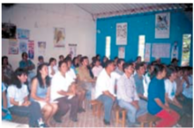
This exercise is done in pairs. The best thing would be to have data from a minimum of 20 pairs according to the characteristics that you want to analyze. Logically, with more data, statistically more robust conclusions can be derived.
In a basin in which the location of the actors is defined by the high, medium, and low parts, it would be interesting to analyze the trust between actors in the basin. It would be best to have variation in terms of who, dependent upon where they are from in the basin, is paired together. For example, 20 couples can be assigned for high-high, 20 couples of high-medium, 20 couples of high-low, 20 couples of medium- medium), 20 couples of medium-low, and 20 couples of low-low.

In another case, the objective might be to explore the type of productive system, for example, we could talk about farmers, ranchers and water users. In this case, it would be best to have 20 pairs of farmers-farmers, 20 pairs of farmers-ranchers, 20 pairs of farmers-users, 20 pairs of ranchers-ranchers, 20 pairs of ranchers-users, and 20 pairs of users-users.

In the same way it can be done between people who have different income levels; For example, you can establish two types of players: by high and low income, and form 40 pairs.
- Type of Participant

All kinds of people can participate in this game. In the case of watersheds, it would be key for groups of actors to engage in the same type of productive system, but this is not strict because equal levels of trust can be measured between residents of the same city and users of an aqueduct., etc.

- Estimating the Payment Incentives for Participants

The payments for this year are designed in Colombian pesos (one dollar = 2,200 pesos), but the payment table can be modified according to the local currency and the daily income in the area where the experiment is carried out.

III. Tools and Logistics

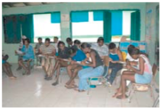
- Type of Place

The experiment must be carried out in a room that offers conditions
In which one can read the instructions to all the
group of participants, and then enable that half of the group stay there and the other half is accommodated in another room or stays outside, with the goal to not permit that one group knows what the other groups is doing. At the end, the whole group meets again in the same room.

- Field Team

For this game you need a moderator who is responsible for explaining the instructions of the exercise and an assistant that collects the formatted decision cards of the players.

The roles of the moderator are: Introduce the group, explain the purpose of the game and read the instructions, and divide the group into two sub-groups.

The roles of the assistant are: Help the moderator distribute and collect the decision cards of the players and monitor the time.

IV. Necessary Formats to Carry out the Game

- For explaining the Instructions

Once the participants know what the intentions of the study are and are organized in groups, the moderator must ensure that they know and understand the dynamics of the exercise. For this reason, it is important to have expanded/enlarged samples of the formats that will be given to each participant later. In these enlarged samples, the moderator will be able to write the examples, so that the players become familiar with the formats and the explanation is more useful.

For the facilitator's ease, we recommend that these samples be laminated, so that they can be written on with erasable markers in order to make different examples.

A | B | C | D | E | F | G | H | I
Quantity given to Player 1 | Quantity given to Player 2 | Quantity sent by Player 1 to Player 2 | Quantity saved by Player 1 | Quantity received by player 2 (C x 3) | Total Quantity of Player 2 (B + E) | Quantity returned by Player 2 | Final Earnings of Player 1 (D + G) | Final Earnings of Player 2 (F – G)

- For Each Pair of Players

Format of Decisions and Results
Pair Number______

(Each pair that participate in the game should fill in a format card)

Place: ____________ Date (mo/day/yr)___/___/___ Start Time: __:___am/pm

A | B | C | D | E | F | G | H | I
Quantity given to Player 1 | Quantity given to Player 2 | Quantity sent by Player 1 to Player 2 | Quantity saved by Player 1 | Quantity received by player 2 (C x 3) | Total Quantity of Player 2 (B + E) | Quantity returned by Player 2 | Final Earnings of Player 1 (D + G) | Final Earnings of Player 2 (F – G)

Total payment for player 1:__________
Total payment for player 2:__________

- More Information for the Facilitators

For the Moderator

Instructions for giving the Introduction:
The following exercise is a different and entertaining way to participate actively in a study about people's economic decisions. According to the decisions you make today, you can earn an amount of money or prizes; that is why it is important that you pay close attention to these instructions.

You may wonder why money is used in these exercises. Money is used because the exercise requires people to make economic decisions; that is to say, that they are decisions with consequences for the pocket, as it happens in the reality. At no time is money expected to be a payment for participating in the study nor the only reason to participate.

Instructions for Explaining the Game:
This exercise is done in pairs. Each pair has a player 1 and a player 2. Each of you will play with one of the people present in this room (remember the group the criteria with which people were selected, for example: farmers, ranchers, water users, etc.).
The player number for each participant (1 or 2) will be assigned randomly by us. It is important that each participant memorize their player number and the type of player they will participate with (for example, to know if the other person is a farmer, a rancher, etc.).

None of you will know who you are playing with; only the moderator knows who is playing with whom and will never say it.

The game is very simple: to start, $ 8,000 will be allocated to player 1 and $ 8,000 to player 2. Then, player 1 will have the opportunity to send a part of his $ 8,000 to player 2. He can send $ 8,000, $ 7,000. $ 6,000, $ 5,000, $ 4,000, $ 3,000, $ 2,000, $ 1,000 or nothing. Any amount that player 1 decides to assign to player 2 will be tripled by the monitor before passing it to the player. Player 2 will then have the option to return to Player 1 a portion of that tripled amount and the money they received.

Now, we are going to see some examples in a group (for this we must use the enlarged samples of the decision formats, when an example is shown, it should be evident the amount that is sent and the result of the triplication).

- Suppose player 1 sends $ 8,000 to player 2. That amount is tripled, and then player 2 receives $ 24,000 (three times $ 8,000 = $ 24,000), in addition to the $ 8,000 they already had. At this point, the player 1 has nothing and the player 2 has $ 32,000. Then, player 2 must decide how much they want to return to player 1. Suppose player 2 decides to return $ 6,000 to player 1. At the end of the game, player 1 will take $ 6,000 and player 2, $ 26,000.

A | B | C | D | E | F | G | H | I
Quantity given to Player 1 | Quantity given to Player 2 | Quantity sent by Player 1 to Player 2 | Quantity saved by Player 1 | Quantity received by player 2 (C x 3) | Total Quantity of Player 2 (B + E) | Quantity returned by Player 2 | Final Earnings of Player 1 (D + G) | Final Earnings of Player 2 (F – G)
8 | 8 | 8 | 0 | 24 | 32 | 6 | 6 | 26

- Suppose that player 1 gives nothing to player 2. There is no amount to triple. The player 2 decides not to return money to player 1 and the game ends here. Player 1 will take $ 8,000 and player 2 will also take $ 8,000.

A | B | C | D | E | F | G | H | I
Quantity given to Player 1 | Quantity given to Player 2 | Quantity sent by Player 1 to Player 2 | Quantity saved by Player 1 | Quantity received by player 2 (C x 3) | Total Quantity of Player 2 (B + E) | Quantity returned by Player 2 | Final Earnings of Player 1 (D + G) | Final Earnings of Player 2 (F – G)
8 | 8 | 0 | 8 | 0 | 8 | 0 | 8 | 8

- Let's suppose that player 1 sends $ 1,000 to player 2. This amount will be multiplied and, then player 2 will receive $ 3,000 (three times $ 1,000 is equal to $ 3,000), in addition to the $ 8,000 they already had. At this point, player 1 has $ 7,000 and player 2 has $ 11,000. Then, player 2 must decide how much they want to return to player 1. Suppose player 2 decides to return $ 2,000 to player 1. At the end of the game, player 1 will take $ 9,000 and player 2, $ 9,000.

A | B | C | D | E | F | G | H | I
Quantity given to Player 1 | Quantity given to Player 2 | Quantity sent by Player 1 to Player 2 | Quantity saved by Player 1 | Quantity received by player 2 (C x 3) | Total Quantity of Player 2 (B + E) | Quantity returned by Player 2 | Final Earnings of Player 1 (D + G) | Final Earnings of Player 2 (F – G)
8 | 8 | 1 | 7 | 3 | 11 | 2 | 9 | 9

- Suppose that player 1 sends $ 2,000 to player 2. If this amount is tripled, player 2 receives $ 6,000 (three times $ 2,000 equal $ 6,000), in addition to the $ 8,000 they already had. At this point, player 1 has $ 6,000 and player 2 has $ 14,000. Then, the player must decide how much they want to return to player 1. Suppose player 2 decides to return $ 3,000 to player 1. At the end of the game, player 1 will take $9,000 and player 2, $ 11,000.

A | B | C | D | E | F | G | H | I
Quantity given to Player 1 | Quantity given to Player 2 | Quantity sent by Player 1 to Player 2 | Quantity saved by Player 1 | Quantity received by player 2 (C x 3) | Total Quantity of Player 2 (B + E) | Quantity returned by Player 2 | Final Earnings of Player 1 (D + G) | Final Earnings of Player 2 (F – G)
8 | 8 | 2 | 6 | 6 | 14 | 3 | 9 | 11

- Imagine that player 1 sends $ 7,000 to player 2. If you triple this amount, then player 2 will receive $ 21,000 (three times $ 7,000 equals $ 21,000), in addition to the $8,000 they already had. At this point, player 1 has $ 1,000 and player 2 has $29,000. Then player 2 must decide how much they want to return to player 1. Suppose player 2 decides to return $ 14,000 to player 1. At the end of the game, player 1 will take $ 15,000 and player 2 will also take $15,000 .

A | B | C | D | E | F | G | H | I
Quantity given to Player 1 | Quantity given to Player 2 | Quantity sent by Player 1 to Player 2 | Quantity saved by Player 1 | Quantity received by player 2 (C x 3) | Total Quantity of Player 2 (B + E) | Quantity returned by Player 2 | Final Earnings of Player 1 (D + G) | Final Earnings of Player 2 (F – G)
8 | 8 | 7 | 1 | 21 | 29 | 14 | 15 | 15

Note that the higher the amount that player 1 gives to player 2, the higher the amount that will triple and pass to the player 2. It is an autonomous decision of the player 1 in terms of how much they want to send, and of player 2 in regard to what amount you want to return to player 1. Player 1 could end up with more than $ 8,000 or less than $ 8,000 as a result.

Assigning Numbers to the Players
At this time, all people have understood the instructions and their options during the game; The moderator must assign who will be the number 1 players and who will be the number 2 players. For this we will take the following example:

The group consists of 40 people: 20 are farmers located in the upper part of the basin and 20 are farmers located in the lower-middle part of the basin. It is recommended that 10 farmers be players number 1 and play with 10 farmers who are number 2, and that 10 farmers are number 1 and play with 10 farmers who are number 2.

The decision on how to organize the players 1 and 2 depends on the intent of the study. It is also suggested to have several game sessions to guarantee the number of the player assigned to each person. That is, you can play with the same group of 40 people, but in two sessions of 20; In the first session, the 10 farmers will be number 1 players, and in the second session, 10 farmers will be number 2 players.

Informed Consent

It is necessary that you, as participants, review and sign the acceptance or informed consent form. In this sheet, we assure you that we will manage all the information collected in the exercises in a confidential manner; In addition, we point out that participating in these exercises does not present any risk. You signature signifies that you are aware of and have accepted the project and the exercises that will be carried out [read the informed consent form to the whole group, aloud].

If you agree to participate, please fill in your acceptance form, and do not forget to write your player number on it.

For the monitor

Sheet on which to register the decisions of players

The Trust Game
Date:___________ Place:____________ Time: _____________ Monitor: _________

Pair | Player 1 Code | Player 2 Code | Quantity sent by Player 1 to Player 2 | Quantity saved by Player 1 | Quantity received by player 2 | Total Quantity of Player 2 | Quantity returned by Player 2 | Final Earnings of Player 1 | Final Earnings of Player 2

Examples:
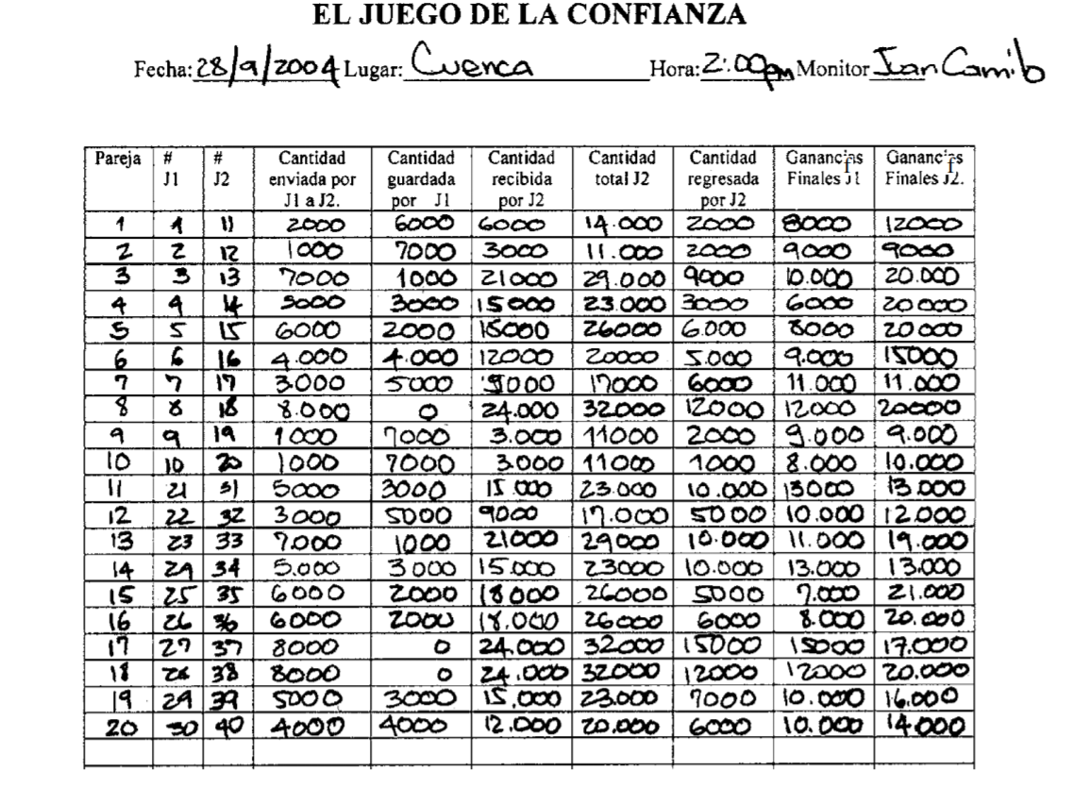
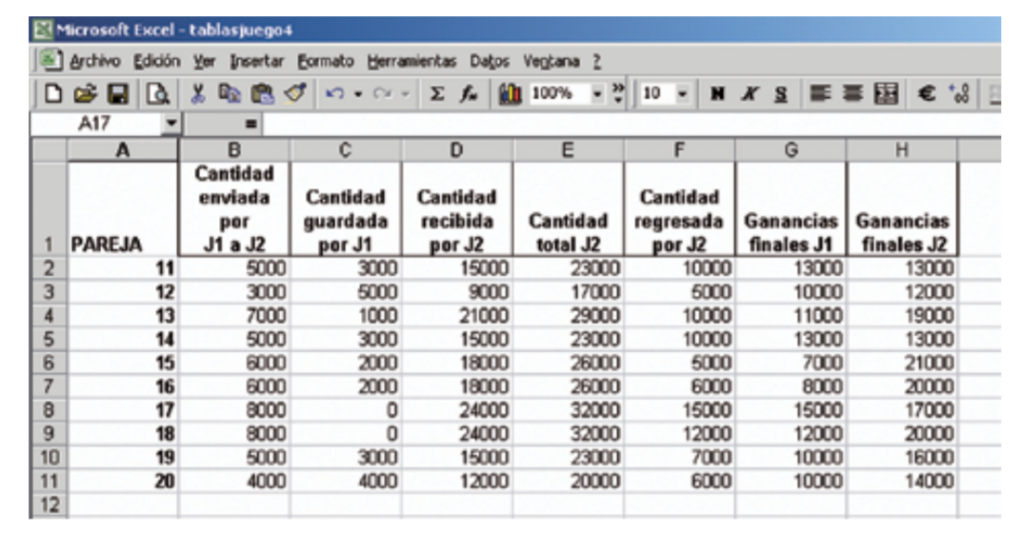
V. Data Analysis

The data analyzed are the following:

- For the group total:
  - Average amount of money sent by player 1 to player 2
Sum of all player 1 submissions divided by 20: 4.750.
  - Average amount of money sent by player 2 to player 1
Sum of all player 2 submissions divided by 20: 6.700.
  - Average player 1 earnings
Sum of the winnings of player 1 divided by 20: 9.950.
  - Average player 2 earnings
Sum of the winnings of player 2 divided by 20: 15.500

- For the first part: 10 agriculture producers as players 1 and 10 ranchers as players 2
  - Average amount of money sent by player 1 to player 2
Sum of all player 1 submissions divided by 10: 3.800.
  - Average amount of money sent by player 2 to player 1
Sum of all player 2 submissions divided by 10: 4.800.
  - Average player 1 earnings
Sum of the winnings of player 1 divided by 10: 9.000.
  - Average player 2 earnings
Sum of the winnings of player 2 divided by 10: 14.600

- For the second part: 10 ranchers as players 1 and 10 agriculture producers as players 2
  - Average amount of money sent by player 1 to player 2
Sum of all player 1 submissions divided by 10: 5.700.
  - Average amount of money sent by player 2 to player 1
Sum of all player 2 submissions divided by 10: 8.600.
  - Average player 1 earnings
Sum of the winnings of player 1 divided by 10: 10.900.
  - Average player 2 earnings
Sum of the winnings of player 2 divided by 10: 16.500

VI. Presentation of the Results

Type of data to present to the whole group:

-Average decisions (how much to send, how much to return)
-Average payments (for each player)
-Difference between the decisions of sending and returning money
-Trust

VII. Material to Photocopy

-Card formatted to record decisions and results (one for each pair)
-Registration sheet for the monitor

Format of Decisions and Results
Pair Number______(Codes: Player 1 ___, Player 1 ___)

(Each pair that participate in the game should fill in a format card)

Place: ____________ Date (mo/day/yr)___/___/___ Start Time: __:___am/pm

A | B | C | D | E | F | G | H | I
Quantity given to Player 1 | Quantity given to Player 2 | Quantity sent by Player 1 to Player 2 | Quantity saved by Player 1 | Quantity received by player 2 (C x 3) | Total Quantity of Player 2 (B + E) | Quantity returned by Player 2 | Final Earnings of Player 1 (D + G) | Final Earnings of Player 2 (F – G)

Total payment for player 1:__________
Total payment for player 2:__________

The Trust Game
Date:___________ Place:____________ Time: _____________ Monitor: _________

Pair | Player 1 Code | Player 2 Code | Quantity sent by Player 1 to Player 2 | Quantity saved by Player 1 | Quantity received by player 2 | Total Quantity of Player 2 | Quantity returned by Player 2 | Final Earnings of Player 1 | Final Earnings of Player 2

Translated from Juan-Camilo Cardenas and Pablos Andres Ramos (2006) Manual de juegos economicos para el analisis del uso colectivo de los recursos naturales, Centro Internacional de la Papa https://economia.uniandes.edu.co/files/profesores/juan_camilo_cardenas/docs/Archivos%20para%20descargar/MANUAL_JUEGOS_CARDENAS_RAMOS.pdf

