The Potato Market Game

I. The Problem Context

- Introduction

The economic environment in which contemporary social agents move is mediated, on multiple occasions, by markets in which producers and buyers meet to exchange agricultural and livestock products. In these markets, buyers pay a price to producers that come to sell their crops. Producers try to obtain a price that surpasses their production costs and buyers will try to pay a price below the real value of the good that they are buying - and that is the maximum that they are willing to pay. For example, buyers might be wholesalers who buy from producers and then resell the product in the retail market at a higher price in order to obtain a profit from their activity as intermediaries.

If this market sustains the minimum conditions of one that is fair and competitive (for example, it has a sufficiently large number of buyers and sellers, transaction costs and the ability to obtain information about possible prices and offers), we can expect that its "Invisible hand" is in charge - in a way not planned by the free play of individual interests - to produce social welfare. Social welfare is defined as a context in which the average equilibrium price and the average quantity of production are those produced at the crossroads between supply and demand for that good.

This experiment is designed to demonstrate, in a simplified manner, that the social interest of a market that generates social welfare can result from the interaction of agents that are motivated by their own individual interests.

- Purpose of the game

The intention of this game is for the participants to recognize the concept of competitive markets and its effect within the social equilibrium, the achievement of this balance (social science), and the result of the balance. The experiment demonstrates that, within certain conditions and without the need for any intervention by a planner or regulator, it is possible to replicate the socially efficient result produced by an equilibrium market.

The participants will make decisions – some as buyers and some as producers – and they will be able to observe how the interaction through the market produces results that maximize the wellbeing of the collective as a result of the fact that each player is trying to maximize their private/individual wellbeing.

- Economic Model of Analysis

The essential theory that supports the argument of the market institution is based on the fact that a set of producers of a good -in this case, for example, an agricultural product such as potatoes or corn- have production costs that vary due to the heterogeneity of their lands, the productivity of their labor, or their working capital. Some producers can produce a sack of a particular good at a lower production cost than others. Together, these producers make up the supply, and that supply can be expressed as a curve that grows from the most efficient producers (those who produce the cheapest) to the least efficient (those who have higher production costs). In a graph in which the vertical axis represents prices and costs and the horizontal axis the quantities produced, we have, then, the classic supply curve that grows as more units of that good are produced, and in which the last units are the most expensive to produce.

On the other hand, we have a group of buyers who are interested in acquiring this product, either a) because they are going to consume it directly (and therefore value it) and are willing to pay a certain amount of money for one unit of it or b) because they are wholesalers who buy from producers and then resell at higher prices to obtain a net profit. Those who place a higher value on a single unit of that good -for example, a sack of corn- will be willing to pay more for the first unit, and as we move forward from the buyers who are more interested or who value the product more towards those who value it less, we obtain the demand curve, which is conventionally decreasing the quantity demanded. As a unit is added to the market, the value that someone is willing to pay for that additional unit is proportionally less than the value of the previous one.

These two curves, of supply (increasing) and of demand (decreasing), eventually intersect at a point that we call the equilibrium point of the market. According to the logic from which it is determined that this is the point at which that market must operate in equilibrium -that is, with no inclinations to leave it- is that any transaction attempt of a buyer or seller outside of that point may be "inefficient," in the sense that someone would be leaving money at the table. At that point, all the players are negotiating at the best price that they can, given the competition. Any buyer A who would like to purchase the product below that price to obtain a higher profit will find an additional B buyer who would offer that producer the equilibrium price, for which the producer would prefer the second offer instead of the Initial offer of A. Similarly, if a producer P wanted to sell at a price higher than the equilibrium price, it would be faced by market competition from another producer Q that could sell at the equilibrium price which is preferred by the potential buyer.

These predictions can be seen in the supply and demand curves shown in the following figure. The numerical example will be the same one that we will use in the experimental design in which 20 producers and 20 buyers interact with the ability to negotiate up to two units each. In this example, it is predicted that with these supply and demand curves, no more than 32 units should be negotiated -although the potential supply is 40 units-. Likewise, it is predicted that the average equilibrium price should be $ 29,000 per sack, even though in this market there are buyers who would be willing to pay more than $ 33,000 and producers who could sell a sack less than $ 25,000. However, the perfect competition of this market says that when negotiating all will become $ 29,000 per unit, a balance from which no one is incentivized to deviate. And, at that point, according to economic theory, the benefits of society are maximized, by producing the maximum of what is called the surplus of the producers and the surplus of the consumers.
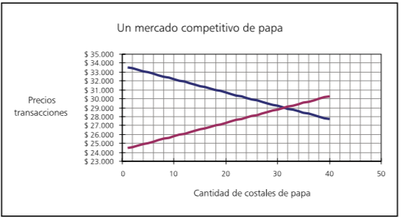
A Competitive Potato Market
Transaction Prices
Quantity of Potato Sacks

II. Game Assembly or Experiment

A. Experimental Design

Potato Market
40 players = 20 producers + 20 buyers
 |  | Demand ($) | Offer ($) | Income ($) | Income ($)
Player | Sacks | Willingness to pay (WTP) | Production Costs (PC) | Buy | Sell
20 | 1 | 33.550 | 24.450 | 4,550 | 4,550
19 | 2 | 33.400 | 24.600 | 4,400 | 4,400
18 | 3 | 33.250 | 24.750 | 4,250 | 4,250
17 | 4 | 33.100 | 24.900 | 4,100 | 4,100
16 | 5 | 32.950 | 25.050 | 3,950 | 3,950
15 | 6 | 32.800 | 25.200 | 3,800 | 3,800
14 | 7 | 32.650 | 25.350 | 3,650 | 3,650
13 | 8 | 32.500 | 25.500 | 3,500 | 3,500
12 | 9 | 32.350 | 25.650 | 3,350 | 3,350
11 | 0 | 32.200 | 25.800 | 3,200 | 3,200
10 | 11 | 32.050 | 25.950 | 3,050 | 3,050
9 | 12 | 31.900 | 26.100 | 2,900 | 2,900
8 | 13 | 31.750 | 26.250 | 2,750 | 2,750
7 | 14 | 31.600 | 26.400 | 2,600 | 2,600
6 | 15 | 31.450 | 26.550 | 2,450 | 2,450
5 | 16 | 31.300 | 26.700 | 2,300 | 2,300
4 | 17 | 31.150 | 26.850 | 2,150 | 2,150
3 | 18 | 31.000 | 27.000 | 2,000 | 2,000
2 | 19 | 30.850 | 27.150 | 1,850 | 1,850
1 | 20 | 30.700 | 27.300 | 1,700 | 1,700
1 | 21 | 30.550 | 27.450 | 1,550 | 1,550
2 | 22 | 30.400 | 27.600 | 1,400 | 1,400
3 | 23 | 30.250 | 27.750 | 1,250 | 1,250
4 | 24 | 30.100 | 27.900 | 1,100 | 1,100
5 | 25 | 29.950 | 28.050 | 950 | 950
6 | 26 | 29.800 | 28.200 | 800 | 800
7 | 27 | 29.650 | 28.350 | 650 | 650
8 | 28 | 29.500 | 28.500 | 500 | 500
9 | 29 | 29.350 | 28.650 | 350 | 350
10 | 30 | 29.200 | 28.800 | 200 | 200
11 | 31 | 29.050 | 28.950 | 50 | 50
12 | 32 | 28.900 | 29.100 | -100 | -100
13 | 33 | 28.750 | 29.250 | -250 | -250
14 | 34 | 28.600 | 29.400 | -400 | -400
15 | 35 | 28.450 | 29.550 | -550 | -550
16 | 36 | 28.300 | 29.700 | -700 | -700
17 | 37 | 28.150 | 29.850 | -850 | -850
18 | 38 | 28.000 | 30.000 | -1,000 | -1,000
19 | 39 | 27.850 | 30.150 | -1,150 | -1,150
20 | 40 | 27.700 | 30.300 | -1,300 | -1,300

The values ​​that are within the columns called Buy and Sell are the net gains expected by buyers and sellers if negotiated at the equilibrium price of the game ($ 29,000). These earnings are decreasing from top to bottom until they are negative, and it is at this point that it is expected that no further transactions will take place.
This table contains the information to be able to assign the values ​​that each player will have at the beginning of the game. The first column contains the number of players, both for buyers (Demand column or WTOP) and for sellers (Offer or PC column). The player numbers have been assigned with the purpose of distributing equally the possible rents gained through purchase or sale between the participants, once the transactions are established around the equilibrium price.

Provided are some examples to illustrate the construction of the table and the assignment of values ​​to the players. For example, let's take player number 17 of the buyers. According to the table, this buyer 17 will be able to resell a unit for up to $ 33,100 and the next unit for $ 28,150. If the equilibrium price is $ 29,000 according to the balance between supply and demand, it means that this buyer will be able to make a profit of $ 4,100 with the first unit but it would not be profitable to buy the second unit at $ 29,000, since they would lose money at a resell price of $ 28,150.
Now let's examine the case of vendor number 17. The first unit has a production cost of $ 24,900 and one can make a profit by selling it at the equilibrium price. But the second unit has a production cost of $ 29,850, and therefore it would be a bad strategy to produce it and sell it at a loss with that equilibrium price.

B. Sample Size (suggested minimum)

The design presented here has 40 players who must be randomly divided into two equal groups of buyers and sellers/producers. If the number of participants is smaller, the way in which the game adapts is very simple: players shown in the previous table must be eliminated from player number 20 downwards; that is, the first and last ones will be eliminated until the number of players present is reached.
It is suggested that the game is played with at least 20 players (10 buyers and 10 producers), for which the previous table is substantially reduced. However, with fewer players, additional changes must be made to the table. Note that for 10 buyers and 10 sellers, the curves will even intersect one or two units after the potential 0 units. One option to reduce the number of players is to increase the slope of the curves, that is, to make it such that the production costs in the previous table will go up at a higher rate and that the resale prices of buyers will decrease at a higher rate.

C. Session Design (N Players, T Rounds)
It is necessary that each group consist of an even number of players (maximum 40 people), so that half (20) are buyers and the other half (20) producers. The game consists of 10 rounds, but you can play fewer or more rounds, dependent upon the time constraints.
In our example, the game consists of 10 rounds or market days, in which each player and buyer must sell or buy up to two bags of potatoes, producers with a minimum sale price according to production costs and prices and buyers with a maximum purchase price determined by the value at which they sell each potato sack to the retailers.
Time: the time for each round (each market day) must be five minutes. The moderator is in charge of announcing the round that is being played - "The first day of the market opens" - and announcing in advance the end of the round - "There is one minute to close the second day of the market" -.

D. Type of Participants

All kinds of people can participate in this game; in the case of watersheds, better results would be obtained if persons dedicated to the same type of production system were to play, but this is not a strict rule.

E. Estimation of the Pay Incentive for Participants

Table of points established on the basis of the total winnings, according to the maximum possible gain for a player.

Virtual $ | Possible Payment in US Dollars
60,000-70,000 | 15
50,000-59,999 | 14
40,000-49,999 | 13
30,000-39,999 | 11
20,000-29,999 | 9
10,000-19,999 | 7
0-9,999 | 5

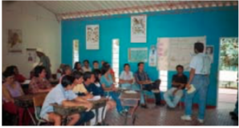
III. Tools, Logistics

A. Room Layout

The experiment must be carried out in a room that offers an environment in which the participants can move freely in order to be able to look for someone to negotiate with.

B. Field Team
For this game you need a moderator to explain the instructions of the exercise and an assistant to help answer the questions of the group in addition to coordinate the times between each round.

The roles of the moderator are:
Show and explain to the group the purpose and operation of the game and answer any questions that the players have.

The roles of the assistant are:

Help the moderator with distributing things when needed as well as moderate the time.

IV. Necessary Formats to Carry out the Game

A. For the Explanation of the Game Instructions
Once the group of participants knows the objectives of the study and it is divided between producers and buyers, the dynamics of the exercise should be explained. For this reason, it is important to have large samples of the formats that will be used later in the game. In these enlarged samples, the moderator will be able to write some examples so that the players become familiar with the formats and the explanation makes more sense.

For the facilitator's ease, we recommend that these samples be laminated (for example, adhesive contact paper) and in this way they can write on them with erasable markers, which will allow the facilitator to show multiple, different examples.
Format of the Contract

Number of the day of the Market:
Buyer Code:
Producer Code:
Agreed Price: $

Format for the Producers

 | Round | 1 | 2 | 3 | 4 | 5 | 6 | 7 | 8 | 9 | 10
First Sack of Potatoes | Retail price that you negotiated
 | Your cost of production
 | A) Net Gain (value – cost)
Second Sack of Potatoes | Retail price that you negotiated
 | Your cost of production
 | B) Net Gain (value – cost)
Earnings for round (A + B) :
Total Earnings:

Format for the Buyers

 | Round | 1 | 2 | 3 | 4 | 5 | 6 | 7 | 8 | 9 | 10
First Sack of Potatoes | Price of Resell (value for yourself)
 | Price paid for the potatoes (cost for yourself)
 | A) Net Gain (value – cost)
Second Sack of Potatoes | Price of Resell (value for yourself)
 | Price paid for the potatoes (cost for yourself)
 | B) Net Gain (value – cost)
Earnings for round (A + B) :
Total Earnings:

B. For those in charge of Facilitating the Game

For the Moderator

Introduction

Thank you for being here. [Greeting and presentation of the group in charge. If necessary, talk about the general objective of the research and the funding agency, the general project, the working time, the relevance of the study, etc.].
The following exercise is a different and entertaining way to actively participate in a study about people's economic decisions. In accordance with the decisions you make today, you can earn an amount of money or prizes; thus, it is important that you pay close attention to these instructions.
You may wonder why money is used in these exercises. Money is used because the exercise requires people to make economic decisions; that is to say, that they are decisions with consequences for the wallet, as happens in the reality. At no time is money expected to be a payment for participating in the study, nor is it the only reason for participating.

Explanation of the Game
In this exercise, we will simulate 10 market days in which producers and buyers of potatoes must negotiate with each other in order to generate surpluses. In each market round (one round is one day) you can negotiate a maximum of two (2) sacks of potatoes per person. Each sack has a price of production or resale.
In the case of producers, each sack produced has a cost. The producer can sell his produce in the market to wholesalers. Profits are equal to the difference between the price at which you sell each bag and your production costs (the data explaining the production costs for each bag will be given to each producer).
In the case of buyers, each bag has a resale price (the buyers are wholesalers, so their job is to buy at a price and sell at a higher price). Your earnings are equal to the difference between your resale value (the resale value data for each bag is delivered to each buyer) and what you pay in the market for each bag.
(It may happen that in certain rounds some of you do not buy or sell potatoes. That is also allowed within the game.)
After randomly selecting who will be the sellers and who the buyers, we will open the market every week to negotiate the potato. When two people agree on a price, they will fill out a contract form and deliver it to the moderator.

Give the Game Materials to the Participants

As we said, we will play 10 rounds. Each round is equivalent to a market day, and during each market day each person can buy/sell up to two bags; At the end you must calculate your profits.

Contract cards: On each of these cards you must enter the market number that is announced by the monitor, the buyer's code, and the seller's code. Ten cards will be given to each person, and when each round ends, each pair will deliver a contract card [During the reading of this part, the moderator must indicate the boxes in the enlarged sample].
Personal account sheets: There are two types of account sheets, one for producers and another for marketers.

Producers must enter the sale price which they negotiated, the cost of production (given by the moderator) and the net profit (which is the subtraction of the sale price to which they negotiated minus the cost of production).

Marketers should note the resale price (the value at which they would sell the sack to the retailers) and the price paid to the producers. Thus, they take out the net profit, which is the value at which they will sell each bag and the price paid for it.

[The monitor should deliver one producer sheet per person to the middle of the group and one buyer sheet per person to the other half. Keep in mind that the number of players in the group must be even and not greater than 40: 20 producers and 20 buyers].

[The group of buyers will be numbered from 1 onwards, and each player will mark his account sheet; the same for the producer group].

Value Cards: Each of the players will be given the card with which they can market each sack in each round. The card for the producers indicates the cost of production and the card of the buyers indicates the sale price of each bag. It is important that the information on this card be private.

Example:
We are going to give the example of a market day for a producer and a buyer. Suppose that a producer costs the bag costing $ 27.150 and that the maximum selling price for the buyer is $ 29.650; After a long negotiation, they manage to agree a price of $ 28.458, fill a contract card and deliver it to the moderator. The account sheets were left like this [this example is presented on the enlarged samples for the whole group]:

Format for the Producers

 | Round | 1 | 2 | 3 | 4 | 5 | 6 | 7 | 8 | 9 | 10
First Sack of Potatoes | Retail price that you negotiated | 28.458
 | Your cost of production | 27.150
 | A) Net Gain (value – cost) | 1.308
Second Sack of Potatoes | Retail price that you negotiated
 | Your cost of production
 | B) Net Gain (value – cost)
Earnings for round (A + B) :
Total Earnings:

Format for the Buyers

 | Round | 1 | 2 | 3 | 4 | 5 | 6 | 7 | 8 | 9 | 10
First Sack of Potatoes | Price of Resell (value for yourself) | 29.650
 | Price paid for the potatoes (cost for yourself) | 28.458
 | A) Net Gain (value – cost) | 1.192
Second Sack of Potatoes | Price of Resell (value for yourself)
 | Price paid for the potatoes (cost for yourself)
 | B) Net Gain (value – cost)
Earnings for round (A + B) :
Total Earnings:

At this time the moderator will provide space for the questions that are generated within the groups and will proceed to read the informed consent.

End of instructions
Frequently asked questions:

Can I buy and/or sell the two sacks of potatoes to the same person?
Of course, you can make the transaction of each sack with any person. The important thing is that for each transacted bag you fill a contract card.

Should I buy-sell every sack of potatoes for the price the card says?
Yes, each of the sacks has a price for you. The order in which they are sold does not matter, but if you sell the two sacks, you must negotiate with the two values ​​that are written on the card.

Can I buy-sell the two sacks of potatoes to different people?
Yes, you can make your transaction with anyone.

If I do not want to buy-sell one or both sacks, can I do it?
Yes, you can pass a round in which you do not make any transaction.

Informed Consent
It is necessary that you, as participants, review and sign the acceptance or informed consent form. In this sheet, we assure you that we will manage all the information collected in the exercises in a confidential manner; In addition, we point out that participating in these exercises does not present any risk. You signature signifies that you are aware of and have accepted the project and the exercises that will be carried out [read the informed consent form to the whole group, aloud]. If you agree to participate, please fill in your acceptance form, and do not forget to write your player number on it.

For the Monitor

Sheet to register the decisions of players for each round

Competitive Potato Market
Sheet for the monitor (to register all of the agreed contracts for each day, noting the price)
Date:_________________ Place:_____________________
UNITS | Day 1 | Day 2 | Day 3 | Day 4 | Day 5 | Day 6 | Day 7 | Day 8 | Day 9 | Day 10
1
2
3
4
5
6
7
8
9
10
11
12
13
14
15
16
17
18
19
20
Total Units Traded
Average Price

Sequence of the Experiment
- Introductions of the Field Team/Facilitators
- Introductions of the Participants
- Instructions Lecture
- Explanation of the Experiment
- Examples
- Play the Game (10 Rounds of 5 minutes each)
- Payment to the participants
- Comments

Examples
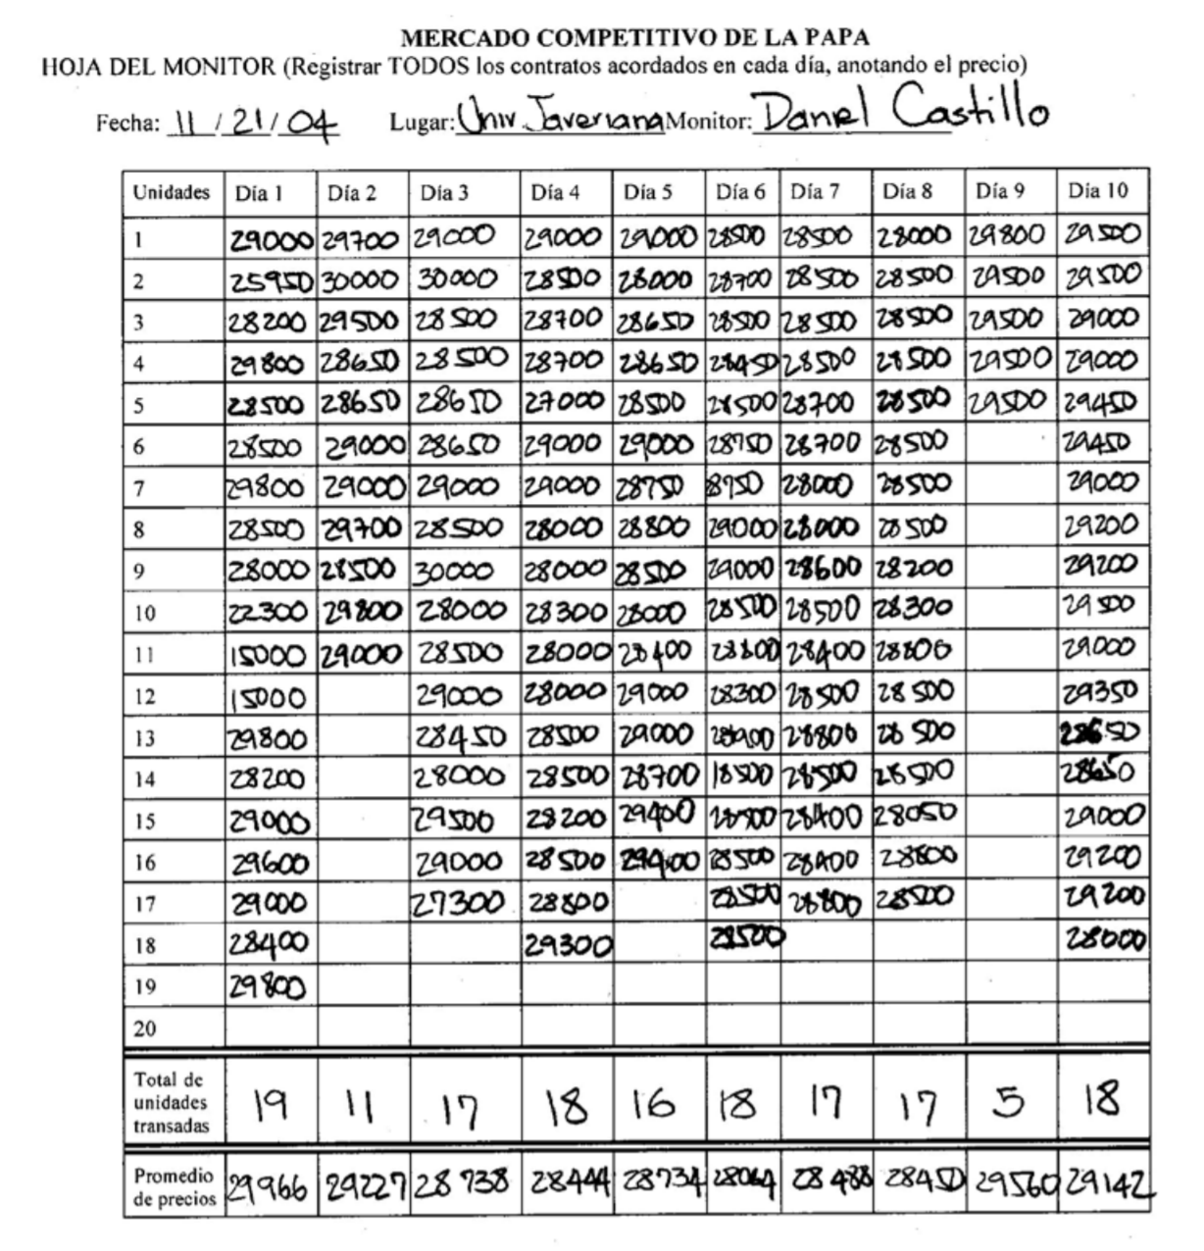

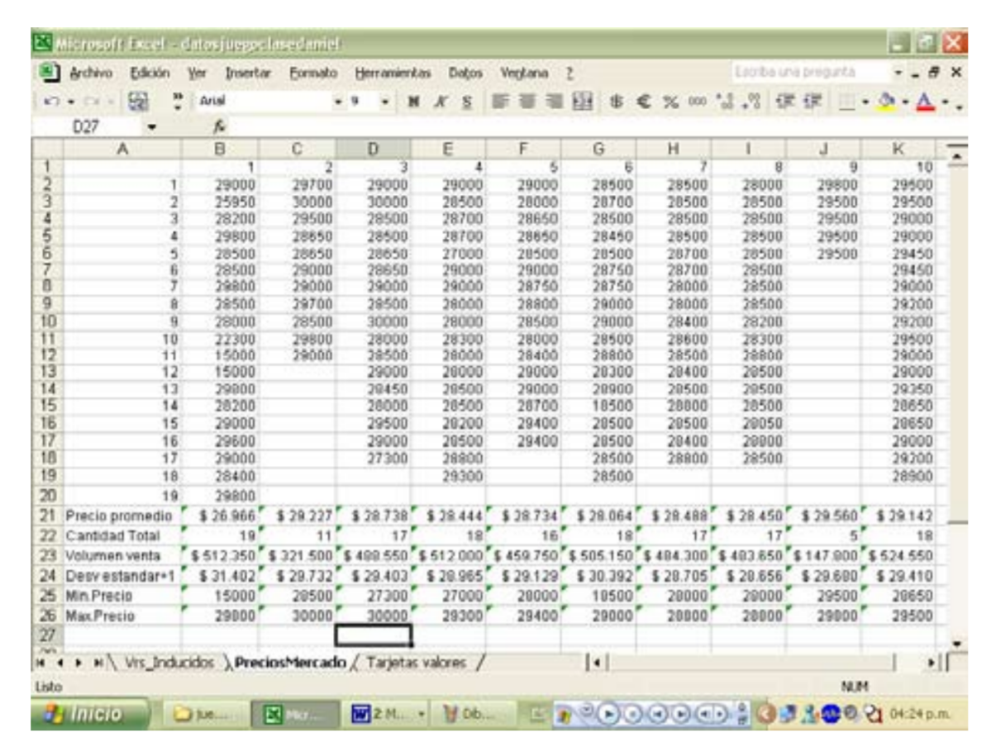
V. Presentation of the Results
The data to present to the group are:
- Quantity of potato sacks negotiated each round
- Average price per round

VI. Materials to Photocopy
The material to be photocopied is:
- Account sheet for producers (on green paper)
- Account sheet for buyers (on green paper)
- Contract cards (on yellow paper)

Value cards [each card is marked with the transaction price per bag for producers and buyers; the values ​​of these cards should only be known by each player].

Potato Market Producer Code______
Personal account sheet (please return this page at the end of the exercise).
You are a potato producer. Each potato sack you produce has a cost to you, and you can sell it in the market to wholesale buyers. In each day (round) of the market you can sell up to two bags, according to the prices they offer and their costs. Your profits are equal to the difference between the price you sell each bag and your production costs. If you produce a bag at $ Z and the price you receive in the market is $ W, your net profit for that bag will be $ (W - Z). Use the following table to record what price you sold, and calculate your profits for each sack sold.
 | Round | 1 | 2 | 3 | 4 | 5 | 6 | 7 | 8 | 9 | 10
First Sack of Potatoes | Retail price that you negotiated
 | Your cost of production
 | A) Net Gain (value – cost)
Second Sack of Potatoes | Retail price that you negotiated
 | Your cost of production
 | B) Net Gain (value – cost)
Earnings for round (A + B) :
Total Earnings:

Potato Market Buyer Code______
Personal account sheet (please return this page at the end of the exercise).

You are a potato buyer that purchases sacks. In each day (round) of the market, you can buy a maximum of up to two bags, according to the prices that are offered. Each sack has a resale price for you as a wholesaler, as you must sell sacks to retailers. Therefore, your earnings are equal to the difference between your resale value and what you pay in this market for each bag. If you buy a sack of $ X from a potato producer and its resale price is $ Y, your net profit for that sack will be $ (Y - X). Use the following table to record what price you bought, and calculate your profits for each bag you purchased.

 | Round | 1 | 2 | 3 | 4 | 5 | 6 | 7 | 8 | 9 | 10
First Sack of Potatoes | Price of Resell (value for yourself)
 | Price paid for the potatoes (cost for yourself)
 | A) Net Gain (value – cost)
Second Sack of Potatoes | Price of Resell (value for yourself)
 | Price paid for the potatoes (cost for yourself)
 | B) Net Gain (value – cost)
Earnings for round (A + B) :
Total Earnings:
Number of the day of the Market:
Buyer Code:
Producer Code:
Agreed Price: $
Contract Cards and Value Cards for the Buyers and Producers

Number of the day of the Market:
Buyer Code:
Producer Code:
Agreed Price: $
Number of the day of the Market:
Buyer Code:
Producer Code:
Agreed Price: $

Number of the day of the Market:
Buyer Code:
Producer Code:
Agreed Price: $
Number of the day of the Market:
Buyer Code:
Producer Code:
Agreed Price: $

Number of the day of the Market:
Buyer Code:
Producer Code:
Agreed Price: $
Number of the day of the Market:
Buyer Code:
Producer Code:
Agreed Price: $

Number of the day of the Market:
Buyer Code:
Producer Code:
Agreed Price: $
Number of the day of the Market:
Buyer Code:
Producer Code:
Agreed Price: $

Number of the day of the Market:
Buyer Code:
Producer Code:
Agreed Price: $
Number of the day of the Market:
Buyer Code:
Producer Code:
Agreed Price: $

Number of the day of the Market:
Buyer Code:
Producer Code:
Agreed Price: $
Number of the day of the Market:
Buyer Code:
Producer Code:
Agreed Price: $

Buyer | Code |  | Cost |  | Producer | Code |  | Production Cost
Buyer | 1 | Sack 1 | $30.700 |  | Producer | 1 | Sack 1 | $27.300
Buyer | 1 | Sack 2 | $30.550 |  | Producer | 1 | Sack 2 | $27.450
Buyer | 2 | Sack 1 | $30.850 |  | Producer | 2 | Sack 1 | $27.150
Buyer | 2 | Sack 2 | $30.400 |  | Producer | 2 | Sack 2 | $27.600
Buyer | 3 | Sack 1 | $31.000 |  | Producer | 3 | Sack 1 | $27.000
Buyer | 3 | Sack 2 | $30.250 |  | Producer | 3 | Sack 2 | $27.750
Buyer | 4 | Sack 1 | $31.150 |  | Producer | 4 | Sack 1 | $26.850
Buyer | 4 | Sack 2 | $30.100 |  | Producer | 4 | Sack 2 | $27.900
Buyer | 5 | Sack 1 | $31.300 |  | Producer | 5 | Sack 1 | $26.700
Buyer | 5 | Sack 2 | $29.950 |  | Producer | 5 | Sack 2 | $28.050
Buyer | 6 | Sack 1 | $31.450 |  | Producer | 6 | Sack 1 | $26.550
Buyer | 6 | Sack 2 | $29.800 |  | Producer | 6 | Sack 2 | $28.200
Buyer | 7 | Sack 1 | $31.600 |  | Producer | 7 | Sack 1 | $26.400
Buyer | 7 | Sack 2 | $29.650 |  | Producer | 7 | Sack 2 | $28.350
Buyer | 8 | Sack 1 | $31.750 |  | Producer | 8 | Sack 1 | $26.250
Buyer | 8 | Sack 2 | $29.500 |  | Producer | 8 | Sack 2 | $28.500
Buyer | 9 | Sack 1 | $31.900 |  | Producer | 9 | Sack 1 | $26.100
Buyer | 9 | Sack 2 | $29.350 |  | Producer | 9 | Sack 2 | $28.650
Buyer | 10 | Sack 1 | $32.050 |  | Producer | 10 | Sack 1 | $25.950
Buyer | 10 | Sack 2 | $29.200 |  | Producer | 10 | Sack 2 | $28.800
Buyer | 11 | Sack 1 | $32.200 |  | Producer | 11 | Sack 1 | $25.800
Buyer | 11 | Sack 2 | $29.050 |  | Producer | 11 | Sack 2 | $28.950
Buyer | 12 | Sack 1 | $32.350 |  | Producer | 12 | Sack 1 | $25.650
Buyer | 12 | Sack 2 | $28.900 |  | Producer | 12 | Sack 2 | $29.100
Buyer | 13 | Sack 1 | $32.500 |  | Producer | 13 | Sack 1 | $25.500
Buyer | 13 | Sack 2 | $28.750 |  | Producer | 13 | Sack 2 | $29.250
Buyer | 14 | Sack 1 | $32.650 |  | Producer | 14 | Sack 1 | $25.350
Buyer | 14 | Sack 2 | $28.600 |  | Producer | 14 | Sack 2 | $29.400
Buyer | 15 | Sack 1 | $32.800 |  | Producer | 15 | Sack 1 | $25.200
Buyer | 15 | Sack 2 | $28.450 |  | Producer | 15 | Sack 2 | $29.550
Buyer | 16 | Sack 1 | $32.950 |  | Producer | 16 | Sack 1 | $25.050
Buyer | 16 | Sack 2 | $28.300 |  | Producer | 16 | Sack 2 | $29.700
Buyer | 17 | Sack 1 | $33.100 |  | Producer | 17 | Sack 1 | $24.900
Buyer | 17 | Sack 2 | $28.150 |  | Producer | 17 | Sack 2 | $29.850
Buyer | 18 | Sack 1 | $33.250 |  | Producer | 18 | Sack 1 | $24.750
Buyer | 18 | Sack 2 | $28.000 |  | Producer | 18 | Sack 2 | $30.000
Buyer | 19 | Sack 1 | $33.400 |  | Producer | 19 | Sack 1 | $24.600
Buyer | 19 | Sack 2 | $27.850 |  | Producer | 19 | Sack 2 | $30.150
Buyer | 20 | Sack 1 | $33.550 |  | Producer | 20 | Sack 1 | $24.450
Buyer | 20 | Sack 2 | $27.700 |  | Producer | 20 | Sack 2 | $30.300

Competitive Potato Market
Sheet for the monitor (to register all of the agreed contracts for each day, noting the price)
Date:_________________ Place:_____________________
UNITS | Day 1 | Day 2 | Day 3 | Day 4 | Day 5 | Day 6 | Day 7 | Day 8 | Day 9 | Day 10
1
2
3
4
5
6
7
8
9
10
11
12
13
14
15
16
17
18
19
20
Total Units Traded
Average Price

Translated from Juan-Camilo Cardenas and Pablos Andres Ramos (2006) Manual de juegos economicos para el analisis del uso colectivo de los recursos naturales, Centro Internacional de la Papa https://economia.uniandes.edu.co/files/profesores/juan_camilo_cardenas/docs/Archivos%20para%20descargar/MANUAL_JUEGOS_CARDENAS_RAMOS.pdf

