The Potato Market Game with Externalities

I. The Problem Context

- Introduction
In the problem analyzed in the watersheds, asymmetries are identified both in the production processes (land, resources, etc.) and in the marketing processes, which, in general, generate social losses for people that have less possibilities of negotiation within the market.

The competitive market game with externalities is used so that the participants, immersed in a context of producers and buyers who seek to maximize their personal well-being through the purchase and sale of a private good -in this case the potato-, recognize the effect of externalities (environmental).
Based on the experience within a market without externalities and with externalities, participants will be able to observe the effects of individual maximization strategies on social welfare efficiency and the impossibility of the existing market institution being able to correct social losses derived from the externalities.

- Purpose of the Game
This game must be played after making the x rounds of the game of the potato market. The purpose is that, now, the participants become familiar with the concept of externality, and discover to what extent an externality - even generated by other agents within the production of potatoes – can affect all people.

- Economic Model of Analysis
The economic model of analysis for this game is the same as the model of the original potato market game. The variation in this case is that all players must assume a cost for the externality generated during the production of potatoes, expressed via a decrease in profits according to the amount of potato sacks marketed per round. The cost of the externality generated by each bag is $50, and this cost must be borne by each player according to the amount of sacks marketed during each round.

II. Game Assembly or Experiment

A. Experimental Design

Potato Market
40 players = 20 producers + 20 buyers
 |  | Demand ($) | Offer ($) | Income ($) | Income ($)
Player | Sacks | Willingness to pay (WTP) | Production Costs (PC) | Buy | Sell
20 | 1 | 33.550 | 24.450 | 4,550 | 4,550
19 | 2 | 33.400 | 24.600 | 4,400 | 4,400
18 | 3 | 33.250 | 24.750 | 4,250 | 4,250
17 | 4 | 33.100 | 24.900 | 4,100 | 4,100
16 | 5 | 32.950 | 25.050 | 3,950 | 3,950
15 | 6 | 32.800 | 25.200 | 3,800 | 3,800
14 | 7 | 32.650 | 25.350 | 3,650 | 3,650
13 | 8 | 32.500 | 25.500 | 3,500 | 3,500
12 | 9 | 32.350 | 25.650 | 3,350 | 3,350
11 | 0 | 32.200 | 25.800 | 3,200 | 3,200
10 | 11 | 32.050 | 25.950 | 3,050 | 3,050
9 | 12 | 31.900 | 26.100 | 2,900 | 2,900
8 | 13 | 31.750 | 26.250 | 2,750 | 2,750
7 | 14 | 31.600 | 26.400 | 2,600 | 2,600
6 | 15 | 31.450 | 26.550 | 2,450 | 2,450
5 | 16 | 31.300 | 26.700 | 2,300 | 2,300
4 | 17 | 31.150 | 26.850 | 2,150 | 2,150
3 | 18 | 31.000 | 27.000 | 2,000 | 2,000
2 | 19 | 30.850 | 27.150 | 1,850 | 1,850
1 | 20 | 30.700 | 27.300 | 1,700 | 1,700
1 | 21 | 30.550 | 27.450 | 1,550 | 1,550
2 | 22 | 30.400 | 27.600 | 1,400 | 1,400
3 | 23 | 30.250 | 27.750 | 1,250 | 1,250
4 | 24 | 30.100 | 27.900 | 1,100 | 1,100
5 | 25 | 29.950 | 28.050 | 950 | 950
6 | 26 | 29.800 | 28.200 | 800 | 800
7 | 27 | 29.650 | 28.350 | 650 | 650
8 | 28 | 29.500 | 28.500 | 500 | 500
9 | 29 | 29.350 | 28.650 | 350 | 350
10 | 30 | 29.200 | 28.800 | 200 | 200
11 | 31 | 29.050 | 28.950 | 50 | 50
12 | 32 | 28.900 | 29.100 | -100 | -100
13 | 33 | 28.750 | 29.250 | -250 | -250
14 | 34 | 28.600 | 29.400 | -400 | -400
15 | 35 | 28.450 | 29.550 | -550 | -550
16 | 36 | 28.300 | 29.700 | -700 | -700
17 | 37 | 28.150 | 29.850 | -850 | -850
18 | 38 | 28.000 | 30.000 | -1,000 | -1,000
19 | 39 | 27.850 | 30.150 | -1,150 | -1,150
20 | 40 | 27.700 | 30.300 | -1,300 | -1,300

The values ​​that are within the columns called Buy and Sell are the net gains expected by buyers and sellers if negotiated at the equilibrium price of the game ($ 29,000). These rents are decreasing from top to bottom until they are negative, and it is at this point that it is expected that no further transactions will take place.

B. Sample Size (suggested minimum)

The design presented here has 40 players who must be randomly divided into two equal groups of buyers and sellers/producers. If the number of participants is smaller, the way in which the game adapts is very simple: players shown in the previous table must be eliminated from player number 20 downwards; that is, the first and last ones will be eliminated until the number of players present is reached.
It is suggested that the game is played with at least 20 players (10 buyers and 10 producers), for which the previous table is substantially reduced. However, with fewer players, additional changes must be made to the table. Note that for 10 buyers and 10 sellers, the curves will even intersect one or two units after the potential 0 units. One option to reduce the number of players is to increase the slope of the curves, that is, to make it such that the production costs in the previous table will go up at a higher rate and that the resale prices of buyers will decrease at a higher rate.

C. Session Design (N Players, T Rounds)
It is necessary that each group consist of an even number of players (maximum 40 people), so that half (20) are buyers and the other half (20) producers. The game consists of 10 rounds, but you can play fewer or more rounds, dependent upon the time constraints.
In our example, the game consists of 10 rounds or market days, in which each player and buyer must sell or buy up to two bags of potatoes, producers with a minimum sale price according to production costs and prices and buyers with a maximum purchase price determined by the value at which they sell each potato sack to the retailers.
Time: the time for each round (each market day) must be five minutes. The moderator is in charge of announcing the round that is being played - "The first day of the market opens" - and announcing in advance the end of the round - "There is one minute to close the second day of the market" -.
After this, the moderator will announce to the group how many bags were marketed and the amount that should be deducted from their profits.

D. Type of Participants

All kinds of people can participate in this game; in the case of watersheds, better results would be obtained if persons dedicated to the same type of production system were to play, but this is not a strict rule.
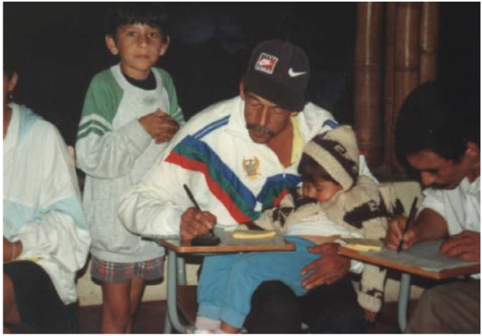
E. Estimation of the Pay Incentive for Participants

Table of points established on the basis of the total winnings, according to the maximum possible gain for a player.

Income ($) | Possible Payment in US Dollars
60,000-70,000 | 15
50,000-59,999 | 14
40,000-49,999 | 13
30,000-39,999 | 11
20,000-29,999 | 9
10,000-19,999 | 7
0-9,999 | 5
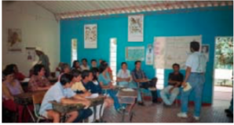
III. Tools, Logistics

A. Room Layout

The experiment must be carried out in a room that offers an environment in which the participants can move freely in order to be able to look for someone to negotiate with.

B. Field Team
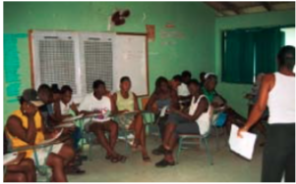
For this game you need a moderator to explain the instructions of the exercise and an assistant to help answer the questions of the group in addition to coordinate the times between each round.

The roles of the moderator are:
Show and explain to the group the purpose and operation of the game and answer any questions that the players have.

The roles of the assistant are:

Help the moderator with distributing things when needed as well as moderate the time.

IV. Necessary Formats to Carry out the Game

A. For the Explanation of the Game Instructions

Format of the Contract

Number of the day of the Market:
Buyer Code:
Producer Code:
Agreed Price: $

Format for the Producers

 | Week | 1 | 2 | 3 | 4 | 5 | 6 | 7 | 8 | 9 | 10
First Sack of Potatoes | Retail price that you negotiated (value for you)
 | Your cost of production (cost for you)
 | A) Net Gain (value – cost)
Second Sack of Potatoes | Retail price that you negotiated (value for you)
 | Your cost of production (cost for you)
 | B) Net Gain (value – cost)
Earnings for round (A + B) :
Total number of sacks sold in the region
(the monitor will announce this):
(C) Additional cost to bring water =
Net gains per week (A + B – C) =
(Net gain for the sale – Cost of water)
Total Earnings: $________

Format for the Buyers

 | Week | 1 | 2 | 3 | 4 | 5 | 6 | 7 | 8 | 9 | 10
First Sack of Potatoes | Resell Price (value for yourself)
 | Price paid for the potatoes (cost for yourself)
 | A) Net Gain (resell price – price paid)
Second Sack of Potatoes | Price of Resell (value for yourself)
 | Price paid for the potatoes (cost for yourself)
 | B) Net Gain (resell price – price paid)
Earnings for round (A + B) :
Total number of sacks sold in the region
(the monitor will announce this):
(C) Additional cost to bring water =
Net gains per week (A + B – C) =
(Net gain for the sale – Cost of water)
Total Earnings: $______

B. For those in charge of Facilitating the Game

For the Moderator

The instructions for this game are the same as those of the previous game; The difference is that a new context is introduced. It reads the following:

You keep selling or buying potatoes at the same sale prices that you had. However, the high mountains from where the water comes for the cultivation of potatoes can be affected, depending on the total amount of potatoes produced in the microbasin. The problem is that if the high mountains are affected, the producers must bring the water from more distant sources, which generates an additional cost for the time they must use to transport the water.
Everyone in the micro-watershed, whether they sell or not, buy or not, suffer the effects of water reduction due to alterations in the high mountains. Depending on how much potato is grown in the micro-basin, everyone will have to assume additional environmental damage, represented by the cost of going to collect water to more distant places or to buy it from those who have it.

Some experts have estimated that for each sack of potatoes produced and sold in the microbasin, each family of buyers or producers have to use an additional wage to pay for water at a cost of $50 per sack.

For example, if 5 bags of potatoes are sold in total, each person must subtract 5 x $ 50 = $ 250 from their earnings. Once the market day ends, the sacks sold will be counted and the total will be announced, so that each participant (seller or buyer) calculates the additional costs for water and subtracts them from their individual earnings.

Sequence of the Experiment
- Introductions of the Field Team/Facilitators
- Introductions of the Participants
- Instructions Lecture
- Explanation of the Experiment
- Examples
- Play the Game (10 Rounds of 5 minutes each)
- Payment to the participants
- Comments

Examples
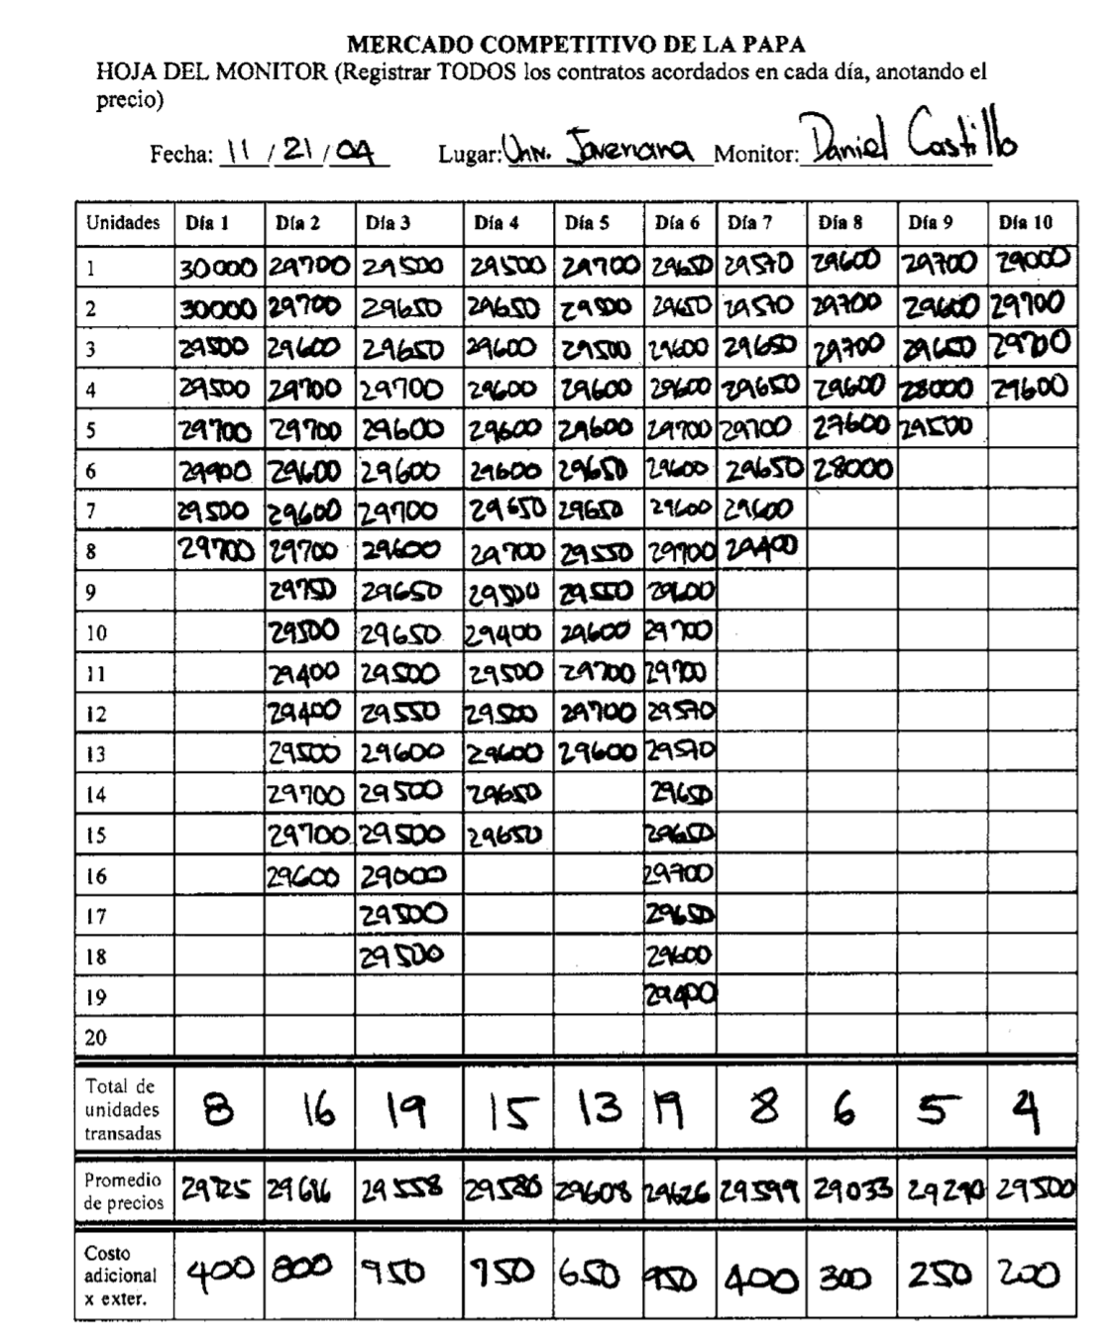
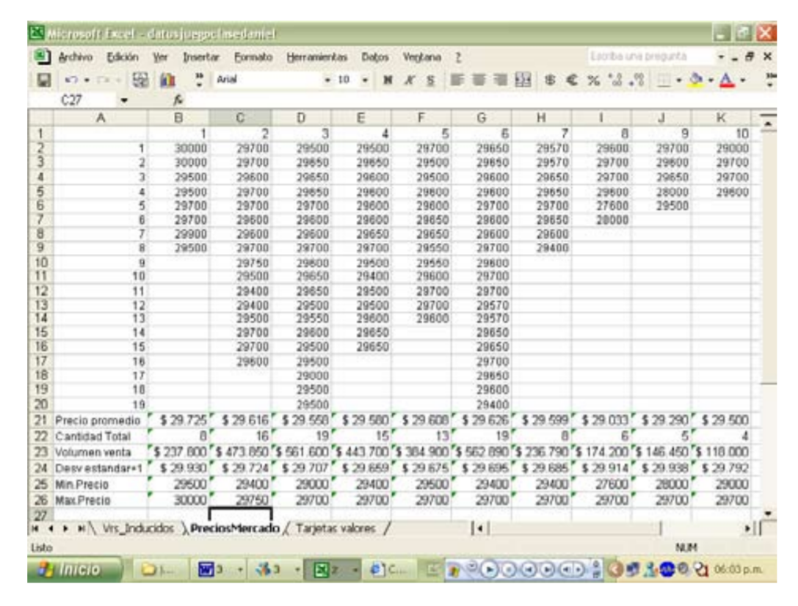
V. Presentation of the Results
The data to present to the group are:
- Quantity of potato sacks negotiated each round
- Average price per round
- The externality price each round, and the relationship between this price and the decrease of transactions
In this game, it is important to make comparisons when assuming the costs of an externality. In this case, it was evident that the costs were economic and very close in time, because the discounts were made in each round after the market day; in real life, this externality could be related to the reduction or contamination of water for human consumption, or to diseases associated with water quality, which also affect the entire community.

VI. Materials to Photocopy
The material to be photocopied is:
- Account sheet for producers and buyers (on green paper)
- Contract cards (on yellow paper)

The transaction prices for each one are the same as they were in the original Potato Market Game.

Potato Market with Externalities Date___/___/___ Buyer Code_________
You are a potato buyer: You keep buying potatoes at the same resale prices that you had. However, depending on the total amount of potatoes produced in the micro-basin, the high mountains from where the water comes for use on your farm may be affected. The problem is that if the high mountains are affected, you will have to get the water from more distant sources, which will generate an additional cost for the time you must dedicate to go get the water. A group of experts has estimated that for each sack of potatoes produced and sold in the region, each family of buyers or producers must use an additional wage at a cost of $ _______

Even if you did not buy potatoes, the cost of water continues to exist - you have to transport it, either way - and you must calculate it even if you obtain negative profits.

 | Week | 1 | 2 | 3 | 4 | 5 | 6 | 7 | 8 | 9 | 10
First Sack of Potatoes | Resell Price (value for yourself)
 | Price paid for the potatoes (cost for yourself)
 | A) Net Gain (resell price – price paid)
Second Sack of Potatoes | Price of Resell (value for yourself)
 | Price paid for the potatoes (cost for yourself)
 | B) Net Gain (resell price – price paid)
Earnings for round (A + B) :
Total number of sacks sold in the region
(the monitor will announce this):
(C) Additional cost to bring water =
Net gains per week (A + B – C) =
(Net gain for the sale – Cost of water)
Total Earnings: $______

Potato Market with Externalities Date___/___/___ Producer Code_________
You keep producing potatoes at the same production costs that you had. However, depending on the total amount of potatoes produced in the high mountains, the micro-basin from where the water comes for use on your farm may be affected. The problem is that if the high mountains are affected, you will have to get the water from more distant sources, which will generate an additional cost for the additional time you must use to get the water. A group of experts has estimated that for each sack of potatoes produced and sold in the region, each family of buyers or producers must use an additional wage at a cost of $ _______.

Even if you did not sell potatoes, the cost of water continues to exist - you have to transport it either way- and you must calculate it even if you made a negative profit.

 | Week | 1 | 2 | 3 | 4 | 5 | 6 | 7 | 8 | 9 | 10
First Sack of Potatoes | Retail price that you negotiated (value for you)
 | Your cost of production (cost for you)
 | A) Net Gain (value – cost)
Second Sack of Potatoes | Retail price that you negotiated (value for you)
 | Your cost of production (cost for you)
 | B) Net Gain (value – cost)
Earnings for round (A + B) :
Total number of sacks sold in the region
(the monitor will announce this):
(C) Additional cost to bring water =
Net gains per week (A + B – C) =
(Net gain for the sale – Cost of water)
Total Earnings: $________

Number of the day of the Market:
Buyer Code:
Producer Code:
Agreed Price: $
Contract Cards and Value Cards for the Buyers and Producers

Number of the day of the Market:
Buyer Code:
Producer Code:
Agreed Price: $
Number of the day of the Market:
Buyer Code:
Producer Code:
Agreed Price: $

Number of the day of the Market:
Buyer Code:
Producer Code:
Agreed Price: $
Number of the day of the Market:
Buyer Code:
Producer Code:
Agreed Price: $

Number of the day of the Market:
Buyer Code:
Producer Code:
Agreed Price: $
Number of the day of the Market:
Buyer Code:
Producer Code:
Agreed Price: $

Number of the day of the Market:
Buyer Code:
Producer Code:
Agreed Price: $
Number of the day of the Market:
Buyer Code:
Producer Code:
Agreed Price: $

Number of the day of the Market:
Buyer Code:
Producer Code:
Agreed Price: $
Number of the day of the Market:
Buyer Code:
Producer Code:
Agreed Price: $

Number of the day of the Market:
Buyer Code:
Producer Code:
Agreed Price: $
Number of the day of the Market:
Buyer Code:
Producer Code:
Agreed Price: $

Competitive Potato Market
Sheet for the monitor (to register all of the agreed contracts for each day, noting the price)
Date:_________________ Place:_____________________ Monitor_______________
UNITS | Day 1 | Day 2 | Day 3 | Day 4 | Day 5 | Day 6 | Day 7 | Day 8 | Day 9 | Day 10
1
2
3
4
5
6
7
8
9
10
11
12
13
14
15
16
17
18
19
20
Total Units Traded
Average Price
Additional Cost of Externalities

Translated from Juan-Camilo Cardenas and Pablos Andres Ramos (2006) Manual de juegos economicos para el analisis del uso colectivo de los recursos naturales, Centro Internacional de la Papa https://economia.uniandes.edu.co/files/profesores/juan_camilo_cardenas/docs/Archivos%20para%20descargar/MANUAL_JUEGOS_CARDENAS_RAMOS.pdf

