Public Goods

- Problem

- Introduction

On many occasions, more than two individuals face the dilemma that we call "cooperation" - commonly referred to as the prisoner's dilemma - described in the second case of the two-by-two games of the third game in this manual. The first case of a cooperation dilemma for more than two players is described in this section with a very simple experimental design. The following games - "Resources of common use" (game 6) and "The game of the basin" (game 7) - are other cases of social dilemmas of more than two players, with particularities that we will describe at the time.

The typical case of public goods is that, because of their "public" nature, they are usually sub-produced from the individual initiative. The reason is that there is a high incentive not to provide them but only to enjoy their benefits. This incentive arises from the following problem in the production and distribution of public goods: once provided, it is difficult to exclude other individuals from the benefitting. If I decide to illuminate the part of the street where my house is located, my neighbors would have very little incentive to contribute to that effort, since, by illuminating the part corresponding to my home, I also illuminate "gratuitously" the rest of the street, and it would be very difficult to exclude them from that benefit, especially if I take into account that the fact that they benefit or not is indifferent to me, because it does not generate additional costs. If I live in the countryside and am in charge of maintaining the water intake for both myself and my neighbors, the fact that I benefit from keeping that infrastructure clean and in good condition means that the rest of the people who derive the water from that same intake will benefit as well, and it would be difficult for me to exclude them from that benefit even if they crossed their arms waiting for me or someone else to take care of the work.

Again, and as in the dilemma of cooperation, individual interest does not lead the group to a maximization of collective well-being, since there is this structural failure of the incentives.

Classic examples of situations for this game are found in the contribution of labor for a collective project such as the maintenance or care of an irrigation district, a community aqueduct or the birth of water in a micro-basin. Caring for a forest - in terms of monitoring, control so that fires do not occur, replanting, etc. - is another example in which social welfare is achieved through individual contributions, but these are
expensive for people. This same game can even be translated into the case of the extraction of resources, as we do in the second section of this chapter, maintaining the conditions of the incentives and the social dilemma.

- Purpose of the Game

In this new game we try to capture the incentives, but in groups larger than two players, maintaining a simple and linear structure of the benefits to cooperate and the benefits for not cooperating. The design of the game is derived from the literature on the "mechanism of voluntary provision," or VCM, which is very well compiled and evaluated by John Ledyard (1995). The version proposed here is one of the most reported and tested in the laboratory and in the field.

We will now show two equivalent versions of the same type of cooperation dilemma for several players. In the first case, we will present a game of four players who must make the decision to contribute or not to a public good. In the second part of the chapter, using the same payment structure of this game, we will expose an adaptation of the same model for five players, for a case in which a community must decide between extracting wood from a forest or receive the benefits of its preservation. The incentive structure is the same, simply that the individual decision is the opposite of the other (contribute to the community project or extract parts of the community resource).

The following theoretical analysis refers to the case of four players and their voluntary contribution to public goods. The same analysis, with minimal adaptation, is equally applicable to the second game design, presented at the end of the chapter.

- Economic Model of Analysis

In the experimental literature (Marwell and Ames 1979), the game of public goods is conventionally known as the "voluntary contribution mechanism" or VCM. In the design presented here for a public goods game, there are a number of players who have an initial allocation tokens. Players have the possibility of investing them in a private option or in a collective or group project. For each token invested in the private option, the player obtains a known and profitable return, while for each token invested in the public project, the player -and all his teammates- obtains a lower return than the token invested in the private project. However, it can be a greater overall return when the returns of the tokens invested by the rest of the members of the public project are added together.

Suppose, for example, that each of four players receives 10 tokens at a time and will receive a return of $ 1 for each saved token and $ 0.50 for each token invested in the public project by them and their teammates. If the four players decide to save their tokens, they will have individually produced an income of $ 10 and a total sum of $ 40 for the group. However, if the four players invest their 10 tokens in the common or public project, each player will receive $ 0.50 x 40 = $ 20, which is substantially higher than the previous option. Now let's think of other possibilities. One player decides to save his 10 tokens and the other three players invest everything in the public project. That player will receive as income (10 x $ 1 + 30 x $ 0.50) = $ 25 of income. It is even more attractive as an option! However, if each of the four players thinks of this as a game strategy, they will all be caught up in the cooperation dilemma, earning just $ 10 when each would have been able to produce $ 20 had they opted for the cooperative strategy, that is , invest all your tokens in the public project.

- Model Predictions
Using the same concepts of game theory, we have, then, for the model described above, the Nash strategy of each player would not contribute to the public good, generating only $ 10 in the balance for each player, with a total of $ 40 for society.

In the social optimum, each of these group members could invest their 10 tokens in the project or public good, generating individual income of $ 20 for a total of $ 80 for the society.

Moreover, note that for any level of contribution of tokens to the public project by the other three players, the fourth player’s best strategy will always be not to invest tokens in the public good, since they always receive the benefits as "free" from the tokens that others have contributed and, simultaneously, get a greater return on their saved tokens. For this reason, the Nash equilibrium results from each player saving their tokens, not investing them in the public good, generating a result that is socially inferior to the social optimum in which $ 80 could be produced for the group instead of $ 40 that is generated when no one contributes.

II. Game or Experimental Set-Up

- Sample Size (Suggested Minimum)
This experiment can be done with a single group of four players and during several rounds, to observe the divergence between the individual and collective incentives. The more sessions you are able to do with different groups, the more improved the quality of population representation in the statistics will be.

- Session Design (N Players, T Rounds)

In this game a maximum of 32 people can participate at the same time in groups of four (8 groups x 4 people = 32 people); In total, 10 rounds are played, 5 initial rounds and then 5 with changes made to the instructions.

- Type of Participant

You can play any type of person that is able to complete basic counting, addition, and subtraction.

- Estimating the Payment Incentives for Participants

At the end of the exercise each player is paid the average of their winnings (in local currency or in dollars) from the 10 rounds.

III. Tools, Logistics

- Type of Location
The exercise should be carried out in a room that offers conditions to read the instructions to all the participants and then form groups of four people, with enough space between them to avoid distractions; It is recommended that each person have their own chair. To participate, each player must have 10 tokens (40 per group, all of the same color). You can also use beans, corn, or the product with which the group identifies; It is important that the tokens of each group be different. For the second part of the exercise, each player will have five tokens (red cards) that they can use in each round to express their dissatisfaction to their teammates.

- Roles of the Facilitation Team

For this game you need a moderator to explain the instructions of the exercise and an assistant to collect the recording cards of the players.

Roles of the Moderator:

Introduce the group, explain the purpose and rules, announce the round that is being played and manage the time.

Roles of the Assistant:

Help the moderator at the time of distributing and collecting the recording cards to the players and moderate the time.

IV. Necessary Recording Card Formats to Carry out the Game

- To explain the Instructions

Once the participants know what the intentions of the study are and are organized in groups, they should know and understand the dynamics of the exercise. For this reason, it is important to have expanded/enlarged samples of the recording cards that will be given to the players later on; In these samples the moderator will be able to write the examples so that the players can become familiar with the formats and the explanation is more useful.

Game 1: Voluntary Contribution to the Public Goods (First Part)
A  Round | B  Initial Quantity | C  Contribution to the Public Good | D  Total Contribution of the Group (Sum of all of the “C’s” in the group) | E  Individual Earnings from the Public Goods (D x 0.5) | F  Total Payment to the Individual (10-C) + E | G  Final Earnings
1 | 10
2 | 10
3 | 10
4 | 10
5 | 10

B. For Each One of the Players

Record of Decisions and Results

Date: __/__/__ Place: ___________ Time: ______ Monitor: ___________

Group: _____ Player: ______

Game 1: Voluntary Contribution to the Public Goods (First Part)
A  Round | B  Initial Quantity | C  Contribution to the Public Good | D  Total Contribution of the Group (Sum of all of the “C’s” in the group) | E  Individual Earnings from the Public Goods (D x 0.5) | F  Total Payment to the Individual (10-C) + E | G  Final Earnings
1 | 10
2 | 10
3 | 10
4 | 10
5 | 10
Game 2: Game of Social Sanction (Second Part)
A  Round | B  Initial Quantity | C  Contribution to the Public Good | D  Total Contribution of the Group (Sum of all of the “C’s” in the group) | E  Individual Earnings from the Public Goods (D x 0.5) | F  Total Payment to the Individual (10-C) + E | G  Sanction (message of dissatisfaction) | H  Total Earnings (F-G)
1 | 10
2 | 10
3 | 10
4 | 10
5 | 10

C. For those in charge to carry out the game

For the Moderator

Introduction:
The following exercise is a different and entertaining way to participate actively in a study about people's economic decisions. According to the decisions you make today you can earn a certain amount of money or prizes; that is why it is important that you pay close attention to these instructions. You may wonder why money is used in these exercises. Money is used because the exercise requires people to make economic decisions, that is, decisions that have consequences for their pocket, as they do in reality. At no time is money expected to be a payment for participating in the study nor the only reason to participate.

Explanation of the Game:
This game is played in groups of four (4) people, which must remain unchanged throughout the year. The game is divided into two parts, the first of five rounds and the second also of five rounds, but with some differences. Each of you will receive 10 tokens in each round of the game (beans, coins, etc.). In the first part of the game, each one must decide between:

Saving them: each token that is saved generates a return of $1
Investing them: each token that you and the rest in the group invest in the project will generate a return of $.50
Tokens saved + Tokens invested = 10 tokens

Example of the first part of the game:

Think of a group in which the decisions were the following:

Player 1: saves 5 tokens, invests 5 tokens
Player 2: saves 9 tokens, invests 1 token
Player 3: saves 2 tokens, invests 8 tokens
Player 4: saves 4 tokens, invests 6 tokens

In total, 20 tokens were invested. We are going to fill in this report card as if we were player 4.
In column C of the table we note the amount of tokens invested by player 4 for the public good: six tokens
In column D of the table we record the total contributions of the group: 20 tokens (the total number of tokens contributed in the group is counted).

In column E we note the individual earnings from the public good, (20 x 0.5 = 10).

Game 1: Voluntary Contribution to the Public Goods (First Part)
A  Round | B  Initial Quantity | C  Contribution to the Public Good | D  Total Contribution of the Group (Sum of all of the “C’s” in the group) | E  Individual Earnings from the Public Goods (D x 0.5) | F  Total Payment to the Individual (10-C) + E | G  Final Earnings
1 | 10 | 6 | 20 | 10 | 14 | 14
2 | 10
3 | 10
4 | 10
5 | 10

In column F we will calculate the profits for this round. The gains in this round for player 4 would be more from the tokens that were saved than from the public good (10 - their contribution to the public good (C) + E), which would be a total of 14.

We write this result in column G of the table.

The tokens, beans, moneys, etc. that are given to the moderator, they count them and announce the total contribution to the group.
In the second part of the game, in addition to the previous options, each player can pay a point (1) for sending a message of dissatisfaction to others in their group. So that you can send your messages of dissatisfaction, each player will be given five red cards; In the round in which you decide to send a message, you must deliver the card to the moderator and make the corresponding entry in your account sheet.

Example for the Second part of the Game:

Think of a group that makes the following decisions:

Player 1: saves 7 tokens, invests 3 tokens
Player 2: saves 7 tokens, invests 3 token
Player 3: saves 6 tokens, invests 4 tokens
Player 4: saves 4 tokens, invests 6 tokens

In total, the number of invested tokens was 16. We are going to fill in the report card as if we were player 2.

In column C of the table we write the amount of tokens that player 2 invested in the public good: 3 tokens

In column D of the table we write the total contribution of the group: 16 tokens

In column E we rite the result of multiplying the invested quantity that is listed in column D by 0.5 (16 x 0.5 = 8).

In column F we calculate the earnings for this round; the earnings of player 2 would be earned more from the tokens that they saved rather than what they earned from the public good (10 – their contribution to the public good (c) + F), which would be a total of 15.

Since the player decided to send a message of dissatisfaction to the group, in column G they write the payment of 1 for sending the message.

Their final earnings, they write in column H, and are 14.

Game 2: Game of Social Sanction (Second Part)
A  Round | B  Initial Quantity | C  Contribution to the Public Good | D  Total Contribution of the Group (Sum of all of the “C’s” in the group) | E  Individual Earnings from the Public Goods (D x 0.5) | F  Total Payment to the Individual (10-C) + E | G  Sanction (message of dissatisfaction) | H  Total Earnings (F-G)
1 | 10 | 3 | 16 | 8 | 15 | 1 | 14
2 | 10
3 | 10
4 | 10
5 | 10

V. Informed Consent

It is necessary that you, as participants, review and sign the acceptance or informed consent form. In this sheet, we assure you that we will manage all the information collected in the exercises in a confidential manner; In addition, we point out that participating in these exercises does not present any risk. You signature signifies that you are aware of and have accepted the project and the exercises that will be carried out [read the informed consent form to the whole group, aloud]. If you agree to participate, please fill in your acceptance form, and do not forget to write your player number on it.

VI. For the Monitor

A. Sheet for registering decisions of the players

In this game a recording sheet will be filled in by each group, and the results obtained in the two parts of the game will be recorded here such as the earnings of each player as well as the average.

Decision Registration Sheet (Monitor)
Public Goods Game
Group_____

Date:___/___/___ Place: _____________ Time:_________ Monitor:__________

Round |  | Player 1 | Player 2 | Player 3 | Player 4
Game 1
1 | Contribution
 | Group Contribution
 | Earnings
2 | Contribution
 | Group Contribution
 | Earnings
3 | Contribution
 | Group Contribution
 | Earnings
4 | Contribution
 | Group Contribution
 | Earnings
5 | Contribution
 | Group Contribution
 | Earnings
Game 2
1 | Contribution
 | Group Contribution
 | Earnings
2 | Contribution
 | Group Contribution
 | Earnings
3 | Contribution
 | Group Contribution
 | Earnings
4 | Contribution
 | Group Contribution
 | Earnings
5 | Contribution
 | Group Contribution
 | Earnings

B. Sequence of the Experiment (Steps)

1. Introduce the field team
2 . Introductions of the participants
3. Reading of the instructions
4. Explanation of the experiment
5. Examples
6. Reading of informed consent
7. First part of the game (5 rounds)
8. Second part of the game (5 rounds)
9. Payment given to the participants
10. Closure of the session

VII. Analysis of Data

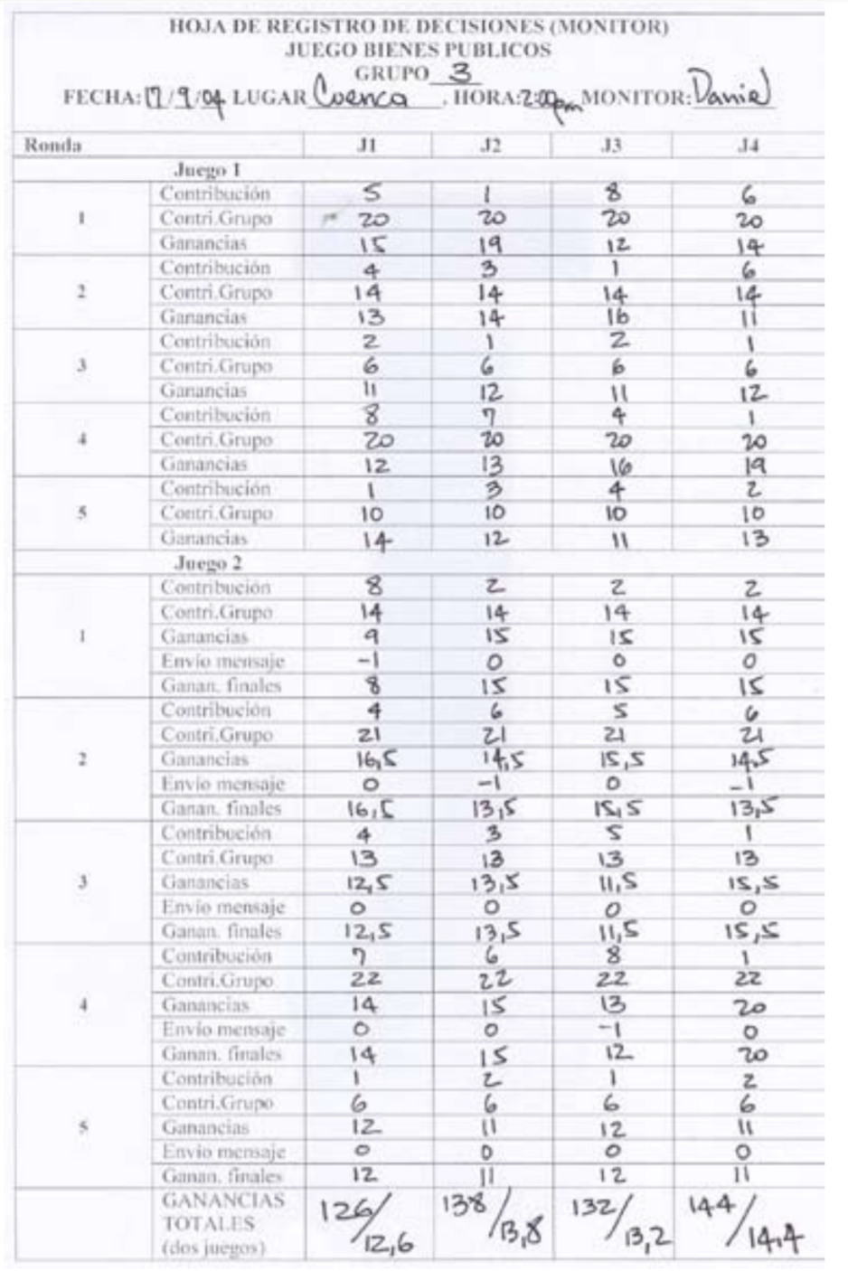
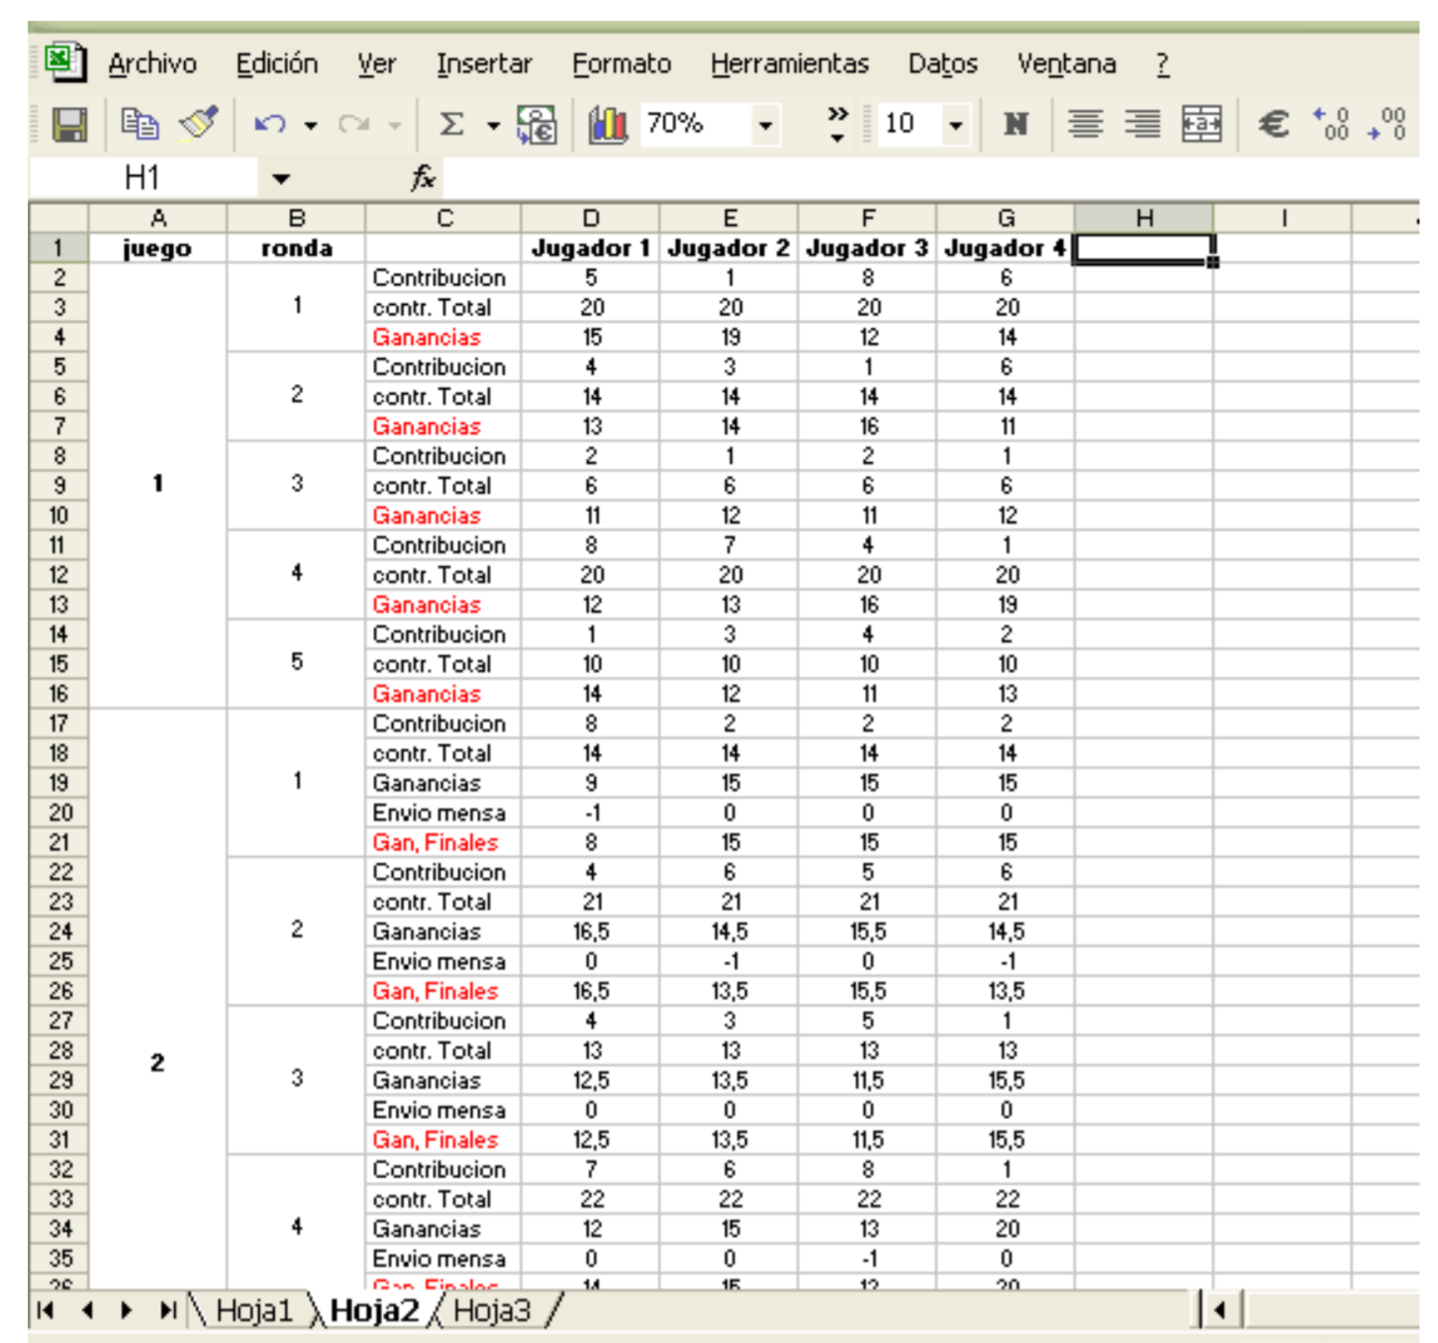

As mentioned at the beginning, the Nash strategy for each player is to not contribute to the common good (0 units) and the social optimum is that each of the players contributes all of their tokens to receive total benefits of 80 units (10 units x 4 players = 80 points). In each round you can analyze the proximity to the social optimum (more than 50 points) or to the Nash equilibrium (less than 30 points).

In the second part of the exercise, it can be noted if the group changes its decisions according to the messages of dissatisfaction given by the players and the proximity to the social optimum.

VIII. Presentation of the Results

Types of data to present to the group of players:

-Average earnings of each player
-Average of decisions in each round (proximity to the Nash equilibrium or to the social optimum)

IX References
Ledyard, J. 0. (1995): Public Goods: A Survey of Experimental Research, in The Handbook of Experimental Economics, ed. by John H. Kagel and Alvin E. Roth. Princeton: Princeton University Press.
Marwell, G., and R. E. Ames (1979). Experiments on the Provision of Public Goods I: Resources, Interest, Group Size, and the Free Rider Problem. American Journal of Sociology 84(May): 1335-60.

X. Material to Photocopy

The materials to be photocopied are:

-accounting sheets of the players
-monitor accounting sheet (one for each group)

Record of Decisions and Results

Date: __/__/__ Place: ___________ Time: ______ Monitor: ___________

Group: _____ Player: ______

Game 1: Voluntary Contribution to the Public Goods (First Part)
A  Round | B  Initial Quantity | C  Contribution to the Public Good | D  Total Contribution of the Group (Sum of all of the “C’s” in the group) | E  Individual Earnings from the Public Goods (D x 0.5) | F  Total Payment to the Individual (10-C) + E | G  Final Earnings
1 | 10
2 | 10
3 | 10
4 | 10
5 | 10
Game 2: Game of Social Sanction (Second Part)
A  Round | B  Initial Quantity | C  Contribution to the Public Good | D  Total Contribution of the Group (Sum of all of the “C’s” in the group) | E  Individual Earnings from the Public Goods (D x 0.5) | F  Total Payment to the Individual (10-C) + E | G  Sanction (message of dissatisfaction) | H  Total Earnings (F-G)
1 | 10
2 | 10
3 | 10
4 | 10
5 | 10

Decision Registration Sheet (Monitor)
Public Goods Game
Group_____

Date:___/___/___ Place: _____________ Time:_________ Monitor:__________

Round |  | Player 1 | Player 2 | Player 3 | Player 4
Game 1
1 | Contribution
 | Group Contribution
 | Earnings
2 | Contribution
 | Group Contribution
 | Earnings
3 | Contribution
 | Group Contribution
 | Earnings
4 | Contribution
 | Group Contribution
 | Earnings
5 | Contribution
 | Group Contribution
 | Earnings
Game 2
1 | Contribution
 | Group Contribution
 | Earnings
2 | Contribution
 | Group Contribution
 | Earnings
3 | Contribution
 | Group Contribution
 | Earnings
4 | Contribution
 | Group Contribution
 | Earnings
5 | Contribution
 | Group Contribution
 | Earnings

Another Version of Public Goods Game Applied to a Forest Resources Context

- Problem

- Purpose of the Game

This game is designed to take advantage of community forestry. The objective of this design is to generate a simple cooperation dilemma to discuss the following elements:

• Dilemma between conserving and extracting resources from the forest
• Individual and collective incentives when there is an extraction program
• The problem of rotation in the use of the forest

The model introduced in Game 6 is more complete and includes other aspects of natural resources, but this version allows to appreciate basic elements of the externalities generated by access to a common resource.

- Model of Economic Analysis

The stock of natural capital is expressed in units of a resource, for example, trees (50 available units); We assume that the forest generates benefits for extraction but also through its conservation (non-timber products, water conservation, habitat that allows biodiversity, landscape benefits, protection against wind erosion or landslides). In the case of a community that has livelihoods based in forestry extraction, we are talking about direct benefits from timber extraction for sale, and indirect benefits from conservation, expressed in the bush meat that can be obtained by hunting .

The parameters of the model are similar to the previous one:

The decision variable is Xi, number of trees, from 1 to 10 units (we eliminate X = 0 to avoid an optimal solution that implies no extraction of the resource). We have N = 5 players (users) that can extract a maximum of 10 units of the resource (trees). The decision of how many units to extract is individual and private. Only the total extracted by the group is announced in public.

At the end of the period, the remaining units are reproduced at an additional 50%, this being the stock of the final natural capital. This renewed resource generates benefits to all users for environmental services (benefits of indirect use and non-use) and for forest conservation for the future. In this model the initial stock = 50 trees, which are regenerated in each round. Therefore, we have a profit function that has the following form:

Player payment function i: ($ 100 x Xi) + ($ 100 x [1/5] x [1.5] x [50 - SumXi]) Eg: if everyone removes 1, then Yi = 100 + ( 100/5) x 1.50 x (50 - 5)

Note that the payment function of the individual earnings increases with Xi but decreases with the sum of Xi, that is, the player i sees their gains increase if their extraction Xi increases, but sees their profits decrease if the group extraction, SumXi, increases, which generates a conflict between individual interests and collective interests.

II. Experimental Set-Up

- Sample Size (suggested minimum)
This experiment can be done with a single group of five players and over several rounds, to observe the divergence between individual and collective incentives.

- Session Design (N players, T rounds)

For a session, it is necessary to have a group of five participants (you can play at the same time with two or three groups, depending on the space and the number of people who make up the field team), who will be identified with a number from 1 to 5, that will be each person’s player number during all rounds of the exercise.

The total number of rounds of each exercise will be 20; 10 will be played during the first part of the game and 10 in the second part, in which the rule with which the group must play will be introduced.

- Type of participants
Any type of person can play.

- Estimation of incentives and Payment to Participants

At the end of the exercise each player is paid the sum of their winnings (in local currency) in the 20 rounds.

III. Tools and Logistics

- Layout of the place

The game must be held in a room that offers conditions in which to read the instructions to all participants and then allow that groups of five people are formed. Between the groups there must be enough space in order to eliminate the possibility of distractions; It is recommended that each person have their own chair.

- Field Team
For this game, you need a moderator to explain the instructions of the exercise and an assistant to collect the players' decision cards; If the experiment is done with several groups, there must be one assistant for each additional group.

The functions of the moderator are:

Introduce the group, explain the intentions of the game and explain it, announce the round that is being played and manage the time.

The functions of the assistant are:

Help the moderator when they are distributing and collecting the decision cards to the players, and moderate the time.

IV. Necessary formats and decision cards needed to carry out a session

- For the explanation of the instructions

Once the participants know the intentions of the study and are organized into groups, they should know and understand the dynamics of the exercise. For this reason, it is important to have expanded samples of the record keeping cards that will be delivered later on; In these extended samples, the moderator will be able to write examples so that the players become familiar with the formats and the explanation is more fluid.

Earnings from the collective benefits provided by the forest

Trees Cut by the Group | My Earnings ($)
5 | 1,350
6 | 1,320
7 | 1,290
8 | 1,260
9 | 1,230
10 | 1,200
11 | 1,170
12 | 1,140
13 | 1,110
14 | 1,080
15 | 1,050
16 | 1,020
17 | 990
18 | 960
19 | 930
20 | 900
21 | 870
2 | 840
23 | 810
24 | 780
25 | 750
26 | 720
27 | 690
Trees Cut by the Group | My Earnings ($)
28 | 660
29 | 630
30 | 600
31 | 570
32 | 540
33 | 510
34 | 480
35 | 450
36 | 420
37 | 390
38 | 360
39 | 330
40 | 300
41 | 270
42 | 240
43 | 210
44 | 180
45 | 150
46 | 120
47 | 90
48 | 60
49 | 30
50 | 0

Decision Registration Cards:
Player Number
Round
My Decision

Point Table
Point Table (Earnings for Extraction + Forest Conservation)
My Level of Extraction (Trees that I cut)

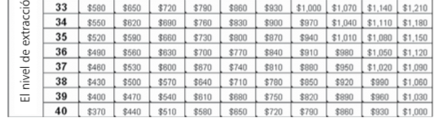
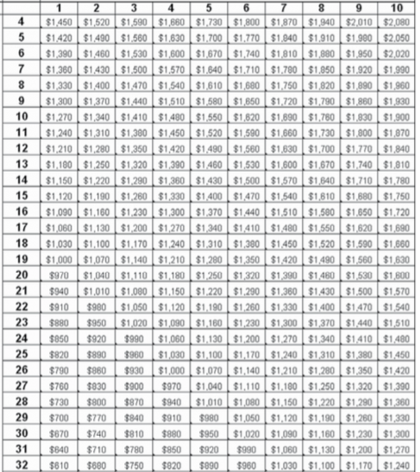
Others Level of Extraction (How many trees the others Cut

Account sheet for the players

Account Sheet
 | A | B | C | D | E
Round | Trees that I cut | My earnings for each cut $100 x A | Total trees cut by the group | My additional earnings | My total earnings for the round
 | I decide | I calculate | The monitor announces | I look at the table | (B + D)
1
2
3
4
5
6
7
8
9
10
11
12
13
14
15
16
17
18
19
20
Total

For each one of the players:

Decision Registration Cards:
Player Number
Round
My Decision
Each one of the players will receive 20 cards printed on yellow paper, with a space to mark the number of the player, the number of the round, and a place to write the level of extraction during this round (from 1 – 10).
Accounting Sheet

As you were told during the instructions, each one of the players will receive a sheet printed on green paper on which there should be written only the number of the player (remember that the decisions are anonymous), the place where the experiment is taking place, and the time.

On this sheet, the player should not their decision during each round (what they have written on their decision registration card and given to the monitor), the earnings for each cut, the total number of trees cut by the group (which is announced by the moderator), and the total number of points obtained in this round.

Date: ____/____ /____ Time: __: ____ Place: ______________ Player Number: ____________

Account Sheet
 | A | B | C | D | E
Round | Trees that I cut | My earnings for each cut $100 x A | Total trees cut by the group | My additional earnings | My total earnings for the round
 | I decide | I calculate | The monitor announces | I look at the table | (B + D)
1
2
3
4
5
6
7
8
9
10
11
12
13
14
15
16
17
18
19
20
Total

For those in Charge of Carrying out the Game

For the Moderator

Introduction: Thank you for being here and accepting our invitation. The following exercise is a different and entertaining kind of participatory study about the economic decisions that people make. In accordance with the decisions that you make today, you will be able to earn a certain amount of money or prizes; thus, it is important that you pay close attention to the instructions.

You will ask why we use money in these exercises. We use money because the exercise requires the participants to make typical economic decisions, in other words, they are decisions that are of consequence for your pocketbook, as it happens in reality. The money should not be interpreted as payment for participating nor the only reason to participate.

Explanation of the Game: This exercise tries to recreate (to imagine, simulate) a situation in which a group of people have to make decisions about how many trees to cut down in the forest. To fell trees generates economic benefits for the group, but the conservation of the forest generates another type of benefits (caring for the environment; landscape, etc)

You have been chosen to participate in a group of five people. The game in which you are going to participate is different than others – there are distinct rules for each game – so the comments that you have heard from other people are not necessarily valid for this exercise.

In each round you are going to determine a number of trees to cut down, which generate a certain amount of earnings, y then receive other earnings through collective benefits. The decision is private and confidential.

You all will play multiple rounds in the same style, for example, as if they were months. At the end of the exercise, you will earn a determined number of points that will convert into money or prizes.

Materials to Deliver to Each Participant

Now, we are going to give you the sheets that will be necessary for the game:

The yellow game cards: each one of these cards has a space to write your player number, the round number, and your decision

The green accounting sheet: on this you will write down your player number (the same which is on the yellow game cards), the date, the time, and the place.

And the most important, the blue point sheet, on which you will find the points that you can earn according to your decision and the decisions of the rest of your group members.
Remember that the points that you earn can be converted into money or prizes that will be delivered at the end of the exercise.

Informed Consent
It is necessary that you, as participants, review and sign the acceptance or informed consent form. In this sheet, we assure you that we will manage all the information collected in the exercises in a confidential manner; In addition, we point out that participating in these exercises does not present any risk. You signature signifies that you are aware of and have accepted the project and the exercises that will be carried out [read the informed consent form to the whole group, aloud]. If you agree to participate, please fill in your acceptance form, and do not forget to write your player number on it.

For the Monitor: Player decision registration sheet

Date:___/___/___ Place:____________ Group:____________ Monitor:___________

Monitor Sheet
 | Player Decisions |  |  |  |  | A | B | C | D
Round |  |  |  |  |  | Total Units extracted by the group | Units of the resource that remain | Final stock of the resource | Earnings through conservation for each player
 | 1 | 2 | 3 | 4 | 5 | Sum Xi | 50 – (A) | 1.5 x (B) | (1/5) x (B) x $100
1
2
3
4
5
6
7
8
9
10
11
12
13
14
15
16
17
18
19
20

The Rules
Until now, all the necessary steps for the first 10 rounds of the game have been explained; Now, let's develop the second part of the game. In this part, there are some changes in the dynamics of the exercise because different rules will be introduced.

The rules of this second part are:
- Communication
- Rotation of extraction

Rule 1: Communication

After finishing the first 10 rounds of the exercise, the moderator tells the group members that they can talk for five minutes. During this time, players can talk about what they want: the game, the winnings, the ways of playing, the similarities between the game and reality, and so on. This conversation is only between the members of the group, it should not be directed by the moderator. The only thing that is forbidden in this exchange is that promises are made about transfers of points during or after the year.

INSTRUCTIONS THAT THE MODERATOR SHOULD READ:

In addition to the rules described in the instructions that we have just explained, there is an additional rule for the participants of this group:

Please, all the members of the group form a circle or sit together around a table. Before making your next decisions, you can hold an open discussion, which will take a maximum of five minutes. You can talk about the topic you want regarding the game and the rules, but cannot make any promises or threats regarding payments or transfers of points during or after the end of the exercise. It is simply an open discussion. The other rules of the game are maintained. We will let you know when the time is up. Afterwards, you should suspend the discussion and each will make his/her individual decision for the next rounds. These decisions will remain private and confidential as in the other rounds.

Once the five minutes have elapsed, the moderator announces that the time has ended. Each of the players must return to their place so that their decision remains private, and the dynamics of the game will continue as in the first part.

Rule 2: Rotation of Extraction

The dynamics of the exercise remain the same as in the first part of the game, but the moderator gives new instructions.

INSTRUCTIONS THAT THE MODERATOR SHOULD READ:

In addition to the rules described in the instructions that we have just explained, there is an additional rule for the participants of this group:

In each round, the possibility of each player to extract the amount resources that they want will be rotated while the other players wait their turn. Therefore, in the 10 rounds, each player will have two turns. In order to control compliance with the plan in each round, the extraction level of the player whose turn it is will be made public. The other players, however, may continue to extract trees and receive individual profits for the sale of these, plus the profits for the collective benefits. The decision remains private and confidential.

Sequence of the Experiment (Steps)
- Introduce the field team
- Introduce the participants
- Explain the instructions
- Explain the experiment
- Give Examples
- Explain the informed consent
- First part of the game (10 rounds)
- Second part of the game (10 rounds with the rules)
- Payment to the participants
- Close the session

V. Digital Capture of the Data

An example with results

Below are the data of the individual decisions derived of the four experimental sessions held in the countryside in Upper Mecca (Putumayo), according to the model and experiment described above. The two tables that we present show the decisions, the collective results and the individual and collective gains for the 20 rounds of each session or group. In each row are the data of a round of the game in each group. The columns show the decisions of players 1 to 5, the sum of the decisions - that is, the total extraction of the forest -, the player's winnings 1 to 5 respectively and the total winnings of the group. In the first 10 rounds, all groups made their decisions individually and without the possibility of its members arriving at any agreement. In the next 10 rounds, two types of rules were included. On the one hand, two of the groups were allowed to communicate internally (table with instit = com in the first column).
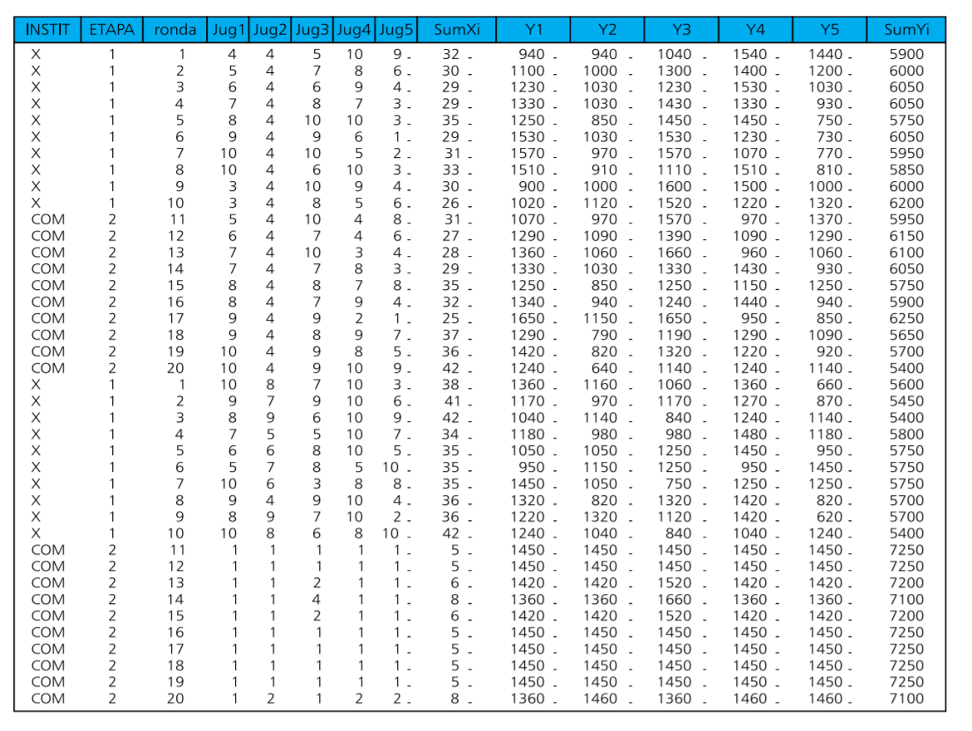
The following table shows the data of the groups in which a plan was proposed of rotation for 10 years and in which each player could extract the amount that you want only in two of the periods, waiting for the others they extracted only one unit in the rest of the rounds. We call this new rule rotation (instit = rota) and the data are presented in the following table.
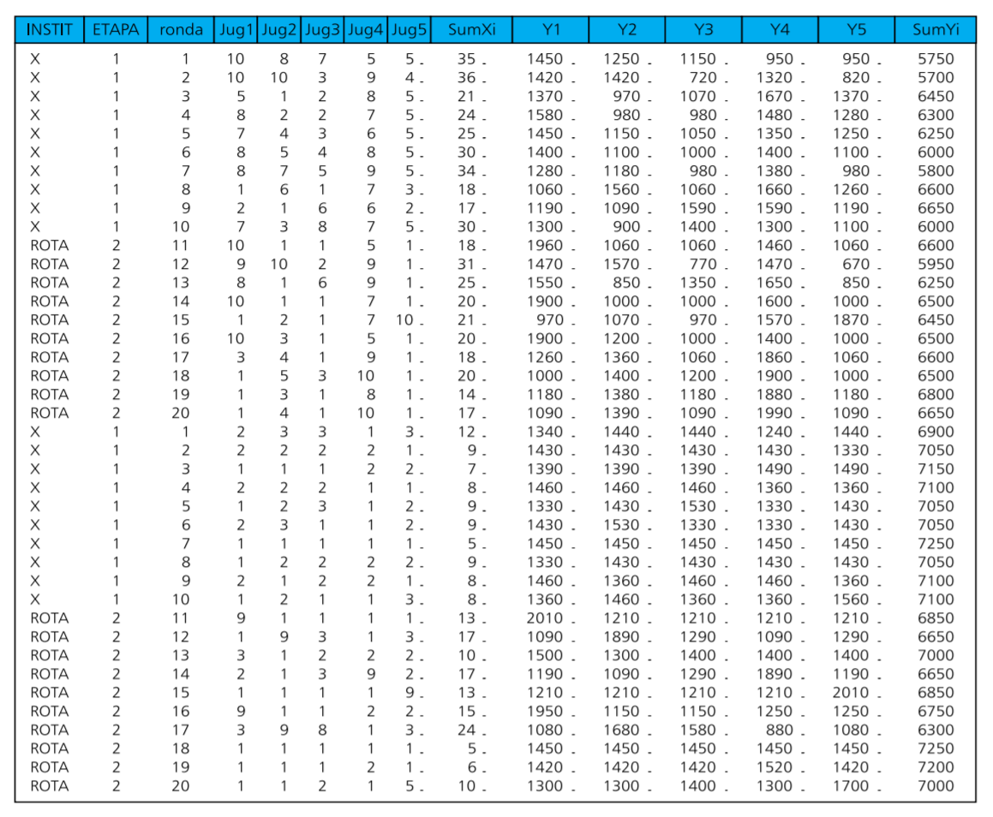
VI. Presentation of the Results
- Decision average
- Payment average
- Difference of decision making according to the rules and payments

VII. Material to be Photocopied
- Decision cards
- Tables of earnings for collective benefit given by the forest
- Tables of earnings from decisions
- Accounting Sheets

Player Number
Round
My decision

Player Number
Round
My decision

Player Number
Round
My decision

Player Number
Round
My decision

Player Number
Round
My decision

Player Number
Round
My decision

Player Number
Round
My decision

Player Number
Round
My decision

Player Number
Round
My decision

Player Number
Round
My decision

Earnings from the collective benefits provided by the forest

Trees Cut by the Group | My Earnings ($)
5 | 1,350
6 | 1,320
7 | 1,290
8 | 1,260
9 | 1,230
10 | 1,200
11 | 1,170
12 | 1,140
13 | 1,110
14 | 1,080
15 | 1,050
16 | 1,020
17 | 990
18 | 960
19 | 930
20 | 900
21 | 870
2 | 840
23 | 810
24 | 780
25 | 750
26 | 720
27 | 690
Trees Cut by the Group | My Earnings ($)
28 | 660
29 | 630
30 | 600
31 | 570
32 | 540
33 | 510
34 | 480
35 | 450
36 | 420
37 | 390
38 | 360
39 | 330
40 | 300
41 | 270
42 | 240
43 | 210
44 | 180
45 | 150
46 | 120
47 | 90
48 | 60
49 | 30
50 | 0

Point Table
Point Table (Earnings for Extraction + Forest Conservation)
My Level of Extraction (Trees that I cut)

Others Level of Extraction (How many trees the others Cut

Date: ____/____ /____ Time: __: ____ Place: ______________ Player Number: ____________

Account Sheet
 | A | B | C | D | E
Round | Trees that I cut | My earnings for each cut $100 x A | Total trees cut by the group | My additional earnings | My total earnings for the round
 | I decide | I calculate | The monitor announces | I look at the table | (B + D)
1
2
3
4
5
6
7
8
9
10
11
12
13
14
15
16
17
18
19
20
Total

Date:___/___/___ Place:____________ Group:____________ Monitor:___________

Monitor Sheet
 | Player Decisions |  |  |  |  | A | B | C | D
Round |  |  |  |  |  | Total Units extracted by the group | Units of the resource that remain | Final stock of the resource | Earnings through conservation for each player
 | 1 | 2 | 3 | 4 | 5 | Sum Xi | 50 – (A) | 1.5 x (B) | (1/5) x (B) x $100
1
2
3
4
5
6
7
8
9
10
11
12
13
14
15
16
17
18
19
20

Translated from Juan-Camilo Cardenas and Pablos Andres Ramos (2006) Manual de juegos economicos para el analisis del uso colectivo de los recursos naturales, Centro Internacional de la Papa https://economia.uniandes.edu.co/files/profesores/juan_camilo_cardenas/docs/Archivos%20para%20descargar/MANUAL_JUEGOS_CARDENAS_RAMOS.pdf

