Manual September 2021

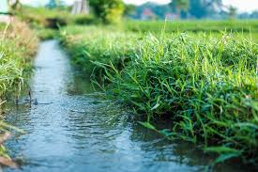
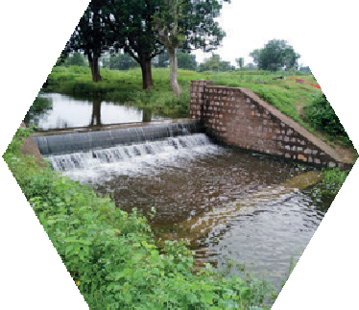
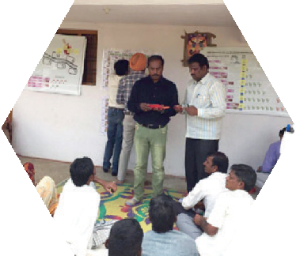
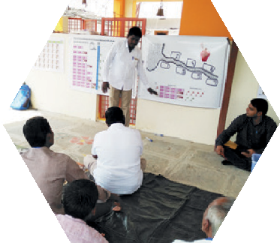
JAL SUTRA game
Joyful gAme Learning – Shaping rUles Together for Rural wAter management

Channel Irrigation Virtual Game Manual

Copyright © International Crops Research Institute for the Semi-Arid Tropics (ICRISAT), 2021.

This publication is licensed for use under a Creative Commons Attribution 4.0 International License (CC BY 4.0). Subject to attribution, you are free to share (copy and redistribute the material in any medium or format), adapt (remix, transform, and build upon the material) for any purpose, even commercially as long as ICRISAT is properly cited. To view this license, visit https://creativecommons.org/licenses/by/4.0.

Suggested citation: International Crops Research Institute for the Semi-Arid Tropics (ICRISAT), Foundation for Ecological Security (FES), and International Food Policy Research Institute (IFPRI). 2021. Channel Irrigation Game Manual. ICRISAT and FES, India; IFPRI, USA, www.gamesforsustainability.org, accessed date

We welcome requests to translate, adapt, or otherwise reproduce the material in this document in noncommercial and educational contexts, provided that the source is credited by including the suggested citation above. For any other purposes, contact us for permission. We would appreciate receiving copies or links to any work that adapts or refers to this work; kindly send such references to: Thomas Falk <t.falk@cgiar.org>.

Background
This channel irrigation game allows students and other interested people to experience experimental learning games which we normally play in with communities. The game is based on framed common pool resource games, strongly inspired by the water games designed by Marco Janssen, Juan Camilo Cardenas and others. It is framed to the Indian context as the game has been developed in the frame of the project on Scaling up experiential learning tools for sustainable water governance in India.
India is one of the world’s most intensive water users: by 2050, the country will be withdrawing 80% of its available water resources. There are dramatic predictions of water demand exceeding supply by twofold within the next 10 years. Agriculture is the largest water user, accounting for close to 90% of all groundwater abstracted. The Indian government and development partners have invested billions of dollars in participatory watershed development. At the same time, many regulations and subsidies provide incentives to use water inefficiently.
Specific agricultural water management challenges occur in the context of large-scale infrastructure such as big dams or channels. Such infrastructure is an important source of irrigation especially in the post-rainy season. Typically, large dams and channels are managed by the government and water is provided on the basis of fees. In India today, such fees are very low neither reflecting the costs of provision nor the economic and ecological value of the water. This makes irrigation water also accessible and affordable to poor farmers. At the same time, the low costs create incentives to inefficiently use water. In the face of the aforementioned water crisis, this further contributes to the nation-wide water shortage. Especially in poor rainfall years, many communities also report conflicts about the allocation of water which is then insufficient for all farmers to grow their preferred crops.
This is a good example for water users imposing unintended consequences onto each other. Consequently, coordination of individual actions is needed to achieve social desirable outcomes and make everybody’s behavior predictable. Rules and norms play an important role in this coordination effort. Therefore, stronger attention needs to be paid to the capacities of communities to design or change rules or by-laws and enforce them to ensure sustainable water management in the interests of the whole community as well as the nation.
The developers of the JalSutra Channel Irrigation Game are driven by the question how the emergence of adapted and sustainable natural resource governance can be facilitated at scale. The game is a structured approach which allows implementing agents to facilitate social learning in communities at scale. The tool enables facilitators to embed governance interventions into large development initiatives.

Hyderabad/India
September 2021

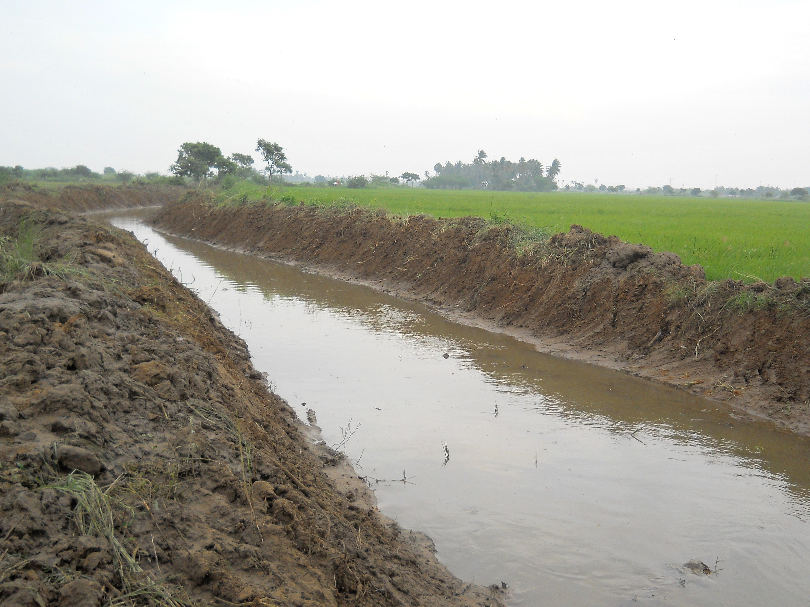

Contents
Background 3
Acknowledgments 6
How to Use this Manual? 7
Basic Structure of the Game 7
Materials Required 7
Get Ready to Use the JAL SUTRA App 8
Platform to Conduct Virtual Game Session 8
Choosing Game Participants 8
Facilitation Team Roles and Responsibilities 9
Basic Information of Location/Community 9
Exchange Rate 10
Registration of Participants 10
Replace/Substitute Player 10
Preparation of Player’s Decision Slides on Ahaslide 10
General Instruction to Participants 12
General Explanation 13
Practice Rounds 15
Starting the Game 16
Allowing Discussion and Revealing the Individual Decisions 17
Discussions 18
Conclusion and Departure after the Game 18
Picture References 19

Acknowledgments

Original Game Design
The game was developed by the International Crops Research Institute for the Semi-Arid Tropics (ICRISAT), the Foundation for Ecological Security (FES), and the International Food Policy Research Institute (IFPRI). ICRISAT based in Hyderabad, India and IFPRI based in Washington DC, USA are nonprofit non-government international research institutes conducting agricultural research for development in semi-arid tropics around the world. FES is a nonprofit non-government organization based in Anand, Gujarat, India, working toward the ecological restoration and conservation of land and water resources in ecologically fragile, degraded, and marginalized regions of the country. Verdentum developed a mobile phone application to support the facilitation of the game.

International Crops Research Institute for the Semi-Arid Tropics (ICRISAT)
Thomas Falk, Vishwambhar Duche

Foundation for Ecological Security
Pratiti Priyadarshini, Richu Sanil

International Food Policy Research Institute (IFPRI)
Ruth Meinzen-Dick, Hagar ElDidi

Funding: This work was undertaken as part of the CGIAR Research Programs on Policies, Institutions, and Markets (PIM) led by the International Food Policy Research Institute (IFPRI) and Water, Land and Ecosystems (WLE) led by the International Water Management Institute (IWMI), supported by the CGIAR Trust Fund. It received financial support from the German Federal Ministry for Economic Cooperation and Development (BMZ) commissioned and administered through the Deutsche Gesellschaft für Internationale Zusammenarbeit (GIZ) Fund for International Agricultural Research (FIA), grant number: 81250397. The opinions expressed here belong to the authors, and do not necessarily reflect those of ICRISAT, IFPRI, IWMI, PIM, WLE or CGIAR.

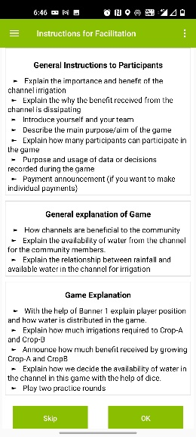
How to Use this Manual?
Figure 1 Facilitation instructions
This document provides guidance on how to use the virtual channel irrigation game tool. Note that text written in red color are statements that we propose to be given directly to the players. Black colored texts are instructions for facilitators only. The specific facilitation team member is highlighted before each instruction as our proposal for the distribution of responsibilities. This manual is prepared to describe the game structure and its facilitation. Once the user understands the process of the game, facilitation instructions [in bullet points-Figure 1] provided in the JAL SUTRA mobile application will help the user to facilitate the game.

Basic Structure of the Game
Before we go into detail on how to facilitate the game, let us explain its basic structure. The JAL SUTRA Channel Irrigation game simulates the management of water from a water supply channel. In the game, there are seven farmers having their fields underneath the channel. Each farmer has a field of the same size, namely 1 hectare (ha). We assume that the distance to the channel influences the farmers’ access to the channel water. As the water flows from the top to the bottom, the farmer living closest to the channel can withdraw water first. Only what he/she does not use becomes available to the second farmer. Only what the second farmer does not use becomes available to the third farmer and so on - up to farmer seven. The amount of water the government allocates to the seven farmer is thereby limited.
In the game, the seven players need to take decision on the selection of the crop they wanted to grow. They can choose between a more profitable crop which requires more water and a water efficient crop which gives slightly less income. The water is insufficient for everybody to grow the water consumptive crop. In fact, there will be no water available for the tail-enders if upstream players choose the water consumptive crop. Consequently, the individual player’s income in the game depends on his/her own crop choice and the crop choices of players who are above them along the channel.
Another feature of the game we consider is that water availability depends on the rainfall in a particular year. In years with low rainfall, the government will offer less water. This is reflected in the game by flipping a coin. If the coin shows tail, then rainfall will be high, and the group gets water sufficient for 20 irrigations. If the coin shows a head, the rainfall is low and water available to the group will be 14 irrigations only. The available water can be used by the players to irrigate a post-rainy crop.

Materials Required
The following materials are required to play the game:
- Android device with JAL SUTRA app (see below)
- 1 Rupees coin
- Power Point presentation provided on https://gamesforsustainability.org
- Decision slides on Ahaslide (cloud-based interactive presentation software)
Electronic copies of the channel irrigation game manual, power point presentation are available at https://gamesforsustainability.org/practitioners/#game-on-managing-check-dams.

Get Ready to Use the JAL SUTRA App
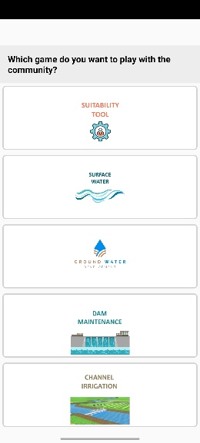
The JAL SUTRA mobile application supports the facilitation of the game by
Figure 2 Options to select intervention
- assisting the facilitators to identify suitable intervention [Figure 2] to use in the community depending on the situation of the selected community,
- giving the facilitator bullet-point reminders on each facilitation step (it is important to study this manual to understand the bullet points),
- allowing data entry,
- making necessary calculations, and
- allowing to save data during the game.
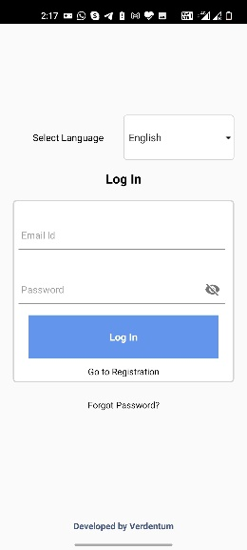
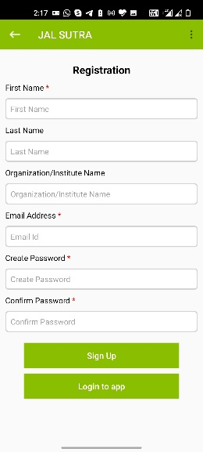
The app saves data for future nonprofit research for development purposes by the International Crop Research Institute for the Semi-Tropics (ICRISAT), the International Food Policy Research Institute (IFPRI), and Foundation for Ecological Security (FES). The data would only be published or shared in an anonymous way, not revealing the facilitators or the players. The user needs to agree with this utilization of the data.
Figure 4 Login Window
Figure 3 Signup window
Please download the JAL SUTRA app through the Google Play store on your android device (mobile or tablet).
After successfully downloading the app to your device, you will need to register and login. During registration, enter your first name, last name, organization name, and email address. You will further be asked to create a password. After entering the mandatory information in the registration form, please click the Login button [Figure 3Error! Reference source not found.].
For login, use your email address as a user ID and enter the password you have given at registration [Figure 4Error! Reference source not found.].
In case you forgot your login details, use the “forgot password” button in the login window and follow the instructions [Figure 4Error! Reference source not found.].
Your device requires Internet access for downloading, registration, initial login, and uploading data. Once you have done the initial login, the app will keep you logged in, and you can use the app offline.

Platform to Conduct Virtual Game Session
There are many free web or video conferencing software options available. The user can arrange the training session with the help of any available virtual meeting platform as per the convenient for the trainer and participants.

Choosing Game Participants
The virtual version of the game has mainly educational purposes. It targets anybody who wants to experience a framed common pool resource learning game. The game can of course also be played with stakeholders in the Indian water sector to make them reflect on the coordination challenges of local communities using channel irrigation.

Facilitation Team Roles and Responsibilities
An optimal facilitation team comprises the lead facilitator [LF], and a data-entry operator [DEO]. The facilitator guides the game and is primarily responsible for player interaction. The data-entry operator make decision slides live and enters the player’s decisions and notes the content of discussions into a mobile application.
 | Lead Facilitator [LF] | Data-Entry Operator [DEO]
Skills | - Listen to participants  - Able to speak in the local Language | - Knowledge of handling computer and android device
Responsibility | - Check required game material before conducting game session  - Explain procedure of the game in to participants  - Encourage participants during discussions | - Downloads and installs the JAL SUTRA app  - Prepare/Revise decision slides in Ahaslide  - Enter players’ information in JAL SUTRA app  - Send unique link to each player via private chat  - Make decision slides live  - Enter players’ decisions in the app  - Announces benefits received o the participants in each round  - Enters notes in the app

Basic Information of Location/Community
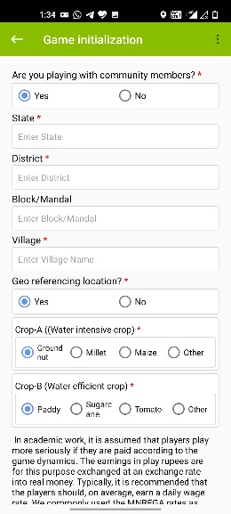
ICRISAT, FES, and IFPRI would like to use the information entered into the app for analysis on water management behavior and social learning processes. Any analysis would be conducted only in an anonymous way, i.e., not revealing who played or facilitated the game. ICRISAT, IFPRI, and FES ask you to approve the use of your data at the bottom of the Session Initialization window [Figure 5].
Figure 5 Game Initialization window
Once you complete a game session, the app will automatically create a data table with the session data, which you can store on your device.
The app is also used for facilitating games with community members. We assume that you are not playing the game with community members. It would be appreciated if you indicate this in the app. If you should use the virtual game, however, to play with communities, please indicate the same on the top of the Game Initialization window [Figure 5].
The app allows to label crops. We recommend not to label crops in the virtual game session unless you play with actual water user communities. You then have the choice to use a more locally adapted framing for the game by labeling the crop options according to crops typically grown in the community. It has been observed that this increased the learning effect. At the same time, please be aware that the water requirements and income amounts defined in the game will not fit to the crops of the community. This may raise questions amongst the participants. In case you want to label the crops, please ask the participants about the major crops which community members grow during the post rainy season. Among these crops, select one water-intensive crop and a crop that uses less water.

Exchange Rate
In academic work, it is assumed that players take the game more seriously if they are paid according to the game dynamics. In case you want to play the virtual game with incentivized payments, then the earnings in play rupees are exchanged at an exchange rate into real money. You can enter the exchange rate for play money to real rupees in the app or leave it at the value of zero in case you do not plan to pay the players [Figure 5].

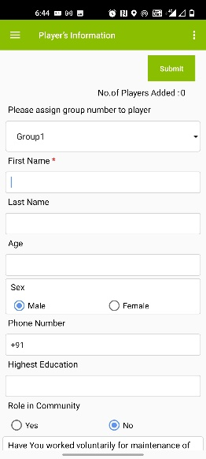
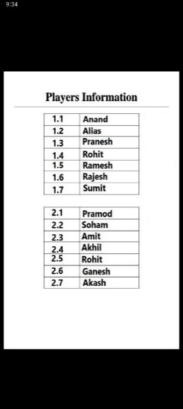
Registration of Participants
Figure 7 Option to download PDF
Figure 6 Players' Registration window
Figure 8 PDF showing player’s group and position
[LS] Select seven players for the game session. [DEO] Please enter the first name of the players in the app. In the app all other information on the last name, age, sex, education, contact number, role in the community, plot-related information, and players’ past water management actions is optional but useful for future analysis when we play the game with farmers [Figure 6].
After entering all participants’ basic information, the app will offer you to create a PDF to show the player’s group [Figure 7 and Figure 8]. You can save the PDF on your devise as you will need it for sending unique links to the players to login in Ahaslide to take their decision in the game.

Replace/Substitute Player
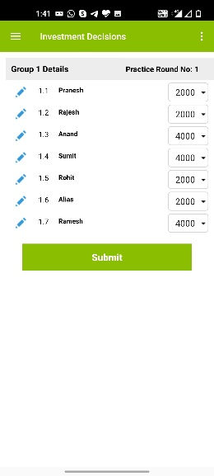
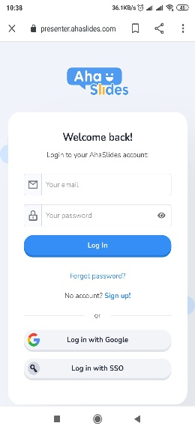
Sometimes, a player needs to leave the game. In such situation, a facilitator can substitute for the player. The app will permit this substitution. The edit option is provided in each round’s investment decisions window [Figure 9]. By clicking on the blue pen icon left to the name, the facilitator can replace the player and enter basic information of the new player and DEO need to send unique link of decision slide to new player.
Figure 9 Replacement Option
Figure 10 Signup Window
Figure 11 Login Window

Preparation of Player’s Decision Slides on Ahaslide
Ahaslides is an interactive presentation software for events, workshops, meetings, and classes. Ahaslides offers many items such as multiple choice questions or quiz competitions which allow to interact virtually with audiences.
Below we describe the process of prepare game decision slides in Ahaslide:

- Signup in Ahaslide:
First you need to sign up in the Ahaslide under https://presenter.ahaslides.com/pages/login ) [Figure 10].
- Login in Ahaslide:
Once you successfully signup, please login in the Ahaslide by entering user name and password [Figure 11] which is given at the time of sign up.
- Prepare new presentation in Ahaslide:
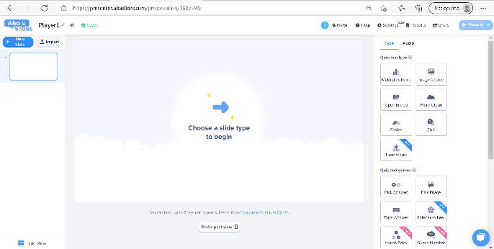
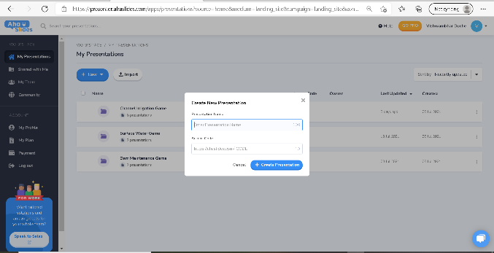
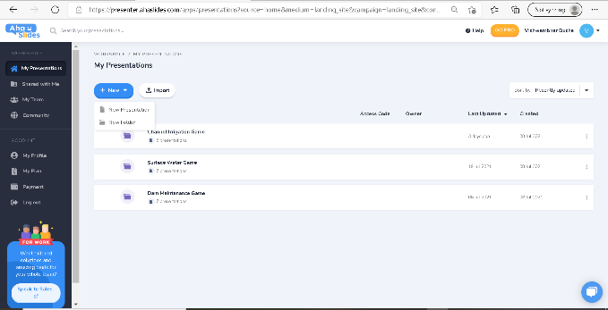
After successfully login in to the Ahalside, click on “New” tab (left hand side on window, see Figure 12). After that select “New Presentation”. After selection of “New Presentation”, one message box will pop up. Please enter the presentation name [Figure 13]. We recommend to prepare separate presentations for each player [in total seven presentations]. Name the presentations by player number. Ahaslide allows users to create access code for presentations. This provision is made below the presentation name. We recommend to assign unique access codes to the presentation of each player and also chose access codes in such way that the players can understand their field position in the group in the game. For example, we have given the access code https://ahaslides.com/PLAYER1 to the presentation file of the first player. In this way, the player better understands which code belongs to her and confirms the position of her field in the game.
Figure 14 Preparation of decision slide
Figure 13 Provide presentation name and Access code
Figure 12 Prepare new presentation in Ahaslide
- Preparation of Decision slides:
Once you have assigned a presentation name and access code, click on create a presentation [Figure 14]. This will allow you to create decision slides. Question type options are provided on the right side [Figure 14]. Please click on the option for multiple choice type of question slides. You now have the opportunity to enter your question.
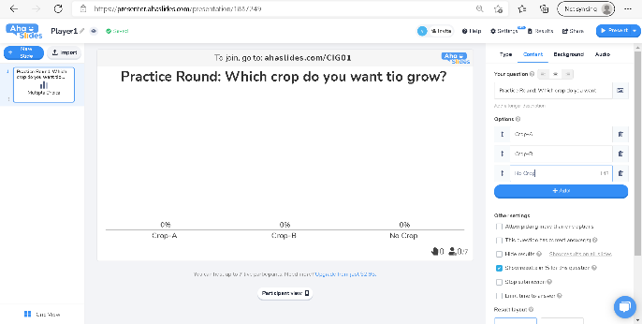
In the channel irrigation game, the player chooses in each round between the water efficient and water intensive crop. The player would make this choice in each of the 6 game rounds. In addition, there would be a practice round to allow the players to better understand the game flow. The first slide would therefore need to have the question: Practice Round: Which crop do you want to grow? [Figure 15].
Figure 15 Option to type questions
In the channel irrigation we give three options to player to choose i.e. Crop-A, Crop-B and No crop. Please enter these three option in the question answer option box.
Bellow the option, other setting options are given. Please uncheck all these options.
The first round of the game is played without letting other players know the decisions. At the same time we want to let each player know what they earned. For this purpose, we add one slide (to reveal result of the round) after the first round’s crop choice decision [Figure 27].

Once you create the first decision slide, you repeat this process for each round. Add a slide by clicking on the “Add slide” option on the left side. Alternatively, you can right click on the first slide and duplicate or edit it. At the end, you need the following slides with the following content:

Slide No. | Questions
1 | Practice Round: Which crop do you want to grow?
2 | Round 1: Which crop do you want to grow?
3 | You have earned INR XX,XXX in Round 1
4 | Round 2: Which crop do you want to grow?
5 | You have earned INR XX,XXX in Round 2
6 | Round 3: Which crop do you want to grow?
7 | You have earned INR XX,XXX in Round 3
8 | Round 4: Which crop do you want to grow?
9 | You have earned INR XX,XXX in Round 4
10 | Round 5: Which crop do you want to grow?
11 | You have earned INR XXXXX in Round 5
12 | Round 6: Which crop do you want to grow?
13 | You have earned INR XXXXX in Round 6
Note: User can download decision slide template from https://presenter.ahaslides.com/share/cig_virtual_game_template-1630585148839-affj9rxwbc. The user can click on the link and can open the template. “Copy to your account” option is provided on right side of the slide. Once user click on “Copy to your account”, the template will save on user’s Ahaslide account. Template is for one player, with the help of saved template, user can edit and prepare decision slides for remaining (six) players.

General Instruction to Participants
[LF] Introduce yourself and your team [Figure 16]. Explain the context in which you are playing the game.
For easy facilitation of the game process, the JAL SUTRA app includes the facilitation procedure in bullet points. The facilitator can see them in Hindi or in English.
Below is a proposal how our [LF] typically enters the facilitation of the game:
Imagine that you live in a region where the allocation of water from a channel is an issue. People have noted that the channels are extremely useful for the community members as they help them to grow crops in the post rainy season. Often, however, only few farmers benefit. But how to deal with this situation? We want to play a game with you to jointly explore this challenge and to develop ideas how to solve this challenge.
The game is all about the allocation of water from the channel in a village. In our game, we assume a channel which provides a certain amount of water for irrigation to farmers connected to it. The amount of available water depends on the rainfall in the round representing a year. If there is good rainfall, farmers can take 20 irrigations. If there is poor rainfall, only 14 irrigations will be available. How many fields can be irrigated with this water depends, among other reasons, on the crops grown by the farmers?
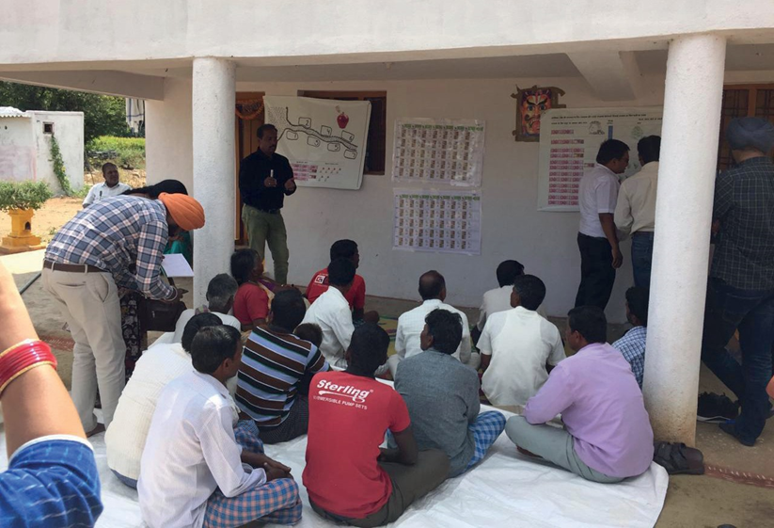
We will play game with 7 participants.
Figure 16 Facilitator explaining JAL SUTRA game to the participants
We will explain the game step-by-step. Please listen to the instructions carefully and ask questions at any point in time.

General Explanation
[LF] Below, you will find a proposal for explaining the game, which is how we have explained it in the past. This procedure considers the diverse challenges we faced in a large number of game sessions. Feel free to adapt this procedure to your specific needs.
Now that you learned about the main idea of the game, we want to explain how you can earn money by using water from the channel.
Slide 1 shows a typical water channel and seven fields downstream of the channel. Every field belongs to a farmer: farmer 1 is closest to the channel; player 7 the farthest away. Each of the farmers needs water to grow crops.
[LF] Point at the channel and the different field positions to illustrate this structure [Slide 1].
How much benefit you receive from the channel depends on the rainfall conditions and the crop cultivated by upstream farmers? The relationship between the rainfall and available irrigations can be seen in the table on Slide 2. We will flip a coin to decide on the rainfall in each round. If the coin shows tail, then rainfall will be high, and the group gets water sufficient for 20 irrigations. If the coin shows a head, the rainfall is low and the water available to the group will be 14 irrigations [See Slide 2Error! Reference source not found.].
[LF] Point at the first and second column of the Slide 2 and show how much irrigations will be available for the group depending in the rainfall.
Now, we come to the main decision of each round, which concerns the choice of crops. We will send one unique link to each player through the private chat. The players need to click on that link or can copy the link and open it in a browser.
Show the Crop choice decision slide [Figure 17].
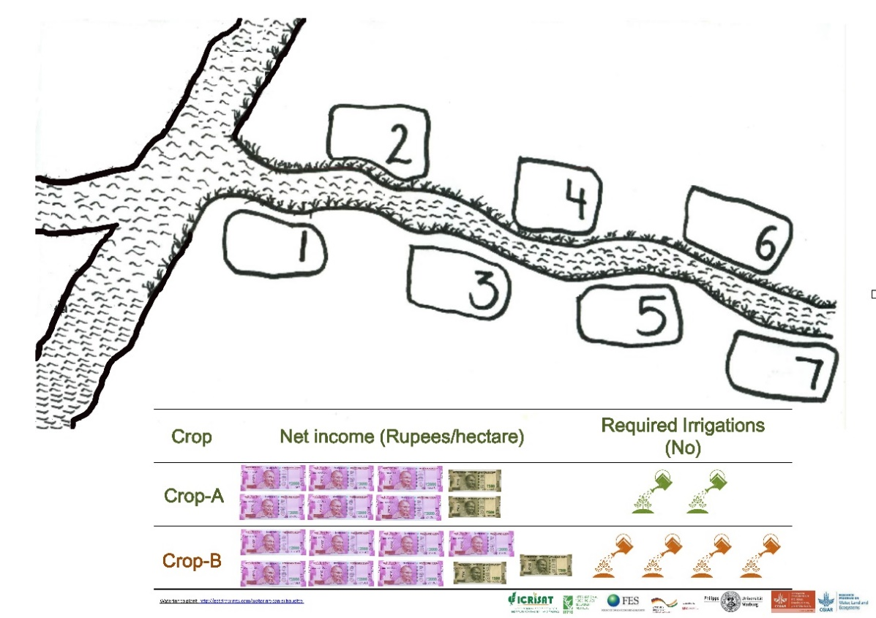
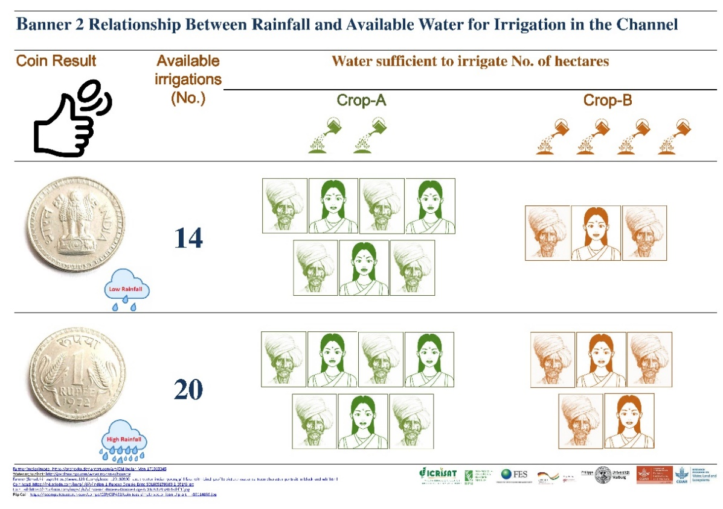
Please note that the last number of each player’s link indicates his/her field position. Keep this position in mind as the water flows from the top to the bottom. The farmers farther up can first take the water; the next farmer can only take from what is left. It continues like this until the water is finished.
Slide 1 Player Position and Benefit from Crop Banner
Slide 2 Payoff Table

In the crop choice decision slide [Figure 17], you can mark which crop you want to grow: Tick the front left box which crop do you want to grow in that round. In the slide we have provided three option Crop-A, Crop-B and No crop. Taking all costs and labor inputs into account, Crop-B gives a better return per hectare than Crop-A, but crop-A requires substantially less water: Crop-B requires four irrigations per season and Crop-A two irrigations.
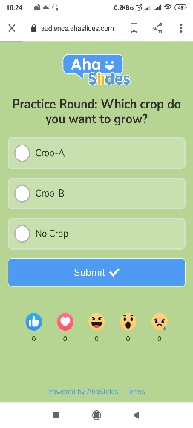
In the game availability of irrigation water from the channel is depend on the rainfall. In the game we use to flip the coin to know the situation of rainfall in that round. If the coin shows tail, then rainfall will be high, and the group gets water sufficient for 20 irrigations. If the coin shows a head, the rainfall is low and water available to the group will be 14 irrigations only. The available water can be used by the players to irrigate a post-rainy crop.
Figure 17 Crop Choice Slide

Practice Rounds
[DEO] In the app, after the introduction window, you get to the window offering you to either directly start the game or play practice rounds. If you want to continue with practice rounds, click on the respective button [Figure 18]. You can then follow the instructions below. If you do not want to play practice rounds, jump to the section Start the Game.
We will now practice this with you.
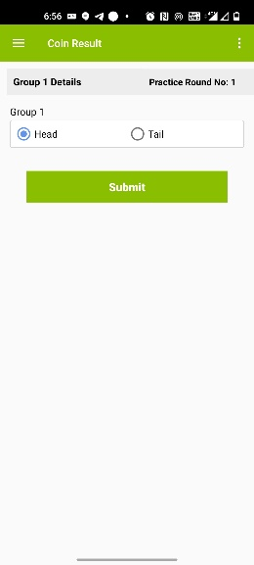
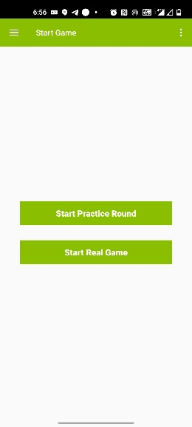
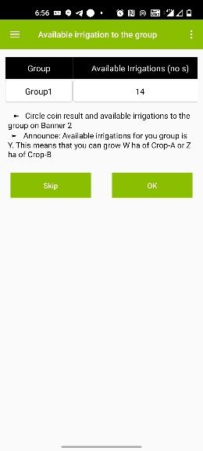
[LF] Ask one representative of the group to toss the coin and toss the coin. Enter the side of the coin into the app [Figure 19] and circle the rainfall situation and available irrigations to the group on slide 2 and write numbers of irrigations available to the group on channel Banner [Slide 1].
Figure 19 Coin Result
Figure 18 Option to play practice game or real game
Figure 20 Available irrigations to the group
For your group rainfall is (low/high) and this gives you Y number of irrigations. This means you can grow W ha of Crop-A or Z ha of Crop-B.
We will make crop choice slides live. Please click on the link or copy link from your chat box and open it in through browser.
You can now take your decision for the practice round on the first Ahaslide. After you have taken your decision and clicked on the submit button, please keep the Ahaslide window open. You need it to take the decision of the subsequent rounds.
Please select which crop do you want to grow in the round and click on submit button once you have taken your decision.

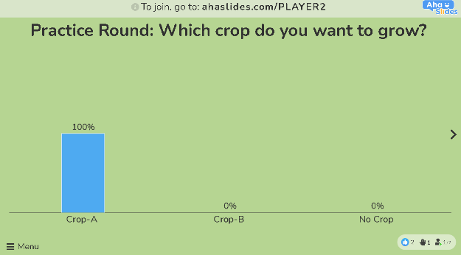
[DEO] Make all players’ practice round’s crop choice decision slide live (to make slide live click on “Present” tab (right top side of window)).
Figure 21 Player submitted his/her decision
[DEO] After the players made their decision [Figure 21], it will display on the respective players slide. Please enter the decisions into the app [Figure 22]. The app will calculate the earnings of each player [Figure 23].
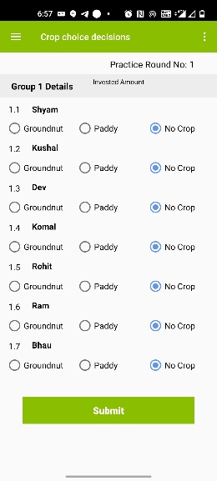
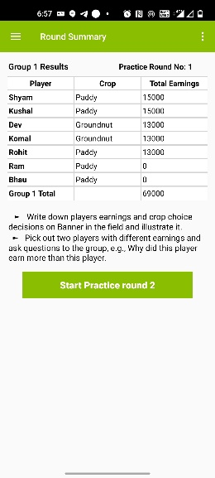
[LF] For each player, write the crop choice and earning on the Slide 1. Pick out two players with different earnings and ask the group:
Figure 22 Crop Choice decisions
Figure 23 Round Summary
Why did this player earn more than this player?
[LF] Use the group to improve the understanding of the game. Let players who understand faster explain the logic using their own words. Explain again with the Slide 1 if anything is still unclear.
Now compare the first and the last player. Typically, player seven did not get water.
Why did this player earn more than this player?

Starting the Game
[LF] Once all participants understand the rules, you can start playing the game. In the first round, players should not talk and not let know others which crop they chose.
Now let us start playing the game. For your very first game round, we want you to make your decisions without anybody else knowing what you decided. Nobody will be able to find out.
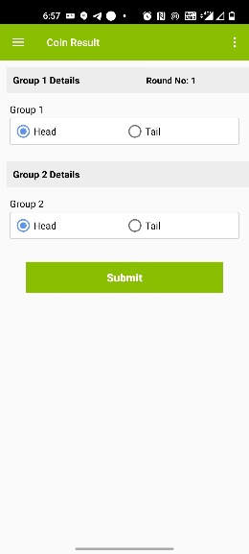
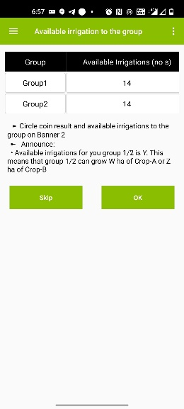
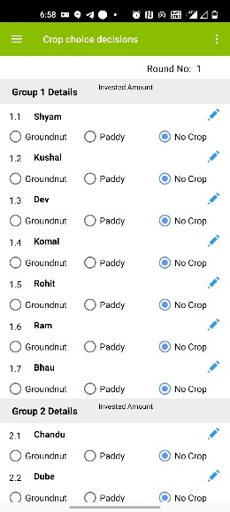
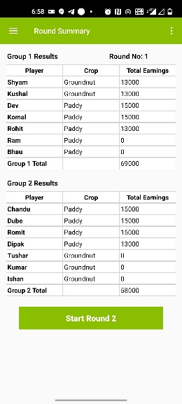
[LF] Please request a representative of the group to toss a coin. [DEO] Enter the result of the toss in the app [Figure 24]. The app will tell you the available irrigations [Figure 25]. [LF] Mark the available number of irrigations on the Slide 1.
Figure 24 Coin Result-Round 1
Figure 25 Available irrigations-Round 1
Figure 26 Crop Choice Decision-Round 1
Figure 27 Round Summary- Round 1
Now you can see the water available to all of you in this round. We now make the crop choice slides live. Please take your decision which crop do you want to grow in this round and click on the submit button.
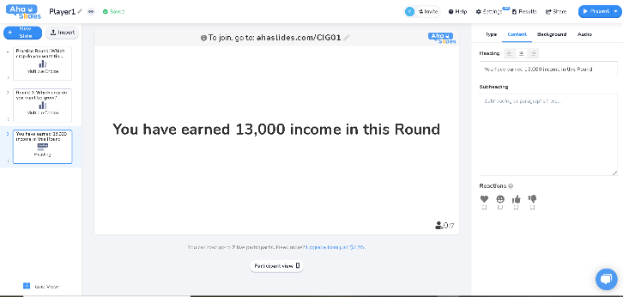
[DEO] Once the player submit their decision start entering the decisions into the app [Figure 26].
Figure 28 Revealing result- Round 1
[DEO] Once all players’ crop choice decisions are entered, the app will tell you the individual earnings [Figure 27]. Write player’s individual earning on respective player’s Ahaslide and make it live [Figure 28].
You can now see in Ahaslide how much you have earned in this game round.

Allowing Discussion and Revealing the Individual Decisions
From round 2 onward, we will allow the players after each round to discuss for five minutes. Yet ethically this can only be done if the players agree to it. We therefore ask participants whether they agree to reveal their decisions openly (Figure 29]. If the participants agree, we will reveal all crop choice decisions on the record sheets [Slide 3]. If not, we continue with the same procedure as in the first round.
Now we play the same game for another 5 rounds. You have, however, the option to discuss after every round. We also offer you to reveal openly which crops each of you has chosen. This means that all other players will get to know your decision. Is there any player who disagrees with the new rules? Is there anybody who would not want the players to discuss and to let us reveal the decisions? Anybody disagreeing, please raise your hand or voice.
In case there is disagreement in a group, you continue playing the game as round 1 has been played. In case there is agreement, follow the instructions below. In any case, please record the decision in the app.
[LF] Please write the names of the players at the empty space on the top of the record poster [Slide 3]. Make sure you put the right name to the right group and player position (use DEO to write the name). The earlier created PDF [Figure 8] tells you the group and position of each player.
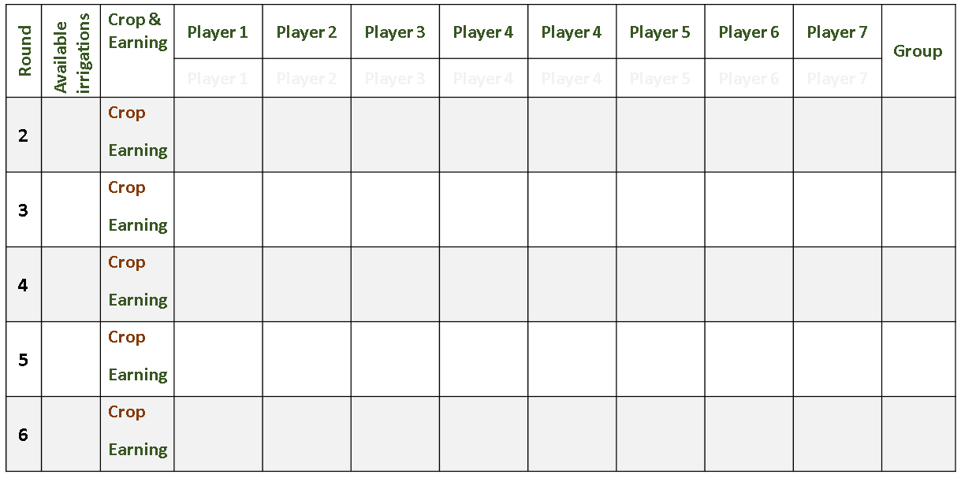
Now you play the same game for another 5 rounds and we will inform you about which crop each player chose, and how much they earned. We use this poster [Slide 3] for this purpose. You will also naturally find out with whom you are playing.
Slide 3 Record poster use for revealing results openly
[LF] Show the empty Record Poster [Slide 3]!
In addition, you can now discuss amongst each other as soon as you have given back the decision cards. You have for every round a maximum of five minutes for discussion.
[LF] Request a representative of the group to toss the coin. [DEO] Enter the result of the coin into the app. The app will tell you the numbers of irrigations available for each group. [LF] Mark the available number of irrigations for the group on the Slide 2.
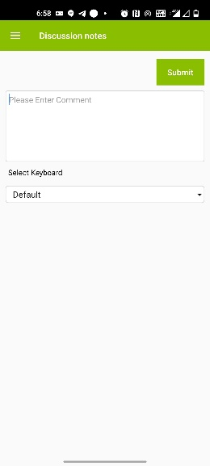
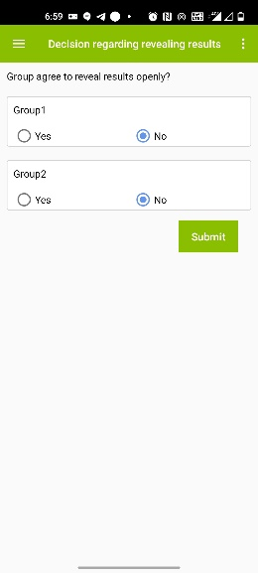
Now you can see the water available to all of you in this round. We now make crop choice decision slide live. Choose which crop you want to grow in this round.
Figure 30 Discussion Notes
Figure 29 Window to enter whether group is agree to reveal results
[DEO] Make crop choice slide live [Figure 17]Error! Reference source not found.. As soon as a player gave their decision, enter the decisions into the app. [DEO] once all crop choices are entered, the app will tell you the individual earnings.
[LF] Please write on the Record Poster [Slide 3] each player’s individual crop choice decision and earning as well as the total group earning. In case, the group did not agree to reveal the decision openly, write the earning of the player on the Ahaslide and make it live [Figure 28]. Once you have finished this task, the players may discuss in the groups.

Discussions
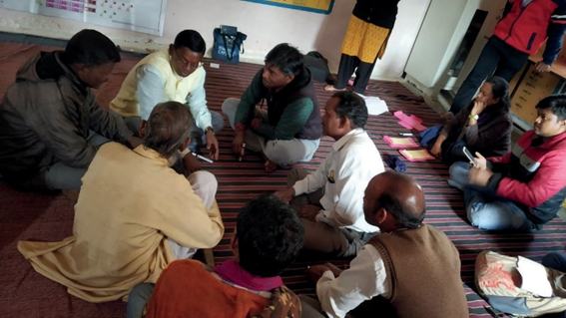
After revealing results on the record poster or privately through Ahaslide, announce that the players now have five minutes time to talk to each other. [DEO] Check the discussion time.
Figure 31 Players' Discussion
Now you have five minutes time to talk to each other.
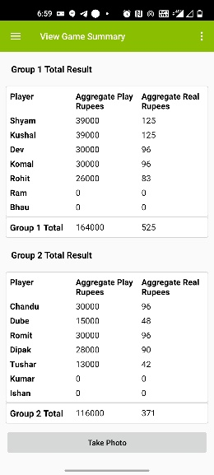
We recommend to avoid interfering in the participants’ discussions. The idea of the game is to let community members find their own solutions. Avoid probing and lecturing. The less the facilitators talk during the discussion the better. [AS] Consider taking notes of the discussion as this may provide input for further discussions with the community at a later stage. The app allows you to record notes [Figure 30]. After five minutes of discussions, repeat the procedure of round 2.
Figure 32 Game Summary
[LF] Repeat the procedure five times/rounds.

Conclusion and Departure after the Game
[DEO] After completing the sixth round, the app will show you a game summary and the data table of the session will be created [Figure 32].
After completion of the game session, clear all results from the Ahaslide. So that it will use for next game session.

Picture References
Picture | Reference
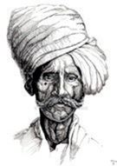 | https://orehovka.deviantart.com/art/Old-Indian-Man-171013045
 | https://www.123rf.com/photo_129100900_stock-vector-indian-young-girl-face-with-bindi-profile-picture-avatar-cartoon-character-portrait-in-black-and-whi.html
 | http://getdrawings.com/watering-can-silhouette
 | https://fscomps.fotosearch.com/compc/CSP/CSP433/coin-toss-simple-vector-icon-clip-art__k83114059.jpg
 | https://n4.sdlcdn.com/imgs/i/6/v/Indian-1-Rupees-Double-Edge-SDL605179380-2-071f6.jpg
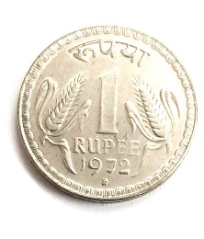 | https://n2.sdlcdn.com/imgs/i/6/v/Indian-1-Rupees-Double-Edge-SDL605179380-1-ddf1f.jpg

We have used Ahaslide. There are different other software packages available and the facilitator can choose anyone as per their convenient. We have explained the setting up of required Ahaslides under section <Preparation of Player’s Decision Slides on Ahaslide> below.

