Manual August 2021

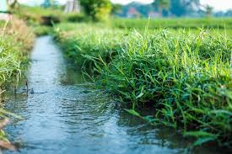
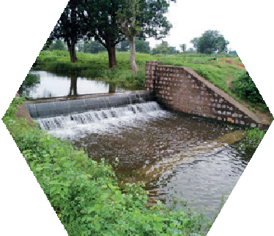
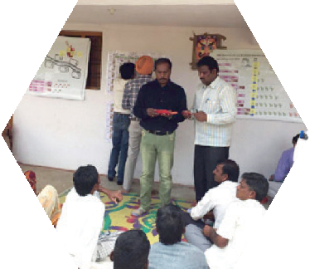
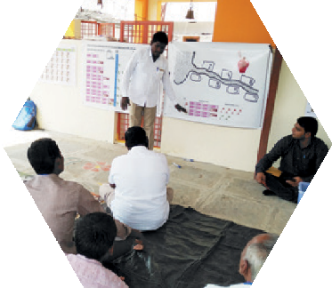
JAL SUTRA game
Joyful gAme Learning – Shaping rUles Together for Rural wAter management

Channel Irrigation Game Manual

Copyright © International Crops Research Institute for the Semi-Arid Tropics (ICRISAT), 2021.

This publication is licensed for use under a Creative Commons Attribution 4.0 International License (CC BY 4.0). Subject to attribution, you are free to share (copy and redistribute the material in any medium or format), adapt (remix, transform, and build upon the material) for any purpose, even commercially as long as ICRISAT is properly cited. To view this license, visit https://creativecommons.org/licenses/by/4.0.

Suggested citation: International Crops Research Institute for the Semi-Arid Tropics (ICRISAT), Foundation for Ecological Security (FES), and International Food Policy Research Institute (IFPRI). 2021. Channel Irrigation Game Manual. ICRISAT and FES, India; IFPRI, USA, www.gamesforsustainability.org, accessed date

We welcome requests to translate, adapt, reprint, or otherwise reproduce the material in this document in noncommercial and educational contexts, provided that the source is credited by including the suggested citation above. For any other purposes, contact us for permission. We would appreciate receiving copies or links to any work that adapts or refers to this work; kindly send such references to: Thomas Falk <t.falk@cgiar.org>.

Contents
Acknowledgments 4
Informative Video on the Channel Irrigation Game 5
Background 6
How to Use this Manual 8
Basic Structure of the Game 8
Materials Required 8
Get Ready to Use the JAL SUTRA App 9
Venue 9
Choosing Experiment Participants 10
Facilitation Team Roles and Responsibilities 10
Set Up Banners and Posters 10
Basic Information of Location/Community 11
Exchange Rate 11
Registration of Participants 12
Replace/Substitute Player 13
Preparation of Decision Envelopes and Cards 13
General Instruction to Participants 13
General Explanation 14
Practice Rounds 16
Starting the Game 17
Allowing Discussion and Revealing the Individual Decisions 18
Discussions 19
Conclusion and Departure after the Game 20
Picture References 21

Acknowledgments

Original Game Design
The game was developed by the International Crops Research Institute for the Semi-Arid Tropics (ICRISAT), the Foundation for Ecological Security (FES), and the International Food Policy Research Institute (IFPRI). ICRISAT based in Hyderabad, India and IFPRI based in Washington DC, USA are nonprofit non-government international research institutes conducting agricultural research for development in semi-arid tropics around the world. FES is a nonprofit non-government organization based in Anand, Gujarat, India, working toward the ecological restoration and conservation of land and water resources in ecologically fragile, degraded, and marginalized regions of the country. Verdentum developed a mobile phone application to support the facilitation of the game.

International Crops Research Institute for the Semi-Arid Tropics (ICRISAT)
Thomas Falk, Vishwambhar Duche

Foundation for Ecological Security
Pratiti Priyadarshini, Richu Sanil

International Food Policy Research Institute (IFPRI)
Ruth Meinzen-Dick, Hagar ElDidi

Funding: This work was undertaken as part of the CGIAR Research Programs on Policies, Institutions, and Markets (PIM) led by the International Food Policy Research Institute (IFPRI) and Water, Land and Ecosystems (WLE) led by the International Water Management Institute (IWMI), supported by the CGIAR Trust Fund. It received financial support from the German Federal Ministry for Economic Cooperation and Development (BMZ) commissioned and administered through the Deutsche Gesellschaft für Internationale Zusammenarbeit (GIZ) Fund for International Agricultural Research (FIA), grant number: 81250397. The opinions expressed here belong to the authors, and do not necessarily reflect those of ICRISAT, IFPRI, IWMI, PIM, WLE or CGIAR.

Informative Video on the Channel Irrigation Game
We have prepared a video which explains about the process of facilitation of the Channel Irrigation Game. This will be help user to understand the process of facilitation of the channel irrigation game. The video is available on <Please provide video link here>

Background
India is one of the world’s most intensive water users: by 2050, the country will be withdrawing 80% of its available water resources. There are dramatic predictions of water demand exceeding supply by twofold within the next 10 years. Agriculture is the largest water user, accounting for close to 90% of all groundwater abstracted. The Indian government and development partners have invested billions of dollars in participatory watershed development. At the same time, many regulations and subsidies provide incentives to use water inefficiently.
Specific agricultural water management challenges occur in the context of large-scale infrastructure such as big dams or channels. Such infrastructure is an important source of irrigation especially in the post-rainy season. Typically, large dams and channels are managed by the government and water is provided on the basis of fees. In India today, such fees are very low neither reflecting the costs of provision nor the economic and ecological value of the water. This makes irrigation water also accessible and affordable to poor farmers. At the same time, the low costs create incentives to inefficiently use water. In the face of the aforementioned water crisis, this further contributes to the nation-wide water shortage. Especially in poor rainfall years, many communities also report conflicts about the allocation of water which is then insufficient for all farmers to grow their preferred crops.
This is a good example for water users imposing unintended consequences onto each other. Consequently, coordination of individual actions is needed to achieve social desirable outcomes and make everybody’s behavior predictable. Rules and norms play an important role in this coordination effort. Therefore, stronger attention needs to be paid to the capacities of communities to design or change rules or by-laws and enforce them to ensure sustainable water management in the interests of the whole community as well as the nation.
The developers of the JalSutra Channel Irrigation Game are driven by the question how the emergence of adapted and sustainable natural resource governance can be facilitated at scale. The game is a structured approach which allows implementing agents to facilitate social learning in communities at scale. The tool enables facilitators to embed governance interventions into large development initiatives.

Hyderabad/India
August 2021
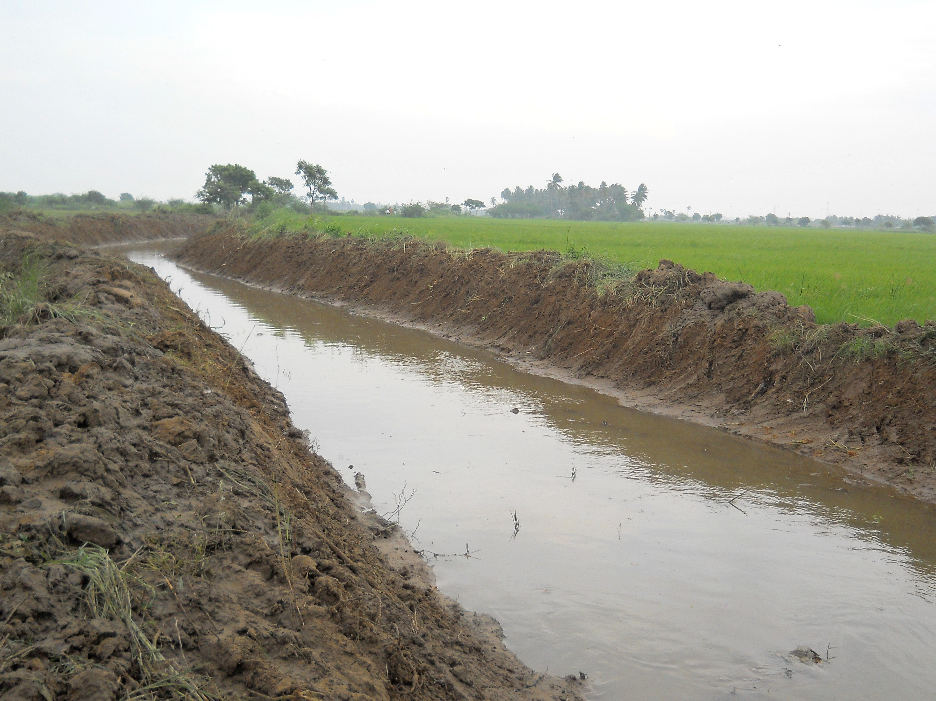

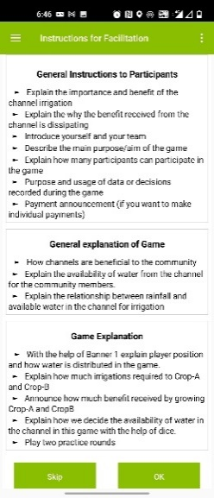
How to Use this Manual
Figure 1 Facilitation instructions
This document provides guidance on how to use the channel irrigation game tool. Note that text written in red color are statements that we propose to be given directly to the players. Black colored texts are instructions for facilitators only. The specific facilitation team member is highlighted before each instruction as our proposal for the distribution of responsibilities. This manual is prepared to describe the game structure and its facilitation. Once the user understands the process of the game, facilitation instructions (in bullet points-Figure 1) provided in the JAL SUTRA mobile application will help the user to facilitate the game.

Basic Structure of the Game
Before we go into detail on how to facilitate the game, let us explain its basic structure. The JAL SUTRA Channel Irrigation game simulates the management of water from a water supply channel. In the game, there are seven farmers having their fields underneath the channel. Each farmer has a field of the same size, namely 1 hectare (ha). We assume that the distance to the channel influences the farmers’ access to the channel water. As the water flows from the top to the bottom, the farmer living closest to the channel can withdraw water first. Only what he/she does not use becomes available to the second farmer. Only what the second farmer does not use becomes available to the third farmer and so on - up to farmer seven. The amount of water the government allocates to the seven farmer is thereby limited.
In the game, the seven players need to take decision on the selection of the crop they wanted to grow. They can choose between a more profitable crop which requires more water and a water efficient crop which gives slightly less income. The water is insufficient for everybody to grow the water consumptive crop. In fact, there will be no water available for the tailenders if upstream players choose the water consumptive crop. Consequently, the individual player’s income in the game depends on his/her own crop choice and the crop choices of players who are above them along the channel.
Another feature of the game we consider is that water availability depends on the rainfall in a particular year. In years with low rainfall, the government will offer less water. This is reflected in the game by flipping a coin. If the coin shows tail, then rainfall will be high, and the group gets water sufficient for 20 irrigations. If the coin shows a head, the rainfall is low and water available to the group will be 14 irrigations only. The available water can be used by the players to irrigate a post-rainy (winter) crop.

Materials Required
The following materials are required to play the game:
- Android device with JAL SUTRA app (see below)
- 1 banner showing player positions and benefits from crops [Banner 1] (A0 paper size)
- 1 payoff table [Banner 2] (A0 paper size)
- 4 laminated record posters [Record Poster 1 and Record Poster 2] (A0 paper size)
- 15 Laminated crop choice cards [Figure 12] (A5 paper size)
- 2 One-rupee Coins
- 20 erasable markers
- 2 cleaning cloths
- 25 envelopes big enough to fit the crop choice decision cards
- 15 reusable name tags
- Strings and adhesive tape (two- and one-sided) to set up the posters

Electronic copies of the channel irrigation game manual, posters, banners, and decision cards are available at https://gamesforsustainability.org/practitioners/#game-on-managing-check-dams.
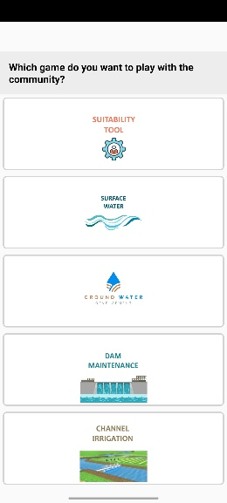
Figure 2 Options to select intervention

Get Ready to Use the JAL SUTRA App
The JAL SUTRA mobile application supports the facilitation of the game by
- assisting the facilitators to identify suitable intervention [Figure 2] to use in the community depending on the situation of the selected community,
- giving the facilitator bullet-point reminders on each facilitation step (it is important to study this manual to understand the bullet points),
- allowing data entry,
- making necessary calculations, and
- allowing to save data during the game.
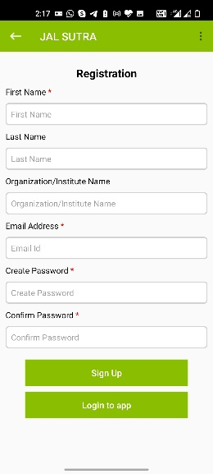
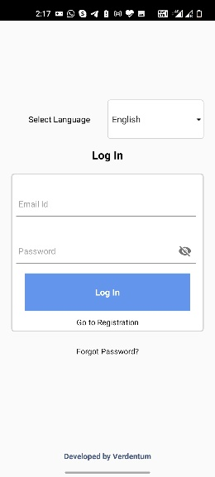
The app saves data for future nonprofit research for development purposes by the International Crop Research Institute for the Semi-Tropics (ICRISAT), the International Food Policy Research Institute (IFPRI), and Foundation for Ecological Security (FES). The data would only be published or shared in an anonymous way, not revealing the facilitators or the players. The user needs to agree with this utilization of the data.
Figure 3 Signup window
Figure 4 Login Window
Please download the JAL SUTRA app through the Google Play store on your android device (mobile or tablet).
After successfully downloading the app to your device, you will need to register and login. During registration, enter your first name, last name, organization name, and email address. You will further be asked to create a password. After entering the mandatory information in the registration form, please click the Login button [Figure 3Error! Reference source not found.].
For login, use your email address as a user ID and enter the password you have given at registration [Figure 4Error! Reference source not found.].
In case you forgot your login details, use the “forgot password” button in the login window and follow the instructions [Figure 4Error! Reference source not found.].
Your device requires Internet access for downloading, registration, initial login, and uploading data. Once you have done the initial login, the app will keep you logged in, and you can use the app offline.

Venue
We recommend to look for a quiet shady place with little disturbance, giving space to at least 20 people. Public meeting places, temple areas, or schools are good choices. You will need to hang two banners for writing purposes hence walls behind them are therefore helpful.

Choosing Experiment Participants
The target group of the game are farmers who live close to irrigation channels which are used for irrigating crops in the post-rainy season. Alternatively, the game can be played with community organizations. In a game session, seven or 14 participants can directly participate.

Facilitation Team Roles and Responsibilities
An optimal facilitation team comprises the lead facilitator [LF], a data-entry operator [DEO], and at least one assistant [AS]. The facilitator guides the game and is primarily responsible for player interaction. The data-entry operator enters the player’s decisions and notes the content of discussions into a mobile application. Assistants help the facilitator and the data-entry operator during the game.
 | Lead Facilitator [LF] | Data-Entry Operator [DEO] | Assistant [AS]
Skills | - Basic knowledge of channel irrigation system  - Listen to people  - Able to speak in the local language | - Knowledge of handling android devices | - Able to read and write
Responsibility | - Check required game material before going to village  - Explain procedure of the game in local language to participants  - Encourage participants to join the discussions | - Downloads and installs the app  - Enters player information in app  - Prepares decision cards  - Enter players’ decisions in the app  - Announces benefits received o the participants in each round  - Enters notes in the app | - Helps facilitator to fix posters and banners  - Helps data-entry operator in preparation of decision cards  - Hands over decision cards to the players and collects them after the players’ decisions  - Helps the data-entry operator in entering the players’ decisions in the app

Set Up Banners and Posters
For setting up the Banner 1, we recommend to use strings and/or adhesive tape. Make sure the banners are displayed in places that are easy for participants to see. In the game session, you can ask the participants whether they want to sit in a class room seating arrangement or in a circle. Alternatively, you can decide what feels more appropriate given current conditions. If you decide to have a class room seating, set up also the Record Poster 1 in front for instance on a wall [Figure 5]. If you decide to use a circular seating arrangement, place Record Poster 2 in the middle of the players on the ground. Be aware that you need to write on the record posters and that there should be enough space to seat all players in a circle around the posters.

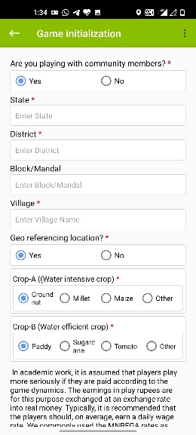
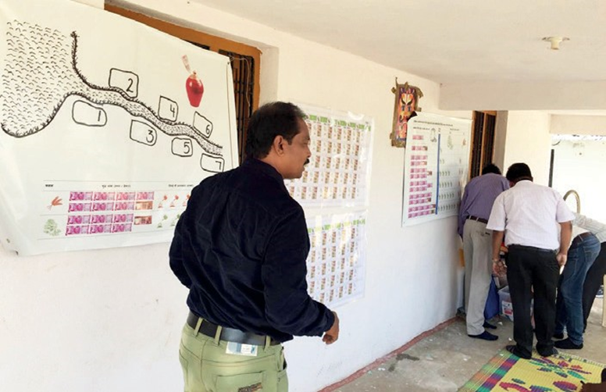
Basic Information of Location/Community
Figure 6 Game Initialization window
Figure 5 Setting up Posters and banners
ICRISAT, FES, and IFPRI would like to use the information entered into the app for analysis on water management behavior and social learning processes. Any analysis would be conducted only in an anonymous way, i.e., not revealing who played or facilitated the game. ICRISAT, IFPRI, and FES ask you to approve the use of your data at the bottom of the Session Initialization window [Figure 6].
Once you complete a game session, the app will automatically create a data table with the session data, which you can store on your device.
We would further like to know whether you are playing with community members or doing a training or demonstration session. Only games played with real community members are used for further analysis. If you are playing the game with community members, please indicate the same on the top of the Game Initialization window [Figure 6].
You have the choice to use a more locally adapted framing for the game by labeling the crop options according to crops typically grown in the community. It has been observed that this increased the learning effect. At the same time, please be aware that the water requirements and income amounts defined in the game will not fit to all the crops of the community. This may raise questions amongst the participants. In case you want to label the crops, please ask the participants about the major crops cultivated by the community members during the post rainy season. Among these crops, select one water-intensive crop and a crop that uses less water. Paste images of both crops on Banner 1 and Banner 2 using adhesive tape.
For monitoring how the tool is used, we request you to click on the GPS tab to record the Geo position of the site where you play the game.

Exchange Rate
In academic work, it is assumed that players take the game more seriously if they are paid according to the game dynamics. Our research also indicates that making incentivized payments increases the probability that players formulate rules for their real-life management challenge after they played the game. At the same time, many non-government organization (NGO) representatives feel uncomfortable making such payments. In case you intend to provide payments to the players, the app allows you to calculate how you have to pay each player after the game. Still, the payments are optional, and you can play the game without them.
In case you want to play the game with incentivized payments, then the earnings in play rupees are exchanged at an exchange rate into real money. Typically, it is recommended that the players should, on average, earn a daily wage rate. We commonly use the MNREGA rates as orientation, which are below INR 200. Accordingly, if you plan to play six rounds, we recommend an exchange rate of 1000 play rupees equal to 2.5 real INR.
Enter the exchange rate for play money to real rupees or leave it at the value of zero in case you do not plan to pay the players (Figure 6).

Registration of Participants
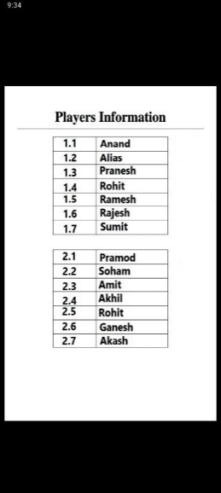
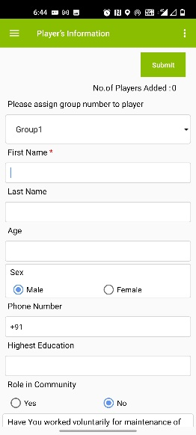
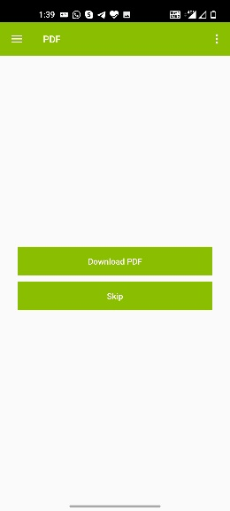
Please enter the basic information of all participants. At least a first name must be entered. All other information such as last name, age, gender, education, contact number, role in the community, plot-related information, and players’ past water management actions is optional but useful for future analysis [Figure 7]. In the player information window, the group option is provided on the top of the window to assign a group number to the player. This is important to give you the opportunity to control the gender composition of the groups. You can decide whether you want to play with mixed groups of men and women or if you want to let women and men play in separate groups. The facilitator in coordination with local staff or representatives from the community should determine what is appropriate.
Figure 9 PDF showing player’s group and position
Figure 7 Players' Registration window
Figure 8 Option to download PDF
It is mandatory to ask each player whether he/she agrees that the game data will be used in an anonymous way for nonprofit research for development purposes. Please indicate this in the registration form. Should a player disagree, emphasize that this decision is respected.

After entering all participants’ basic information, the app will offer you to create a PDF to show the player’s group [Figure 8 & Figure 9]. You can save the PDF on your devise as you will need it for the preparation of the game materials.

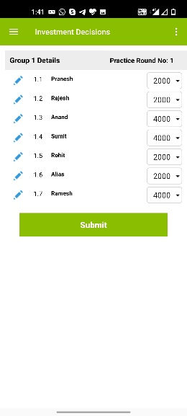
Replace/Substitute Player
Figure 10 Replacement Option
Sometimes, a player needs to leave the game. In such situation, a facilitator can ask other participants as substitute for the player. The app will permit this substitution. The edit option is provided in each round’s investment decisions window [Figure 10]. By clicking on the blue pen icon left to the name, the facilitator can replace the player and enter basic information of the new player.
[DEO and AS] Write the players’ names on the name tags and distribute them. The aforementioned PDF can be useful here.

Preparation of Decision Envelopes and Cards
[DEO and AS] Write the player group and position number on the envelopes using the before generated PDF [Figure 9]. Ensure that the name is written on the right envelope with the right group and position number as provided in the PDF. Place the crop choice cards [Figure 12] in the envelopes.

General Instruction to Participants
[LF] Introduce yourself and your team. Explain the project context in which you are playing the game [Figure 11].
For easy facilitation of the game process, the JAL SUTRA app includes the facilitation procedure in bullet points available both in Hindi and English. The facilitator should be able to access them.
Below is a proposal how our [LF] typically enters the facilitation of the game:
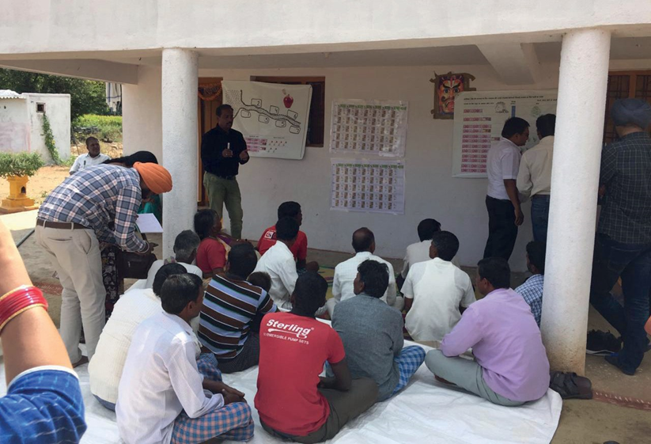
It has come to our attention that in your region the allocation of the water from the channel is an issue. People have noted that the channels are extremely useful for the community members particularly when growing crops during the post-rainy season. Often, however, only few farmers benefit. So how to deal with this situation? We are aware that this is a difficult situation, and we want to play a game with you to jointly explore this issue and to develop ideas how to solve this challenge.
Figure 11 Facilitator explaining JAL SUTRA game to the participants
The game is all about the allocation of water from the channel in your village. In our game, we assume a channel which provides a certain amount of water for irrigation to farmers connected to it. The amount of available water depends on the rainfall in the round representing a year. If there is good rainfall, farmers can take 20 irrigations. If there is poor rainfall, only 14 irrigations will be available. The number of fields that can be irrigated with this available water depends, among other factors, on the crops grown by the farmers.
We have gathered 7/14 people today to play our game.
In case you are playing with two groups, mention: You will play in two groups of seven players each. At the beginning of the game, you will not know who plays with whom in one group. We will tell you only later during the game.
We will explain the game step-by- step. Please listen to the instructions carefully and ask questions at any point in time.
Optional: As mentioned above, it is common in experimental economics to play such games with incentivized payments. In case you intend to make individual payments, please give the explanation below.
You can win real money in this game. How much you win depends on how you play as well as how the other participants play in the game. In the game, we play with play rupees; at the end, we will exchange 1,000 play rupees for <YOUR EXCHANGE RATE> real Indian rupees. The money provided is not our personal money; it comes from our organization/project.

General Explanation
[LF] Below, you will find a proposal for explaining the game, which is how we have explained it in the past. This procedure considers the diverse challenges we faced in numerous game sessions. Feel free to adapt this procedure to your specific needs. We generally recommend involving the players by asking questions rather than repeating explanations. This can motivate their active thinking; further, rephrasing explanations by fellow players help others to grasp the game rules.
Now that you learned about the main idea of the game, we want to explain how you can earn money by using water from the channel.
Banner 1 shows a typical water channel and seven fields downstream of the channel. Every field belongs to a farmer: farmer (player) 1 is closest to the channel; farmer (player) 7 the farthest. Each of the farmers need water to grow crops.
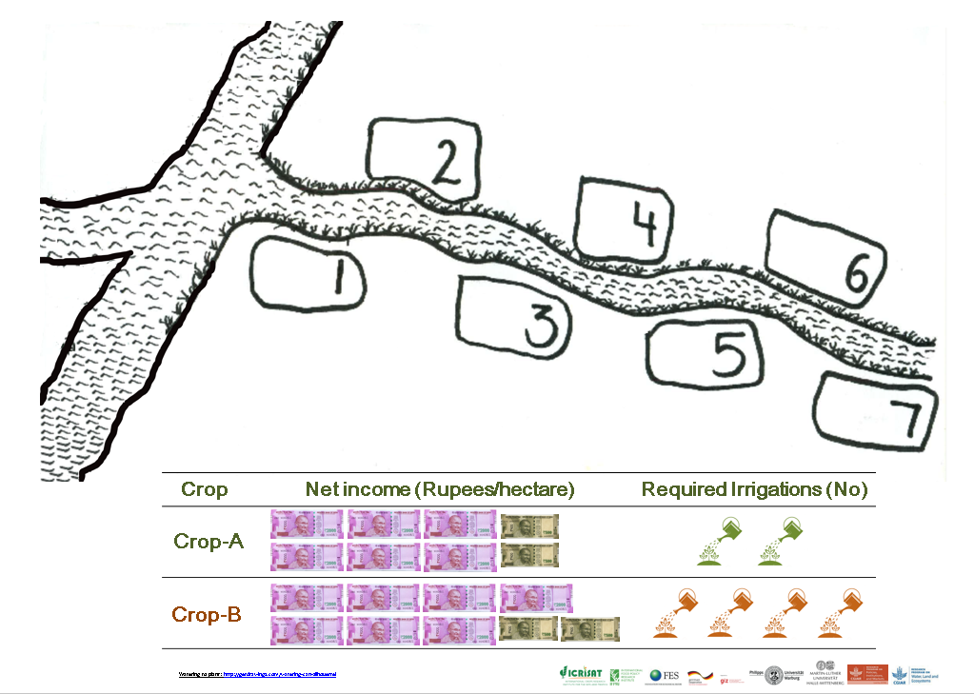
[LF] Point at the channel and the different field positions to illustrate this structure [Banner 1].
Banner 1 Player Position and Benefit from Crop Banner
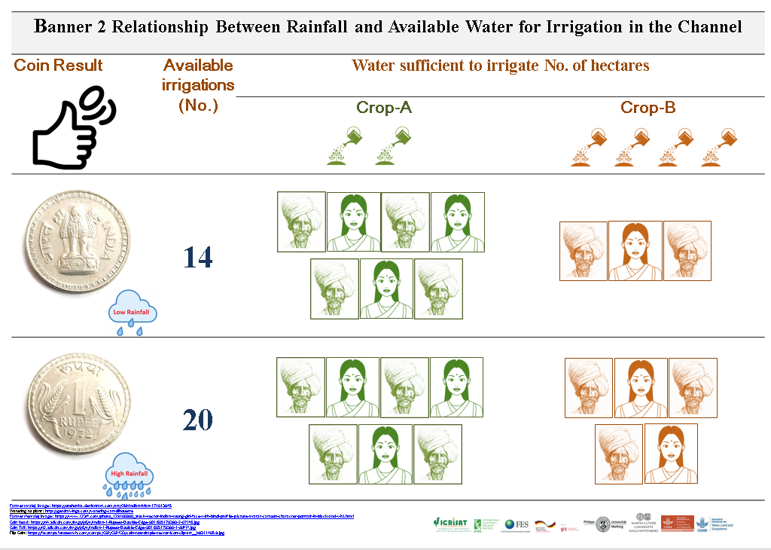
How much benefit you receive from the channel depends on the rainfall conditions and the crop cultivated by upstream farmers? The relationship between the rainfall and available irrigations can be seen in the table [Banner 2] in front. We will flip a coin to decide on the rainfall in each round. If the coin shows tail, then rainfall will be high, and the group gets water sufficient for 20 irrigations. If the coin shows a head, the rainfall is low and the water available to the group will be 14 irrigations [See Banner 2Error! Reference source not found.].
Banner 2 Payoff Table
[LF] Point at the first and second column of the Banner 2 and show how much irrigations will be available for the group depending in the rainfall.
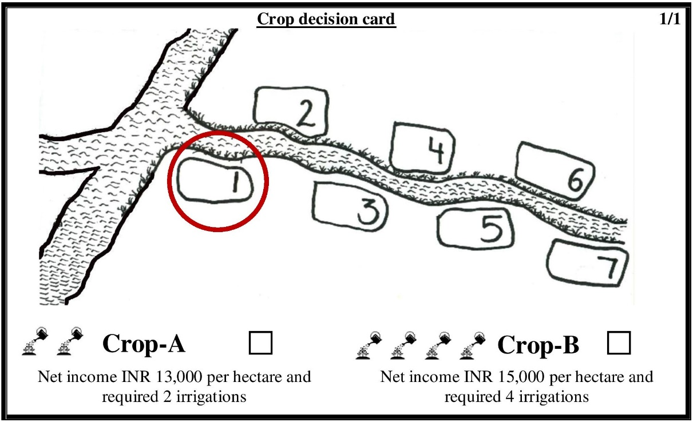
Now, we come to the main decision of each round, which concerns the choice of crops. We will distribute these cards to each of you.
Figure 12 Crop Choice Card
Show the crop choice cards [Figure 12].

In the upper part, you see the painting as on Banner 1. There is a channel and seven fields. You can find your field position on this card: It is the circled field. Keep this position in mind as the water flows from the top to the bottom. The farmers close to the main channel can first withdraw the water; the next farmer can only take from what is left. This continues until the water is completely utilized.
In the lower part of the card, you can mark which crop you want to grow: Tick the left box if you want to grow Crop-A or the right box if you want to grow Crop-B. Taking all costs and labor inputs into account, Crop-B gives a better return per ha than Crop-A, but crop-A requires substantially less water. Crop-B requires four irrigations per season and Crop-A two irrigations. If you do not want to grow a crop, then hand over your card to the assistant without ticking any box.

Practice Rounds
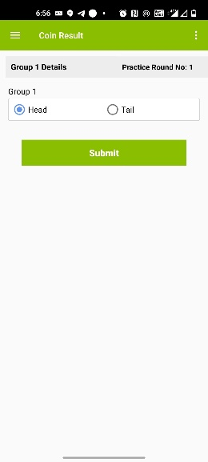
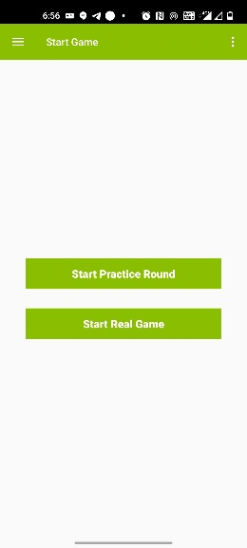
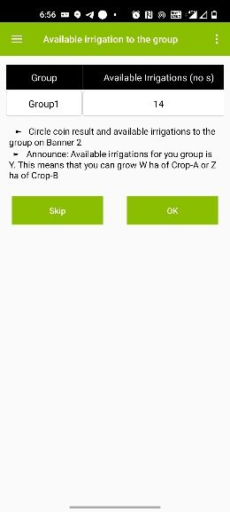
[DEO] In the app, after the introduction window, you get to the window showing to either directly start the game or play practice rounds. If you want to continue with practice rounds, click on the respective button [Figure 13]. You can then follow the instructions below. If you do not want to play practice rounds, jump to the section Start the Game.
Figure 14 Coin Result
Figure 13 Option to play practice game or real game
Figure 15 Available irrigations to the group
We will now practice this with seven of you.
[LF] Invite one representative of the group to toss the coin then circle the rainfall situation based on the coin outcome and available irrigations to the group on Banner 2 Then write the numbers of irrigations available to the group on channel Banner [Banner 1]. Enter the side of the coin into the app [Figure 14].
For your group rainfall is (low/high) and this gives you Y number of irrigations [Figure 15]. This means you can grow W ha of Crop-A or Z ha of Crop-B.
We will now distribute to each of you your crop choice card. Please tick the left box if you want to grow Crop-A or the right box if you want to grow Crop-B. If you do not want to grow a crop, then hand over your card to the assistant without ticking any box.
[AS] Hand the cards out to the players [Figure 12].
[AS] After the players made their decision, collect the Crop Choice Cards. [DEO] Enter the decisions into the app [Figure 16]. The app will calculate the earnings of each player [Figure 17].
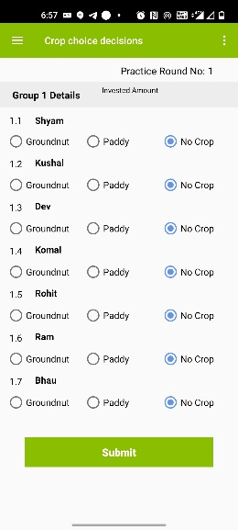
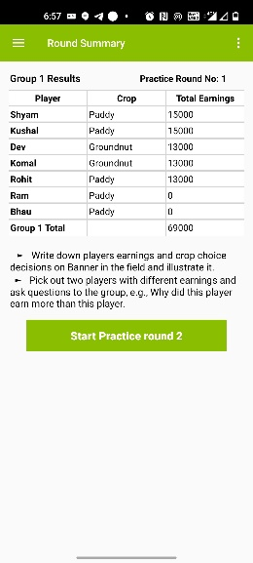
[LF] For each player, write the crop choice and earning on the Banner 1. Pick out two players with different earnings and ask the group:
Figure 16 Crop Choice decisions
Figure 17 Round Summary
Why did this player earn more than this other player?
[LF] Use the group discussions to improve the understanding of the game. Let players who understand faster explain the logic using their own words. Explain again with the dam banner [Banner 1] if anything is still unclear.
Now compare the first and the last players. Typically, player seven did not get any water.
Why did this player earn more than this other player?
[LF] Ask first those players with slower understanding or not fully focused. Let other players who understood the outcome of the game explain again with the dam banner if anything is still unclear. Only as a last resort, you can explain the outcome again to the group.
Repeat the practice round procedure with the other seven players.

Starting the Game
[LF] Once all participants understand the rules, you can start playing the game. In the first round, players should not talk and not let know others which crop they chose.
[DEO & AS] Before every round, prepare crop choice cards [Figure 12Error! Reference source not found.].
Now let us start playing the game. For your very first game round, we want you to make your decisions without anybody else knowing what you decided. Nobody will be able to find out.
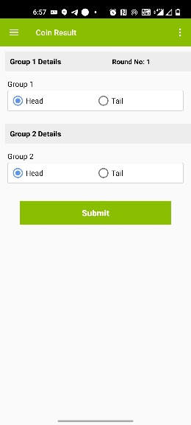
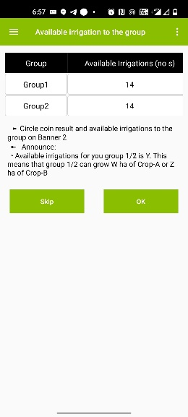
[LF] Please invite a representative of the group to toss the coin. [DEO] Enter the result of the toss in the app [Figure 18]. The app will tell you the available irrigations for each group [Figure 19]. [LF] Mark the available number of irrigations for both groups on the Banner 2.
Figure 18 Coin Result-Round 1
Figure 19 Available irrigations -Round 1
Now you can see the water available to all of you in this round. We now hand out the crop choice decision cards. Tick on your card for the crop you want to grow in this round. Do not let anyone see your decision.
[AS] As soon as a player is ready, collect that player’s card. [DEO] Start entering the decisions into the app, make sure that nobody can see the individual player’s decision [Figure 20].
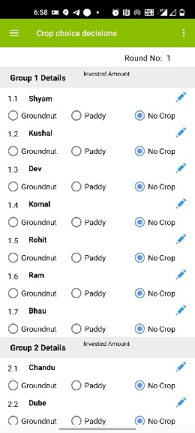
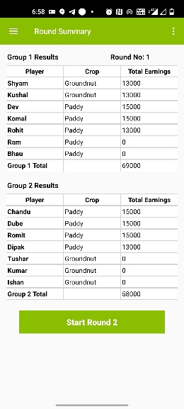
[DEO & AS] Once all players’ crop choice decisions are entered, the app will tell you the individual earnings [Figure 21]. Write on the back of the crop choice cards each player’s individual earnings [Figure 22]. Give the cards to the players in a way that nobody can see the amount on the cards.
Figure 20 Crop Choice Decision-Round 1
Figure 21 Round Summary- Round 1
Figure 22 Revealing result- Round 1

On the card given to you, you can see how much you have earned in this game round. Make sure that nobody can see the amount.

Allowing Discussion and Revealing the Individual Decisions
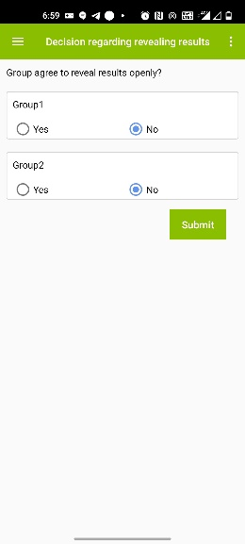
From round 2 onward, we will allow the players after each round to discuss for five minutes. In addition, we will ask participants whether they agree to reveal their decisions openly [Figure 23]. If the participants agree, we will reveal all crop choice decisions on the record sheets [Record Poster 1 or Record Poster 2].
Figure 23 Window to enter whether group agrees to reveal results openly
Now we play the same game for another 5 rounds. You have, however, the option to discuss after every round. We also offer that you reveal which crop you have chosen in each round. This means that all other players will get to know your decision. Is there any player who disagrees with the new rules? Is there anybody who does not want the players to discuss and to let us reveal the decisions? Anybody disagreeing, please raise your hand.
In case there is disagreement in a group, at least this group should continue playing the game as round 1 has been played. In case there is agreement, follow the instructions below. In any case, please record the decision in the app.
[LF] Please write the names of the players at the empty space on the bottom [Semi-circular poster, Record Poster 2] or top [Record Poster 1] of the record poster. Make sure you put the right name to the right group and player position (use DEO to write the name). The earlier created PDF [Figure 9] tells you the group and position of each player.
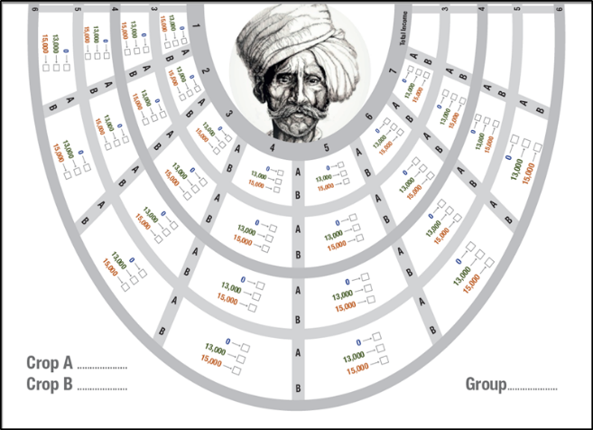
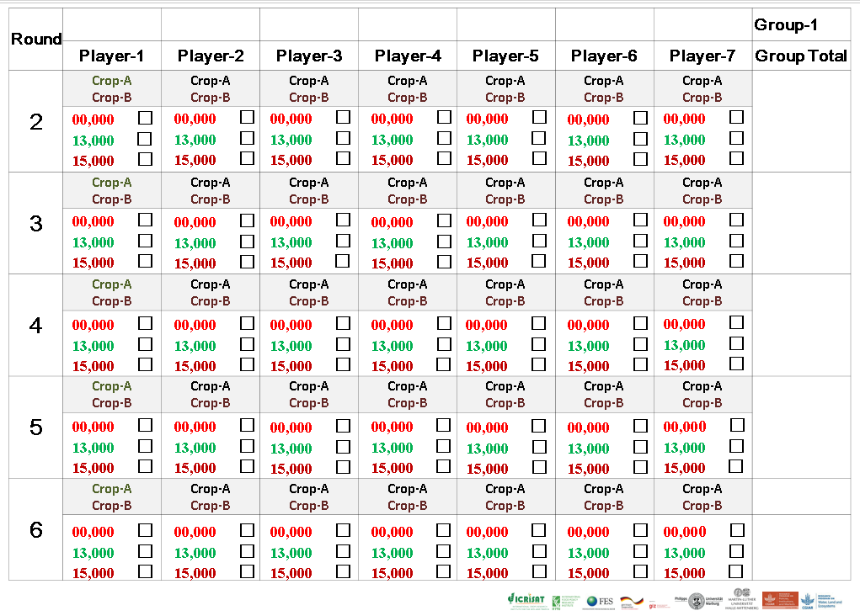
Record Poster 2 Semi-Circular Poster to set in middle of the game site on the floor
Record Poster 1 Record poster to hand on wall

Now you play the same game for another 5 rounds and we will inform you which crop each player chose, and how much they earned. We use this poster for this purpose. You will also naturally find out with whom you are playing.
[LF] Show the empty Record Poster [Record Poster 1 or Record Poster 2]!
In addition, you can now discuss amongst yourselves as soon as you have given back the decision cards. You have for every round a maximum of five minutes for discussion.
[DEO & AS] Before every round, clean the crop choice cards and put in the yellow envelopes. [LF] Invite a representative of the group to toss the coin. [DEO] Enter the result of the coin into the app. The app will tell you the number of irrigations available for each group. [LF] Mark the available number of irrigations for both groups on the Record Poster 1 or Record Poster 2 in front.
Now you can see the water available to all of you in this round. We now hand out the crop choice decision cards. Tick on your card which crop you want to grow in this round. Do not let anyone see your decision.
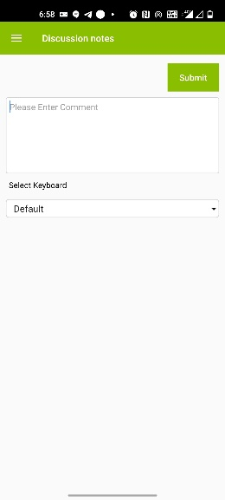
[AS & DEO] Hand out the crop choice cards [Figure 12Error! Reference source not found.]. As soon as a player is ready, collect this player’s card and start entering the decisions into the app. [DEO] Once all crop choices are entered, the app will tell you the individual earnings.
Figure 24 Discussion Notes
[LF] Please write on the Record Poster [Record Poster 1 or Record Poster 2] each player’s individual crop choice decision and earning as well as the total group earning. In case, the group did not agree to reveal the decision openly, write the earning of the player on the backside of the crop choice card [Figure 22] and show it to the respective player. Once you have finished this task, the players may discuss in the groups.

Discussions
After revealing results on the record poster or on laminated choice card, announce that the players now have five minutes time to talk to each other. [DEO] Check the discussion time.
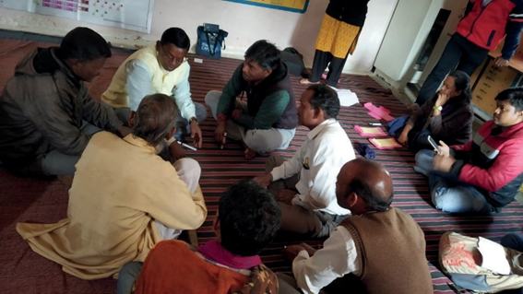
Now you have five minutes time to talk to each other.
Figure 25 Players' Discussion
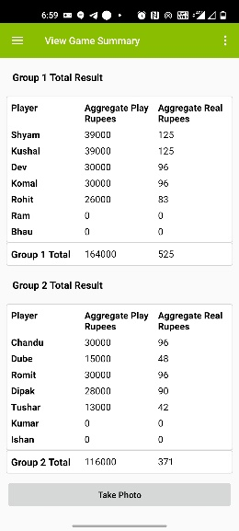
We recommend to please avoid interfering in the participants’ discussions. The idea of the game is to let community members find their own solutions. Avoid probing and lecturing. The less the facilitators talk during the discussion the better. [AS] Consider taking notes of the discussion as this may provide input for further discussions with the community at a later stage. The app allows you to record notes [Figure 24]. After five minutes of discussions, repeat the procedure of round 2.
Figure 26 Game Summary
[LF] Repeat the procedure five times/rounds.

Conclusion and Departure after the Game
[DEO] After completing the sixth round, the app will show you a game summary and the data table of the session will be created [Figure 26]. The option to take a group photograph of the game participants is given on the game summary window.
After completion of the game session, clean all the posters and banners and fold them properly. Collect erasable markers pens and name tags from the players. Before leaving the site, ensure you have all the decision envelopes with you. Erase players name from the decision envelopes. Keep all the decision envelopes in sequence, so that it will save time in the next game session.

Picture References
Picture | Reference
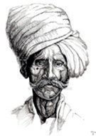 | https://orehovka.deviantart.com/art/Old-Indian-Man-171013045
 | https://www.123rf.com/photo_129100900_stock-vector-indian-young-girl-face-with-bindi-profile-picture-avatar-cartoon-character-portrait-in-black-and-whi.html
 | http://getdrawings.com/watering-can-silhouette
 | https://fscomps.fotosearch.com/compc/CSP/CSP433/coin-toss-simple-vector-icon-clip-art__k83114059.jpg
 | https://n4.sdlcdn.com/imgs/i/6/v/Indian-1-Rupees-Double-Edge-SDL605179380-2-071f6.jpg
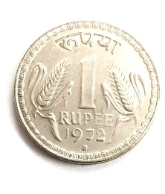 | https://n2.sdlcdn.com/imgs/i/6/v/Indian-1-Rupees-Double-Edge-SDL605179380-1-ddf1f.jpg

