Manual August 2021

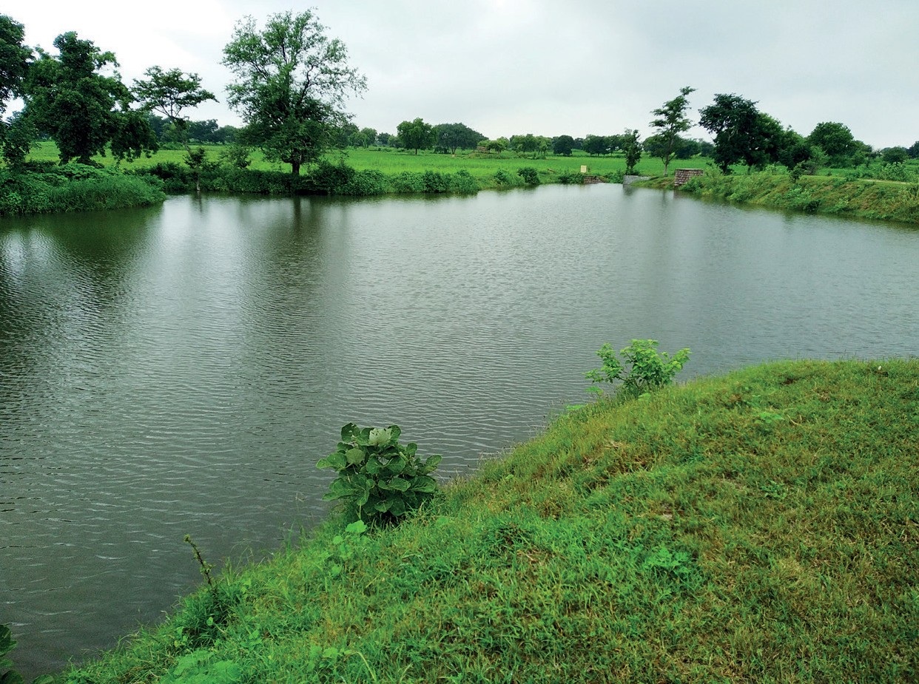
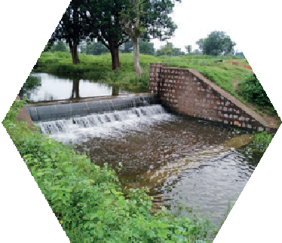
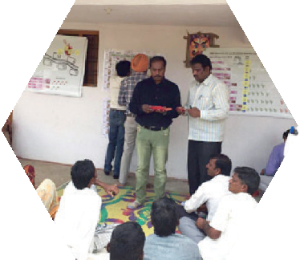
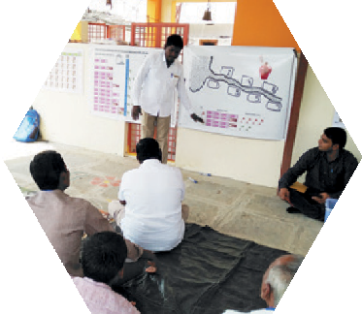
JAL SUTRA game
Joyful gAme Learning – Shaping rUles Together for Rural wAter management

Dam Maintenance Game Manual

Copyright © International Crops Research Institute for the Semi-Arid Tropics (ICRISAT), 2021.

This publication is licensed for use under a Creative Commons Attribution 4.0 International License (CC BY 4.0). Subject to attribution, you are free to share (copy and redistribute the material in any medium or format), adapt (remix, transform, and build upon the material) for any purpose, even commercially as long as ICRISAT is properly cited. To view this license, visit https://creativecommons.org/licenses/by/4.0.

Suggested citation: International Crops Research Institute for the Semi-Arid Tropics (ICRISAT), Foundation for Ecological Security (FES), and International Food Policy Research Institute (IFPRI). 2021. Dam Maintenance Game Manual. ICRISAT and FES, India; IFPRI, USA, www.gamesforsustainability.org, accessed date

We welcome requests to translate, adapt, reprint, or otherwise reproduce the material in this document in noncommercial and educational contexts, provided that the source is credited by including the suggested citation above. For any other purposes, contact us for permission. We would appreciate receiving copies or links to any work that adapts or refers to this work; kindly send such references to: Thomas Falk <t.falk@cgiar.org>.

Contents
Acknowledgments 4
Informative Video on the Dam Maintenance Game 5
Background 6
How to Use this Manual 8
Basic Structure of the Game 8
Materials Required 8
Get Ready to Use the JAL SUTRA App 9
Venue 9
Choosing Experiment Participants 10
Facilitation Team Roles and Responsibilities 10
Set Up Banners and Posters 10
Basic Information of Location/Community 11
Exchange Rate 11
Registration of Participants 12
Replace/Substitute Player 12
Preparation of Decision Envelopes and Cards for Practice Round 12
General Instruction to Participants 13
General Explanation 14
Practice Rounds 15
Starting the Game 16
Allowing Discussion and Revealing the Individual Decisions 17
Discussions 18
Departing the Game or Game Variations 19
Game Variation 1: NREGA 19
Game Variation 2: New Development Program 20
Game Variation 3: Path Dependency 21
Game Variation 4: Vote for Exclusion 23
Conclusion and Departure after the Game or Continuing 24
Picture References 25

Acknowledgments

Original Game Design
The game was developed by the International Crops Research Institute for the Semi-Arid Tropics (ICRISAT), the Foundation for Ecological Security (FES), and the International Food Policy Research Institute (IFPRI). ICRISAT is a research center of CGIAR (a worldwide partnership engaged in agricultural research for development) based in Hyderabad, India is a nonprofit non-government international research institute conducting agricultural research for development in semi-arid tropics around the world. IFPRI based in Washington DC, USA is also research center of CGIAR that provides research-based policy solutions to sustainably reduce poverty and end hunger and malnutrition in developing countries. FES is a nonprofit non-government organization based in Anand, Gujarat, India, working toward the ecological restoration and conservation of land and water resources in ecologically fragile, degraded, and marginalized regions of the country. Verdentum developed a mobile phone application to support the facilitation of the game.

International Crops Research Institute for the Semi-Arid Tropics (ICRISAT)
Thomas Falk, Vishwambhar Duche

Foundation for Ecological Security (FES)
Pratiti Priyadarshini, Richu Sanil

International Food Policy Research Institute (IFPRI)
Ruth Meinzen-Dick, Hagar ElDidi

Funding
This work was undertaken as part of the CGIAR Research Programs on Policies, Institutions, and Markets (PIM) led by the International Food Policy Research Institute (IFPRI) and Water, Land and Ecosystems (WLE) led by the International Water Management Institute (IWMI), supported by the CGIAR Trust Fund. It received financial support from the German Federal Ministry for Economic Cooperation and Development (BMZ) commissioned and administered through the Deutsche Gesellschaft für Internationale Zusammenarbeit (GIZ) Fund for International Agricultural Research (FIA), grant number: 81250397. The opinions expressed here belong to the authors, and do not necessarily reflect those of ICRISAT, IFPRI, IWMI, PIM, WLE or CGIAR.

Informative Video on the Dam Maintenance Game
We have prepared a video which explains about the process of facilitation of the Dam Maintenance Game. This will be help user to understand the process of facilitation of the Dam Maintenance game. The video is available on <Please provide video link here>

Background
The Dam Maintenance Game was created to support development partners involved in water-related projects in facilitating communities’ social learning and innovation with regard to crafting locally adopted water management rules specifically related to minor water infrastructures. The game is played with stakeholders and other interested parties, such as local farmers, who manage minor water infrastructures. It is designed as a participatory intervention supporting communities to find locally adapted solutions. The game requires facilitation as well as a package of hard-copy materials (listed below). This document describes the game structure and facilitation flow.

Hyderabad/India
August 2021

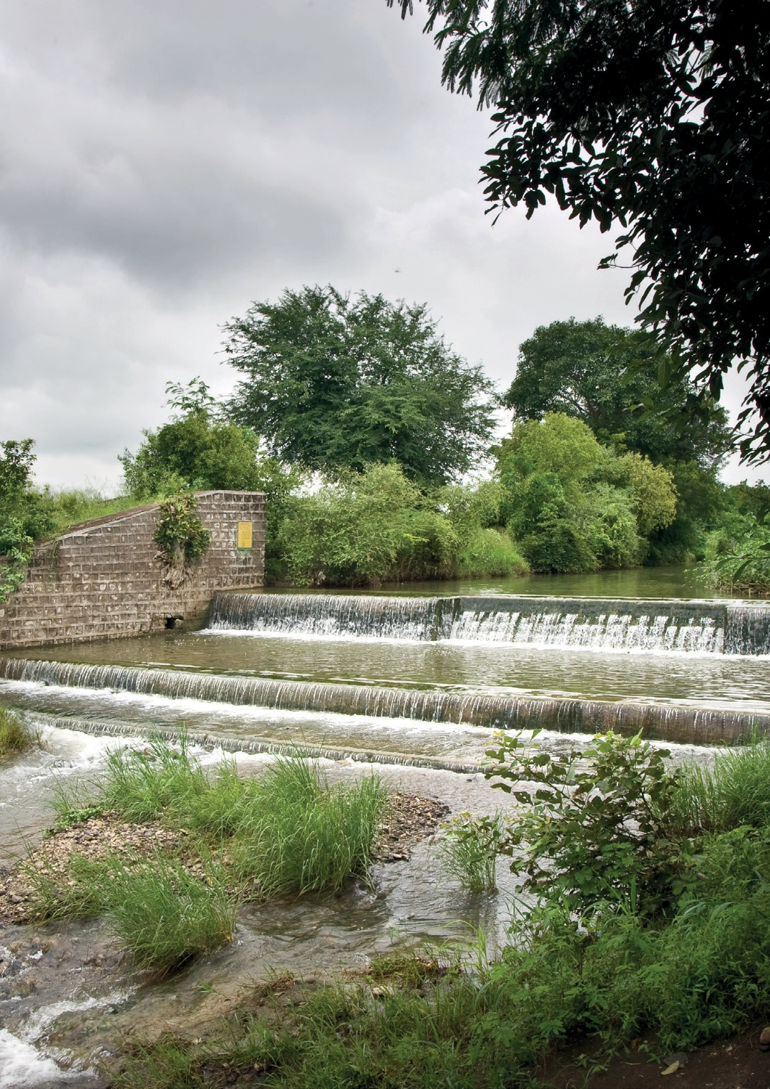

How to Use this Manual
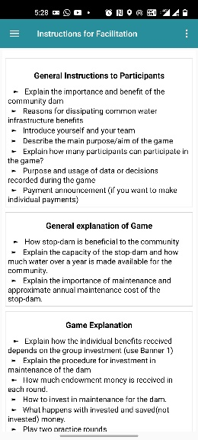
This document provides guidance on how to use this game tool. Note that text written in red color are statements that we propose to be given directly to the players. Black colored text is instruction for facilitators only. The specific facilitation team member is highlighted before each instruction as our proposal for the distribution of responsibilities. This manual is prepared to describe the game structure and its facilitation. Once the user understands the process of the game, facilitation instructions [in bullet points, see Figure 1] provided in the JAL SUTRA mobile application will help to facilitate the game during a session.
Figure 1 Instructions for facilitation

Basic Structure of the Game
Before we go into detail on how to facilitate the game, let us describe the basic structure of the game. The JAL SUTRA dam maintenance game simulates the management of small check dams in a village. The dams provide diverse benefits including domestic water supply, livestock water needs, or the recharge of open wells. The players can contribute to the maintenance of the dam. The extent of the benefits the dam will be able to provide depends on the contributions of the players. The benefits received from the dam are equally distributed among all players.

Materials Required
The following materials are required to play the game:
- Android device with JAL SUTRA app (see below)
- 1 Payoff table [Banner 1] (A0 paper size)
- 1 Path dependency table [Banner 2] (A0 paper size)
- 4 color-printed and laminated Record posters [Record Poster 1 & Record Poster 2] (A0 paper size)
- 15 Laminated NREGA decision cards [Figure 23] (A5 paper size)
- 90,000 Play money in 2,000 bills
- 3 Dice
- 20 Erasable markers
- 2 Cleaning cloths
- 25 Red envelopes big enough to fit the play money bills
- 25 Brown¹ envelopes big enough to fit the play money bills
- 15 Yellow¹ envelopes big enough to fit the NREGA decision cards
- 15 Reusable name tags
- String to set up the posters
- Adhesive tape (two- and one-sided) to set up the posters
- 15 Laminated cards to reveal earnings in round 1 (A5 paper size)
Electronic copies of the dam maintenance game protocol, posters, banners, and decision cards are available at https://gamesforsustainability.org/practitioners/#game-on-managing-check-dams.

Get Ready to Use the JAL SUTRA App
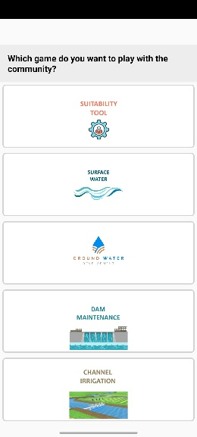
The JAL SUTRA mobile application is a package of four types of the games [Figure 2] viz. surface water game, groundwater game, dam maintenance game, and channel irrigation game. It supports the facilitation of the game by
Figure 2 Option to choose intervention
- assisting the facilitator to identify suitable intervention to use in the community based on the situation of the selected community,
- giving the facilitator bullet-point reminders [Figure 1] on each facilitation step (it is important to study this manual to understand the bullet points),
- allowing data entry,
- making necessary calculations, and
- allowing to save data during the game.
The app also saves data for future nonprofit research for development purposes by International Crops Research Institute for the Semi-Arid Tropics (ICRISAT), International Food Policy Research Institute (IFPRI), and Foundation for Ecological Security (FES). The data would only be published or shared in an anonymous way, not revealing the facilitators or the players. The data will only be analyzed if the user and the player agree to the utilization of the data.
Download the JAL SUTRA app through the Google Play store on your android device (mobile or tablet).
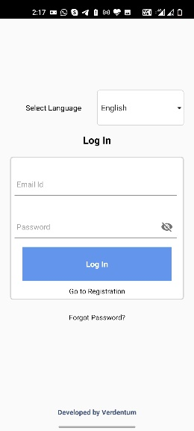
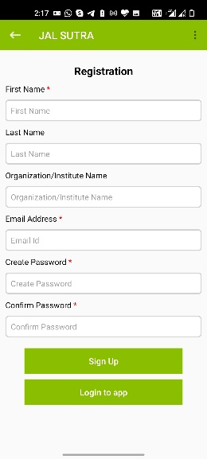
After successfully downloading the app to your device, you will need to register and login [Figure 3 & Figure 4]Error! Reference source not found.. During registration, enter your first name, last name, organization name, and email address. You will further be asked to create a password. After entering the mandatory information in the registration form, please click the Login button.
Figure 4 login Window
Figure 3 Signup Window
For login, use your email address as a user ID and enter the password you have given at registration. In case you forgot your login details, use the “forgot password” button in the login window and follow the instructions [Figure 4].
PLEASE NOTE: Your device requires Internet access for registration, initial login, and to upload or downloading data. Once you have done the initial login, the app will keep you logged in and you can use the app offline.

Venue
The game is designed to be played in a real workshop setting. We recommend to look for a quiet shady venue with little disturbance, giving space to at least 20 people. Public meeting places, temple areas, or schools are good choices. You will need to hang one banner and a record poster. In case you prefer a circle as seating arrangement, you will need to place two A0 paper size record posters in the middle of the meeting place on the ground. Be mindful that you need to write on the record posters and that there should be enough space for you to walk around the poster.

Choosing Experiment Participants
The target group of the experiment is water managers. We mainly play the game with farmers who live close to a stop-dam or water-harvesting structure. Alternatively, the game can be played with community leaders such as representatives of the Gram Panchayat, water-user associations, or other community organizations. In a game session seven or 14 participants can participate.

Facilitation Team Roles and Responsibilities
An optimal facilitation team comprises the lead facilitator [LF], a data-entry operator [DEO], and at least one assistant [AS]. The facilitator guides the game and is primarily responsible for player interaction. The data-entry operator enters player’s decisions and notes the content of discussions into a mobile application. Assistants help the facilitator and the data-entry operator during the game.
Lead Facilitator [LF] |  | Data-Entry Operator [DEO] | Assistant [AS]
Skills | - Basic knowledge of common water resources  - Listen to people  - Able to speak in local language | - Knowledge of handling android devices | - Able to read and write
Responsibility | - Check required game material before going to village  - Explain procedure of the game in local language to participants  - Encourage participants to join the discussions | - Downloads and installs apps in the device  - Enters player information in the app  - Prepares decision envelopes  - Enter players’ decisions in app  - Announces benefits received by the participants in each round and other variation rounds  - Enter notes in the app | - Helps facilitator to fix posters and banners  - Helps data-entry operator in preparation of decision envelopes  - Hands over decision envelopes to the players and collects them after the players’ decisions  - Helps the data-entry operator in entering the players’ decisions in app

Set Up Banners and Posters
For setting up the Banner 1, we recommend to use strings and/or adhesive tape. Make sure the banners are displayed in places that are easy for participants to see. In the game session, you can ask the participants whether they want to sit in a class room seating arrangement or in a circle. Alternatively you can decide what feels more appropriate given current condition. If you decide to have a class room seating, set up the Record Poster 1 in front for instance on a wall [Figure 5]. If you decide to use a circular seating arrangement, place Record Poster 2 in the middle of the players on the ground. Be aware that you need to write on the record posters and that there should be enough space to seat all players in a circle around the posters.
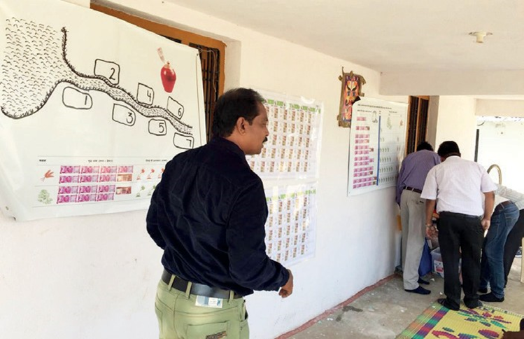
Figure 5 Setting up Banners and Posters

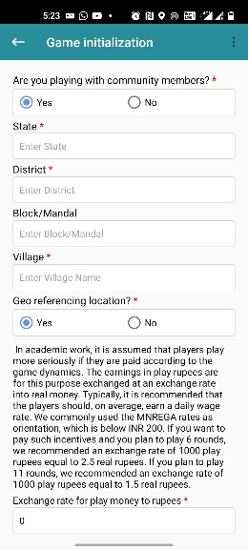
Basic Information of Location/Community
Figure 6 Game Initialization
ICRISAT, FES, and IFPRI would like to use the information entered into the app for analysis on water management behavior and social learning processes. Any analysis would be conducted only in an anonymous way, i.e., not revealing who played or facilitated the game. ICRISAT, IFPRI, and FES ask you to approve the use of your data at the bottom of the Session Initialization window [Figure 6].
Once you complete a game session, the app will automatically create a data table with the session data, which you can store on your device.
We would further like to know whether you are playing with community members or doing a training or demonstration session. Only games played with real community members are used for further analysis. If you are playing the game with community members, please indicate the same on the top of the Game Initialization window [Figure 6].
For monitoring how the tool is used, we request you to click on the GPS tab to record the Geo position of the site where you play the game.

Exchange Rate
In academic work, it is assumed that players take the game more seriously if they are paid according to the game dynamics. Our research also indicates that making incentivized payments increases the probability that players formulate rules for their real-life management challenge after they played the game. At the same time, many non-government organization (NGO) representatives feel uncomfortable with making such payments. In case you intend to make payments, the app allows you to calculate the amount you need to pay each player after the game. Still, the payments are optional, and you can play the game without them.
In case you want to play the game with incentivized payments, then the earnings in play rupees are exchanged at an exchange rate into real money. Typically, it is recommended that the players should, on average, earn a daily wage rate. We commonly use the MNREGA rates as orientation, which are below INR 200. Accordingly, if you plan to play six rounds, we recommend an exchange rate of 1000 play rupees equal to 2.5 real INR. If you plan to play 11 rounds, we recommend an exchange rate of 1000 play rupees to 1.5 real rupees.
Enter the exchange rate for play money to real rupees or leave it at the value of zero in case you do not plan to pay the players [Figure 6].

Registration of Participants
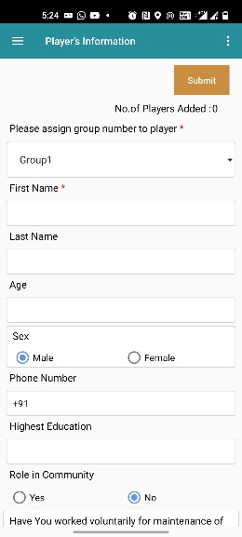
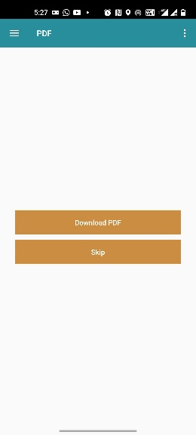
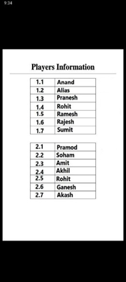
Please enter the basic information of all participants. At least a first name must be entered. All other information on the last name, age, gender, education, contact number, role in the community, plot-related information, and players’ past water management actions is optional but useful for future analysis [Figure 7]. In the player information window, the group option is provided on the top of the window to assign a group number to the player. This is important to give you the opportunity to control the gender composition of the groups. You can decide whether you want to play with mixed groups of men and women or if you want to let women and men play in separate groups. The facilitator in coordination with local staff or representatives from the community should determine what is appropriate.
Figure 7 Player Registration Window
Figure 8 Option for PDF
Figure 9 PDF showing players' group
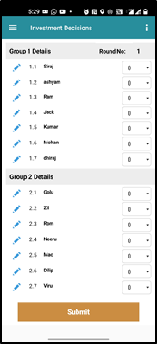
It is mandatory to ask each player whether he/she agrees that the game data will be used in an anonymous way for nonprofit research for development purposes. Please indicate this in the registration form. Should a player disagree, emphasize that this decision is respected.
Figure 10 Investment Decision- Round 1
After entering all participants’ basic information, the app will offer you to create a PDF to show the player’s group [Figure 8 & Figure 9]. You can save the PDF on your devise as you will need it for the preparation of the game materials.

Replace/Substitute Player
Sometimes, a player needs to leave the game. In such situation, a facilitator can ask other participants as substitute for the player. The app will permit this substitution. The edit option is provided in each round’s investment decisions window [Figure 10]. By clicking on the blue pen icon left to the name, the facilitator can replace the player and enter basic information of the new player.
[DEO and AS] Write the players’ names on the name tags and distribute them. The aforementioned PDF can be useful here.

Preparation of Decision Envelopes and Cards for Practice Round
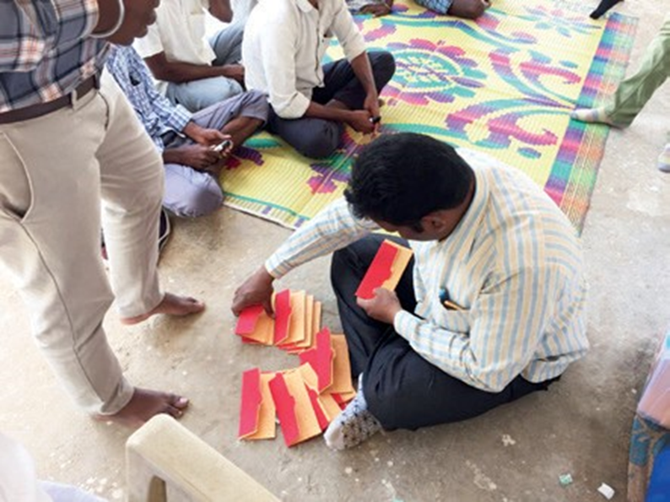
We recommend to prepare all materials before you start with the instructions. First, [DEO and AS} write the players’ names on name tags and distribute them. You further need materials for practice rounds and the real game. For the practice round, prepare seven sets of red and brown envelopes. Write on all envelopes of the first set number 1, the second set number 2 and so on up to number 7. Please place 4,000 play rupees in the red envelope and leave the brown envelopes empty.
Figure 11 Assistant preparing investment envelopes
For preparing the materials for the real game, use the aformentioned PDF [Figure 9]Error! Reference source not found. showing the group and position of each player. [DEO and AS] Write the player group, position number, and players’ names on the sets of envelopes. Ensure that the name is written on the right envelope with the right group and position number as provided in the PDF. [DEO and AS] Place in each red envelope 4,000 play rupees [Figure 11]. Leave the brown envelopes empty.

General Instruction to Participants
[LF] Introduce yourself and your team. Explain the project context in which you are playing the game.
For easy facilitation of the game process, the JAL SUTRA app includes the facilitation procedure in bullet points available both in Hindi or in English.
Below is a proposal how our [LF] typically carries out the facilitation of the game:
Across India and also in your region, watershed interventions have been implemented. Talking to people where watershed projects have been completed confirmed that these helped their communities in several ways and they experienced wide range of benefits provided by these water projects. At the same time, some of these benefits are declining. For instance, dams are filled with silt and overgrown with grass and bushes. As a result, the benefits in terms of groundwater recharge, surface water availability, and flood and soil erosion control become less and less. This is the main topic of this game!
So how to deal with this situation? We are aware that this is a difficult situation and we want to play a little game with you to jointly explore this challenge and to develop ideas and potential solutions to address these challenges for ensuring the continued functioning of the watershed infrastructure.
In our game, we assume a check dam which can store a certain volume of water over the year - including local groundwater storage. The dam water can be used for domestic use, livestock needs, or fish production as examples.
The dam in our game was built 5 years ago and some problems have appeared such as cracked walls and filled with silt. This indicates that the dam requires regular minor maintenance to ensure continuous benefits. This makes investments in terms of material, labor, and hiring machinery necessary. The benefits the dam will be able to provide in a particular year depend on the maintenance efforts of the community.
We have gathered 7/14 people today to play our game.
In case you play with two groups: You will play in two groups of seven players each. At the beginning of the game, you will not know who plays with whom in one group.
Whatever information we collect during this game will be treated confidential. The main purpose of the exercise is to encourage discussion within the community. We hope that, in this way, it will be beneficial for you.
We will explain the game step-by-step. Please listen to the instructions carefully and ask questions at any point. We will play with you the first round to serve as an example.
Optional: As mentioned above, it is common in experimental economics to play such games with incentivized payments. In case you intend to make individual payments, please give the explanation below.
You can win real money in this game. How much you win depends on how you play as well as how the other participants play in the game. In the game, we play with play rupees; at the end, we will exchange 1,000 play rupees for <YOUR EXCHANGE RATE> real Indian rupees. The money we will provide is not our personal money; it comes from our organization/project.

General Explanation
Below you will find a proposal for explaining the game. This procedure considers the diverse challenges we faced in large number of game sessions. Feel free to adapt this procedure to your specific needs. We generally recommend to involve the players by asking questions rather than repeating explanations. This can increase their active thinking; further, rephrasing explanations by fellow players helps others to grasp the game rules.
The game assumes that all players benefit equally from the dam using it for domestic, livestock, or fishing purposes. In the game, each of you can make individual contributions to maintaining the dam. These individual contributions are put together in a group account. The benefits you will receive as a group depend on the total amount invested by the group (see Banner 1 column A & B). This group income is then equally divided to the seven players (see Banner 1 column C).
This laid out the basic idea of the game. Let us explain how investments in the maintenance of the dam are made and how you can earn money. In every game round, we will give each of you 4,000 play rupees. Assume that this the excess money you have at the end of every month and you can freely decide how to use it. You have the opportunity to invest money in the maintenance of the dam, or you can keep the money to yourself and use it for household expenditures. Any amount you do not invest remains in your personal account and nobody can touch it. The money you invested will be put into the group account and the range of benefits from the dam depend on the total investment given by the group. The total benefit will then be equally distributed amongst all players. The relationship between the income from the dam and the investment in the dam maintenance can be seen in the Banner 1 in front. These calculations are rather symbolic. We consulted with experts to ensure that the amounts are in a realistically possible range.
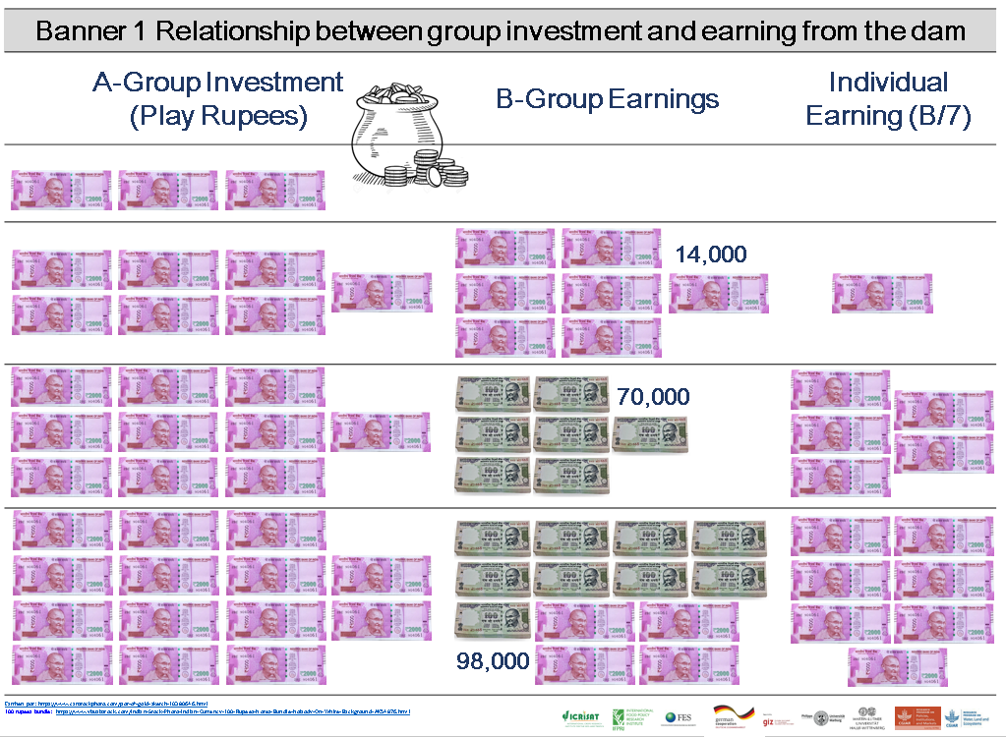
To make your investment decision, we will give you two envelopes: a red and a brown one. In the red one, you will find 4,000 play rupees. The brown envelope is empty. If you want to invest money in the dam maintenance, transfer the amount you would like to invest into the brown envelope.
Banner 1 Payoff Table
Once all players’ investment decisions are entered into the app, it will automatically calculate the group as well as each player’s income for that round.
For a better understanding of the game, ask the questions below to the participants. Use the group to improve the understanding of the game. Explain again with the Banner 1 if anything is still unclear.
- How much should the group have invested in the maintenance of the dam to earn 98,000 rupees benefit?
- If each player invests 2,000 play rupees in the dam maintenance, how much benefit does each player get?

Practice Rounds
[DEO] In the app, after the introduction window, you get to the window offering you to either directly start the game or play practice rounds [Figure 12]. For playing practice rounds, please follow the instructions below. If you do not want to play practice rounds, jump to Section Starting the Game.
We will now practice this with seven of you.
[AS] Hand over the prepared practice round investment envelopes (red and brown) to the first seven players.
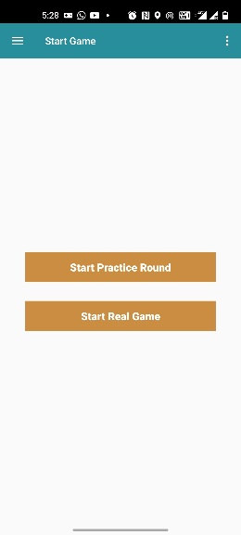
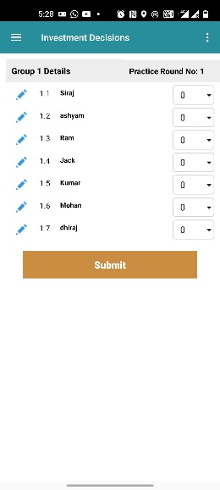
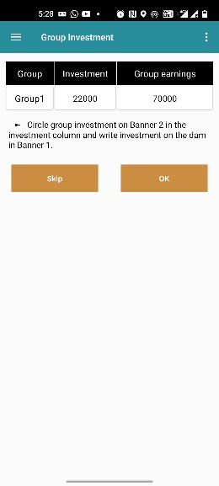
Now you can decide how much of your 4,000 play rupees you want to invest in the maintenance of the dam. Please move as much play money from the red to the brown envelope as you want to invest into the dam maintenance. Once you have made your decision, hand over both envelopes to the assistants.
Figure 12 Option to play practice round or start the game
Figure 13 Investment Decision- Practice Round
Figure 14 Group Investment- Practice Round
[DEO] Enter the investment decisions into the app [Figure 13]. After all decisions are entered, the app will calculate the earnings of each player as well as group earning for that round [Figure 14].
[LF] Circle the investment level on Banner 1.
Your group made an investment of X play rupees, this yields Y play rupees benefit to the group. This means each group member gets Z play rupees benefit.
Repeat the practice round procedure with the other seven players. This is how the game is played.

Starting the Game
Once all participants understand the rules, you can start playing the actual game. The first round should be anonymous.
[AS] Before every round, prepare the red and brown envelopes by putting 4,000 play rupees into the red envelopes. The brown envelopes should be empty.
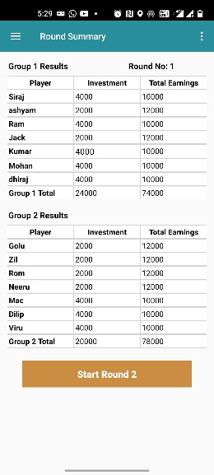
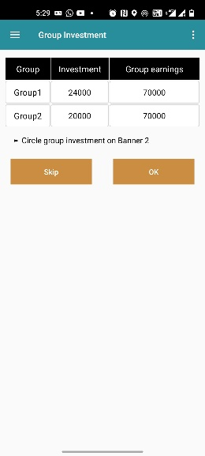
Now let us start playing the game. For your very first game round, we want you to make your decisions without anybody else knowing what you have decided. We now give you the envelopes for your investment decision. Please move the amount you want to invest from the red into the brown envelope. Do not let anyone see how much you put in.
Figure 15 Investment Decision- Round 1
Figure 17 Game summary- Round 1
Figure 16 Group Investment- Round 1
[AS] As soon as a player is ready, please collect that player’s envelopes.
[DEO] Enter the decisions into the app [Figure 15]. Make sure that nobody can see how much individual players invested. Once all investments are entered, the app will tell you the group investment and income [Figure 16]. The next step shows the individual earnings [Figure 17]. Write the players’ income on the laminated cards [Figure 18] and hand over the card to the respective player. Give the laminated cards to the players in a way that nobody can see what is written on them.

On the laminated cards given to you, you can see how much you have earned in this game round.
Figure 18 Earnings of the player written on laminated card

Allowing Discussion and Revealing the Individual Decisions
From round 2 onward, we will allow the players after each round to discuss for five minutes. In addition, we will ask participants whether they agree to reveal their decisions openly. If the participants agree, we will reveal all investment decisions and earnings on the two record sheets.
Now we will play the same game for another 5 rounds. You have, however, the option to discuss after every round. We also offer that you reveal openly how much you invested. This means that all other players will get to know your decision. Is there any player who disagrees with the new rules? Is there anybody who would not want the players to discuss and to let us reveal the decisions? Anybody disagreeing, please raise your hand.
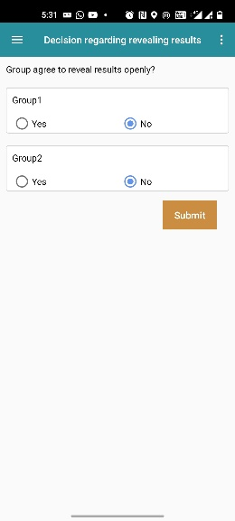
In case there is disagreement in a group, at least this group should continue playing the game as round 1 has been played. In case there is agreement, follow the instructions below. In any case, please record the decision in the app [Figure 19]
Figure 19 Option to enter result reveal openly
[LF, DEO] Depending on your seating arrangement, please write the names of the players at the empty space on top of Record Poster 1 or the bottom of the semi-circular Record Poster 2 which is used to hang on a wall. Make sure you put the right name to the right group and player position. The earlier created PDF [Figure 9] tells you the group and position of each player.
Now you play the same game for another 5 rounds; from now on, however, at the end of each round, we will inform you about how much each player contributed and how much she/he earned. We will use this poster for this purpose. You will also naturally find out with whom you are playing in a group.
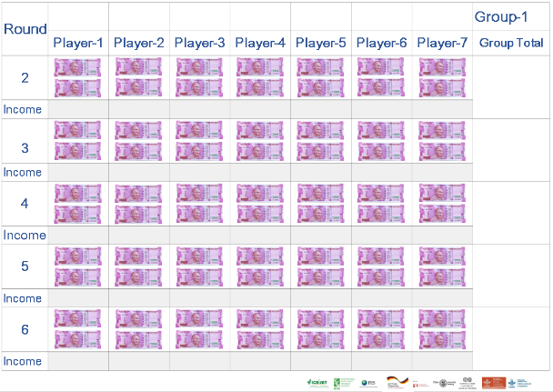
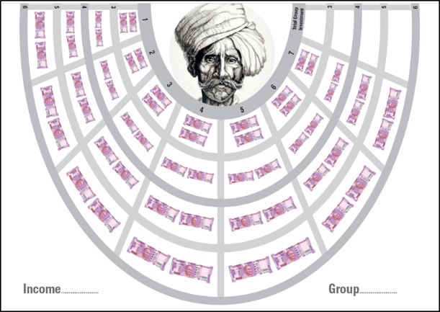
[LF] Show the empty Record Poster!
Record Poster 1 Poster used to set on the wall at game site
Record Poster 2 Semi-Circular Poster to set middle of the game site on floor

In addition, you can now discuss amongst yourselves as soon as you have given back the decision envelopes. To keep the exercise short, you have for every round a maximum of five minutes of discussion.
[AS] Before every round, prepare the envelopes by putting 4,000 play rupees into the red envelopes. Hand over the red and brown envelopes.
[AS and DEO] As soon as a player is ready, collect this player’s envelopes and start entering the decisions into the app.
[LF] Once all investment decisions are entered, the app will tell you the individual earnings. If the group agrees for revealing the decisions openly, please write on the Record Poster for each player the individual investment and earning as well as the group investment and earning. In case the group did not agree to reveal decisions openly, write the earning of the player on the laminated card and show it to the respective player. Once you have finished this task, the players may discuss in groups.

Discussions
After revealing results on the record poster or on laminated card, announce that the players now have five minutes time to talk to each other [Figure 20]. [DEO] Check the discussion time.
Now you have five minutes time to talk to each other.
We recommend to please avoid interfering in the participants’ discussions. The idea of the game is to let community members find their own solutions. Avoid probing and lecturing. The less the facilitators talk during the discussion the better. [AS] Consider taking notes of the discussion as this may provide input for further discussions with the community at a later stage. The app allows you to record notes [Figure 21]. After five minutes of discussions, repeat the procedure of round 2. [LF] Repeat the procedure five times/rounds.
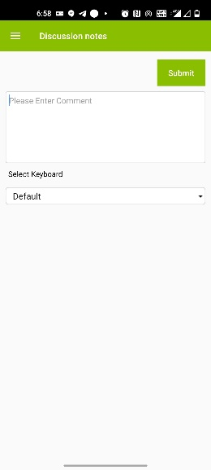
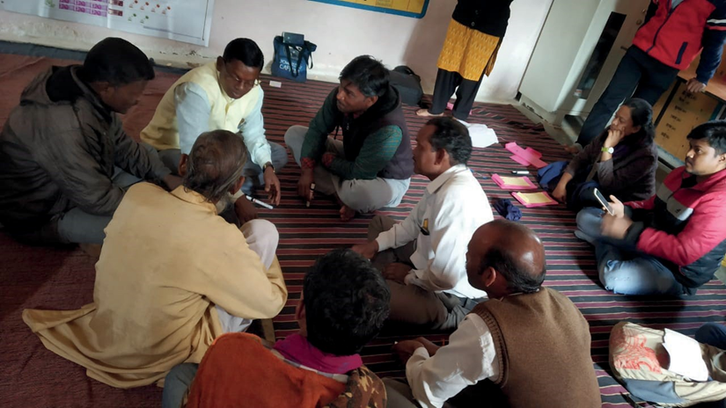
Figure 21 Discussion Notes
Figure 20 Players' Discussion

Departing the Game or Game Variations
[DEO] After completion of the sixth round, the app will ask whether you want to close or continue the game. If you finish your game, the data table of the session will be created, and you will leave the app [Figure 28]. The option to take a group photograph of the game participants is given on the game summary window.
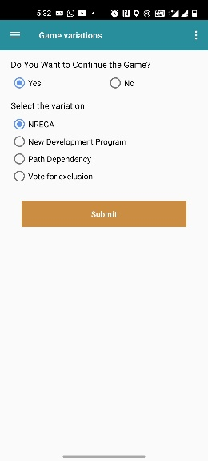
[LF and DEO] If you want to continue, you will be given the choice between different game variations [Figure 22], which are explained below. We recommend to choose a variation that responds to the needs of the particular community presented during the discussions.
Figure 22 Game Variation Options

Game Variation 1: NREGA
[DEO and AS] Prepare NREGA decision cards by writing the player’s name on envelopes based on the position and group. Before every round, prepare the envelopes by putting 4,000 play rupees into the red envelopes. Also, clean the NREGA decision cards.
As an additional rule, you can now make use of the Mahatma Gandhi National Rural Employment Guarantee Act (NREGA) scheme. Imagine that in this game, the Panchayat has decided to dedicate the NREGA to work that does not give you much benefit. If NREGA was used to maintain the stop-dam, this could save you and your fellow watershed farmers a significant amount of money. In order to convince the Panchayat to change its decision and indeed use the NREGA work for the dam, you would have to go to meetings and discuss with them. During this time, you cannot do other activities, and this means you lose income. Let us assume that, if one person is attending the Panchayat meeting and advertising the watershed work, this would result in investment equivalent to 2,000 play rupees into the dam maintenance. In order to attend the Panchayat meeting, however, you lose time and even money (e.g., for petrol). This time and petrol will be valued with 1,000 play rupees. This amount of 1,000 play rupees would be taken from your account, but it would be equal to 2,000 play rupees invested in dam maintenance. For clarification, imagine now that each player in your group, including yourself, attended the Panchayat meeting. In this case, each of you would pay 1,000 play rupees, but the dam would be maintained at the level of 14,000 play rupees. Additional maintenance investments would have to be done by yourself as in the basic game.
Keep in mind that, if NREGA is partly maintaining the dam, you can achieve the maximum possible income by investing less of your own money into the dam.
You will now receive a decision card on which you can tick whether you want to make the effort of convincing the village leaders to dedicate NREGA work to the dam maintenance.
[LF] Show NREGA decision card [Figure 23].
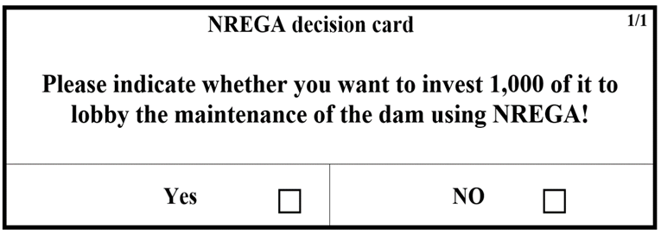
Please make your decision:
Figure 23 NREGA Decision Card
- Tick for lobbying of NREGA investment in dam maintenance on the decision card.
- Individually invest in the dam maintenance by moving play money from the red to the brown envelope.
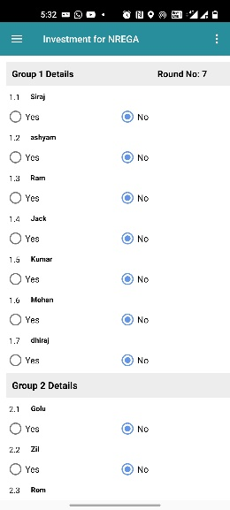
[AS] Hand over investment envelopes and NREGA decision cards. As soon as a player is ready, collect the player’s envelopes.
Figure 24 NREGA Decision
[DEO] Start entering the player’s decisions into the app [Figure 24].
[LF] Once all investments are entered, the app will tell you the total group investments and income, as well as the individual player’s investment and income. If the group agreed to reveal the decision openly, please write the round summary with the aforementioned information on the Record Poster. Once you have finished this task, the players may discuss.
You see here in front all the decisions and earnings of all players. Before we start with the next round, you now have five minutes to talk to each other.
In case the group did not agree to revealing decisions openly, write the earning of the player on the laminated card and show it to the respective player.
[LF] Repeat the procedure five times/rounds.

Game Variation 2: New Development Program
It is possible that another development project is stepping in and maintaining the dam again. This is of course uncertain. In this game we assume that there is a one-out-of-six chance that the government or an international donor would be doing the maintenance work. If the donor is maintaining the dam, you get the whole income and does not have to pay for the maintenance. If the donor (e.g., the government) maintains the dam, the money you have invested is gone. Equally, however, if you do not invest in dam maintenance, and the donor does not step in, you have no benefits from the dam.
To simulate this situation, one of you will roll the dice. If the dice shows a 1, then another development project is maintaining your dam free of charge. If any other number but 1 is shown, then nobody from outside is helping in maintaining the dam. In this case, the maintenance again solely depends on how much each of you is investing into the maintenance. You need to make your decision on how much to invest in the dam before we throw the dice.
Given this information, we ask you again to decide how much you are willing to invest into the maintenance of the dam.
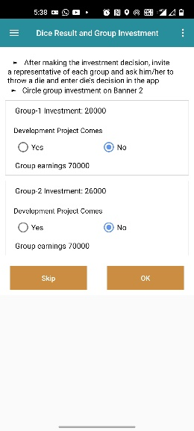
[DEO and AS] Before every round, prepare the envelopes by putting 4,000 play rupees into the red envelopes.
Figure 25 Dice Result
[LF] Hand over investment envelopes.
Please make your investment decisions. Do not let others see your decision.
[AS and DEO] As soon as a player is ready, collect the player’s envelopes and start entering the decisions into the app.
[LF] After all group members have made their decisions, let one player of each group throw the dice.
[DEO] Record in the app [Figure 25] by group whether a 1 is the outcome of the thrown dice. If it is 1, the group gets optimal income from the dam. If other than 1, then the group income depends on the investment of that group.
The app will tell you the total group investments and income as well as the individual player’s investment and income. If the group agreed to reveal the decision openly, please write the round summary with the aforementioned information on the Record Poster. Once you have finished this task, the players may discuss.
You see here in front all the decisions and earnings of all players. Before we start with the next round, you now have five minutes to talk to each other.
In case, the group did not agree to revealing decisions openly, write the earning of the player on the laminated card and show it to the respective player.
[LF] Repeat the procedure five times/rounds.

Game Variation 3: Path Dependency
[LF and AS] Before starting the explanations, please put up Banner 2: Payoff Table for Path Dependency.
We add a slight modification to the game. The new rules consider that a dam, which has not been sufficiently maintained in the previous year, requires more intensive maintenance in the following year.
If in the previous round, the dam has been maintained at least at a group level of 28,000 play rupees, your maintenance cost will decrease in the following round. The following pay-off/income table applies. Please allow me to make this clear. In the first round of this game phase, you play with the Banner 1 again as in the initial game. If in this first round of this game phase, you invest less than 28,000 play rupees, you continue playing with Banner 1. If you invest, however, more than 28,000 play rupees, then you will have to pay less in the following rounds in order to achieve the same outcomes Banner 2 will apply in this case. If you then manage to invest again at least 14,000 play rupees, you will continue playing with Banner 2. If the investment is below 14,000 play rupees, you will have to go back to Banner 1.

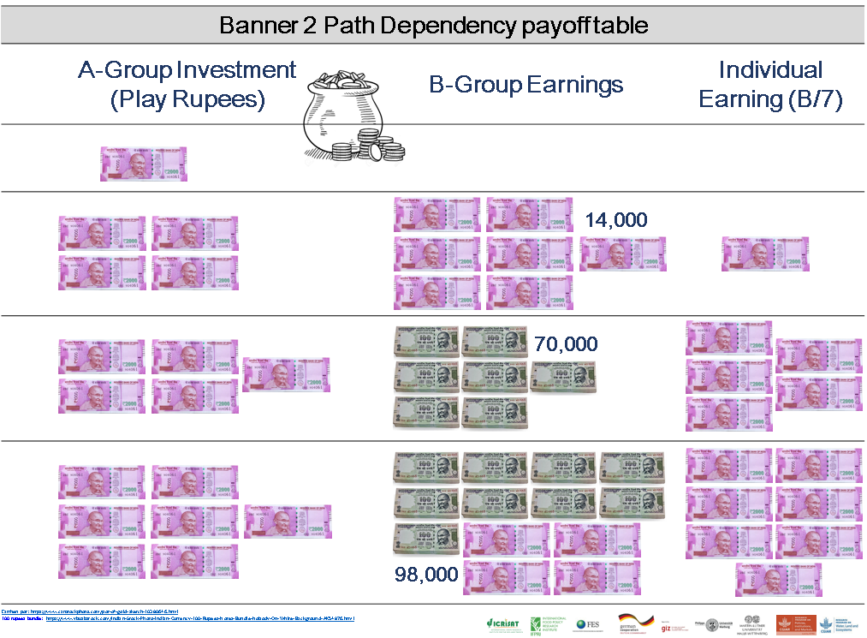
Banner 2 Path Dependency payoff table

[AS and DEO] Before every round, prepare the envelopes by putting 4,000 play rupees into the red envelopes. Hand over the envelopes.
Please make your investment decisions. Do not let others see your decision.
[AS and DEO] As soon as a player is ready, collect this player’s envelopes and start entering the decisions into the app.
[DEO] Once all investments are entered, the app will tell you the players’ income.
The app will tell you the total group investments and income as well as the individual player’s investment and income. If the group agreed to reveal the decision openly, please write the round summary with the aforementioned information on the Record Poster. Once you have finished this task, the players may discuss.
You see here in front all the decisions and earnings of all players. You can also see whether your investment was sufficient to move in the next round to the lower-cost table. Before we start with the next round, you now have five minutes to talk to each other.
In case the group did not agree to revealing decisions openly, write the earning of the player on the laminated card and show it to the respective player.
[LF] In case the group investment was above 28,000, please emphasize that in the next round, Banner 2 will apply. In case in any round the investment drops below 14,000 again, please emphasize that Banner 1 applies again.
[LF] Repeat the procedure five times/rounds.

Game Variation 4: Vote for Exclusion
Now you play with a new rule. After every round, the group can decide to exclude somebody from the game for one round, which eventually means that the person loses her/his benefits. The group can decide the criteria for exclusion and agreed upon by the group. You can for instance decide to use a simple majority vote. The logic is that if a farmer is excluded from the dam, he/she will not get any income from it in the following round. After every round, once the payments and earnings of all players have been announced, anybody from the group can propose to exclude another player from the game. If a player is excluded, he/she will be excluded only for one round. If you want to exclude her/him again, you need to re-decide on this.
We consider that it takes an effort to enforce the exclusion of somebody from the dam. Therefore, if any player is excluded by the group, each of the other group members will have to pay 500 play rupees.
[AS and DEO] Before every round, prepare the envelopes by putting 4,000 play rupees into the red envelopes. Hand over the red and brown envelopes.
Please make your investment decisions.
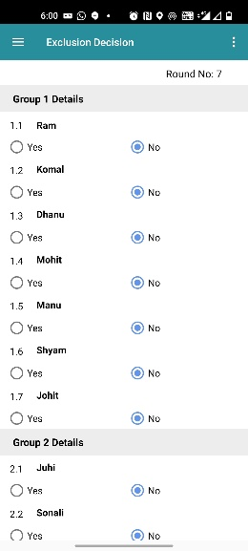
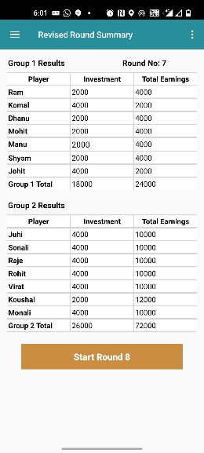
[DEO] After all group members have made their decisions and you entered them in the app, the app will tell you the total group investments and income as well as the individual player’s investment and income. If the group agreed to reveal the decision openly, please write the round summary with the aforementioned information on the Record Poster. Once you have finished this task, the players may discuss.
Figure 26 Exclusion Decision
Figure 27 Revised Summary
You see here in front all the decisions and earnings of all players. Before we start with the next round, you now have five minutes to discuss amongst yourselves. Then let us know whether you want to exclude any player in the next round.
[DEO] Enter in the app if the group excludes any player from the group [Figure 26].
If a group excludes a player from the game, the app will show you a changed/revised round summary [Figure 27].
[LF] Repeat the procedure five times/rounds.

Conclusion and Departure after the Game or Continuing
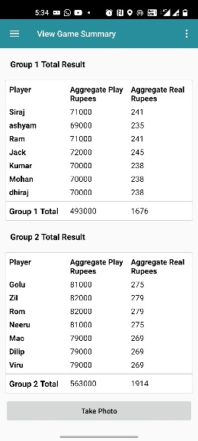
After completion of the 11th round, the app will display the game summary [Figure 28]. A game summary consists of aggregate play rupees and aggregate real rupees (aggregate play rupees*exchange rate/1000) earned by the player in the game. If you want to download the game session data, click on the Export to CSV button. If your device has access to the Internet, the game session data will be uploaded to the server.
Figure 28 Game Summary
In case the device does not have access to the Internet, the next time your device does have access, the message “data from previous game was not synchronized, please click on sync button to sync the data to server” will pop up. If you click on the sync button, data will upload to the server.
After completion of the game session, clean all the posters and banners and fold them properly. Collect erasable markers, pens and name tags from the players. Before leaving the site, ensure you have all the decision envelopes with you. Erase players name from the decision envelopes. Keep all the decision envelopes in sequence, so that it will save time in the next game session.

Picture References
Picture | Reference
 | https://www.canstockphoto.com/pot-of-gold-sketch-10380646.html
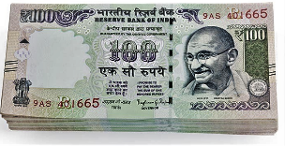 | https://www.visualsstock.com/Indian-Stock-Photo-Indian-Currency-100-Rupees-Notes-Bundle-Nobody-On-White-Background-AK54876.html

Envelope color can be changed; be aware, however, that we use the colors given above for explanations.

