Manual August 2021
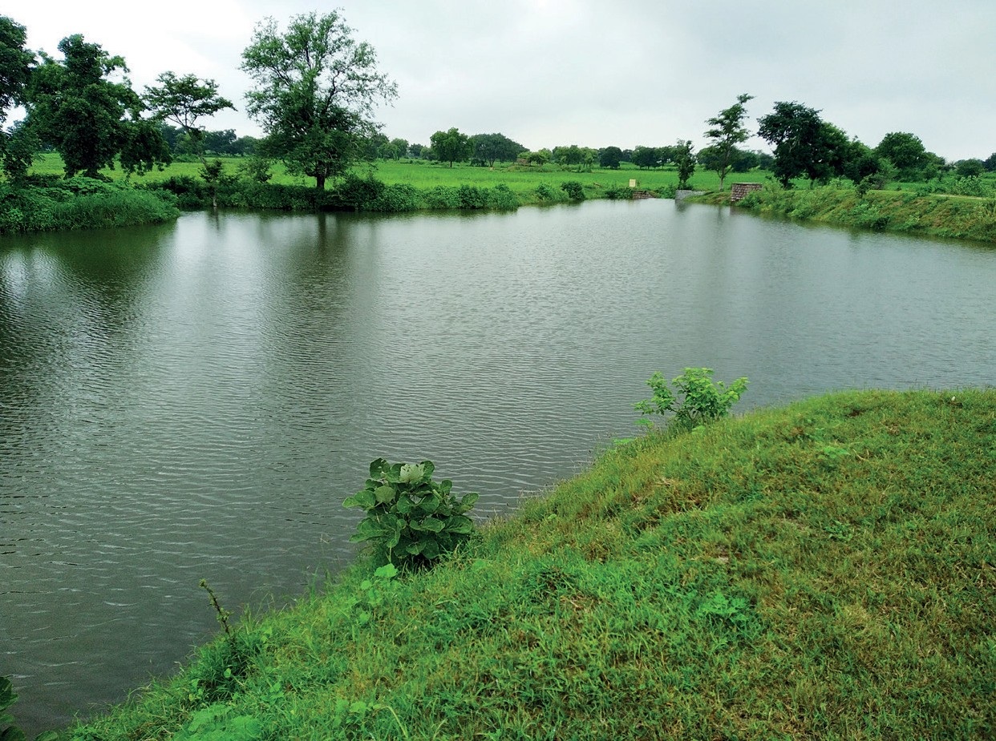
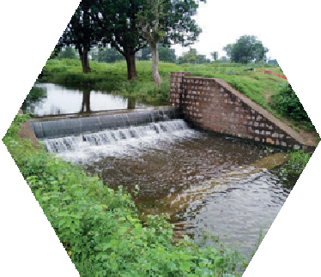
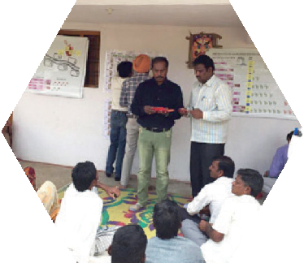
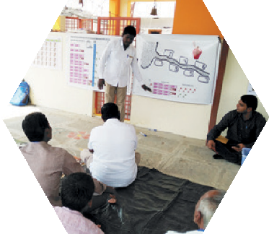
JAL SUTRA game
Joyful gAme Learning – Shaping rUles Together for Rural wAter management

Surface Water Game Manual

Copyright © International Crops Research Institute for the Semi-Arid Tropics (ICRISAT), 2021.

This publication is licensed for use under a Creative Commons Attribution 4.0 International License (CC BY 4.0). Subject to attribution, you are free to share (copy and redistribute the material in any medium or format), adapt (remix, transform, and build upon the material) for any purpose, even commercially as long as ICRISAT is properly cited. To view this license, visit https://creativecommons.org/licenses/by/4.0.

Suggested citation: International Crops Research Institute for the Semi-Arid Tropics (ICRISAT), and Foundation for Ecological Security (FES). 2021. Surface Water Game Manual. ICRISAT and FES, India, www.gamesforsustainability.org, accessed date

We welcome requests to translate, adapt, reprint, or otherwise reproduce the material in this document in noncommercial and educational contexts, provided that the source is credited by including the suggested citation above. For any other purposes, contact us for permission. We would appreciate receiving copies or links to any work that adapts or refers to this work; kindly send such references to: Thomas Falk <t.falk@cgiar.org>.

Contents
Acknowledgments 4
Informative Video on the Surface Water Game 5
Background 6
How to Use this Manual 8
Basic Structure of the Game 8
Materials Required 9
Get Ready to Use the JAL SUTRA App 9
Venue 10
Choosing Experiment Participants 10
Facilitation Team Roles and Responsibilities 10
Set Up Banners and Posters 11
Basic Information of Location/Community 12
Exchange Rate 12
Registration of Participants 13
Replace/Substitute Player 13
Preparation of Decision Envelopes and Cards 14
General Instruction to Participants 14
General Explanation 16
Practice Rounds 18
Starting the Game 21
Allowing Discussion and Revealing the Individual Decisions 22
Discussions 24
Leaving the Game or Playing Game Variations 24
Game Variation 1: NREGA 24
Game Variation 2: New Development Program 26
Game Variation 3: Path Dependency 27
Game Variation 4: Vote for Exclusion 28
Conclusion and Departure after the Game or Continuing 29
Picture References 30

Acknowledgments

Original Game Design
The game was developed by the International Crops Research Institute for the Semi-Arid Tropics (ICRISAT), and the Foundation for Ecological Security (FES). ICRISAT based in Hyderabad, India is nonprofit non-government international research institute conducting agricultural research for development in semi-arid tropics around the world. FES is a nonprofit non-government organization based in Anand, Gujarat, India, working toward the ecological restoration and conservation of land and water resources in ecologically fragile, degraded, and marginalized regions of the country. Verdentum developed a mobile phone application to support the facilitation of the game.

International Crops Research Institute for the Semi-Arid Tropics (ICRISAT)
Thomas Falk, Vishwambhar Duche

Foundation for Ecological Security (FES)
Pratiti Priyadarshini, Richu Sanil

Manual Compilation and Design
ICRISAT and FES

Funding: This work was undertaken as part of the CGIAR Research Programs on Policies, Institutions, and Markets (PIM) led by the International Food Policy Research Institute (IFPRI) and Water, Land and Ecosystems (WLE) led by the International Water Management Institute (IWMI), supported by the CGIAR Trust Fund. It received financial support from the German Federal Ministry for Economic Cooperation and Development (BMZ) commissioned and administered through the Deutsche Gesellschaft für Internationale Zusammenarbeit (GIZ) Fund for International Agricultural Research (FIA), grant number: 81250397. The opinions expressed here belong to the authors, and do not necessarily reflect those of ICRISAT, IFPRI, IWMI, PIM, WLE or CGIAR.

Informative Video on the Surface Water Game
We have prepared a video which explains about the process of facilitation of the Surface Water Game. This will be help user to understand the process of facilitation of the Surface Water Game. The video is available on <Please provide video link here>

Background
The Surface Water Game was created to support development partners involved in water-related projects in facilitating communities’ social learning and innovation with regard to crafting locally adopted water management rules specifically related to minor water infrastructures. The game is played with stakeholders and other interested parties, such as local farmers, who manage minor water infrastructures. It is designed as a participatory intervention supporting communities to find locally adapted solutions. The game requires facilitation as well as a package of hard-copy materials outlined in succeeding sections. This manual describes the game structure and the facilitation flow.
The game was developed by the International Crops Research Institute for the Semi-Arid Tropics (ICRISAT) and the Foundation for Ecological Security (FES) in the frame of the CGIAR Research Program Policies, Institutions and Markets (PIM) and was supported by the CGIAR Research Program Water, Land and Ecosystems (WLE). Funding support was provided by the German Federal Ministry for Economic Cooperation and Development (BMZ) commissioned and administered through the Deutsche Gesellschaft für Internationale Zusammenarbeit (GIZ) Fund for International Agricultural Research (FIA), grant number: 81250397. ICRISAT is a nonprofit nongovernment international research institute conducting agricultural research for development in semi-arid tropics around the world headquartered in Patancheru, India with several regional centers and research station. FES is a nonprofit nongovernment organisation based in Anand, Gujarat, India, working toward the ecological restoration and conservation of land and water resources in ecologically fragile, degraded, and marginalised regions of the country. Verdentum developed a mobile phone application to support facilitation of the game.

Hyderabad/India
August 2021

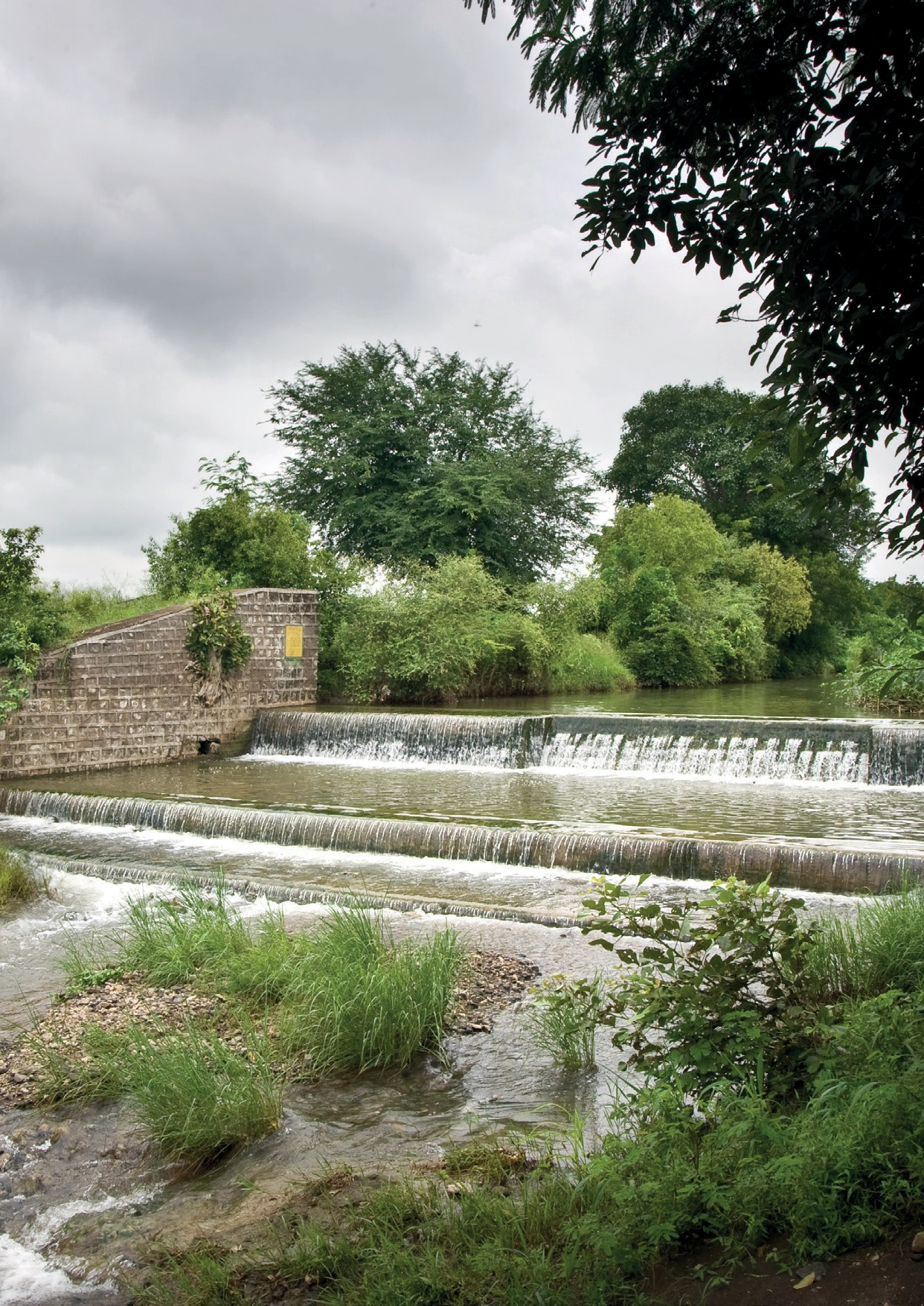

iii

How to Use this Manual
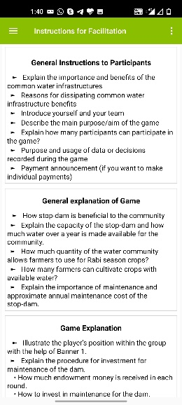
This document provides guidance on how to use the surface water game tool. Note that text written in red color are statements that we propose to be given directly to the players. Black colored texts are instructions for facilitators only. The specific facilitation team member is highlighted before each instruction as our proposal for the distribution of responsibilities. This manual was prepared to describe the game structure and its facilitation. Once the user understands the process of the game, facilitation instructions (in bullet points Figure 1) provided in the JAL SUTRA mobile application will help the user to facilitate the game.
Figure 1 Instructions for facilitator

Basic Structure of the Game
Before we go into detail on how to facilitate the game, let us describe the basic structure of the game. The JAL SUTRA surface water game simulates the management of a small dam which is used for irrigation in the post rainy (winter) season. In the game, there are seven farmers having their fields below the dam. Each farmer has a field of the same size, that is, 1 hectare (ha). We assume that the distance to the dam influences the farmers’ access to the dam water. As the water flows from the top to the bottom, the farmer living closest to the dam can withdraw water first. Only what she/he does not use becomes available to the second farmer. Only what the second farmer does not use becomes available to the third farmer and so on - up to farmer seven.
The players in the game, representing the seven farmers, need to make two decisions:
- First, they need to give contributions to the maintenance of the dam. The dam will be able to provide irrigation depending on how much all players contribute to its maintenance.
- Second, they need to choose between a more profitable crop which requires more water and a water efficient crop which gives slightly less income. They receive income in the game depending on the crop they choose and the other players’ crop choice.
Investment Decision: How much water is available for irrigation depends on how good the dam is maintained. In real life, contributions can be money or labor. In the game we simulate this with play money contributions. In every game round, the player will receive 4,000 play rupees. She/he has the opportunity to invest money in the maintenance of the dam or can keep the money to herself/himself. Any amount the player does not invest remains in her/his personal account. The money invested in the dam will be put into the group account. How much everybody pays into this account determines how well the dam is maintained. This eventually determines the water holding capacity of the dam and the water available for irrigation.
Crop Choice Decision: The available irrigation water can be used by the players to grow a post rainy crop. The first player takes water first, then the second, then the third, and so on, until the water is completely utilized.
The players can choose between two crops. Crop A gives an income of 13,000 play rupees and requires two irrigations. Crop B gives an income of 15,000 play rupees but requires four irrigations. From this, it becomes clear that even if the dam is fully maintained, the irrigations are only enough for everybody to grow Crop A. If only one farmer choses Crop B, the last farmer would not receive any water and could not grow anything, regardless how much she/he contributed to the maintenance.

Materials Required
The following materials are required to play the game:
- Android device with JAL SUTRA app (see below)
- 1 Player position and benefit from crop banner [Banner 1] (A0 paper size)
- 1 Payoff table [Banner 2] (A0 paper size)
- 1 Path dependency table [Banner 3] (A0 paper size)
- 4 Record posters [Record Poster 1 & Record Poster 2] (A0 paper size) color print and lamination
- 22 Laminated crop choice cards [Figure 18] (A5 paper size)
- 15 Laminated NREGA (National Rural Employment Guarantee Act) decision cards [Figure 30] (A5 paper size)
- 84,000 Play money in 2,000 bills
- 3 Dices
- 20 Erasable markers
- 2 Cleaning cloths
- 25 Red envelopes big enough to fit the play money bills
- 25 Brown¹ envelopes big enough to fit the play money bills
- 40 Yellow¹ envelopes Error! Reference source not found.big enough to fit the crop choice and NREGA decision cards
- 15 Reusable name tags
- String to set up the posters
- Adhesive tape (two- and one-sided) to set up the posters
- Laminated images of the crops (A5 paper size)
Electronic copies of the JAL SUTRA surface water game protocol, posters, banners, and decision cards are available at https://gamesforsustainability.org/practitioners/#game-on-managing-check-dams.

Get Ready to Use the JAL SUTRA App
The JAL SUTRA mobile application supports the facilitation of the game by
- assisting facilitators to identify suitable intervention to use in the community depending on the situation of the selected community,
- giving the facilitator bullet-point reminders on each facilitation step (it is important to study this manual to understand the bullet points),
- allowing data entry,
- making necessary calculations, and
- allowing to save data during the game.
The JAL SUTRA application also saves data for future nonprofit research for development purposes by International Crops Research Institute for the Semi-Arid Tropics (ICRISAT), International Food Policy Research Institute (IFPRI), and Foundation for Ecological Security (FES). The data would only be published or shared in an anonymous way, not revealing the facilitators or the players. The data will only be analyzed if the user and the player agree to the utilization of the data.
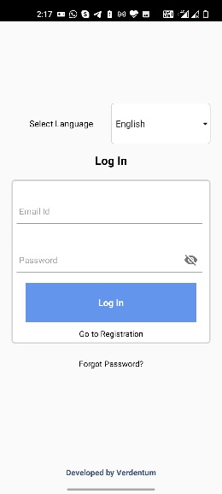
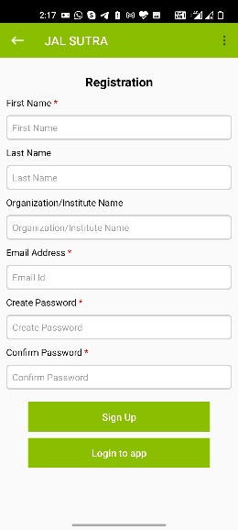
Download the JAL SUTRA app through the Google Play store on your android device (mobile or tablet).
Figure 3 Login Window
Figure 2 Signup Window
After successfully downloading the app to your device, you will need to register and login [Figure 2 & Figure 3]. During registration, enter your first name, last name, organization name, and email address. You will further be asked to create a password. After entering the mandatory information in the registration form, please click the Login button.
For login, use your email address as a user ID and enter the password you have given at registration.
In case you forgot your login details, use the “forgot password” button in the login window and follow the instructions [Figure 3].
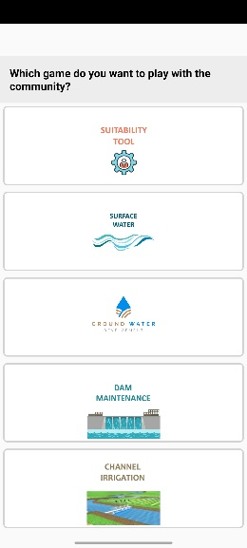
PLEASE NOTE: Your device requires Internet access for downloading, registration, initial login, and to upload/synchronize data. Once you have done the initial login, the app will keep you logged in, and you can use the app offline.
Figure 4 Options to select tool
In the next step you can choose the tool you want to use [Figure 4]. This manual is about the surface water game. Accordingly, please click on the surface water game button.

Venue
The game is designed to be played in a real workshop setting. We recommend to look for a quiet shady venue with little disturbance, giving space to at least 20 people. Public meeting places, temple areas, or schools are good choices. You will need to hang two banners on which you will have to write. Walls behind the banners are therefore helpful.

Choosing Experiment Participants
The target group of the game is water managers. We mainly played the game with farmers who live close to a stop-dam or water-harvesting structure, which is used for irrigating crops in the post-rainy/Rabi season. Alternatively, the game can be played with representatives of water-user associations or community organizations. In a game session seven or 14 participants can participate.

Facilitation Team Roles and Responsibilities
An optimal facilitation team comprises of the lead facilitator [LF], a data-entry operator [DEO], and at least one assistant [AS]. The facilitator guides the game and is primarily responsible for player interaction. The data-entry operator enters player’s decisions and notes the content of discussions into a mobile application. Assistants help the facilitator and the data-entry operator during the game.

Lead Facilitator [LF] |  | Data-Entry Operator [DEO] | Assistant [AS]
Skills | - Basic knowledge of common water resources  - Listen to people  - Able to speak in local language | - Knowledge of handling android devices | - Able to read and write
Responsibility | - Check required game material before going to village  - Explain procedure of the game in local language to participants  - Encourage participants to join the discussion | - Downloads and installs apps in device  - Enters player information in app  - Prepares decision envelopes/cards  - Enter players’ decisions in app  - Announces group investment and available number of irrigations in each round  - Announces results after each communication rounds and other variation rounds  - Enter notes in the app | - Helps facilitator to fix posters and banners  - Helps data-entry operator in preparation of decision cards  - Hands over decision cards to the players and collects them after the players’ decisions  - Helps the data-entry operator in entering the players’ decisions in app

Set Up Banners and Posters
Set up banners [Banner 1 and Banner 2]Error! Reference source not found. using string and adhesive tape. Make sure the banners are displayed in places that are easy for participants to see. There are two versions of the record posters. The first is meant to be put up on the wall [Record Poster 1, Figure 5], the second can be placed on the ground [Record Poster 2]. The first option supports a normal classroom type of sitting arrangement, the second allows the players to sit in a circle. While setting the record posters [Record Poster 2] in the middle of the meeting place on the ground if the second option was chosen, be aware that you need to write on the record posters and that there should be enough space to seat all players in a circle around the posters.
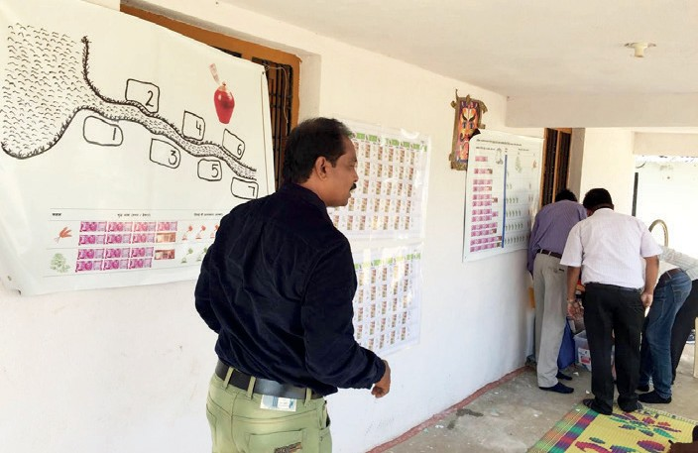
Figure 5 Setting up Posters and Banners in selected site

Basic Information of Location/Community
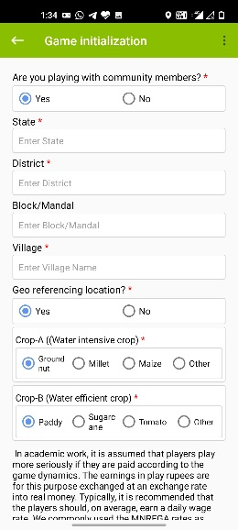
ICRISAT, IFPRI and FES would like to use the information entered into the app for analysis on water management, social learning, and for improving the tool and the app. Any analysis would be conducted only in an anonymous way, i.e., not revealing who played or facilitated the game. ICRISAT, IFPRI, and FES request you to approve the use of your data at the bottom of the Session Initialization window [Figure 6].
Figure 6 Game Initialization Window
Once you complete a game session, the app will automatically create a data table with the session data, which you can store on your device.
We would further like to know whether you are playing with community members or doing a training or demonstration session. Only games played with real community members are used for further analysis. If you are playing the game with community members, please indicate the same on top of the Game Initialization window [Figure 6]. Enter basic session information (state, district, block/mandal, and village name) of the selected site or community [Figure 6]Error! Reference source not found.. Once all participants gathered at the venue, we recommend that you ask the participants a few optional questions which can be found in the app.
The app then allows you to select farming of the crops which best fits the experience of the particular community. For making the game more illustrative, you can select a water-intensive crop and a crop that uses less water which are commonly grown in the community.
For monitoring how the tool is used, we request you to click on the GPS tab to record the Geo position of the site where you play the game.

Exchange Rate
In academic work, it is assumed that players take the game more seriously if they are paid according to the game dynamics. Our research also indicates that making incentivized payments increases the probability that players formulate rules for their real-life management challenges after they played the game. At the same time, many non-government (NGO) representatives feel uncomfortable with making such payments. In case you intend to make individual payments to the players, the app allows you to calculate how much you would have to pay each player after the game. Still, the payments are optional, and you can play the game without them.
In case you want to play the game with incentivized payments, then the earnings in play rupees are exchanged at an exchange rate into real money. Typically, it is recommended that the players should, on average, earn a daily wage rate. We commonly use the MNREGA rates as orientation, which are below INR 200. Accordingly, if you plan to play six rounds, we recommend an exchange rate of 1,000 play rupees equal to 2.5 real INR. If you plan to play 11 rounds, we recommend an exchange rate of 1,000 play rupees to 1.5 real rupees.
Enter the exchange rate for play money to real rupees or leave it at the value of zero in case you do not plan to pay the players [Figure 6].

Registration of Participants
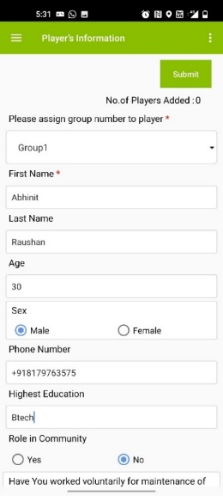
For playing the game, you need to enter at least a first name of each player. All other information on age, gender, education, contact number, role in the community, plot-related information, and players’ past water management actions is optional but useful for future analysis [Figure 7]. We therefore encourage you to enter this information as well. In the player information window, the group option is provided on the top of the window to assign a group number to the player. User needs to assign players to groups. To organize the games, it would be important to understand the gender dynamics at the local context to determine whether a mixed group of men and women can be selected to play the game or if it would be more preferable to organize them in separate groups. The facilitator in coordination with local staff or representatives from the community should determine what is appropriate.
Figure 7 Players' Registration
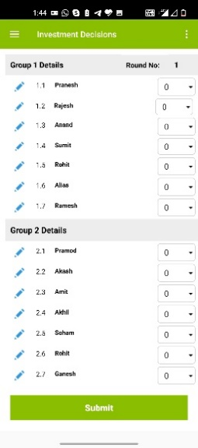
It is mandatory to ask each player whether he/she agrees that the game data will be used in an anonymous way for nonprofit research for development purposes. Please indicate this in the registration form. Should a player disagree, emphasize that this decision is respected.
Figure 8 Player replacement option
After entering all participants’ basic information, and assigning the group number of each player, the app will randomly assign a position to each player within the group. The relevance of the position will be explained below.

Replace/Substitute Player
Sometimes, because of an emergency, a player needs to leave the game. In such situation, a facilitator can ask other participants as substitute for the player. The app will permit this substitution. The edit option is provided in each round’s investment decisions window [Figure 8]. By clicking on the blue pen in front of the player name, the facilitator can replace the player and enter basic information of the new player.

Preparation of Decision Envelopes and Cards
We recommend to prepare all materials before you start with the instructions to the participants. First, [DEO and AS} write the players’ names on name tags and distribute them. Note that you need additional materials for practice rounds and the real game. For the practice round, prepare seven sets of red, brown, and yellow envelopes [Figure 9]. Write on all envelopes of the first set number 1, the second set number 2 and so on up to number 7. Please place 4,000 play rupees in the red envelope; the crop decision cards in the yellow; and leave the brown envelopes empty.
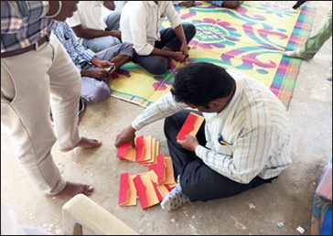
Figure 9 Data entry operator preparing decision envelopes

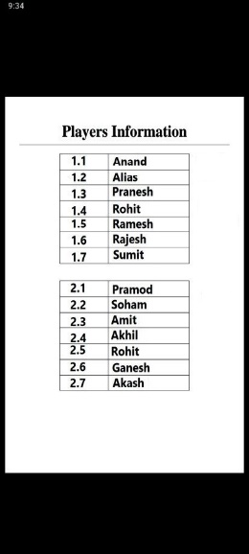
In preparing the materials for the real game, the app generates a PDF [Figure 11]Error! Reference source not found. showing the group and position of each player. An option to download the PDF is also provided [Figure 10]. [DEO and AS] Write the player group, position number, and players’ names on the sets of envelopes. Ensure that the name is written on the right envelop with the right group and position number as provided in the PDF. Place the crop choice cards [See Figure 18 in later section] in the yellow envelopes. [DEO and AS] Place in each red envelope 4,000 play rupees. Leave the brown envelopes empty.
Figure 11 PDF showing player's group and position

General Instruction to Participants
[LF] Introduce yourself and your team. Explain the project context in which you are playing the game [Figure 12].
For easy facilitation of the game process, the JAL SUTRA app includes the facilitation procedure in bullet points. The facilitator can see them in Hindi or in English.
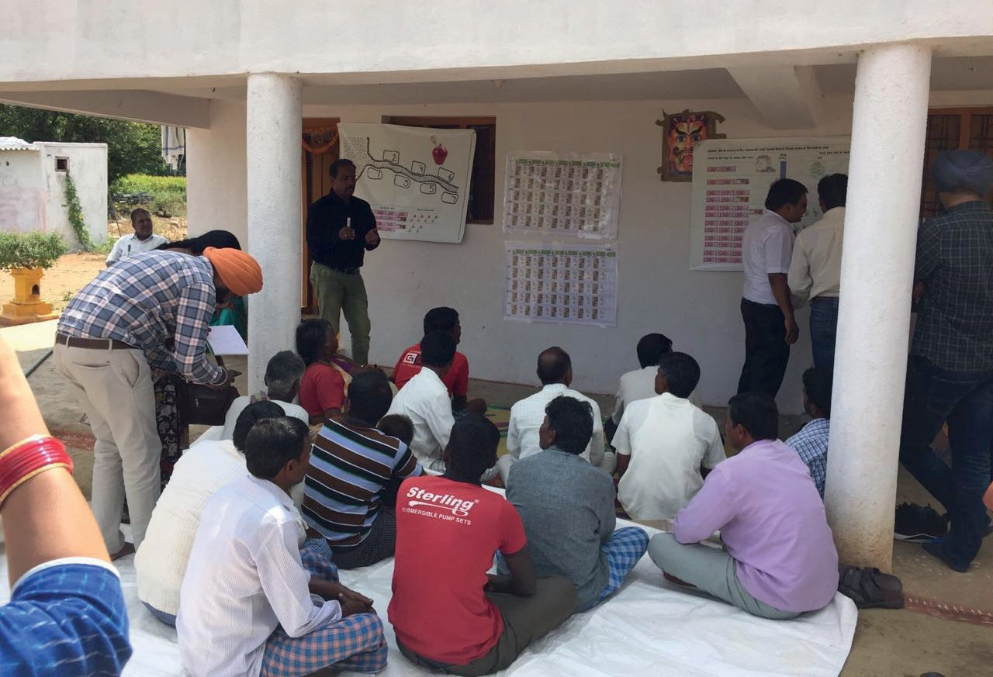
Figure 12 Facilitator explaining JAL SUTRA game to the participants
Below is a proposal how our [LF] typically enters the facilitation of the game:
It has come to our attention that in your region the management of stop-dams (alternatively tanks, any cuts, etc.) is an issue. People have noted that the dams can help the community and farmers experience a wide range of benefits as a result of withdrawing water from the dam. It has also been noted that some of the benefits are declining. Dams are filled with silt and overgrown with grass and bushes. Sluices get damaged. Because of poor maintenance, communities feel that the benefits of groundwater recharge, surface irrigation water availability, and flood and soil erosion control are greatly reduced. This is the main topic of this game, that is, equitable accessibility, distribution, and benefits from surface water irrigation.
So how to deal with this situation? We are aware that this is a difficult situation, and we want to play a game with you to jointly explore this challenge and to develop ideas and potential solutions for ensuring the continuous functioning of the watershed infrastructure.
The game is all about maintaining small dams or tanks in your community. The dams support the recharge of downstream open wells and makes water available for irrigation. In our game, we assume a stop-dam which stores certain volume of water over the year, including local groundwater storage. Many communities agree that certain amount of water needs to be made available for domestic use, livestock consumption, fish production, and other non-irrigation uses. Taking these activities into account, we assume that communities allow farmers to withdraw maximum water from the dam sufficient for 14 irrigations to irrigate post rainy season crops. This water can be used by the farmers below the dam to irrigate their fields. How many fields can be irrigated depends, among other reasons, on the crops grown by the farmers.
As you know, even if the stop-dam is in good condition, it requires regular minor maintenance in terms of materials, labor, and hiring machinery. The water available for irrigation depends on the amount invested in maintenance.
We have gathered 7/14 people today to play our game.
In case you will play with two groups, please mention:
You will play in two groups of seven players each. At the beginning of the game, you will not know who plays with whom in one group. We will tell you only later during the game.
Whatever information we collect during this game will be treated confidential. The main purpose of the exercise is to encourage discussion within the community. We hope that, in this way, it will be beneficial for you.
We will explain the game step-by-step. Please listen to the instructions carefully and ask questions at any point. We will play with you the first round to serve as an example.
Optional: It is common in experimental economics to play such games with incentivized payments. To make the game more realistic, players are paid according to their game earnings, which depend on their own and the other players’ decisions. You must enter your individual exchange rate in case you want to pay the players. The app does automatically calculate how much each player needs to be paid. You can adjust the exchange rate as given below again. If you want to make individual payments, please give the following explanation.

You can win real money in this game. How much you win depends on how you play as well as how the other participants play in the game. In the game, we will use play rupees; at the end, we will exchange 1,000 play rupees for <YOUR EXCHANGE RATE> real Indian rupees. The money we will provide is not our personal money; it comes from our organization/project.

General Explanation
[LF] Below you will find a proposal for explaining the game, which is how we have explained it in the past. This procedure considers the diverse challenges we faced in large number of game sessions. Feel free to adapt this procedure to your specific needs. We generally recommend to involve the players by asking questions rather than repeating explanations. This can increase their active thinking; further, rephrasing explanations by fellow players helps others to grasp the game rules.
Now that you learned about the main idea of the game, we want to explain how investments for the maintenance of the dam are made and how you can earn money.
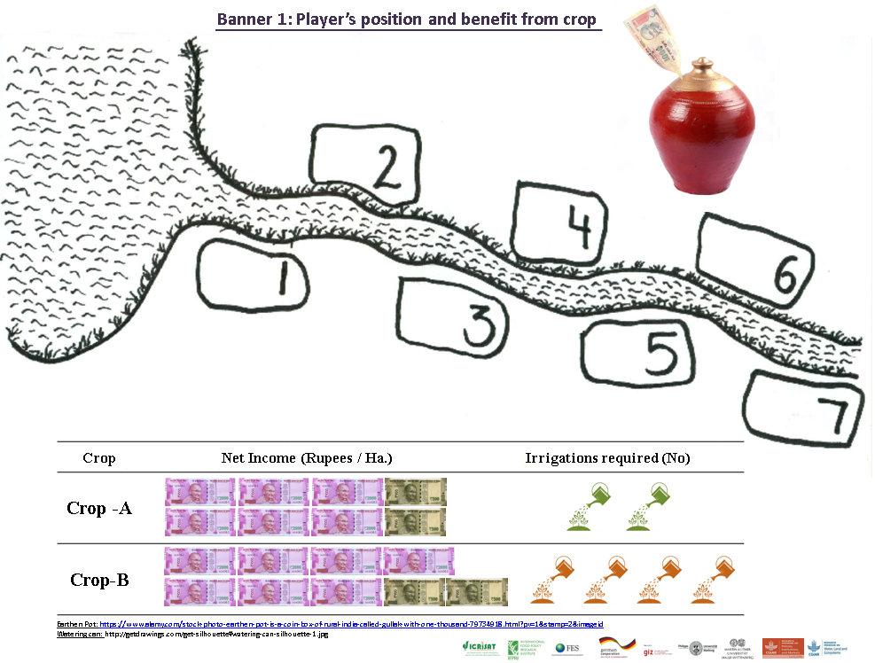
Banner 1 shows a typical dam and seven fields downstream of the dam. Every field belongs to a farmer: farmer 1 is closest to the dam; player 7 the farthest. Each of the farmers needs water to grow crops.
Banner 1 Player Position and Benefit from Crop Banner
[LF] Point at the dam and different field positions to illustrate this structure [Banner 1].

The water can be received from the dam. How much water is available depends on how good the dam is maintained. For maintenance of the dam, money is needed. This money comes from the investments you as a group voluntarily provide. We will, in every game round, give each of you 4,000 play rupees. Assume that this is the excess money you have at the end of every month and you can freely decide how to use it. You have the opportunity to invest money in the maintenance of the dam, or you can keep the money to yourself and use it for household expenditures. Any amount you do not invest remains in your personal account and nobody can touch it. The money invested by you will be put into the group account.
The relationship between the water available for irrigation and the investment in the dam maintenance can be seen in the table in front. Depending on how much the group invested, the dam will have water available for irrigation. The volume of stored water considerably increases for average investments. These calculations are made based on the engineers’ experiences in your area.
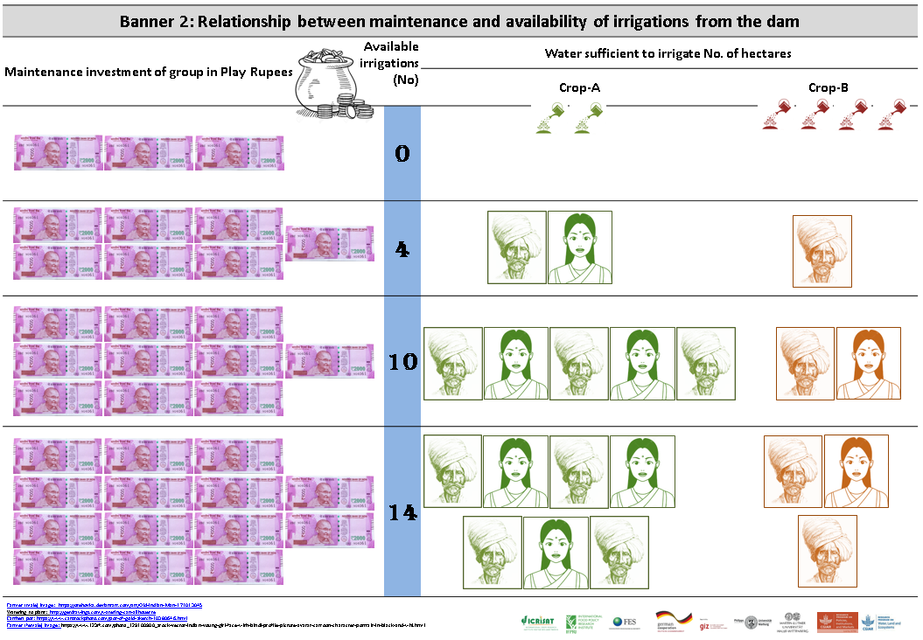
[LF] Point at the first and second column of the Payoff Table and show how the number of irrigations increases with the amount of money invested [Banner 2].
Banner 2 Payoff Table
Now, for example, imagine your group made an overall investment of INR 28,000.
[LF] Circle the 28,000 on the Payoff Table [Banner 2], and write 28,000 next to the pot on Banner 1.
This will yield 14 irrigations for your fields.
[LF] Circle the 14 on the Banner 2 and write 14 on the dam poster [Banner 1].
You can use this water to irrigate your fields and grow a post rainy crop.
Each of you can choose between two crops: Crop-A or Crop-B. You can see in the table below the differences between growing crop-A or crop-B.
Taking all costs and labor inputs into account, crop-B gives a better return per ha than crop-A, but crop-A requires substantially less water, with only two irrigations while Crop-B requires four irrigations per season.
How many fields can be cultivated with which crops given any investment is illustrated on the right side of this table.
[LF] Point at the third and fourth respective column of the Payoff Table and show the relationship between investment, amount of available water, and the number of farmers who can grow crop-A and crop-B [Banner 2].
Let us assume your group made an overall investment of 28,000 play rupees. With the available 14 irrigations either all of you can grow 1 ha of crop-A, or three of you can grow each 1 ha of crop-B. Keep in mind that, in our game, each player has exactly 1 ha to farm on.
[LF] Point at the third and fourth respective column of the Payoff Table to show the numbers [Banner 2].
In the first case, all of you received returns and made a profit. In the latter case, however, there is not enough water left for the remaining three players to grow any crop. Thus, only four received some returns, whereas the other three farmers did not make any return despite their investments in the dam maintenance.
[LF] Use the Payoff Table to illustrate this case [Banner 2].
But not in every case that the investments are high enough for every farmer to potentially grow crops. Consider the case in which your group made an overall investment of 20,000 play rupees.
[LF] Circle the 20,000 on the Payoff Table [Banner 2], and write 20,000 in the pot on the dam banner [Banner 1].
This will yield 10 irrigations for your fields.
[LF] Circle the 10 on the Banner 2, and write 10 on the Dam banner [Banner 1].
You can again use this water to irrigate your fields and grow crop-A or crop-B. With the 10 available irrigations, only five of the seven of you can each grow 1 ha of crop-A, or two of you can grow 1 ha of crop-B each.
[LF] Point at the third and fourth respective column of the Payoff Table [Banner 2] to show the numbers.
In both cases, there is not enough water for all farmers to grow crops. The farmers downstream again will not receive any returns despite their investment in the dam.
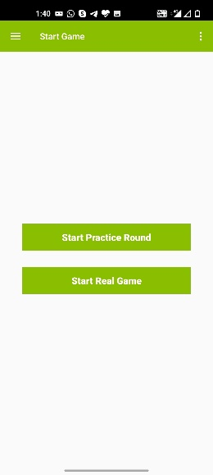
[LF] Use the dam banner [Banner 1] to illustrate this case.
Figure 13 Start Game
To make your investment decision, we will give you two envelopes: a red and a brown one. In the red one, you find 4,000 play rupees. The brown envelope is empty. If you want to invest money in the dam maintenance, transfer the amount you’d like to invest into the brown envelope.

Practice Rounds
[DEO] In the app, after the introduction window, you get to the window offering you to either directly start the game or play practice rounds. If you want to play practice rounds – which we recommend, click on the respective button [Figure 13]. You can then follow the instructions below. If you do not want to play practice rounds, jump to Section Start the Game.
We will now practice this with seven of you.
[AS] Hand over the prepared practice round investment envelopes (red & brown) to the first 7 players.
Now you can freely decide how much of your 4,000 play rupees you want to invest in the maintenance of the stop-dam. Please transfer the amount of play money you want to invest into the dam maintenance from the red to the brown envelope [see Figure 14 as example]. Do this in a discrete way. Once you have made your decision, hand over both envelopes to the assistant. All individuals make their decision at the same time and without talking to or consulting with anybody.
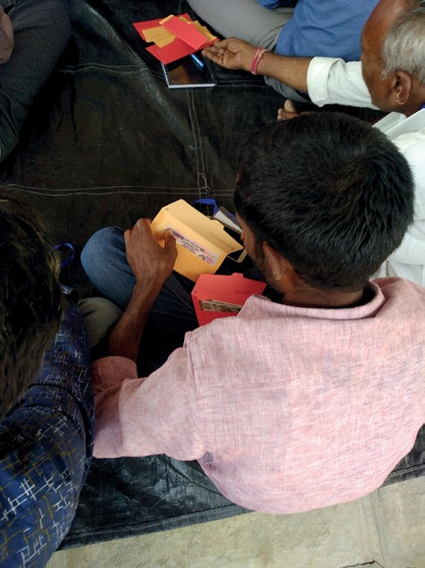
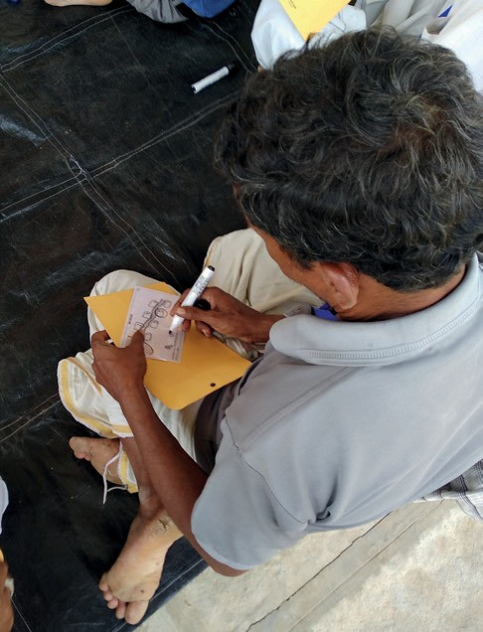
Figure 14 Investment decision for maintenance of the dam
Figure 15 Player choosing crop in the game
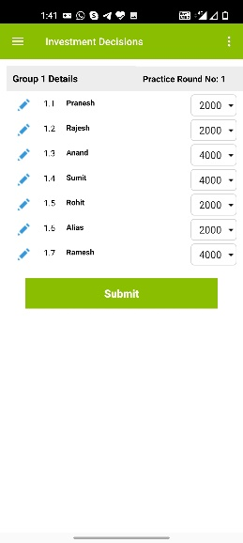
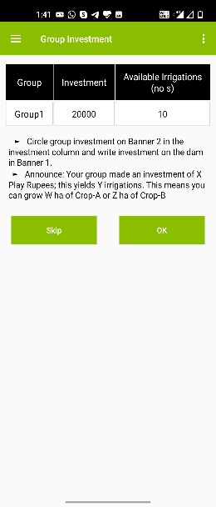
Figure 16 Practice Round investment decision
Figure 17 Practice Round Group Investment
[DEO] Enter the investment decisions into the app [Figure 16]. After all decisions are entered, the app will tell you the total investment level [Figure 17].

[LF] Circle the investment level on the Payoff Table [Banner 2], and write it onto the dam banner [Banner 1].

Your group made an investment of X play rupees in dam maintenance; this yields Y irrigations. This means you can grow W hectares of crop-A or Z hectares of crop-B.
Now, we come to the second decision of each round, which concerns the distribution of the dam water and the choice of crops.
We will distribute to each of you one card. In the upper part, you see a painting as here on the banner. There is a dam, a channel, and seven fields. You can find your field position on this card: It is the circled field. Keep this position in mind as the water flows from the top to the bottom. The farmers nearest the dam can first take the water; the next farmer can only take from what is left. This continues until the water is completely utilized.
In the lower part of the card you can mark which crop you want to grow: Tick the left box if you want to grow crop-A or the right box if you want to grow crop-B. If you don’t want to grow a crop, then hand over your card to the Assistant without ticking any box. Whether you will indeed get an income from this crop depends if there is enough water available to grow your crop. This depends a) on how much the group has invested in the dam and b) on how much water the players before you have taken.
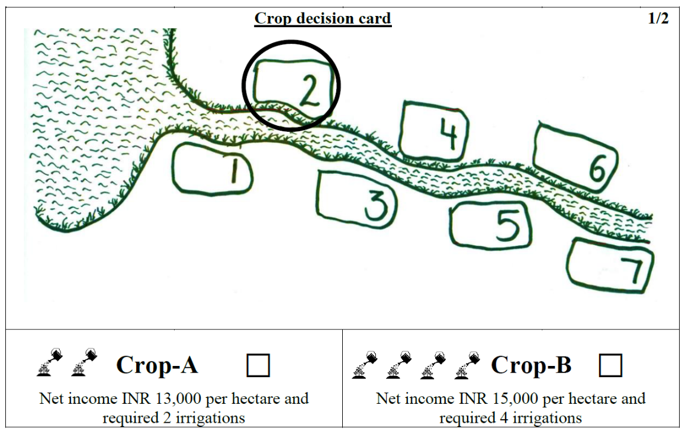
[LF] Show empty crop choice decision cards [Figure 18].
Figure 18 Crop Choice card

[AS] Hand the cards out to the players.
Please tick the box in front of the crop you want to grow.
[AS] After the players made their decision, collect the Crop Choice Cards.
[DEO] Enter the decisions into the app [Figure 19]. The app will calculate the earnings of each player [Figure 20].
[LF] For each player, write crop choice and the earning on one of the dam banner [Banner 1]. Pick out two players with different earnings and ask the group:
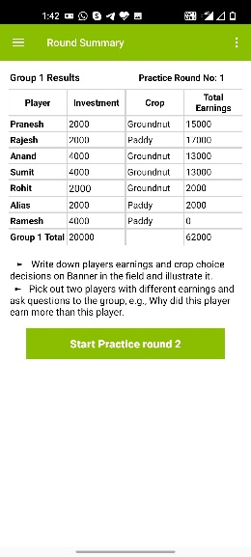
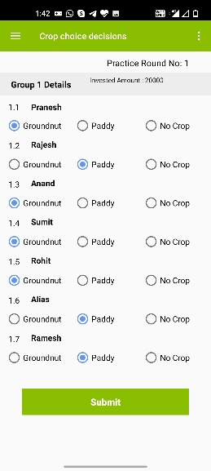
Why did this player earn more than this player?
Figure 20 Practice Round Summary

Figure 19 Practice Round Crop choice decision
[LF] Use the group to improve the understanding of the game. Explain again with the dam banner if anything is still unclear.
Now compare the first and the last player. Typically, player seven did not get water.
Why did this player earn more than this player?
[LF] Use the group to improve the understanding of the game. Explain again with the dam banner if anything is still unclear.
Repeat the practice round procedure with the other seven players.
This is how the game is played.

Starting the Game
Once all participants understand the rules, you can start playing the actual game. The first round should be anonymous.
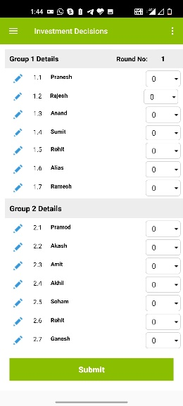
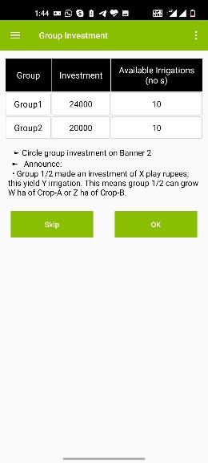
[AS] Before every round, prepare the red and brown envelopes by putting 4,000 play rupees into the red envelopes. The brown envelopes should be empty.
Figure 21 Investment decision-Real game
Figure 22 Group investment-Real Game
Now let us start playing the game. For your very first game round, please make your decisions without anybody else knowing what you decided. Nobody will be able to find out. Please don’t talk! We will now distribute the envelopes for your investment decision. Please transfer the amount you want to invest from the red into the brown envelope. Do not let anyone see how much you put in.
[LF] Please hand over the envelopes to the Assistant.
[LF] As soon as a player is ready, please collect this player’s envelopes.
[DEO] Start entering the decisions into the app [Figure 21]. Make sure that nobody can see how much individual player invested.
Once all investments are entered, the app will tell you the total group investments [Figure 22].
[LF] Mark the available number of irrigations for both groups on the Payoff Table in front.
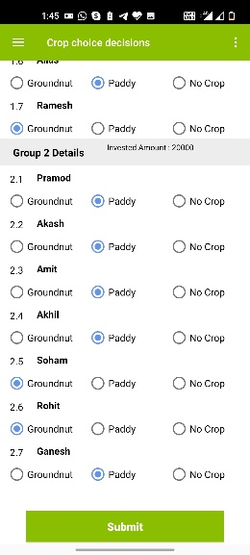
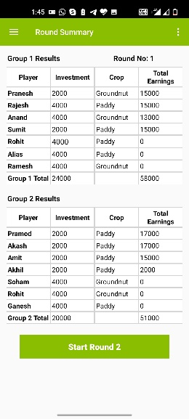
Now you can see the water available to all of you in this round. We will now hand out the crop choice decision cards. Tick on your card which crop you want to grow in this round. Do not let anyone see your decision.
Figure 23 Crop choice decision-Real Game
Figure 24 Round summary-Real game
[LF] As soon as a player is ready, collect that player’s card.
[DEO] Start entering the decisions into the app [Figure 23]. Make sure that nobody can see the individual player’s decision.
[DEO and AS] Once all crop choices are entered, the app will tell you the individual earnings [Figure 24]. Write on the back of the crop choice cards [Figure 25] each player’s individual earnings. Give the cards to the players in a way that nobody can see the amount on the cards.
On the card given to you, you can see how much you have earned in this game round. Make sure that nobody can see the amount.
Figure 25 Blank side of crop choice card use to reveal result

Allowing Discussion and Revealing the Individual Decisions
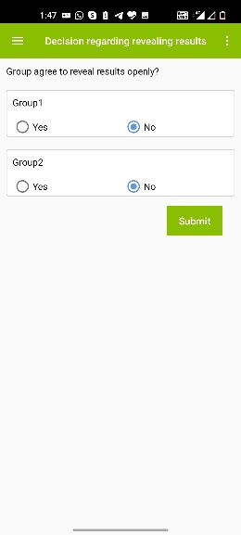
From round 2 onward, we will allow the players after each round to discuss for five minutes. In addition, we will ask participants whether they agree to reveal their decisions openly. If the participants agree, we will reveal all investment and crop choice decisions on the two record sheets.
Figure 26 Window to enter group’s agreement on revealing result
Now we play the same game for another 5 rounds. You now have the option to discuss after every round. We also offer you to reveal how much each of you invested and which crop you have chosen. This means that all other players will know your decisions. Is there any player who disagrees with the new rules? Is there anybody who would not want the players to discuss and to let us reveal the decisions? Anybody disagreeing, please raise your hand.
In case there is disagreement in a group, at least this group should continue playing the game as round 1 has been played. In case there is agreement, follow the instructions below. [DEO] Enter group’s agreement or disagreement into the app [Figure 26]. Than write [LF] the names of the players at the empty space on the top [Record Poster 1] or the bottom [Semi-circular Record Poster 2]. Make sure you put the right name to the right group and player position (use DEO to write the name). The earlier created PDF [Figure 11] tells you the group and position of each player.
As you all agreed, from here on, the players will know how much each player contributed, which crop she/he has chosen and how much she/he earned at the end of every round. We use this poster for this purpose. You will also naturally find out with whom you are playing.
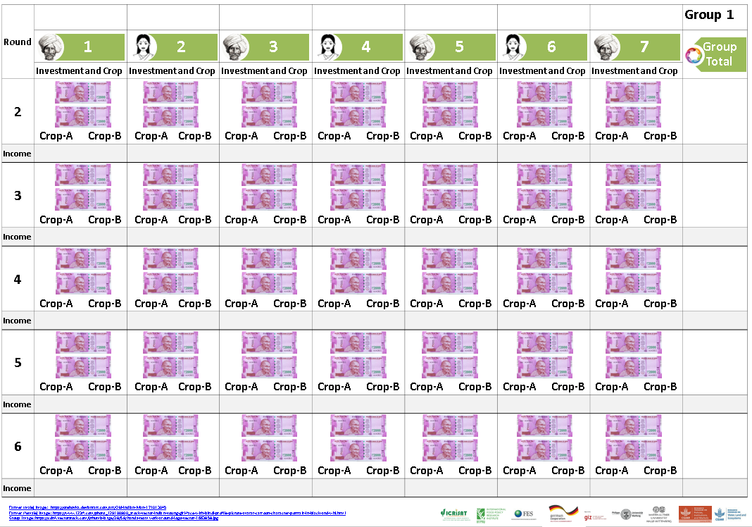
[LF] Show the empty Record Poster [Record Poster 1 or Record Poster 2]!
Record Poster 1 Record poster hang on wall
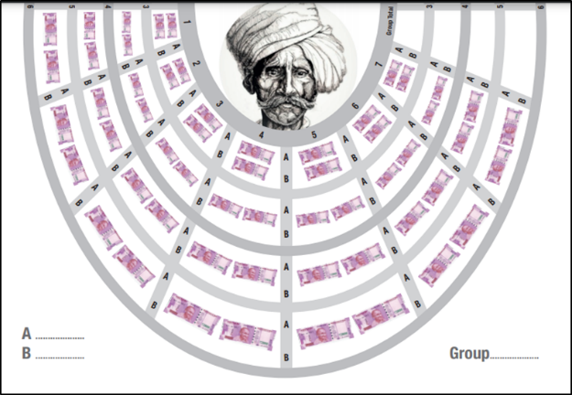
In addition, you can now discuss amongst yourselves as soon as you have given back the decision cards. To keep the exercise short, you have for every round a maximum of five minutes of discussion.
Record Poster 2 Semi-circle record poster
[AS] Before every round, prepare the envelopes by putting 4,000 play rupees into the red envelopes. Clean the crop choice decision cards. Hand over the red and brown envelopes to the players.
Please make your investment decisions. Avoid letting others see your decision.
[AS] Hand over the envelopes.
[AS and DEO] As soon as a player is ready, collect this player’s envelopes and start entering the decisions into the app.
Once all investments are entered, the app will tell you the total group investments.
[LF] Mark the available number of irrigations for both groups on the Payoff Table [Banner 2] in front.
Now you can see the water available to all of you in this round. We now hand out the crop choice decision cards. Tick on your card which crop you want to grow in this round. Do not let anyone see your decision.
[AS] As soon as a player is ready, collect this player’s card and the DEO can start entering the decisions into the app.
[LF] Once all crop choices are entered, the app will tell you the individual earnings. If group agreed to reveal decisions openly, please write on the Record Poster for each player the investment, crop choice, and the total earning as well as the group investment and earning. Once you have finished this task, the players may discuss in groups.

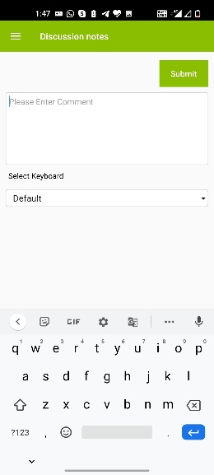
Discussions
Figure 27 Discussion notes
We recommend to avoid interfering in the participants’ discussions. The idea of the game is to let community members find their own solutions. Avoid probing and lecturing. The less the facilitators talk during the discussion the better.
The DEO should take notes during the discussions as this may provide input or clarifications for further discussions with the community at a later stage. The app allows you to record some notes [Figure 27]. The DEO checks the discussion time. After five minutes of discussions, repeat the procedure of round 2.
After revealing the results on record poster or on crop choice card, announce that the groups have five minutes to discuss [See Figure 28 as sample].
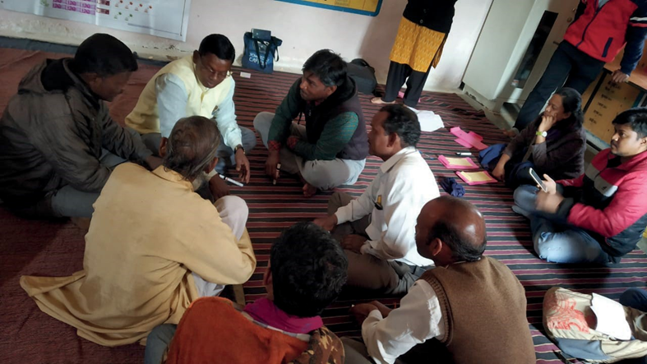
Now you have five minutes time to talk to each other.
Figure 28 Players' discussion

Leaving the Game or Playing Game Variations
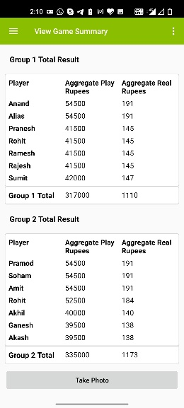
[DEO] After completion of the sixth round, the app will ask if you want to continue the game. If you don’t want to continue, the data table of the session will be created, and you will leave the app [Figure 29]. The option to click a group photograph of the game participant is given on the game summary window.
Figure 29 Game Summary
[LF and DEO] If you want to continue, you will be given the choice between different game variations, which are explained below. We recommend you to choose a variation that responds to the discussion in the particular community.

Game Variation 1: NREGA
As an additional rule, you can now make use of the Mahatma Gandhi National Rural Employment Guarantee Act (NREGA) scheme. Imagine that in this game, the Panchayat has decided to dedicate the NREGA to work that does not give you much benefit. If NREGA was used to maintain the stop-dam, this could save you and your fellow watershed farmers a significant amount of money. In order to convince the Panchayat to change its decision and indeed use the NREGA work for the dam, you would have to go to meetings and discuss with them. During this time, you cannot do other things, and this means you lose income. Let us assume that, if one person is attending the Panchayat meeting and advertising the watershed work, this would result in investment equivalent to 2,000 play rupees into the dam maintenance. In order to attend the Panchayat meeting, however, you lose time and even money (e.g., for petrol). This time and petrol will be valued with 1,000 play rupees. This amount of 1,000 play rupees would be taken from your account, but it would be equal to 2,000 play rupees invested in dam maintenance. For clarification, imagine that each player in your group, including yourself, attended the Panchayat meeting. In this case, each of you would pay only 1,000 play rupees, but the dam would be maintained at the level of 14,000 play rupees. Additional maintenance investments would have to be done by yourself as in the basic game.
Keep in mind that if NREGA is partly maintaining the dam, you can achieve the maximum possible income by investing less of your own money into the dam.
You will now receive a decision card on which you can tick whether you want to make the effort of convincing the village leaders to dedicate NREGA work to the dam maintenance.
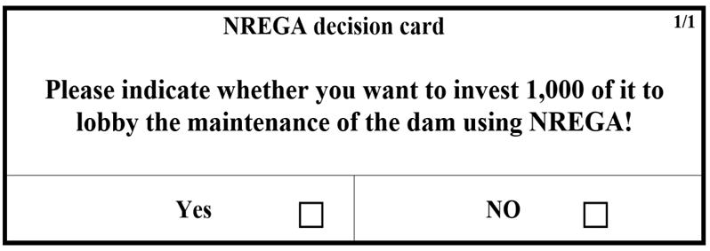
[LF] Show NREGA decision card [Figure 30].
Figure 30 NREGA Decision card
[DEO and AS] Prepare NREGA decision cards by writing the player’s name on envelopes as per the position and group. Before every round, prepare the envelopes by putting 4,000 play rupees into the red envelopes. Also clean the crop choice decision cards and the NREGA decision.
Please make your decision:
- Tick for lobbying of NREGA investment in dam maintenance.
- Individually invest in the dam maintenance by transferring play money from the red to the brown envelope.
[AS] Hand over the envelopes and NREGA decision cards. As soon as a player is ready, collect this player’s envelopes.
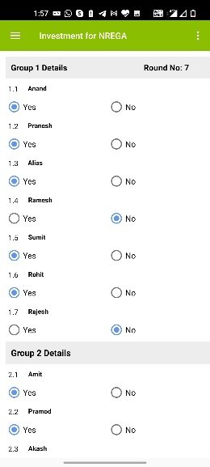
[DEO] Start entering player’s decisions into the app [Figure 31].
Figure 31 NREGA Decision window
[LF] Once all investments are entered, the app will tell you the total group investments. Mark the available number of irrigations for both groups on the Banner 2 in front.
Now you can see the water available to all of you in this round. We will now hand out the crop choice decision cards. Tick on your card which crop you want to grow in this round. Do not let anyone see your decision.
[AS] Hand over the decision cards. As soon as a player is ready, collect this player’s card and start entering the decisions into the app.
[DEO] Once all crop choices are entered, the app will tell you the individual earnings. Please announce results.
[LF] If group agreed to reveal decision openly, then please write on the Record Poster for each player the investment, crop choice, and the total earning as well as the group investment and earning. Once you have finished this task, the players may discuss for five minutes.
You see here in front all the decisions and earnings of all players. Before we start with the next round, you now have five minutes to talk to each other.
[LF] Repeat the procedure five times/rounds.

Game Variation 2: New Development Program
It is possible that another development project is being generated that includes dam maintenance. This is of course uncertain. In this game we assume that there is a one-out-of-six chance that the government or an international donor would be doing the maintenance work. If the donor is maintaining the dam, you get the whole income and does not need to pay for the dam maintenance. If the donor (e.g., the government) maintains the dam, the money you have invested is gone. Equally, however, if you do not invest in dam maintenance, and the donor does not step in, you have no benefits from the dam.
To simulate this situation, one of you will roll the dice. If the dice shows a 1, then another development project is maintaining your dam free of charge. If any other number but 1 is shown, then nobody from outside is helping in maintaining the dam. In this case, the maintenance again solely depends on how much each of you is investing into the maintenance. You need to make your decision on how much to invest in the dam before we throw the dice.
Given this information, we ask you again to decide how much you are willing to invest into the maintenance of the dam.
[DEO and AS] Before every round, prepare the envelopes by putting 4,000 play rupees into the red envelopes. Also clean the crop choice decision cards.
[LF] Hand over the envelopes.
Make your investment decisions. Do not let others see your decision.
[AS and DEO] As soon as a player is ready, collect this player’s envelopes and start entering the decisions into the app.
[LF] After all group members have made their decisions, let one player of each group throw the dice.
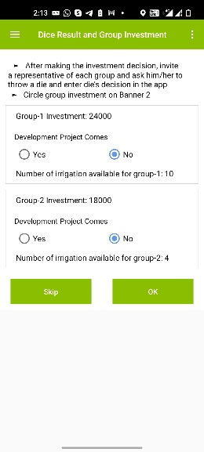
[DEO] Record in the app [Figure 32] by group whether a 1 is the outcome of the thrown dice. If it is 1, the number of irrigations available to the group is optimal level. If other than 1, then availability of irrigations to group depends on the investment of that group.
Figure 32 Dice Result Window
[LF] Mark the available number of irrigations for both groups on Banner 2 in front.
Now you can see the water available to all of you in this round. We now hand out the crop choice decision cards. Tick on your card which crop you want to grow in this round. Do not let anybody see your decision.
[AS] Please hand over the crop decision cards.
[AS] As soon as any player is ready, please collect the player’s cards.
[DEO] Start entering the decisions into the app. Once all crop choices are entered, the app will tell you the individual earnings.
[LF] If the group agreed to reveal decisions openly, please write on the Record Poster for each player the investment, crop choice, and the total earnings as well as the group investment and earnings. Once you have finished this task, the players may discuss in groups for five minutes.
You see here in front all the decisions and earnings of all players. Before we start with the next round, you have now five minutes to talk to each other.
[LF] Repeat the procedure five times/rounds.

Game Variation 3: Path Dependency
[LF and AS] Before starting the explanations of this game variation, please put up Banner 3: Payoff Table for Path Dependency.
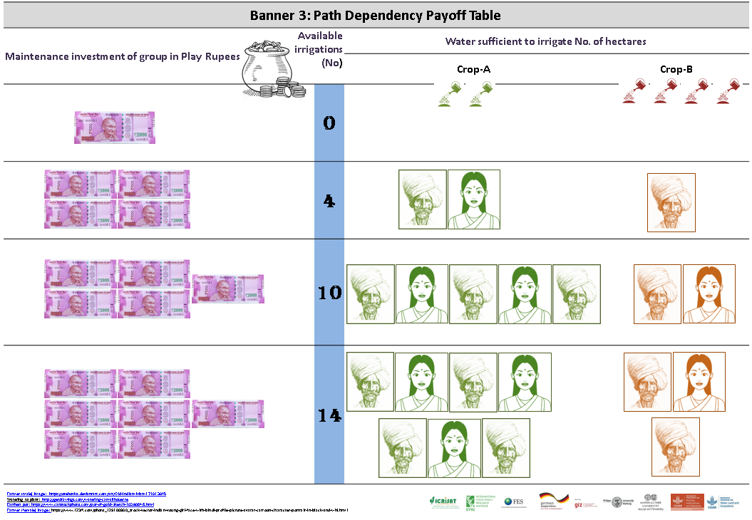
Banner 3 Path Dependency payoff table
We add a slight modification to the game. The new rules consider that a dam, which has not been sufficiently maintained in the previous year, requires more intensive maintenance in the following year. If, in the previous round, the dam was maintained at least at a group investment of 28,000 play rupees, your maintenance cost will decrease in the following round. The following pay-off/income table applies.
[LF and AS] Point at Banner 3!
In the first round of this game phase, you play with the Banner 2 again as in the initial game. If you invest in this round less than 28,000 play rupees, you continue playing with Banner 2 in the next round. If you invest, however, more than 28,000 play rupees, then you will have to pay less in the following rounds in order to achieve the same outcomes. Banner 3 will apply in this case. If you then manage to invest again at least 14,000 play rupees, you will continue playing with Banner 3. If the investment is below 14,000 play rupees, you will have to go back to Banner 2.
[AS and DEO] Before every round, prepare the envelopes by putting 4,000 play rupees into the red envelopes. Clean the crop choice decision cards. Hand over the envelopes.
Please make your investment decisions. Do not let others see your decision.
[AS and DEO] As soon as a player is ready, collect this player’s envelopes and start entering the decisions into the app.
[DEO] Once all investments are entered, the app will tell you the total group investments.
[LF] Mark the available number of irrigations for both groups on Banner 2 in front.
Now you can see the water available to all of you in this round. We now hand out the crop choice decision cards. Tick on your card which crop you want to grow in this round. Do not let anyone see your decision.
[DEO] Once all crop choices are entered, the app will tell you the individual earnings.
[LF] If the group agreed for revealing the decision openly, please write on the Record Poster for each player the investment, crop choice, and the total earnings as well as the group investment and earnings. Once you have finished this task, the players may discuss in groups.
You see here all the decisions and earnings of all players. Before we start with the next round, you now have five minutes to talk to each other.
You can also see whether your investment was sufficient to move in the next round to the lower-cost table.
[LF] In case the investment was sufficient (above 28,000 play rupees), please emphasize that, in the next round, Banner 3 will apply. In any round the investment drops below 14,000 play rupees again, please emphasize that Banner 2 applies again.
[LF] Repeat the procedure five times/rounds.

Game Variation 4: Vote for Exclusion
Now you play with a new rule. After every round, the group can decide to exclude somebody from the game for one round, which eventually means that the person loses her/his benefits. The group can decide the criteria for exclusion and agreed upon by the group. You can for instance decide to use a simple majority vote. The logic is that, if a farmer is excluded from the dam, he/she will not get any income from it in the following round. After every round, once the payments and earnings of all players have been announced, anybody from the group can propose to exclude another player from the game. If a player is excluded, he/she will be excluded only for one round. If you want to exclude her/him again, you need to re-decide on this.
We consider that it takes an effort to enforce the exclusion of somebody from the dam. Therefore, if any player is excluded by the group, each of the other group members will have to pay 500 play rupees.
[AS and DEO] Before every round, prepare the envelopes by putting 4,000 play rupees into the red envelopes. Clean the crop choice decision cards. Hand over the red and brown envelopes.
Please make your investment decisions.
[DEO] After all group members have made their decisions, the app will calculate the water available in the round to the group. Announce group investment and available water by group.
[LF] Mark group investment and available irrigations on Banner 2 in front.
[AS] Hand out the crop decision cards.
Now you can see the water available to all of you in this round marked here in front. Tick on your crop choice decision card which crop you want to grow in this round.
[AS and DEO] As soon as a player is ready, collect this player’s envelopes and start entering the decisions into the app.
[DEO] Once all crop choices are entered, the app will tell you the individual earnings. Please announce results.
[LF] If the group agreed for revealing results, please write on the Record Poster for each player the investment, crop choice, and the total earning as well as the group investments and earnings. Once you have finished this task, the players may discuss in groups.
You see here in front all the decisions and earnings of all players. Before we start with the next round, you now have five minutes to discuss amongst yourselves. Then let us know whether you want to exclude any player in the next round.
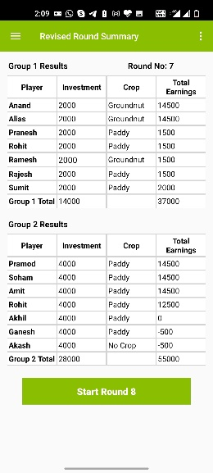
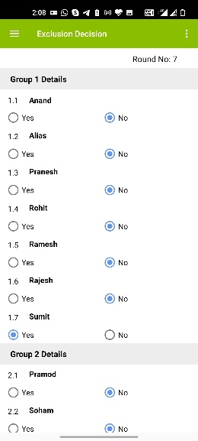
[DEO] Enter in the app if the group excludes any player [Figure 33].
Figure 34 Revised Round Summary
Figure 33 Exclusion Decision
If a group excluded a player, the app will show you a changed/revised round summary [Figure 34].
[LF] Repeat the procedure five times/rounds.

Conclusion and Departure after the Game or Continuing
After completion of the 11th round, the app will display the game summary [Figure 29]. A game summary consists of aggregate play rupees and aggregate real rupees (aggregate play rupees*exchange rate/1000) earned by the player in the game. If you want to download the game session data, click on the Export to CSV button. If your device has access to the Internet, the game session data will be uploaded to the server.
In case the device does not have access to the Internet, the next time your device does have access, the message “data from previous game was not synchronized, please click on sync button to sync the data to server” will pop up. If you click on the sync button, data will upload to the server.
After completion of the game session, clean all the posters and banners and fold them properly. Collect erasable markers pens and name tags from the players. Before leaving the site, ensure you have all the decision envelopes with you. Erase players name from the decision envelopes. Keep all the decision envelopes in sequence, so that it will save time in the next game session.

Picture References
Picture | Reference
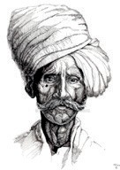 | https://orehovka.deviantart.com/art/Old-Indian-Man-171013045
 | http://getdrawings.com/watering-can-silhouette
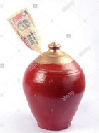 | https://www.alamy.com/stock-photo-earthen-pot-is-a-coin-box-of-rural-india-called- gullak-with-one-thousand-79734918.html?pv=1&stamp=2&imageid
 | https://www.visualsstock.com/Indian-Stock-Photo-Indian-Currency-100-Rupees-Notes-Bundle-Nobody-On-White-Background-AK54876.html
 | https://www.123rf.com/photo_129100900_stock-vector-indian-young-girl-face-with-bindi-profile-picture-avatar-cartoon-character-portrait-in-black-and-whi.html

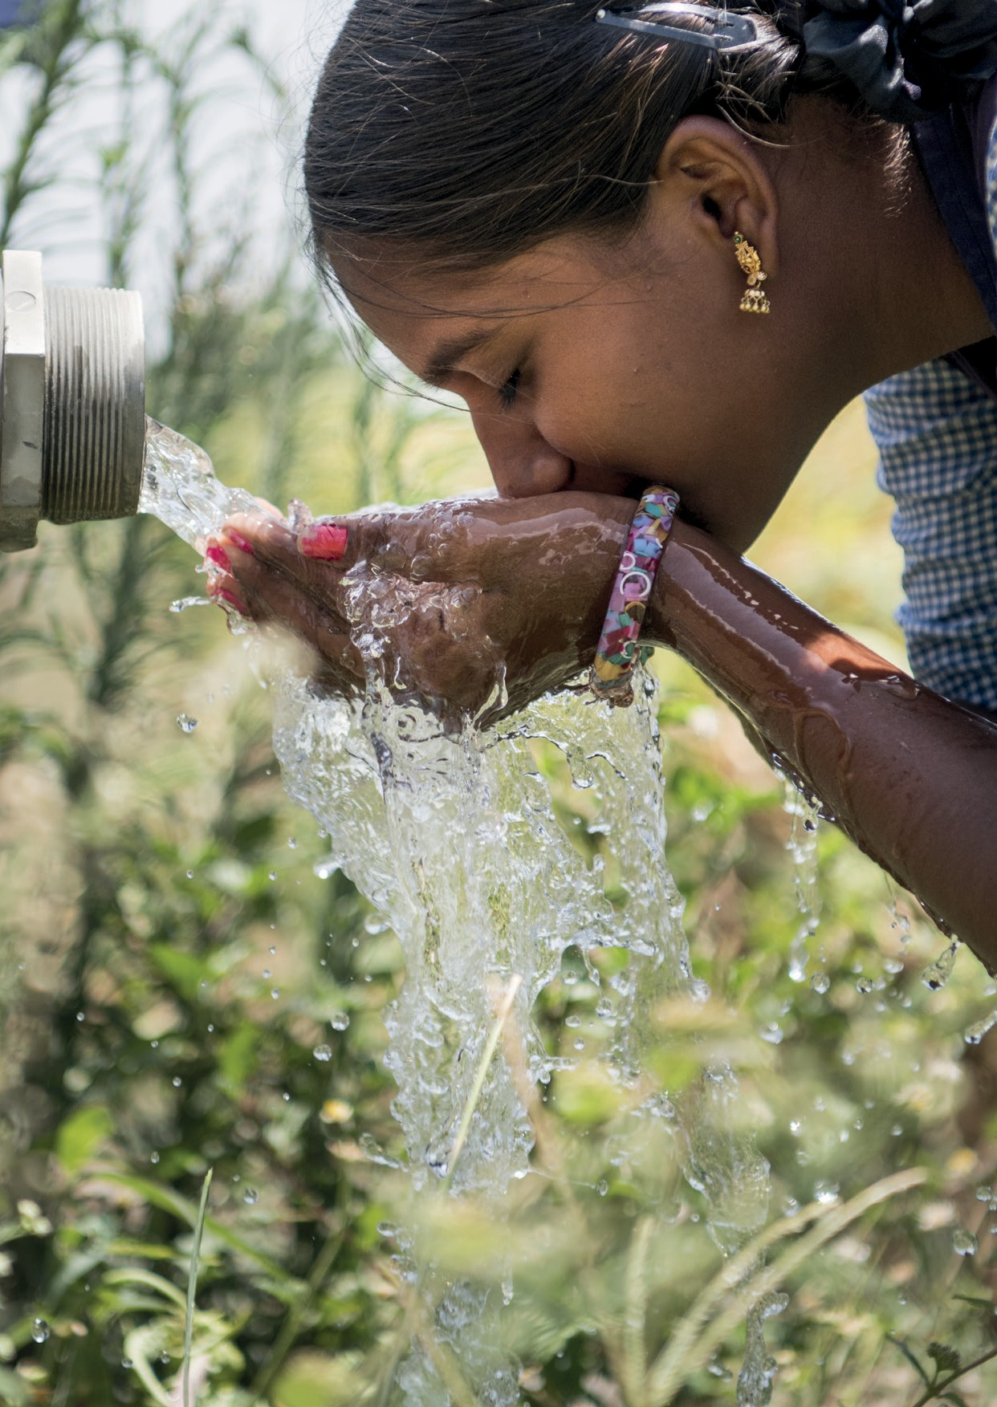

Envelope color can be changed. Note that we use colors for clarity and explanations provided in succeeding sections.

